Low-Level Design — Part 1
Sections 1–3: Document Overview, Functional Overview, System Components

1. Document Overview

1.1 Purpose
This Low-Level Design (LLD) translates the provided business and architecture documents into an implementation-ready design for the CardDemo Application.
This part of the LLD covers:
- document purpose and scope
- business and technical references
- assumptions and constraints
- glossary
- detailed functional overview for each business capability
- system component decomposition
- component responsibilities and interactions
This LLD is intended to be used directly by:
- backend engineers
- frontend engineers
- database engineers
- QA engineers
- DevOps/platform engineers
- solution architects
- support and operations teams

1.2 Scope
This LLD part covers the functional and component-level design for the following areas evidenced in the source documents:
- User authentication and access
- Main and administrative navigation
- User administration
- Account inquiry and update
- Bill payment
- Card inquiry and update
- Transaction inquiry and creation
- Transaction type/reference maintenance
- Pending authorization review
- Fraud marking and unmarking
- Report request submission
- Request/response services
- Authorization decision service
- Account inquiry service
- Date/time service
- Background processing services
- Daily transaction validation
- Daily transaction posting
- Interest processing
- Account transformation
- Import/export
- Statement generation
- Transaction reporting
- Pending authorization cleanup and migration
This part does not yet include the detailed per-endpoint API contracts, full database schema definitions, class diagrams, or testing catalog; those will follow in subsequent parts.

1.3 Intended Audience
Audience | Usage
Backend Developers | Service implementation, orchestration, validations, transaction boundaries
Frontend Developers | Page design, form validation, routing, state management
Database Engineers | Entity modeling, table design, indexing, constraints
QA Engineers | Functional coverage, negative scenarios, validation rules
DevOps Engineers | Deployment planning, service topology, environment configuration
Architects | Design validation and traceability to BRD and Architecture
Support/Ops Teams | Operational awareness of background jobs and service boundaries

1.4 References
Ref ID | Document | Purpose
BRD-ALL | BRD Ver3.docx | Business source of truth
ARCH-ALL | Final_Architecture_Document.docx | Technical source of truth
BRD-4 | BRD Section 4 | Business overview and roles
BRD-5 | BRD Section 5 | Common screen behavior and validation patterns
BRD-6.1 | BRD Authentication and Access | Sign-on
BRD-6.2 | BRD Main Menu | Standard user navigation
BRD-6.3 | BRD Admin Menu | Admin navigation
BRD-6.4 | BRD User Administration | User CRUD flows
BRD-6.5 | BRD Account Management | Account inquiry, update, bill payment
BRD-6.6 | BRD Card Management | Card list, detail, update
BRD-6.7 | BRD Transaction Management | Transaction list, detail, add
BRD-6.8 | BRD Transaction Type Maintenance | Reference data maintenance
BRD-6.9 | BRD Pending Authorization and Fraud | Review and fraud update
BRD-6.10 | BRD Report Request Management | Report submission
BRD-6.11–6.13 | BRD Request/response services | Auth decision, account inquiry, date/time
BRD-6.14–6.19 | BRD Background and shared utilities | Batch and utilities
ARCH-5 | Architecture UI Architecture | Screen and component structure
ARCH-6 | Architecture Frontend State Model | Client state model
ARCH-7 | Architecture Microservice Candidates | Logical service boundaries
ARCH-8 | Architecture Service Responsibilities | Backend responsibilities
ARCH-10 | Architecture API Specification | Candidate endpoints
ARCH-12 | Architecture Data Flows | End-to-end and service-level data flows
ARCH-14 | Architecture System Components | Component inventory
ARCH-16–17 | Architecture Database and ERD | Logical entity model

1.5 Assumptions
Only assumptions necessary for implementation structure are included here.
ID | Assumption | Source Basis
A1 | The application will be implemented as a modular service-oriented system, but can be deployed either as a modular monolith or as multiple deployable services. | ARCH-20 A8
A2 | UI will be a web-based application or equivalent screen-based client, because BRD defines screen-oriented behavior but not a specific UI technology. | BRD-5, ARCH-20 A1
A3 | Backend services are the final authority for validation; frontend performs immediate usability validations only. | BRD-5.3, ARCH-6
A4 | Role-based access control must be enforced at both UI routing and backend authorization layers. | BRD-4.2, BRD-6.2, BRD-6.3, ARCH-18
A5 | Concurrency protection for update flows will use a version/timestamp mechanism or equivalent optimistic locking approach. | BRD-6.5.2, BRD-6.6.3, ARCH-20 A13
A6 | Sensitive fields such as SSN, password, government ID, account/card identifiers will require masking or restricted visibility in implementation, even where BRD does not define exact masking rules. | BRD-6.5.1, ARCH-18
A7 | Background jobs can be scheduler-triggered, operator-triggered, or orchestration-triggered depending on runtime design. | BRD-6.14–6.18, ARCH-20 A6
A8 | The common UI shell will include title, date/time, function context, message area, and error area. | BRD-5.1, ARCH-5
A9 | Pagination for list screens will be implemented consistently using page/pageSize or cursor model per final API design. | BRD-6.4.1, 6.6.1, 6.7.1, 6.9.1; ARCH-10
A10 | A centralized validation utility/library will be used across services to enforce consistency. | BRD-6.19.1, ARCH-14

1.6 Constraints
ID | Constraint | Impact
C1 | BRD is reconstructed from repository artifacts only. | Some business rules are evidenced but not fully explicit.
C2 | No undocumented functionality may be invented. | Design must remain conservative where source docs are incomplete.
C3 | Some validation wording/messages may be generated or truncated. | Final user-facing text may need stakeholder review.
C4 | Exact deployment topology, protocols, security token model, and physical storage technology are not defined in the source docs. | Implementation choices must be explicitly documented as technical assumptions.
C5 | Some relationship cardinalities are not fully explicit in the BRD. | Database and service boundaries must be designed with clearly flagged assumptions.

1.7 Glossary
Term | Meaning
Admin User | User with access to administrative menu and maintenance functions
Standard User | User with access to standard menu and permitted business functions
Account | Financial servicing record associated with customer and card activity
Customer | Person profile linked to an account
Card | Payment card linked to an account
Transaction | Financial or operational event tied to account/card
Transaction Type | Reference/master data describing transaction type
Pending Authorization | Unsettled authorization record awaiting later completion/cleanup/review
Fraud Record | Record reflecting mark/unmark fraud action tied to a pending authorization
Report Request | User-submitted request for monthly, yearly, or custom reporting
Concurrency Check | Validation ensuring data has not changed since retrieval before update
No-Change Detection | Validation preventing persistence if submitted values equal original values
Background Job | Scheduled or operational non-interactive process
Request/Response Service | Service responding synchronously to external or internal requests
EFA | Electronic Funds Account reference
Row Version | Version/timestamp token used to support optimistic locking

2. Functional Overview
This section converts each business capability into a development-oriented functional definition.

2.1 Authentication and Access

2.1.1 Feature Description
Authenticate a user using User ID and Password, determine role, and route to the appropriate landing menu.

2.1.2 Actors
- Standard User
- Administrative User

2.1.3 Preconditions
- User has access to sign-on page
- User record exists in user repository for successful authentication
- Authentication service is available

2.1.4 Postconditions
On success:
- authenticated session/context established
- role resolved
- user routed to Main Menu or Admin Menu
On failure:
- no authenticated session created
- error displayed on sign-on screen

2.1.5 Business Rules
- User ID is mandatory
- Password is mandatory
- User must exist
- Password must match stored credential
- User type determines landing page
- Unauthorized users must not be routed to admin functions

2.1.6 Validation Rules
- User ID not blank
- Password not blank
- user lookup must succeed
- password comparison must succeed

2.1.7 Error Scenarios
- missing User ID
- missing Password
- user not found
- wrong password
- authentication store unavailable
- unable to verify user

2.1.8 Edge Cases
- user exists but role missing or invalid
- duplicate user records for same ID due to data corruption
- locked/inactive user if such status is implemented as technical extension
- session created but menu retrieval fails after authentication

2.1.9 Dependencies
- Authentication Service
- User repository/store
- Navigation/Access Control component
- UI Sign-on Page

2.1.10 Traceability
BRD: 6.1Architecture: 5.4.1, 8, 10.1, 12.2.1

2.2 Main Menu Navigation

2.2.1 Feature Description
Display the standard user menu and route the authenticated user to allowed functions based on selected option.

2.2.2 Actors
- Standard User

2.2.3 Preconditions
- User successfully authenticated as standard user
- Menu configuration available
- Access rules available

2.2.4 Postconditions
- Valid selection routes user to target function
- Invalid selection returns error without navigation

2.2.5 Business Rules
- Option must be valid
- Option must be numeric or valid mapped command form
- Restricted functions must not be accessible
- Unavailable functions must return informational message

2.2.6 Validation Rules
- option present
- option format valid
- option exists in current role menu
- user has permission

2.2.7 Error Scenarios
- invalid option number
- unavailable function
- unauthorized selection
- menu retrieval failure

2.2.8 Edge Cases
- stale menu configuration between login and selection
- user session expired before option selection
- menu item available but downstream service unavailable

2.2.9 Dependencies
- Navigation Service
- Authorization layer
- Main Menu UI

2.2.10 Traceability
BRD: 6.2Architecture: 5.4.2, 8, 10.1.4–10.1.6

2.3 Administrative Menu Navigation

2.3.1 Feature Description
Display administrative menu options and route admin users to maintenance functions.

2.3.2 Actors
- Administrative User

2.3.3 Preconditions
- User successfully authenticated as admin user

2.3.4 Postconditions
- valid option routes to selected administrative capability
- invalid option redisplays menu with error

2.3.5 Business Rules
- only admin menu options are valid
- only authorized admin users may access this menu
- unavailable downstream functions must fail gracefully

2.3.6 Validation Rules
- option required
- option must map to valid admin function

2.3.7 Error Scenarios
- invalid selection
- unauthorized access attempt
- menu configuration failure
- downstream component unavailable

2.3.8 Edge Cases
- admin user downgraded while session remains active
- partial menu configuration loaded

2.3.9 Dependencies
- Authentication Service
- Navigation Service
- Authorization layer
- Admin Menu UI

2.3.10 Traceability
BRD: 6.3Architecture: 5.4.2, 8, 10.1.5–10.1.6

2.4 User Administration
This includes list, add, update, and delete flows.

2.4.1 User List
Feature DescriptionBrowse paginated user records and select a user for update or deletion.
ActorsAdministrative User
Preconditions
- admin user authenticated
- user administration service available
Postconditions
- user list displayed
- selected user context passed to update or delete flow
Business Rules
- list is paginated
- start from specific User ID may be supported
- only allowed row actions are update and delete
Validation Rules
- action code valid
- page navigation within boundaries
Error Scenarios
- invalid row selection
- top of page / bottom of page reached
- user lookup failure
Edge Cases
- page becomes empty after deletion
- selected user deleted by another admin before update screen loads
Dependencies
- User Administration Service
- User List UI
- Pagination utility
TraceabilityBRD: 6.4.1Architecture: 5.4.3, 8, 10.2.1

2.4.2 Add User
Feature DescriptionCreate a new user access record.
ActorsAdministrative User
Preconditions
- admin user authenticated
- user type values available
Postconditions
- new user record created on success
- confirmation displayed
Business Rules
- First Name required
- Last Name required
- User ID required
- Password required
- User Type required
- User ID must be unique
Validation Rules
- all fields present
- user type valid
- user ID uniqueness check
Error Scenarios
- duplicate user ID
- missing required fields
- persistence failure
Edge Cases
- whitespace-only values
- password policy added later as technical enhancement
- race condition on duplicate user creation
Dependencies
- User Administration Service
- User repository
- Add User UI
TraceabilityBRD: 6.4.2Architecture: 5.4.4, 8, 10.2.3

2.4.3 Update User
Feature DescriptionRetrieve an existing user and modify allowed fields.
ActorsAdministrative User
Preconditions
- target user exists
- user record retrievable
Postconditions
- updated user record saved on success
- no-change message shown if unchanged
Business Rules
- existing user must be found
- all required fields must remain valid
- unchanged record should not be saved
Validation Rules
- User ID required for retrieval
- First Name required
- Last Name required
- Password required
- User Type required
Error Scenarios
- user not found
- update failure
- no-change detected
- concurrent modification if implemented
Edge Cases
- submitted values differ only by trim/case normalization
- user deleted after retrieval and before save
Dependencies
- User Administration Service
- User Update UI
- validation utility
TraceabilityBRD: 6.4.3Architecture: 5.4.4, 8, 10.2.4

2.4.4 Delete User
Feature DescriptionRetrieve a user record and delete it after confirmation action.
ActorsAdministrative User
Preconditions
- target user exists
Postconditions
- target user removed from user store on success
Business Rules
- user must exist before deletion
- deletion occurs only after explicit delete action
Validation Rules
- User ID required for lookup and delete target identification
Error Scenarios
- user not found
- delete failure
- delete/update generic repository failure
Edge Cases
- deleting currently logged-in user
- deleting last admin user if policy later disallows it
- target user already deleted
Dependencies
- User Administration Service
- Delete User UI
TraceabilityBRD: 6.4.4Architecture: 5.4.4, 8, 10.2.5

2.5 Account Management
Includes account inquiry, account update, and bill payment.

2.5.1 Account Inquiry
Feature DescriptionRetrieve and display account information together with linked customer information.
ActorsAllowed authenticated users
Preconditions
- authenticated user
- account identifier entered
- account data exists
Postconditions
- account and customer details displayed
Business Rules
- inquiry is based on Account ID
- account must exist
- associated customer must exist for complete response
Validation Rules
- Account ID required
- Account ID numeric
- Account ID expected as non-zero 11-digit number per evidence
Error Scenarios
- no input
- invalid account format
- account not found
- customer not found
- retrieval failure
Edge Cases
- account exists but linked customer missing
- multiple customers linked unexpectedly
- masked display required for sensitive customer data
Dependencies
- Account Service
- Customer data access
- Account Inquiry UI
TraceabilityBRD: 6.5.1Architecture: 5.4.5, 8, 10.3.1

2.5.2 Account Update
Feature DescriptionRetrieve account and linked customer details, allow edits, validate them, and save both record sets.
ActorsAllowed authenticated users
Preconditions
- valid account ID
- account and customer exist
- data successfully loaded
Postconditions
- account and customer updated together on success
- no-change or concurrency message returned when applicable
Business Rules
- account maintenance includes customer maintenance in same flow
- no-change detection enforced
- record changed-by-someone-else protection enforced
- save updates account and customer together
Validation Rules
- Account ID valid
- field-level validations on account/customer data
- save allowed only after successful validation
Error Scenarios
- no input
- invalid field data
- retrieval failure
- no-change detected
- concurrent update conflict
- persistence failure
Edge Cases
- account updated but customer save fails
- customer updated but account save fails
- user loads data, another user updates one child record only
- formatting-only changes after normalization
Dependencies
- Account Service
- Customer data access
- validation utility
- optimistic locking/concurrency mechanism
- Account Update UI
TraceabilityBRD: 6.5.2Architecture: 5.4.5, 8, 10.3.2, 13.3

2.5.3 Bill Payment
Feature DescriptionPay the current balance of an account, creating a payment transaction and reducing the account balance.
ActorsAllowed authenticated users
Preconditions
- valid account exists
- current balance available
- user confirms payment
Postconditions
- payment transaction created
- account balance updated
- success/failure shown to user
Business Rules
- payment allowed only when current balance > 0
- observed flow indicates full current balance payment
- confirmation required
- payment creates transaction record
Validation Rules
- account ID required
- account exists
- confirmation valid
- payable balance must be positive
Error Scenarios
- account not found
- zero or negative balance
- invalid confirmation value
- transaction creation failure
- account update failure
Edge Cases
- balance changes between preview and confirm
- duplicate submit causes duplicate payment risk
- account locked during payment
- payment transaction created but balance update fails
Dependencies
- Payment Service
- Account Service/account store
- Transaction Service/store
- Bill Payment UI
TraceabilityBRD: 6.5.3Architecture: 5.4.6, 8, 10.4, 13.4

2.6 Card Management

2.6.1 Card List/Search
Feature DescriptionSearch and browse cards using account and/or card filters; select a row for detail or update.
ActorsAllowed authenticated users
Preconditions
- authenticated user
- optional filters entered
Postconditions
- paginated card results displayed
- selected row routed to detail or update
Business Rules
- filter by account and/or card number
- one row selection at a time
- allowed row actions are detail and update
- results paginated
Validation Rules
- account filter numeric if present
- card filter numeric if present
- account expected as 11 digits
- card expected as 16 digits
- only one row may be selected
Error Scenarios
- invalid filter formats
- invalid action code
- no records found
- page boundary reached
Edge Cases
- both filters entered but contradictory
- large result set
- record disappears between search and row selection
Dependencies
- Card Service
- Card Search/List UI
TraceabilityBRD: 6.6.1Architecture: 5.4.7, 8, 10.5.1

2.6.2 Card Detail
Feature DescriptionDisplay full detail for a selected or explicitly entered card.
ActorsAllowed authenticated users
Preconditions
- account/card identifiers available directly or via selection
Postconditions
- card detail displayed
Business Rules
- valid account/card association required for complete inquiry
Validation Rules
- account required
- card number required
- account numeric
- card numeric
- card must exist
Error Scenarios
- no input
- missing account
- missing card
- card not found
- lookup failure
Edge Cases
- card exists but linked account mismatched
- card inactive/expired but still viewable
Dependencies
- Card Service
- Card Detail UI
TraceabilityBRD: 6.6.2Architecture: 5.4.7, 8, 10.5.2

2.6.3 Card Update
Feature DescriptionModify selected editable card fields and persist changes after validation.
ActorsAllowed authenticated users
Preconditions
- target card exists
- existing details loaded
Postconditions
- updated card saved on success
- no-change or concurrency result returned when applicable
Business Rules
- editable fields evidenced: Card Name, Active Status, Expiry Month, Expiry Year
- no-change detection enforced
- save allowed only after validation
- record-changed-by-someone-else check before save
Validation Rules
- account required
- card number required
- card name required
- card name alphabets and spaces only
- active status Y or N
- expiry month 1..12
- expiry year valid
Error Scenarios
- invalid card data
- no-change detected
- lock/update conflict
- save failure
Edge Cases
- card name normalization differences
- expired card updated to invalid future/past state based on final business interpretation
- row version conflict
Dependencies
- Card Service
- validation utility
- Card Update UI
TraceabilityBRD: 6.6.3Architecture: 5.4.7, 8, 10.5.3, 13.5

2.7 Transaction Management

2.7.1 Transaction List
Feature DescriptionBrowse paginated transaction summaries and select a transaction for detail view.
ActorsAllowed authenticated users
Preconditions
- authenticated user
Postconditions
- transaction page displayed
- selected transaction routed to detail view
Business Rules
- list paginated
- only detail selection supported from this screen
Validation Rules
- starting transaction ID numeric if entered
- valid action code only
Error Scenarios
- invalid selection
- invalid transaction ID format
- lookup failure
- paging boundary reached
Edge Cases
- empty result page
- transaction deleted/archived after listing
Dependencies
- Transaction Service
- Transaction List UI
TraceabilityBRD: 6.7.1Architecture: 5.4.8, 8, 10.6.1

2.7.2 Transaction Detail
Feature DescriptionDisplay complete transaction detail for selected or entered transaction.
ActorsAllowed authenticated users
Preconditions
- transaction ID available
- transaction exists
Postconditions
- detail rendered to user
Business Rules
- transaction must exist
Validation Rules
- transaction ID required
Error Scenarios
- missing transaction ID
- not found
- lookup failure
Edge Cases
- transaction exists but linked reference data missing
- display formatting inconsistency for dates
Dependencies
- Transaction Service
- Transaction Detail UI
TraceabilityBRD: 6.7.2Architecture: 5.4.8, 8, 10.6.2

2.7.3 Add Transaction
Feature DescriptionCreate a transaction manually using account/card and transaction metadata.
ActorsAllowed authenticated users
Preconditions
- authenticated user
- reference data available for valid type/category
- confirmation submitted
Postconditions
- new transaction record created
- new transaction ID returned
Business Rules
- transaction can be created using account and/or card number
- missing related identifier may be derived
- confirmation required
- transaction ID is system-generated
- copy-last-transaction convenience exists
Validation Rules
- account/card linkage valid where provided
- type/category/source valid
- amount valid
- description present if required
- original date valid
- process date valid
- merchant fields valid
- confirmation valid
Error Scenarios
- missing or invalid account/card data
- linkage not found
- invalid dates
- invalid confirmation
- reference data invalid
- create failure
Edge Cases
- both account and card provided but mismatch
- derived identifier ambiguous
- duplicate user submit
- future or backdated process/original dates depending on allowed rules
Dependencies
- Transaction Service
- Account/Card linkage access
- validation utility
- Add Transaction UI
TraceabilityBRD: 6.7.3Architecture: 5.4.8, 8, 10.6.3–10.6.4, 13.6

2.8 Transaction Type Maintenance

2.8.1 Transaction Type List
Feature DescriptionBrowse and filter transaction reference records; choose a record for update or deletion.
ActorsAdministrative User
Preconditions
- admin authenticated
Postconditions
- list returned
- chosen item routed to maintenance action
Business Rules
- centralized reference data maintenance
- paginated list
- update/delete are row-level actions
- add available from maintenance flow
Validation Rules
- filter values valid if supplied
- action selection valid
Error Scenarios
- retrieval failure
- invalid action selection
Edge Cases
- deleting type referenced by transactions if policy disallows
- duplicate descriptions with different type codes
Dependencies
- Transaction Reference Service
- Transaction Type List UI
TraceabilityBRD: 6.8.1Architecture: 5.4.9, 8, 10.7.1

2.8.2 Transaction Type Detail Maintenance
Feature DescriptionCreate, update, or delete a single transaction type reference record.
ActorsAdministrative User
Preconditions
- admin authenticated
- selected type code entered or chosen
Postconditions
- type created, updated, or deleted based on action
Business Rules
- existing record may be updated or deleted
- non-existing record may be added
- same screen supports add/update/delete depending on record state
Validation Rules
- type code required for lookup
- description required for create/update
- uniqueness rules on type code
Error Scenarios
- record not found
- create/update/delete failure
- reference integrity failure
- data access failure
Edge Cases
- create attempted for existing type
- delete attempted for referenced type
- concurrent update
Dependencies
- Transaction Reference Service
- maintenance UI
- validation utility
TraceabilityBRD: 6.8.2Architecture: 5.4.9, 8, 10.7.2–10.7.5

2.9 Pending Authorization and Fraud Management

2.9.1 Pending Authorization Summary/List
Feature DescriptionDisplay account summary, customer summary, pending authorization summary, and paginated pending authorization items for an account.
ActorsAllowed authenticated users
Preconditions
- valid account ID entered
Postconditions
- summary and list displayed
- selected item routed to detail view
Business Rules
- inquiry is account-based
- only detail selection supported from list
- results paginated
Validation Rules
- account input required
- account format valid
- row action valid
Error Scenarios
- invalid account
- no pending authorizations
- retrieval failure
- invalid row selection
Edge Cases
- account exists with zero pending auth count
- summary and detail counts out of sync
- pending authorization removed before detail open
Dependencies
- Pending Authorization Service
- Account and customer summary access
- Pending Authorization Summary/List UI
TraceabilityBRD: 6.9.1Architecture: 5.4.10, 8, 10.8.1

2.9.2 Pending Authorization Detail
Feature DescriptionDisplay selected pending authorization detail and support mark/unmark fraud actions plus next-item navigation.
ActorsAllowed authenticated userspossibly restricted by final role rules for fraud actions
Preconditions
- authorization selected or ID available
- authorization exists
Postconditions
- detail shown
- fraud action persisted if executed
- next item retrieved when requested
Business Rules
- fraud action performed from detail screen
- next-item navigation supported
Validation Rules
- valid authorization ID
- valid fraud action
Error Scenarios
- authorization not found
- fraud persistence failure
- next item unavailable
- unauthorized fraud action if restricted
Edge Cases
- item already marked fraud
- mark/unmark repeated
- next item deleted before navigation
Dependencies
- Pending Authorization Service
- Fraud Service
- Pending Authorization Detail UI
TraceabilityBRD: 6.9.2Architecture: 5.4.10, 8, 10.8.2–10.8.5

2.9.3 Fraud Record Maintenance
Feature DescriptionPersist fraud-related status against pending authorizations.
ActorsAllowed authenticated users or restricted fraud operators based on final authorization matrix
Preconditions
- selected authorization exists
Postconditions
- fraud record created or updated
Business Rules
- fraud status initiated from pending authorization detail
- fraud status must be stored for future inquiry/review
Validation Rules
- authorization ID required
- action must be mark or unmark
Error Scenarios
- authorization not found
- fraud store unavailable
- update conflict
Edge Cases
- multiple fraud actions on same authorization over time
- maintaining history vs current status only
Dependencies
- Fraud Service
- Fraud repository/store
TraceabilityBRD: 6.9.3Architecture: 7, 8, 10.8.4–10.8.6

2.10 Report Request Management

2.10.1 Feature Description
Submit report requests for Monthly, Yearly, or Custom date range reports.

2.10.2 Actors
Allowed authenticated users

2.10.3 Preconditions
- authenticated user
- report type selected
- valid date input for custom type
- confirmation provided

2.10.4 Postconditions
- report request submitted for background processing
- request status/message returned

2.10.5 Business Rules
- report type required
- Monthly derives current month range
- Yearly derives current year range
- Custom requires valid start and end dates
- confirmation required
- confirmation restricted to valid values

2.10.6 Validation Rules
- report type mandatory
- for custom: start date required, end date required
- month/day/year values valid
- dates valid calendar dates
- confirmation required
- confirmation Y/N

2.10.7 Error Scenarios
- no report type selected
- missing custom date fields
- invalid dates
- invalid confirmation
- submission failure

2.10.8 Edge Cases
- start date after end date
- same-day start/end
- duplicate request submission
- background queue unavailable

2.10.9 Dependencies
- Report Request Service
- date validation utility
- report processing handoff/store
- Report Request UI

2.10.10 Traceability
BRD: 6.10Architecture: 5.4.11, 8, 10.9.1–10.9.2

2.11 Authorization Decision Service

2.11.1 Feature Description
Process inbound authorization requests, approve or decline, return a response, and update pending authorization data.

2.11.2 Actors
Upstream authorization caller/system

2.11.3 Preconditions
- request payload received
- required linked account/card/customer data accessible

2.11.4 Postconditions
- authorization response returned
- pending authorization summary/detail updated

2.11.5 Business Rules
- decision depends on valid linked customer/account/card information
- decision depends on available amount and related financial controls
- pending authorization data updated after processing

2.11.6 Validation Rules
- request structure valid
- account/card identifiers valid
- amount valid
- linkage valid

2.11.7 Error Scenarios
- invalid request
- linkage not found
- insufficient funds/eligibility failure
- pending authorization update failure
- service unavailable

2.11.8 Edge Cases
- duplicate authorization requests
- retry from upstream after timeout
- approve decision returned but pending auth write partially fails

2.11.9 Dependencies
- Authorization Decision Service
- Account/Card/Customer data
- Pending Authorization stores
- validation utility

2.11.10 Traceability
BRD: 6.11Architecture: 7, 8, 10.10.1, 13.8

2.12 Account Inquiry Service

2.12.1 Feature Description
Provide account information synchronously in response to another process or channel.

2.12.2 Actors
internal/external caller

2.12.3 Preconditions
- valid request content
- account exists

2.12.4 Postconditions
- account data returned or error response returned

2.12.5 Business Rules
- request-driven inquiry
- account must exist

2.12.6 Validation Rules
- valid account identifier

2.12.7 Error Scenarios
- invalid request
- account not found
- service failure

2.12.8 Edge Cases
- partial account data availability
- caller timeout

2.12.9 Dependencies
- Account Inquiry Service
- Account store

2.12.10 Traceability
BRD: 6.12Architecture: 7, 8, 10.10.2

2.13 Date/Time Service

2.13.1 Feature Description
Return current system date and time to a requesting process or UI shell.

2.13.2 Actors
internal/external callerUI shell/header component

2.13.3 Preconditions
- service available

2.13.4 Postconditions
- current date/time response returned

2.13.5 Business Rules
none beyond returning current timestamp

2.13.6 Validation Rules
request shape valid if endpoint requires one

2.13.7 Error Scenarios
- service unavailable
- clock/source failure

2.13.8 Edge Cases
- timezone standardization
- leap second/daylight-saving interpretation depending on implementation

2.13.9 Dependencies
- Date/Time Service

2.13.10 Traceability
BRD: 6.13Architecture: 7, 8, 10.10.3

2.14 Background Processing Features

2.14.1 Daily Transaction Validation
Feature DescriptionValidate daily transaction input and identify missing or invalid linked data.
Actorsscheduler / ops trigger
Preconditions
- daily transaction input available
Postconditions
- invalid conditions recorded
- valid items prepared for next stage
Business Rules
- required account/linkage data must exist
Validation Rules
- transaction input format valid
- linkage/account references valid
Error Scenarios
- malformed input
- missing related data
- source unavailable
Edge Cases
- partial batch corruption
- duplicate records in source file/stream
Dependencies
- validation processor
- account/linkage data
- staging/error output
TraceabilityBRD: 6.14.1Architecture: 7, 12.3.10

2.14.2 Daily Transaction Posting
Feature DescriptionPost valid daily transactions, reject invalid entries, and update financial balances.
Actorsscheduler / ops trigger
Preconditions
- validated daily transaction input available
Postconditions
- valid transactions posted
- balances updated
- rejected transactions recorded
Business Rules
- invalid transactions rejected
- valid transactions update account balances
- valid transactions update category balances
- accepted transactions written to transaction records
Validation Rules
- input must pass validation stage
- transaction posting rules must hold
Error Scenarios
- balance update failure
- transaction insert failure
- category balance update failure
Edge Cases
- partial posting failure
- retry after partial success
Dependencies
- posting processor
- account store
- transaction store
- category balance store if modeled
TraceabilityBRD: 6.14.2Architecture: 7, 12.3.10

2.14.3 Interest Computation and Account Update
Feature DescriptionCompute interest, create interest transactions, and update account balances.
Actorsscheduler / ops trigger
Preconditions
- account financial data available
- applicable rate data available or default rate fallback available
Postconditions
- interest transaction created
- account balance and cycle values updated
Business Rules
- applicable interest rate used
- default reference data may be used if specific rate lookup fails
- both transaction history and balance data updated
Validation Rules
- rate available or fallback available
- account balance inputs valid
Error Scenarios
- rate lookup failure with no fallback
- transaction create failure
- balance update failure
Edge Cases
- zero-interest accounts
- negative or closed accounts
- re-run of same processing date
Dependencies
- Interest Processing Service
- Account store
- Transaction store
- Reference/rate data store
TraceabilityBRD: 6.14.3Architecture: 7, 12.3.11

2.14.4 Account Data Transformation
Feature DescriptionTransform account input data into one or more required output formats.
Actorsscheduler / ops trigger
Preconditions
- source account data available
Postconditions
- transformed output records created
Business Rules
- one source may create multiple output structures
Validation Rules
- source record format valid
Error Scenarios
- malformed source record
- output write failure
Edge Cases
- unsupported output format
- partial output generation
Dependencies
- Account Transformation Service
TraceabilityBRD: 6.14.4Architecture: 7

2.14.5 Customer/Card/Linkage Review
Feature DescriptionSequentially review customer, card, or account-card linkage data for background inspection/processing.
Actorsscheduler / ops trigger / operator
Preconditions
- corresponding source files/data available
Postconditions
- review output produced or records processed sequentially
Business Rules
- sequential read behavior evidenced
Validation Rules
- source availability
- source record validity
Error Scenarios
- read failure
- malformed record
Edge Cases
- empty source
- unexpected record order
Dependencies
- Customer Review Processor
- Card Review Processor
- Linkage Review Processor
TraceabilityBRD: 6.14.5, 6.14.6, 6.14.7Architecture: 7, 14

2.14.6 Export Processing
Feature DescriptionCreate a consolidated export from multiple business entities.
Actorsscheduler / ops trigger
Preconditions
- source entities available
Postconditions
- export file/output produced
Business Rules
- export sources include customer, account, linkage, transaction, and card
- records typed by entity
- common metadata may be added
Validation Rules
- source data accessible
- output destination available
Error Scenarios
- source read failure
- output write failure
- transformation failure
Edge Cases
- one entity source missing while others available
- large export size
Dependencies
- Export Service
- multiple data stores
TraceabilityBRD: 6.15.1Architecture: 7, 12.3.12

2.14.7 Import Processing
Feature DescriptionRead consolidated import input and split records into destination outputs by record type.
Actorsscheduler / ops trigger
Preconditions
- consolidated import input available
Postconditions
- records routed to entity-specific outputs
- unknown types routed to error output
Business Rules
- record type determines destination
- unknown types are invalid
Validation Rules
- input record structure valid
- record type present and recognized
Error Scenarios
- input read failure
- unknown type
- output write failure
Edge Cases
- mixed valid and invalid record types
- malformed record type field
Dependencies
- Import Service
TraceabilityBRD: 6.15.2Architecture: 7, 12.3.12

2.14.8 Statement Generation
Feature DescriptionGenerate statements using account, customer, transaction, and linkage data.
Actorsscheduler / ops trigger
Preconditions
- required source data available
Postconditions
- statement output generated in one or more formats
Business Rules
- statement content assembled from multiple entities
Validation Rules
- required data available
Error Scenarios
- data retrieval failure
- output generation failure
Edge Cases
- no transactions for statement period
- customer/linkage data incomplete
Dependencies
- Statement Generation Service
TraceabilityBRD: 6.16.1Architecture: 7, 12.3.13

2.14.9 Transaction Report Generation
Feature DescriptionGenerate transaction reports for requested date range.
Actorsscheduler / report processing runtime
Preconditions
- date range available
- transaction data accessible
Postconditions
- report output produced
Business Rules
- reporting uses transaction data and reference data as required
Validation Rules
- valid date parameters
Error Scenarios
- invalid date range
- reference lookup failure
- output write failure
Edge Cases
- empty report result
- large date range
Dependencies
- Transaction Reporting Service
- transaction data
- reference data
TraceabilityBRD: 6.16.2Architecture: 7, 12.3.13

2.14.10 Pending Authorization Cleanup
Feature DescriptionDelete aged pending authorization records that are no longer required.
Actorsscheduler / ops trigger
Preconditions
- pending authorization data available
- retention rule/config available
Postconditions
- expired pending authorizations removed
Business Rules
- deletion based on configured retention logic
Validation Rules
- retention threshold valid
Error Scenarios
- cleanup query failure
- delete failure
Edge Cases
- partially expired related summary/detail data
- re-run after partial failure
Dependencies
- Pending Authorization Cleanup Service
TraceabilityBRD: 6.17.1Architecture: 7, 12.3.14

2.14.11 Pending Authorization Migration
Feature DescriptionMove pending authorization data between operational and file-based forms.
Actorsscheduler / ops trigger
Preconditions
- source and destination available
Postconditions
- data unloaded, loaded, or transformed
Business Rules
- supports unload, load, and transformation to alternate structures
Validation Rules
- source readable
- destination writable
- structure recognized
Error Scenarios
- source unavailable
- transform failure
- destination write failure
Edge Cases
- duplicate loads
- partial migration success
Dependencies
- Pending Authorization Migration Service
TraceabilityBRD: 6.17.2Architecture: 7, 12.3.14

2.14.12 Background Transaction Type Maintenance
Feature DescriptionSupport batch add/update/delete of transaction type reference records from structured input.
Actorsscheduler / ops trigger / admin ops
Preconditions
- structured reference input available
Postconditions
- reference records maintained
Business Rules
- supports add/update/delete outside online UI
Validation Rules
- type code valid
- action valid
Error Scenarios
- malformed input
- reference integrity failure
Edge Cases
- duplicate operations for same type in single batch
Dependencies
- Background Transaction Type Maintenance Service
TraceabilityBRD: 6.18.1Architecture: 7, 14

2.14.13 Shared Utilities
Feature DescriptionProvide common date validation and technical wait/delay support.
Actors
all services/processors
Preconditions
- utility components available
Postconditions
- validation result or technical delay applied
Business Rules
- date validation shared across date-dependent flows
- wait/delay utility is technical, not user-facing
Dependencies
- Shared Validation Utility
- Wait/Delay Utility
TraceabilityBRD: 6.19.1, 6.19.2Architecture: 7, 14

3. System Components
This section defines the implementation-oriented component breakdown.

3.1 Component Model Overview
The CardDemo solution is decomposed into the following layers:
Presentation Layer
- web UI/screens
- routing
- form validation
- user interaction state
Application/API Layer
- REST-style endpoints
- request validation
- auth/authorization
- orchestration
Business Service Layer
- domain-specific services
- business rules
- transaction management
- concurrency control
Persistence Layer
- repositories/DAOs
- relational tables
- file readers/writers for background jobs
Background Processing Layer
- scheduled or triggered jobs
- batch pipelines
- import/export
- reporting and statement generation
Shared Platform Layer
- validation utility
- logging
- audit
- security
- config
- retry/circuit breaker support where needed

3.2 High-Level Component Interaction Diagram
Not supported language -76 lines
mermaid
flowchart TD
U[User / External Caller] --> UI[Web UI / Client Screens]
U --> EXT[External Service Callers]
UI --> GW[API Gateway / Edge Layer]
EXT --> GW
GW --> AUTH[Authentication Service]
GW --> NAV[Navigation Service]
GW --> USER[User Administration Service]
GW --> ACCT[Account Service]
GW --> PAY[Payment Service]
GW --> CARD[Card Service]
GW --> TXN[Transaction Service]
GW --> REF[Transaction Reference Service]
GW --> PAUTH[Pending Authorization Service]
GW --> FRAUD[Fraud Service]
GW --> RPT[Report Request Service]
GW --> ADEC[Authorization Decision Service]
GW --> AINQ[Account Inquiry Service]
GW --> DTS[Date/Time Service]
SCHED[Scheduler / Ops Trigger] --> BATCH[Background Processing Runtime]
BATCH --> DTV[Daily Transaction Validation Processor]
BATCH --> DTP[Daily Transaction Posting Processor]
BATCH --> INT[Interest Processing Service]
BATCH --> ATR[Account Transformation Service]
BATCH --> EXP[Export Service]
BATCH --> IMP[Import Service]
BATCH --> STMT[Statement Generation Service]
BATCH --> TRPT[Transaction Reporting Service]
BATCH --> PACL[Pending Authorization Cleanup Service]
BATCH --> PAMG[Pending Authorization Migration Service]
BATCH --> BREF[Background Transaction Type Maintenance]
AUTH --> DB[(Operational Database)]
NAV --> DB
USER --> DB
ACCT --> DB
PAY --> DB
CARD --> DB
TXN --> DB
REF --> DB
PAUTH --> DB
FRAUD --> DB
RPT --> DB
ADEC --> DB
AINQ --> DB
DTV --> DB
DTP --> DB
INT --> DB
ATR --> FILES[(Files / Staging / Outputs)]
EXP --> FILES
IMP --> FILES
STMT --> FILES
TRPT --> FILES
PACL --> DB
PAMG --> FILES
PAMG --> DB
BREF --> DB
SHARED[Shared Validation / Logging / Audit / Config / Security] --> AUTH
SHARED --> USER
SHARED --> ACCT
SHARED --> PAY
SHARED --> CARD
SHARED --> TXN
SHARED --> REF
SHARED --> PAUTH
SHARED --> FRAUD
SHARED --> RPT
SHARED --> ADEC
SHARED --> AINQ
SHARED --> DTV
SHARED --> DTP
SHARED --> INT
SHARED --> EXP
SHARED --> IMP
SHARED --> STMT
SHARED --> TRPT
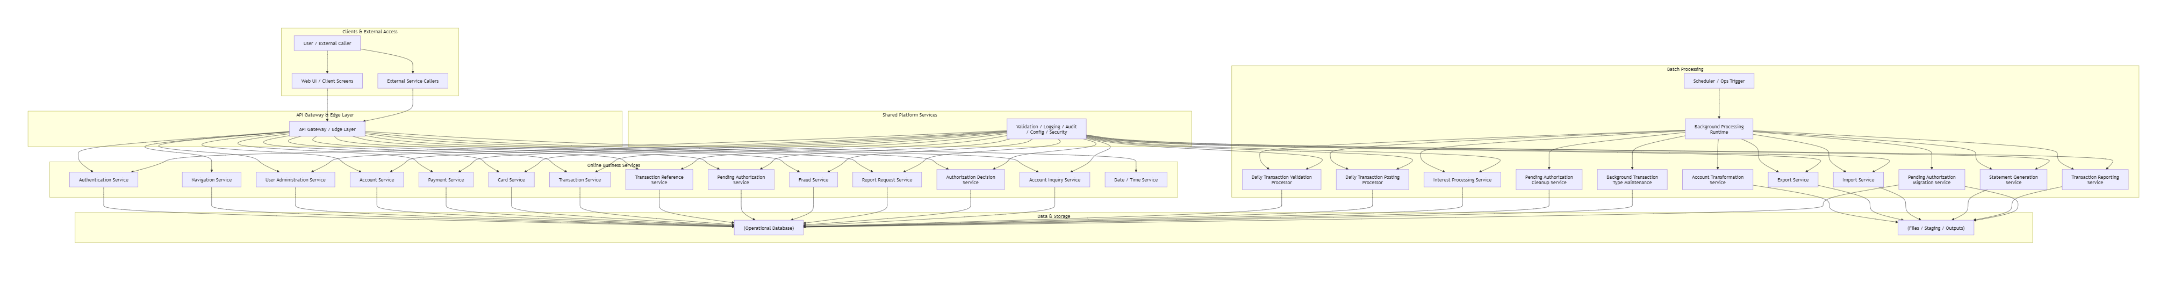

3.3 Presentation Layer Components

3.3.1 Application Shell
Responsibilities
- common layout container
- header rendering
- date/time display
- session context display
- message and error panels
Internal Modules
- header component
- global notification/message component
- error summary panel
- route outlet/container
- session timeout handler
Interactions
- Date/Time Service for current time if server-driven
- Auth state store
- Navigation state
Technology Stack
- Web SPA framework or server-rendered equivalent
- component-based UI library
- centralized state/store
Deployment Considerations
- can be hosted as static UI behind reverse proxy/CDN or app server
- must support protected routes
Traceability
BRD-5.1, 5.2ARCH-5.2

3.3.2 Sign-on Page
Responsibilities
- capture user credentials
- invoke login API
- display auth errors
- initiate route to role-based landing page
Internal Modules
- login form
- submit action
- field validators
- auth error mapper
Interactions
- Authentication Service
Technology
frontend form module with client-side validation
Deployment Considerations
- public route
- protected against brute force at edge/API layer
Traceability
BRD-6.1ARCH-5.4.1

3.3.3 Menu Pages
Includes Main Menu and Admin Menu.
Responsibilities
- display role-specific menu
- validate selection format locally
- invoke navigation validation if server-driven
- route to selected page
Internal Modules
- menu item list
- option input or action controls
- authorization guard
Interactions
- Navigation Service
- session/auth store
Traceability
BRD-6.2, 6.3ARCH-5.4.2

3.3.4 CRUD and Inquiry Pages
These include:
- User List/Add/Update/Delete
- Account Inquiry/Update
- Card Search/Detail/Update
- Transaction List/Detail/Add
- Transaction Type List/Maintenance
- Pending Auth Summary/Detail
- Report Request
Responsibilities
- form rendering
- field validation
- paging
- detail view rendering
- row action handling
- optimistic edit state handling where applicable
Common Internal Modules
- filter form
- list/grid
- pagination control
- detail panel
- edit form
- confirmation dialog
Interactions
- corresponding backend service APIs
Traceability
BRD-6.4 to 6.10ARCH-5.4.3 to 5.4.11

3.4 API / Edge Layer Components

3.4.1 API Gateway / Edge Layer
Responsibilities
- route requests to backend services
- enforce authentication where required
- inject/request correlation IDs
- centralized security controls
- rate limiting
- request/response logging hooks
- CORS / TLS termination if applicable
Internal Modules
- route mapper
- auth filter/interceptor
- rate limiter
- observability interceptors
Interactions
- all backend APIs
- auth/security subsystem
Technology Stack
- API gateway / ingress / reverse proxy
- service mesh optional
Deployment Considerations
- highly available
- central TLS termination
- header propagation required
Traceability
derived from Architecture API model and security considerationsARCH-9, 18, 19

3.5 Core Business Services

3.5.1 Authentication Service
Responsibilities
- validate credentials
- resolve user type/role
- return auth context
- support session/token bootstrap
Internal Modules
- credential validator
- user lookup adapter
- password verification module
- role resolver
- auth audit logger
Interactions
- User repository
- Navigation Service or role-to-landing config
- audit/logging components
Technology Stack
- backend service module
- secure credential verification library
- token/session provider
Deployment Considerations
- low latency
- secure secret handling
- brute-force protections upstream
Traceability
BRD-6.1ARCH-7, 8, 10.1

3.5.2 Navigation Service
Responsibilities
- provide menu options
- validate menu selections
- enforce access restrictions
Internal Modules
- role-menu mapper
- option validator
- authorization evaluator
Interactions
- Authentication/Authorization context
- menu configuration store or static config
Traceability
BRD-6.2, 6.3ARCH-8, 10.1.4–10.1.6

3.5.3 User Administration Service
Responsibilities
- list users
- create user
- update user
- delete user
- support pagination
- enforce required fields and uniqueness
Internal Modules
- user query service
- user command service
- uniqueness validator
- no-change detector
- audit logger
Interactions
- User repository
- validation utility
- audit subsystem
Technology Stack
CRUD service with transactional write operations
Deployment Considerations
- admin-only access
- row-level audit recommended
Traceability
BRD-6.4ARCH-7, 8, 10.2

3.5.4 Account Service
Responsibilities
- retrieve account + customer composite view
- validate account update
- persist coordinated account/customer changes
- support concurrency checks
Internal Modules
- account query module
- composite account-customer assembler
- update validator
- no-change detector
- optimistic locking handler
- transactional save coordinator
Interactions
- Account repository
- Customer repository
- validation utility
- audit logger
Technology Stack
transactional service module
Deployment Considerations
- account and customer writes should participate in one logical transaction where implemented in same DB
- consistency critical
Traceability
BRD-6.5.1, 6.5.2ARCH-8, 10.3, 13.2, 13.3

3.5.5 Payment Service
Responsibilities
- preview bill payment
- validate payable status
- create payment transaction
- update account balance
- enforce idempotency for payment submission
Internal Modules
- payment preview module
- payable validator
- payment command coordinator
- transaction creation adapter
- account balance updater
- idempotency guard
Interactions
- Account repository
- Transaction repository/service
- audit/logger
Technology Stack
transactional financial service
Deployment Considerations
- strongest consistency requirement
- duplicate-submit protection mandatory
Traceability
BRD-6.5.3ARCH-8, 10.4, 13.4

3.5.6 Card Service
Responsibilities
- search cards
- retrieve detail
- update card
- enforce card-specific validations and concurrency rules
Internal Modules
- card search/query
- card detail query
- update validator
- no-change detector
- optimistic locking
Interactions
- Card repository
- Account/Card linkage repository if needed
- validation utility
Traceability
BRD-6.6ARCH-8, 10.5, 13.5

3.5.7 Transaction Service
Responsibilities
- list transactions
- get transaction detail
- create manual transaction
- derive missing identifiers when possible
- support copy-last-transaction helper
Internal Modules
- transaction query module
- transaction detail assembler
- transaction create validator
- account-card resolution module
- transaction ID generator
- create command handler
Interactions
- Transaction repository
- Linkage repository
- reference data service/store
- validation utility
Deployment Considerations
create flow may need anti-duplicate controls
Traceability
BRD-6.7ARCH-8, 10.6, 13.6

3.5.8 Transaction Reference Service
Responsibilities
- list/search transaction types
- get transaction type
- add/update/delete transaction type
- maintain reference integrity
Internal Modules
- reference query module
- reference command module
- dependency checker
- audit logger
Interactions
- Transaction Type repository
- possibly Transaction repository for delete integrity checks
Traceability
BRD-6.8ARCH-8, 10.7

3.5.9 Pending Authorization Service
Responsibilities
- retrieve account-level pending authorization summary/list
- retrieve authorization detail
- support next-item navigation
- expose pending auth context to Fraud Service
Internal Modules
- summary query
- detail query
- account/customer summary assembler
- next-item resolver
Interactions
- Pending Auth Summary repository
- Pending Auth Detail repository
- Account repository
- Customer repository
Traceability
BRD-6.9.1, 6.9.2ARCH-8, 10.8.1–10.8.3

3.5.10 Fraud Service
Responsibilities
- mark fraud
- unmark fraud
- persist fraud record
- optionally maintain fraud action history
Internal Modules
- fraud action validator
- fraud command handler
- fraud query adapter
- audit logger
Interactions
- Fraud repository
- Pending Authorization repository/service
- authorization layer for privileged action if required
Traceability
BRD-6.9.2, 6.9.3ARCH-8, 10.8.4–10.8.6

3.5.11 Report Request Service
Responsibilities
- validate report request
- derive date range for monthly/yearly
- persist or enqueue request
- return submission result
Internal Modules
- report type validator
- date-range resolver
- request persistence/enqueue module
- duplicate guard optional
Interactions
- Report Request repository or queue
- validation utility
- background reporting runtime
Traceability
BRD-6.10ARCH-8, 10.9

3.5.12 Authorization Decision Service
Responsibilities
- receive auth request
- validate linkage and eligibility
- approve or decline
- write pending authorization summary/detail updates
- return response code/decision
Internal Modules
- request validator
- linkage resolver
- eligibility evaluator
- decision engine
- pending auth updater
- response mapper
Interactions
- Account repository
- Card repository
- Customer/linkage data
- Pending Auth repositories
- validation utility
Deployment Considerations
- low latency
- external caller reliability requirements
- idempotency and retry-awareness important
Traceability
BRD-6.11ARCH-8, 10.10.1, 13.8

3.5.13 Account Inquiry Service
Responsibilities
- respond to account information requests from other channels/processes
Internal Modules
- request validator
- account query module
- response mapper
Interactions
- Account repository
Traceability
BRD-6.12ARCH-8, 10.10.2

3.5.14 Date/Time Service
Responsibilities
- return current server/application time
Internal Modules
- clock provider
- response formatter
Interactions
none mandatory
Traceability
BRD-6.13ARCH-8, 10.10.3

3.6 Background Processing Components

3.6.1 Daily Transaction Validation Processor
Responsibilities
- read daily transaction input
- validate structure and linkage
- separate valid and invalid records
Interactions
- input source
- linkage/account repositories
- staging/error outputs
Traceability
BRD-6.14.1ARCH-7, 12.3.10

3.6.2 Daily Transaction Posting Processor
Responsibilities
- post validated transactions
- update account and category balances
- write accepted transactions
Interactions
- staging input
- account repository
- transaction repository
Traceability
BRD-6.14.2ARCH-7, 12.3.10

3.6.3 Interest Processing Service
Responsibilities
- compute interest
- determine rate
- create interest transactions
- update account cycle values
Traceability
BRD-6.14.3ARCH-7, 12.3.11

3.6.4 Account Transformation / Import / Export / Reporting / Statement Components
These processors follow a similar pattern:
Responsibilities
- ingest source data
- validate/transcode
- produce destination output
Subcomponents
- file readers
- mappers/transformers
- output writers
- job summary logger
Traceability
BRD-6.14.4 to 6.16.2ARCH-7, 12.3.12–12.3.13

3.6.5 Pending Authorization Cleanup and Migration Components
Responsibilities
- cleanup expired pending auth data
- move pending auth data between file and operational forms
Traceability
BRD-6.17ARCH-7, 12.3.14

3.6.6 Background Transaction Type Maintenance
Responsibilities
- batch add/update/delete transaction types from structured input
Traceability
BRD-6.18.1ARCH-7, 14

3.7 Persistence Components

3.7.1 Repositories / DAOs
Each core domain service will use repository abstractions for persistence.
Repository | Purpose
UserRepository | User CRUD and login lookup
AccountRepository | Account retrieval and update
CustomerRepository | Customer retrieval and update
CardRepository | Card search/detail/update
TransactionRepository | Transaction list/detail/create
TransactionTypeRepository | Reference data maintenance
PendingAuthSummaryRepository | Summary retrieval/update
PendingAuthDetailRepository | Detail retrieval/update
FraudRepository | Fraud mark/unmark persistence
ReportRequestRepository | Report request persistence
JobRunRepository | Background operational tracking if implemented

Design Principles
- repositories do not contain UI logic
- business validations remain in services
- transactional boundaries defined at service layer

3.8 Shared Cross-Cutting Components

3.8.1 Validation Utility
Responsibilities
- common date validation
- numeric/length checks
- enum/value-set checks
- format validation
- reusable validation error model
Traceability
BRD-6.19.1ARCH-14

3.8.2 Logging Component
Responsibilities
- structured logs
- correlation ID propagation
- audit log emission
- exception logging

3.8.3 Audit Component
Responsibilities
- track sensitive admin and financial actions
- record who/when/what changed

3.8.4 Security Component
Responsibilities
- auth context propagation
- role checking
- sensitive data masking support
- secret retrieval support

3.8.5 Configuration Component
Responsibilities
- environment-specific properties
- batch sizes
- timeouts
- retry counts
- feature flags

3.8.6 Error Mapping Component
Responsibilities
- translate technical errors to API-safe error responses
- map business codes/messages consistently

3.9 Suggested Technology Stack
This is an implementation recommendation derived from the architecture, not a business requirement.
Layer | Recommended Stack Characteristics
UI | SPA framework or server-rendered web app; component-based forms and routing
API Layer | RESTful service framework with interceptor/filter support
Business Layer | Service-oriented modules with transaction management
DB | Relational database for operational data
Batch | Scheduled job framework / worker runtime
Messaging/Queue | Optional for report/background handoff where async needed
Security | Token/session-based auth; role-based authorization
Observability | Structured logging, metrics, tracing
Config | Externalized configuration and secrets

3.10 Deployment Considerations by Component
Component | Deployment Notes
UI | Can be independently deployable; requires environment-specific API base URL
Auth Service | Hardened security, low latency, restricted secret access
Account/Payment Services | Prefer co-location with primary DB for consistency/performance
Reporting/Batch Services | Can be scaled independently from online traffic
Import/Export Components | Need file/staging access and operational controls
Authorization Decision Service | Requires high availability and strict timeout management
Shared Libraries | Versioned consistently across services

3.11 Component Traceability Matrix
Component | BRD Sections | Architecture Sections
Application Shell | 5.1, 5.2 | 5.2, 5.3
Sign-on Page / Auth Service | 6.1 | 5.4.1, 8, 10.1
Navigation Service / Menu Pages | 6.2, 6.3 | 5.4.2, 8, 10.1
User Administration Service | 6.4 | 5.4.3, 5.4.4, 8, 10.2
Account Service | 6.5.1, 6.5.2 | 5.4.5, 8, 10.3
Payment Service | 6.5.3 | 5.4.6, 8, 10.4
Card Service | 6.6 | 5.4.7, 8, 10.5
Transaction Service | 6.7 | 5.4.8, 8, 10.6
Transaction Reference Service | 6.8 | 5.4.9, 8, 10.7
Pending Authorization Service | 6.9.1, 6.9.2 | 5.4.10, 8, 10.8
Fraud Service | 6.9.2, 6.9.3 | 8, 10.8
Report Request Service | 6.10 | 5.4.11, 8, 10.9
Authorization Decision Service | 6.11 | 7, 8, 10.10.1
Account Inquiry Service | 6.12 | 7, 8, 10.10.2
Date/Time Service | 6.13 | 7, 8, 10.10.3
Batch Processors | 6.14–6.18 | 7, 12, 14
Shared Validation Utility | 6.19.1 | 14
Wait/Delay Utility | 6.19.2 | 14

Low-Level Design — Part 2
Section 4: API Design

4. API Design

4.1 API Design Standards

4.1.1 API Style
The implementation will use REST-style JSON APIs over HTTPS.

4.1.2 Base Path Strategy
Recommended logical base paths:
- /api/v1/auth
- /api/v1/navigation
- /api/v1/admin/users
- /api/v1/accounts
- /api/v1/payments
- /api/v1/cards
- /api/v1/transactions
- /api/v1/reference/transaction-types
- /api/v1/pending-authorizations
- /api/v1/fraud
- /api/v1/reports/requests
- /api/v1/services/authorizations
- /api/v1/services/accounts
- /api/v1/services/datetime
- /api/v1/ops/jobs

4.1.3 Content Type
Request: application/jsonResponse: application/json

4.1.4 Authentication Model
Because the BRD does not define token/session technology, this design assumes:
- login returns a session/token bootstrap payload
- subsequent authenticated calls carry:
Authorization: Bearer <token>orsecure session cookie
For API examples below, bearer token is used as the reference model.

4.1.5 Authorization Model
Role-based authorization:
- ADMIN
- STANDARD
- SYSTEM
- OPS
Where source docs do not define exact permissions, access is conservatively mapped.

4.1.6 Common Headers
Header | Required | Purpose
Content-Type: application/json | POST/PUT | request payload format
Accept: application/json | Recommended | response format
Authorization: Bearer <token> | All protected APIs | auth context
X-Request-Id | Recommended | request correlation
X-Idempotency-Key | Required for selected write APIs | duplicate submission protection
If-Match | Recommended for update APIs | optimistic locking/version support

4.1.7 Common Success Envelope
{
"success": true,
"message": "Operation completed successfully",
"data": {},
"meta": {
"requestId": "a2c4a7a2-9a5e-4e6b-9d6a-4f9481a2f100",
"timestamp": "2026-08-05T10:30:00Z"
}
}

4.1.8 Common Error Envelope
{
"success": false,
"errorType": "VALIDATION_ERROR",
"errorCode": "VAL-001",
"message": "Validation failed",
"fieldErrors": [
{
"field": "accountId",
"code": "REQUIRED",
"message": "Account ID is required"
}
],
"meta": {
"requestId": "a2c4a7a2-9a5e-4e6b-9d6a-4f9481a2f100",
"timestamp": "2026-08-05T10:30:00Z"
}
}

4.1.9 Standard Error Types
Error Type | Meaning
VALIDATION_ERROR | request field validation failure
BUSINESS_RULE_ERROR | request valid structurally but violates business rules
AUTHENTICATION_ERROR | invalid/missing credentials
AUTHORIZATION_ERROR | authenticated but not permitted
NOT_FOUND | target resource not found
CONFLICT | optimistic locking or duplicate action conflict
EXTERNAL_SERVICE_ERROR | downstream service failed
PROCESSING_ERROR | internal business processing failure
SYSTEM_ERROR | unhandled technical failure

4.1.10 HTTP Status Mapping
Condition | HTTP Status
Successful GET | 200
Successful create | 201
Accepted async operation | 202
Validation error | 400
Authentication failure | 401
Authorization failure | 403
Not found | 404
Conflict / duplicate / optimistic locking | 409
Too many requests | 429
External/downstream unavailable | 502 / 503
Internal server error | 500

4.2 Security and Operational Standards Applied to All APIs

4.2.1 Logging
All APIs must log:
- request start
- request completion
- correlation/request ID
- authenticated user ID if present
- status code
- processing duration
- business key where available (masked if sensitive)
Sensitive data must not be fully logged:
- password
- full SSN
- full government ID
- full card number unless masked
- full account number unless masked where policy requires

4.2.2 Audit
Audit events must be written for:
- login success/failure
- user create/update/delete
- account update
- bill payment
- card update
- transaction add
- transaction type add/update/delete
- fraud mark/unmark
- report request submission
- background job trigger operations

4.2.3 Retry Logic
GET APIs: caller-level retry allowed for transient 502/503/504Write APIs: retries only when idempotency key is used or operation proven safeExternal-service-like APIs: use bounded retry with jitter for transient downstream failures

4.2.4 Idempotency
Required for:
- bill payment create
- add transaction
- fraud mark/unmark
- report request submission
- authorization decision if external caller may retry
- background job trigger APIs

4.2.5 Rate Limiting
Recommended baseline:
- login: strict rate limiting
- public/system request-response services: moderate rate limiting
- admin write APIs: controlled per user
- search/list APIs: moderate per user/client
- background trigger APIs: restricted to OPS/SYSTEM identities

4.2.6 Performance Considerations
- paginated APIs must enforce sane default/max page sizes
- list APIs should avoid N+1 queries
- account composite retrieval should use optimized joined/fetch strategy
- auth decision service should minimize round-trips
- writes affecting financial data should keep transaction scope tight

4.3 Authentication APIs

4.3.1 POST /api/v1/auth/login
API NameLogin API
PurposeAuthenticate a user with User ID and Password and return user role and landing context.
EndpointPOST /api/v1/auth/login
HTTP MethodPOST
AuthenticationNone
AuthorizationPublic
Headers
Header | Required
Content-Type: application/json | Yes
Accept: application/json | Recommended
X-Request-Id | Recommended

Path ParametersNone
Query ParametersNone
Request BodyJSON Schema
{
"type": "object",
"required": ["userId", "password"],
"properties": {
"userId": {
"type": "string",
"minLength": 1,
"maxLength": 64
},
"password": {
"type": "string",
"minLength": 1,
"maxLength": 256
}
},
"additionalProperties": false
}
Example
{
"userId": "USR001",
"password": "Secret@123"
}
Response BodySuccess Response
{
"success": true,
"message": "Login successful",
"data": {
"userId": "USR001",
"displayName": "John Doe",
"userType": "ADMIN",
"landingPage": "ADMIN_MENU",
"token": "eyJhbGciOi...",
"expiresAt": "2026-08-05T18:30:00Z"
},
"meta": {
"requestId": "req-1001",
"timestamp": "2026-08-05T10:30:00Z"
}
}
Validation Error
{
"success": false,
"errorType": "VALIDATION_ERROR",
"errorCode": "AUTH-VAL-001",
"message": "Validation failed",
"fieldErrors": [
{
"field": "userId",
"code": "REQUIRED",
"message": "User ID is required"
}
],
"meta": {
"requestId": "req-1001",
"timestamp": "2026-08-05T10:30:00Z"
}
}
Business Error
{
"success": false,
"errorType": "AUTHENTICATION_ERROR",
"errorCode": "AUTH-401-002",
"message": "Wrong password",
"meta": {
"requestId": "req-1001",
"timestamp": "2026-08-05T10:30:00Z"
}
}
Server Error
{
"success": false,
"errorType": "SYSTEM_ERROR",
"errorCode": "AUTH-500-001",
"message": "Unable to verify user",
"meta": {
"requestId": "req-1001",
"timestamp": "2026-08-05T10:30:00Z"
}
}
Status Codes200 success400 missing/invalid input401 invalid credentials429 too many attempts500 internal failure
Validation Rules
- userId required
- password required
- trim leading/trailing whitespace before validation
- blank-after-trim values invalid
Business Logic Flow
- Receive login request
- Validate presence of userId and password
- Retrieve user by userId
- If not found, return authentication error
- Verify password
- Resolve user type/role
- Build token/session context
- Return success response with landing page
Service Layer Logic
text
login(request):
validateRequired(request.userId, request.password)
user = userRepository.findByUserId(request.userId)
if user is null:
auditLoginFailure(userId, "USER_NOT_FOUND")
raise AuthenticationException("User not found")
if !passwordVerifier.matches(request.password, user.passwordHash):
auditLoginFailure(userId, "WRONG_PASSWORD")
raise AuthenticationException("Wrong password")
token = tokenProvider.issue(user)
landingPage = roleResolver.resolveLandingPage(user.userType)
auditLoginSuccess(user.userId, user.userType)
return LoginResponse(...)
Database OperationsRead USERS by user_idNo write required unless login audit stored in DB
Exception Handlinginvalid input → 400user not found / wrong password → 401password verifier or repository failure → 500
Retry LogicClient retries not recommended for invalid credentialsTransient server/network error may be retried by client with backoff
IdempotencyNot required
Rate LimitingStrict, e.g. per IP and per user ID
Loggingrequest receivedauth attempt resultno password logging
Audit EventsLOGIN_SUCCESSLOGIN_FAILURE
Performance Considerationsindexed lookup on user_idconstant-time password comparisonminimal auth response size
Security Considerationsdo not reveal whether user exists beyond approved message policynever log passwordrate limit and brute-force protectionssecure token signing/storage
API Sequence Diagram (Mermaid)
mermaid
sequenceDiagram
participant Client
participant Gateway as API Gateway
participant Auth as Authentication Service
participant DB as Database
Client->>Gateway: POST /api/v1/auth/login
Gateway->>Auth: Forward request
Auth->>DB: SELECT user by user_id
DB-->>Auth: User record
Auth->>Auth: Verify password
Auth->>Auth: Generate token and landing page
Auth-->>Gateway: 200 Success
Gateway-->>Client: Login response
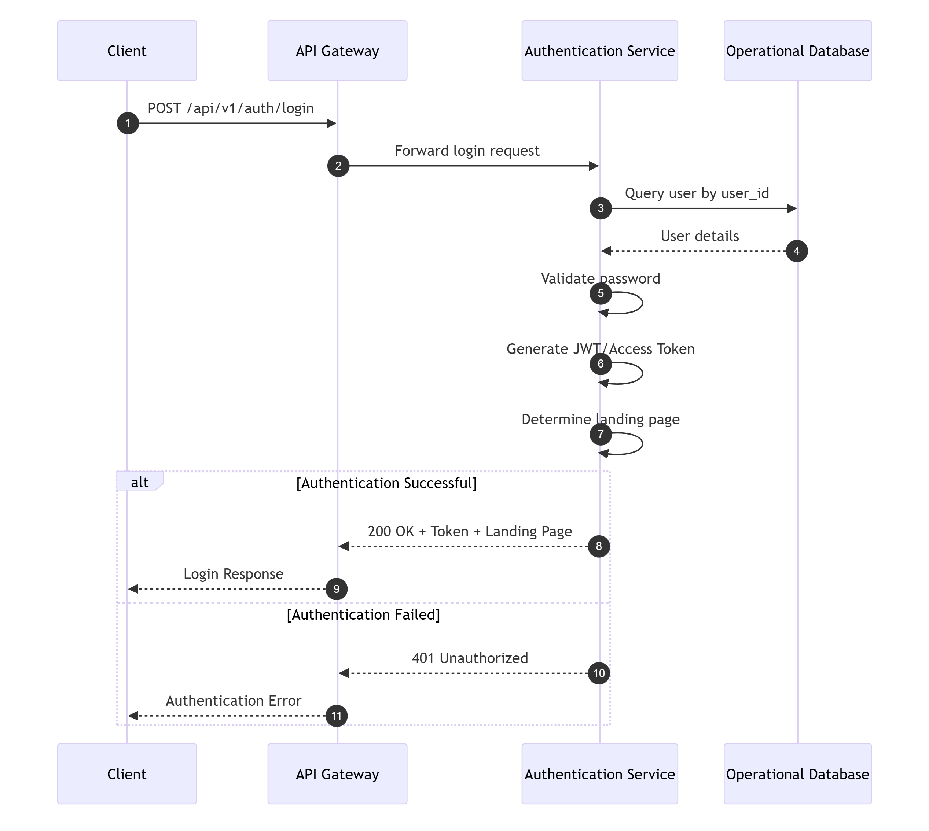
TraceabilityBRD: 6.1Architecture: 10.1.1

4.3.2 POST /api/v1/auth/logout
API NameLogout API
PurposeInvalidate user session/token context.
EndpointPOST /api/v1/auth/logout
HTTP MethodPOST
AuthenticationRequired
AuthorizationAny authenticated user
HeadersAuthorizationX-Request-Id
Request Body
{
"type": "object",
"properties": {},
"additionalProperties": false
}
Example:
{}
Response BodySuccess
{
"success": true,
"message": "Logout successful",
"data": {},
"meta": {
"requestId": "req-1002",
"timestamp": "2026-08-05T10:35:00Z"
}
}
Server Error
{
"success": false,
"errorType": "SYSTEM_ERROR",
"errorCode": "AUTH-500-002",
"message": "Unable to process logout",
"meta": {
"requestId": "req-1002",
"timestamp": "2026-08-05T10:35:00Z"
}
}
Status Codes200401500
Validation Rulesvalid authenticated context required
Business Logic Flow
- Resolve authenticated principal
- Invalidate token/session
- Write audit event
- Return success
Service Layer Logic
text
logout(principal):
tokenProvider.invalidate(principal.token)
audit("LOGOUT", principal.userId)
return success
Database Operationsnone required unless session store used
Exception Handlinginvalid token → 401session store failure → 500
Retry LogicSafe to retry
IdempotencyYes; repeated logout returns success or 200-equivalent
Rate LimitingLow concern; standard authenticated control
Loggingrequest, principal, result
Audit EventsLOGOUT
Performance ConsiderationsConstant-time invalidation if stateless blacklist or session store design used
Security ConsiderationsEnsure token invalidation semantics consistent
API Sequence Diagram
mermaid
sequenceDiagram
participant Client
participant Gateway
participant Auth
Client->>Gateway: POST /api/v1/auth/logout
Gateway->>Auth: Authenticated request
Auth->>Auth: Invalidate token/session
Auth-->>Gateway: 200 Success
Gateway-->>Client: Logout response
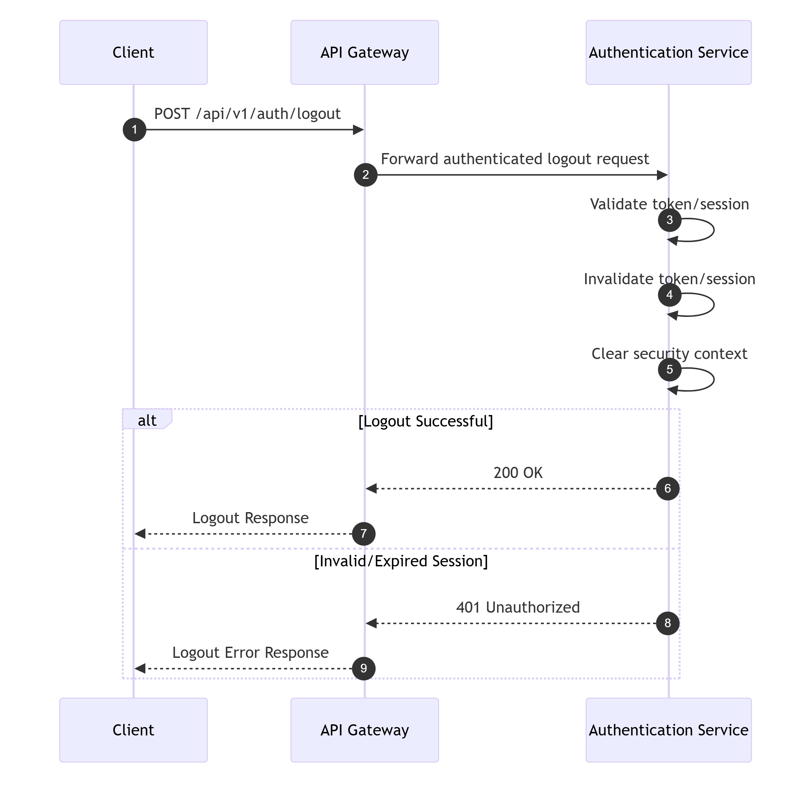
TraceabilityArchitecture assumption endpoint, 10.1.2

4.3.3 GET /api/v1/auth/me
API NameCurrent User Context API
PurposeReturn authenticated user profile and authorization context for UI bootstrap.
EndpointGET /api/v1/auth/me
HTTP MethodGET
AuthenticationRequired
AuthorizationAuthenticated user
HeadersAuthorizationX-Request-Id
Request BodyNone
Response BodySuccess
{
"success": true,
"message": "User context retrieved",
"data": {
"userId": "USR001",
"displayName": "John Doe",
"userType": "ADMIN",
"permissions": ["USER_ADMIN", "ACCOUNT_VIEW", "CARD_UPDATE"]
},
"meta": {
"requestId": "req-1003",
"timestamp": "2026-08-05T10:36:00Z"
}
}
Status Codes200401500
Validation Rulesvalid auth context required
Business Logic FlowRead principal from auth contextReturn normalized user profile and permissions
Database Operationsoptional read from USERS if fresh profile needed
Retry LogicSafe GET retry
IdempotencyYes
TraceabilityArchitecture assumption endpoint, 10.1.3

4.4 Navigation APIs

4.4.1 GET /api/v1/navigation/main-menu
API NameMain Menu API
PurposeReturn menu options available to a standard user.
EndpointGET /api/v1/navigation/main-menu
HTTP MethodGET
AuthenticationRequired
AuthorizationSTANDARD or any user allowed to access standard menu
HeadersAuthorizationX-Request-Id
Response BodySuccess
{
"success": true,
"message": "Menu retrieved",
"data": {
"menuType": "MAIN",
"items": [
{ "option": "1", "code": "ACCOUNT_INQUIRY", "label": "Account Inquiry" },
{ "option": "2", "code": "ACCOUNT_UPDATE", "label": "Account Update" },
{ "option": "3", "code": "BILL_PAYMENT", "label": "Bill Payment" }
]
},
"meta": {
"requestId": "req-2001",
"timestamp": "2026-08-05T10:40:00Z"
}
}
Authorization Error
{
"success": false,
"errorType": "AUTHORIZATION_ERROR",
"errorCode": "NAV-403-001",
"message": "No access to requested menu",
"meta": {
"requestId": "req-2001",
"timestamp": "2026-08-05T10:40:00Z"
}
}
Status Codes200401403500
Validation Rulesuser must be authenticatedrole must support main menu
Business Logic FlowResolve principalValidate roleFetch configured menu itemsReturn menu
Database Operationsoptional read from menu config table or static config source
Retry LogicSafe GET retry
IdempotencyYes
Rate LimitingStandard
Logging/AuditMenu retrieval usually not audited; log request only
API Sequence Diagram
mermaid
sequenceDiagram
participant Client
participant Gateway
participant Nav as Navigation Service
Client->>Gateway: GET /api/v1/navigation/main-menu
Gateway->>Nav: Authenticated request
Nav->>Nav: Resolve menu by role
Nav-->>Gateway: Menu items
Gateway-->>Client: 200 Success
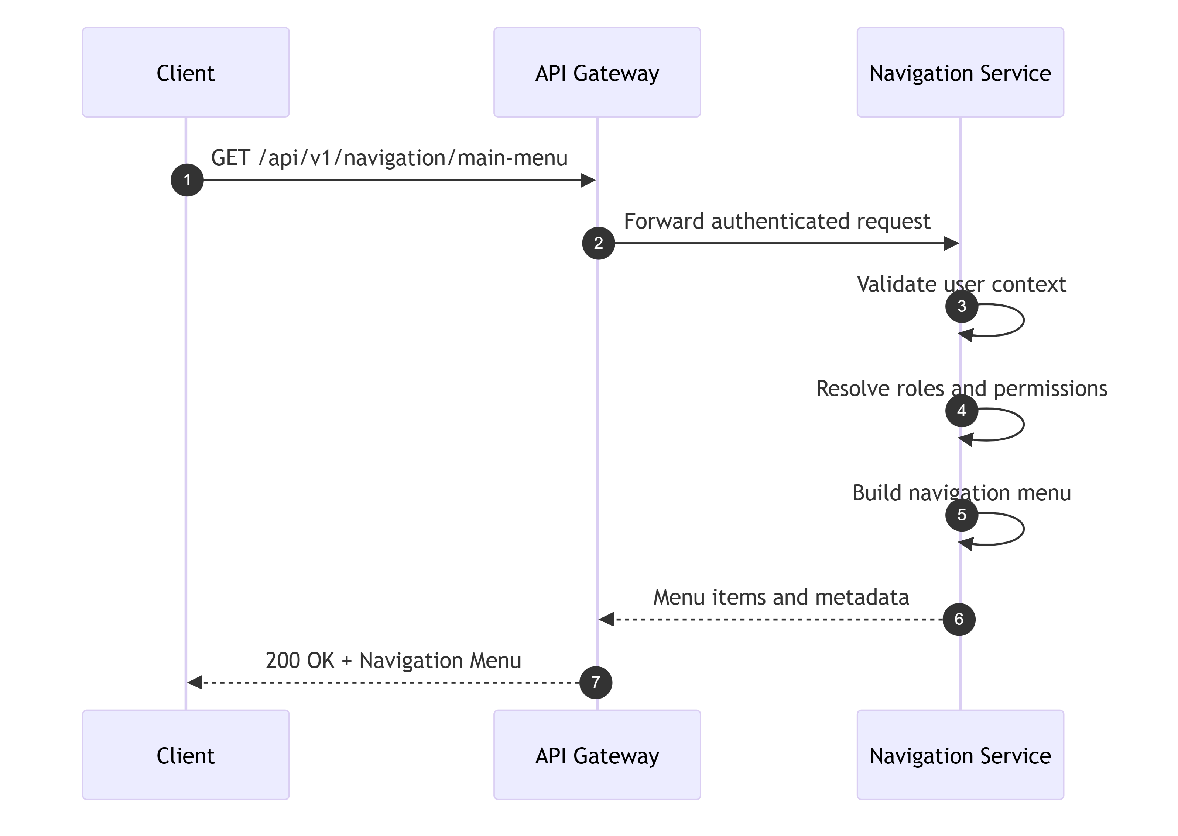
TraceabilityBRD: 6.2Architecture: 10.1.4

4.4.2 GET /api/v1/navigation/admin-menu
Same structure as main menu, but authorization requires ADMIN.
Success Example
{
"success": true,
"message": "Menu retrieved",
"data": {
"menuType": "ADMIN",
"items": [
{ "option": "1", "code": "USER_LIST", "label": "User Administration" },
{ "option": "2", "code": "TXN_TYPE_LIST", "label": "Transaction Type Maintenance" }
]
},
"meta": {
"requestId": "req-2002",
"timestamp": "2026-08-05T10:41:00Z"
}
}
TraceabilityBRD: 6.3Architecture: 10.1.5

4.4.3 POST /api/v1/navigation/validate-option
API NameMenu Option Validation API
PurposeValidate selected menu option and return target page/function.
EndpointPOST /api/v1/navigation/validate-option
AuthenticationRequired
AuthorizationAuthenticated user with applicable menu access
Request Body Schema
{
"type": "object",
"required": ["option"],
"properties": {
"option": {
"type": "string",
"minLength": 1,
"maxLength": 8
}
},
"additionalProperties": false
}
Example
{
"option": "3"
}
Success Response
{
"success": true,
"message": "Option validated",
"data": {
"valid": true,
"targetPage": "ACCOUNT_INQUIRY",
"targetRoute": "/accounts/inquiry"
},
"meta": {
"requestId": "req-2003",
"timestamp": "2026-08-05T10:42:00Z"
}
}
Business Error
{
"success": false,
"errorType": "BUSINESS_RULE_ERROR",
"errorCode": "NAV-400-002",
"message": "Enter a valid option number",
"meta": {
"requestId": "req-2003",
"timestamp": "2026-08-05T10:42:00Z"
}
}
Validation Rulesoption requiredoption must exist for role/menuunavailable option returns business error
Service Layer Logic
text
validateOption(principal, option):
menu = menuProvider.forRole(principal.role)
item = menu.find(option)
if item is null:
raise BusinessRuleException("Enter a valid option number")
if !authorizationEvaluator.allowed(principal, item):
raise AuthorizationException("No access")
return item.target
Database Operationsoptional config read
IdempotencyYes
TraceabilityBRD: 6.2, 6.3Architecture: 10.1.6

4.5 User Administration APIs

4.5.1 GET /api/v1/admin/users
API NameList Users API
PurposeReturn paginated list of users, optionally starting from a specific user ID.
EndpointGET /api/v1/admin/users
HTTP MethodGET
AuthenticationRequired
AuthorizationADMIN
HeadersAuthorizationX-Request-Id
Query Parameters
Name | Type | Required | Notes
startUserId | string | No | optional starting point
page | integer | No | default 1
pageSize | integer | No | default 20, max 100

Response Success
{
"success": true,
"message": "Users retrieved",
"data": {
"items": [
{
"userId": "USR001",
"firstName": "John",
"lastName": "Doe",
"userType": "ADMIN"
},
{
"userId": "USR002",
"firstName": "Mary",
"lastName": "Smith",
"userType": "STANDARD"
}
],
"pagination": {
"page": 1,
"pageSize": 20,
"hasNext": true,
"hasPrevious": false
}
},
"meta": {
"requestId": "req-3001",
"timestamp": "2026-08-05T11:00:00Z"
}
}
Validation Error
{
"success": false,
"errorType": "VALIDATION_ERROR",
"errorCode": "USR-VAL-001",
"message": "Validation failed",
"fieldErrors": [
{
"field": "pageSize",
"code": "MAX",
"message": "pageSize must be less than or equal to 100"
}
],
"meta": {
"requestId": "req-3001",
"timestamp": "2026-08-05T11:00:00Z"
}
}
Status Codes200400401403500
Validation Rulespage >= 1pageSize between 1 and 100startUserId if present max length 64
Business Logic FlowValidate query paramsVerify admin roleQuery users with paginationMap to response DTOReturn page
Service Layer Logic
text
listUsers(page, pageSize, startUserId):
validatePage(page, pageSize)
return userRepository.findPaged(page, pageSize, startUserId)
Database OperationsRead from USERSordered by user_id
Exception Handlinginvalid page params → 400unauthorized → 403repository failure → 500
Retry LogicSafe GET retry
IdempotencyYes
Rate LimitingModerate admin rate
Loggingadmin access log with page/pageSize
Audit EventsOptional admin browse event; usually not mandatory
Performance Considerationsindex on user_idavoid count(*) if expensive; support optimized pagination
Security Considerationsdo not expose password hashrestrict to admin
API Sequence Diagram
mermaid
sequenceDiagram
participant Client
participant Gateway
participant UserSvc as User Administration Service
participant DB as Database
Client->>Gateway: GET /api/v1/admin/users?page=1&pageSize=20
Gateway->>UserSvc: Authenticated ADMIN request
UserSvc->>DB: SELECT paged users
DB-->>UserSvc: User rows
UserSvc-->>Gateway: User list response
Gateway-->>Client: 200 Success
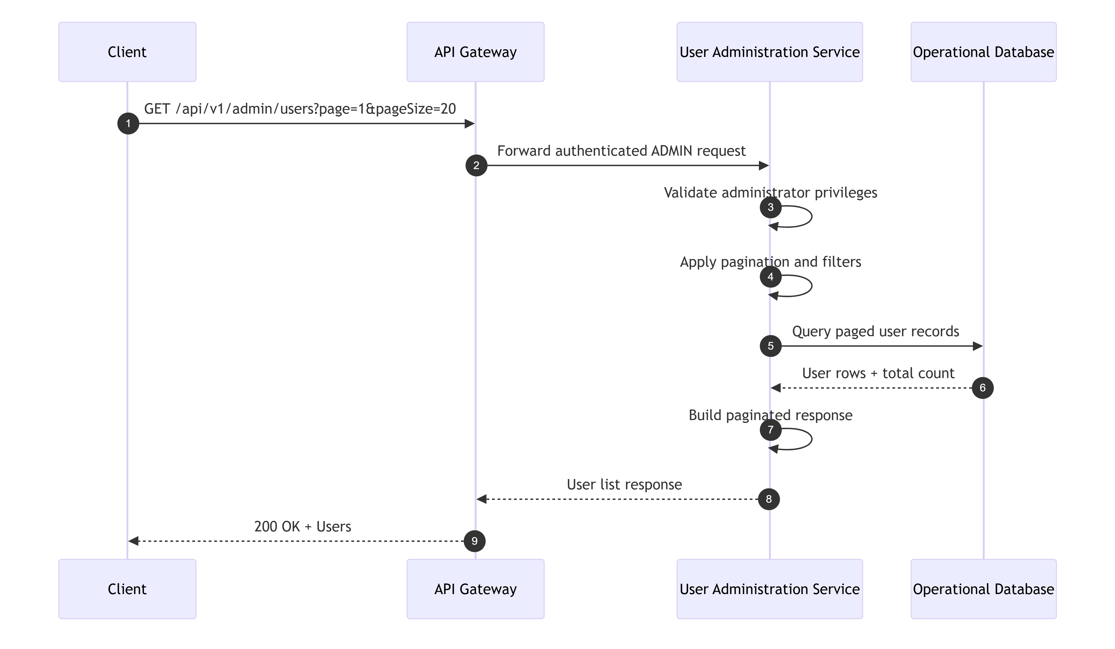
TraceabilityBRD: 6.4.1Architecture: 10.2.1

4.5.2 GET /api/v1/admin/users/{userId}
API NameGet User API
PurposeRetrieve one user record for update/delete screen population.
EndpointGET /api/v1/admin/users/{userId}
Path Parameters
Name | Type | Required
userId | string | Yes

Success Response
{
"success": true,
"message": "User retrieved",
"data": {
"userId": "USR001",
"firstName": "John",
"lastName": "Doe",
"userType": "ADMIN",
"rowVersion": 5
},
"meta": {
"requestId": "req-3002",
"timestamp": "2026-08-05T11:02:00Z"
}
}
Not Found
{
"success": false,
"errorType": "NOT_FOUND",
"errorCode": "USR-404-001",
"message": "User not found",
"meta": {
"requestId": "req-3002",
"timestamp": "2026-08-05T11:02:00Z"
}
}
Database OperationsRead USERS by user_id
TraceabilityBRD: 6.4.3, 6.4.4Architecture: 10.2.2

4.5.3 POST /api/v1/admin/users
API NameCreate User API
PurposeCreate a new user.
EndpointPOST /api/v1/admin/users
AuthenticationRequired
AuthorizationADMIN
HeadersAuthorizationContent-TypeX-Request-Idoptional X-Idempotency-Key
Request Body Schema
{
"type": "object",
"required": ["firstName", "lastName", "userId", "password", "userType"],
"properties": {
"firstName": { "type": "string", "minLength": 1, "maxLength": 100 },
"lastName": { "type": "string", "minLength": 1, "maxLength": 100 },
"userId": { "type": "string", "minLength": 1, "maxLength": 64 },
"password": { "type": "string", "minLength": 1, "maxLength": 256 },
"userType": { "type": "string", "enum": ["ADMIN", "STANDARD"] }
},
"additionalProperties": false
}
Example
{
"firstName": "John",
"lastName": "Doe",
"userId": "USR101",
"password": "Secret@123",
"userType": "STANDARD"
}
Success Response
{
"success": true,
"message": "User created successfully",
"data": {
"userId": "USR101"
},
"meta": {
"requestId": "req-3003",
"timestamp": "2026-08-05T11:05:00Z"
}
}
Validation Error
{
"success": false,
"errorType": "VALIDATION_ERROR",
"errorCode": "USR-VAL-002",
"message": "Validation failed",
"fieldErrors": [
{
"field": "firstName",
"code": "REQUIRED",
"message": "First Name is required"
}
],
"meta": {
"requestId": "req-3003",
"timestamp": "2026-08-05T11:05:00Z"
}
}
Business Error
{
"success": false,
"errorType": "CONFLICT",
"errorCode": "USR-409-001",
"message": "User already exists",
"meta": {
"requestId": "req-3003",
"timestamp": "2026-08-05T11:05:00Z"
}
}
Server Error
{
"success": false,
"errorType": "PROCESSING_ERROR",
"errorCode": "USR-500-001",
"message": "Unable to create user",
"meta": {
"requestId": "req-3003",
"timestamp": "2026-08-05T11:05:00Z"
}
}
Status Codes201400401403409500
Validation Rulesall fields mandatorytrim valuesuserId uniqueuserType enumpassword never echoed back
Business Logic FlowValidate request bodyCheck admin authorizationCheck if user ID already existsHash/encrypt password representationInsert user recordAudit createReturn 201
Service Layer Logic
text
createUser(request, principal):
validate(request)
existing = userRepository.findByUserId(request.userId)
if existing != null:
raise ConflictException("User already exists")
passwordHash = passwordEncoder.encode(request.password)
userRepository.insert(
userId=request.userId,
firstName=request.firstName,
lastName=request.lastName,
passwordHash=passwordHash,
userType=request.userType,
createdBy=principal.userId
)
audit("USER_CREATE", principal.userId, request.userId)
return created
Database OperationsRead USERS by user_idInsert into USERS
Exception Handlingduplicate user → 409DB insert failure → 500
Retry LogicRetry only with idempotency key or after confirming no insert occurred
IdempotencyRecommended for admin UI double-submit protection
Rate LimitingModerate, admin protected
Loggingrequest metadata, created userId, admin principal
Audit EventsUSER_CREATE
Performance Considerationsunique index on user_id
Security Considerationspassword hashed, never stored plainrestrict to adminsanitize returned payload
API Sequence Diagram
mermaid
sequenceDiagram
participant Client
participant Gateway
participant UserSvc as User Administration Service
participant DB as Database
Client->>Gateway: POST /api/v1/admin/users
Gateway->>UserSvc: Authenticated ADMIN request
UserSvc->>DB: SELECT user by user_id
DB-->>UserSvc: No existing user
UserSvc->>UserSvc: Hash password
UserSvc->>DB: INSERT user
DB-->>UserSvc: Insert success
UserSvc-->>Gateway: 201 Created
Gateway-->>Client: Success response
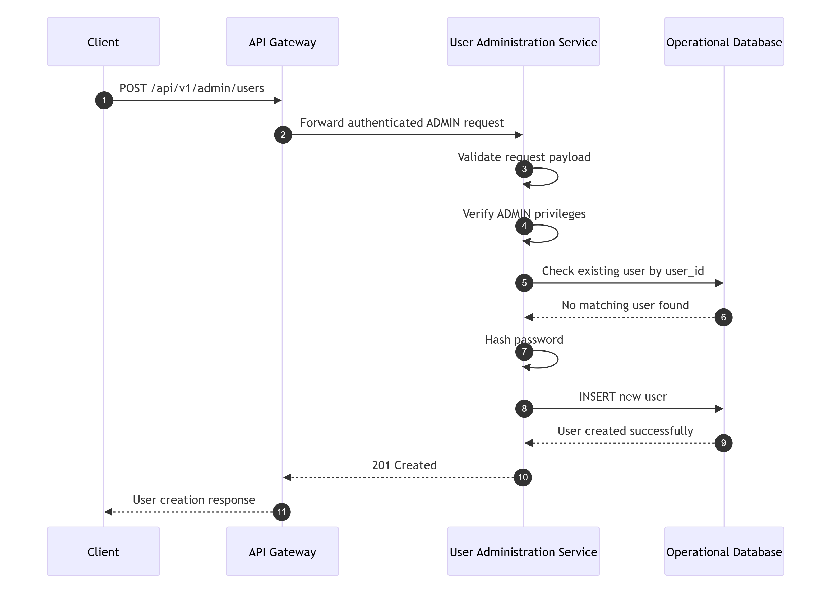
TraceabilityBRD: 6.4.2Architecture: 10.2.3

4.5.4 PUT /api/v1/admin/users/{userId}
API NameUpdate User API
PurposeUpdate an existing user.
EndpointPUT /api/v1/admin/users/{userId}
AuthenticationRequired
AuthorizationADMIN
HeadersAuthorizationContent-TypeIf-Match optional if header-based versioning usedX-Request-Id
Path ParametersuserId
Request Body Schema
{
"type": "object",
"required": ["firstName", "lastName", "password", "userType", "rowVersion"],
"properties": {
"firstName": { "type": "string", "minLength": 1, "maxLength": 100 },
"lastName": { "type": "string", "minLength": 1, "maxLength": 100 },
"password": { "type": "string", "minLength": 1, "maxLength": 256 },
"userType": { "type": "string", "enum": ["ADMIN", "STANDARD"] },
"rowVersion": { "type": "integer", "minimum": 0 }
},
"additionalProperties": false
}
Example
{
"firstName": "John",
"lastName": "Doe",
"password": "Updated@123",
"userType": "ADMIN",
"rowVersion": 5
}
Success Response
{
"success": true,
"message": "User updated successfully",
"data": {
"userId": "USR001",
"rowVersion": 6
},
"meta": {
"requestId": "req-3004",
"timestamp": "2026-08-05T11:10:00Z"
}
}
Business Error - No Change
{
"success": false,
"errorType": "BUSINESS_RULE_ERROR",
"errorCode": "USR-400-003",
"message": "Please modify to update",
"meta": {
"requestId": "req-3004",
"timestamp": "2026-08-05T11:10:00Z"
}
}
Conflict Error
{
"success": false,
"errorType": "CONFLICT",
"errorCode": "USR-409-002",
"message": "Record changed by someone else",
"meta": {
"requestId": "req-3004",
"timestamp": "2026-08-05T11:10:00Z"
}
}
Validation Rulesrequired fields mandatoryuser must existrowVersion requiredno-change detection before update
Business Logic FlowValidate requestLoad existing userIf not found → 404Compare rowVersionIf mismatch → 409Normalize and compare valuesIf unchanged → business errorHash new password if changed or always re-encode per implementation policyUpdate rowReturn updated rowVersion
Service Layer Logic
text
updateUser(userId, request):
validate(request)
existing = userRepository.findByUserId(userId)
if existing is null:
raise NotFoundException("User not found")
if existing.rowVersion != request.rowVersion:
raise ConflictException("Record changed by someone else")
if isNoChange(existing, request):
raise BusinessRuleException("Please modify to update")
passwordHash = passwordEncoder.encode(request.password)
updated = userRepository.update(...)
audit("USER_UPDATE", actor, userId)
return updated
Database OperationsRead USERS by user_idUpdate USERS set values, increment row_version
IdempotencyNot inherently idempotent across changed data; safe repeat only with same rowVersion semantics may fail as expected
TraceabilityBRD: 6.4.3Architecture: 10.2.4

4.5.5 DELETE /api/v1/admin/users/{userId}
API NameDelete User API
PurposeDelete an existing user.
EndpointDELETE /api/v1/admin/users/{userId}
AuthenticationRequired
AuthorizationADMIN
HeadersAuthorizationX-Request-Id
Path ParametersuserId
Success Response
{
"success": true,
"message": "User deleted successfully",
"data": {
"userId": "USR001"
},
"meta": {
"requestId": "req-3005",
"timestamp": "2026-08-05T11:15:00Z"
}
}
Not Found
{
"success": false,
"errorType": "NOT_FOUND",
"errorCode": "USR-404-001",
"message": "User not found",
"meta": {
"requestId": "req-3005",
"timestamp": "2026-08-05T11:15:00Z"
}
}
Business Logic FlowValidate admin authorizationFind userIf not found → 404Delete userAudit deleteReturn success
Database OperationsRead USERSDelete USERS
Retry LogicSafe if delete is idempotent by returning 404 after deletion or 200 with prior-delete semantics per API contract. Recommended: first delete returns 200, later attempt returns 404.
Audit EventsUSER_DELETE
TraceabilityBRD: 6.4.4Architecture: 10.2.5

4.6 Account and Customer APIs

4.6.1 GET /api/v1/accounts/{accountId}
API NameGet Account Composite API
PurposeRetrieve account details with linked customer information.
EndpointGET /api/v1/accounts/{accountId}
AuthenticationRequired
AuthorizationAuthenticated user with account inquiry permission
Path Parameters
Name | Type | Required
accountId | string | Yes

Success Response
{
"success": true,
"message": "Account retrieved",
"data": {
"account": {
"accountId": "12345678901",
"accountStatus": "ACTIVE",
"currentBalance": 450.75,
"creditLimit": 5000.00,
"cashCreditLimit": 1000.00,
"currentCycleCredit": 100.00,
"currentCycleDebit": 50.00,
"openDate": "2025-01-01",
"expirationDate": "2028-01-01",
"reissueDate": "2027-01-01",
"groupId": "GRP001",
"rowVersion": 8
},
"customer": {
"customerId": "CUST001",
"ssnMasked": "***-**-1234",
"creditScore": 710,
"dateOfBirth": "1990-05-20",
"firstName": "Jane",
"middleName": "A",
"lastName": "Doe",
"addressLine1": "Street 1",
"addressLine2": "",
"city": "Austin",
"state": "TX",
"zip": "78701",
"country": "US",
"phone1": "1234567890",
"phone2": "",
"governmentIdMasked": "***12345",
"electronicFundsAccountRef": "EFA001",
"primaryCardHolderIndicator": "Y",
"rowVersion": 3
}
},
"meta": {
"requestId": "req-4001",
"timestamp": "2026-08-05T11:20:00Z"
}
}
Validation Error
{
"success": false,
"errorType": "VALIDATION_ERROR",
"errorCode": "ACC-VAL-001",
"message": "Validation failed",
"fieldErrors": [
{
"field": "accountId",
"code": "FORMAT",
"message": "Account must be a non-zero 11-digit number"
}
],
"meta": {
"requestId": "req-4001",
"timestamp": "2026-08-05T11:20:00Z"
}
}
Not Found
{
"success": false,
"errorType": "NOT_FOUND",
"errorCode": "ACC-404-001",
"message": "Account/customer not found",
"meta": {
"requestId": "req-4001",
"timestamp": "2026-08-05T11:20:00Z"
}
}
Status Codes200400401403404500
Validation RulesaccountId requirednumeric onlyexactly 11 digitsnon-zero
Business Logic FlowValidate accountIdLoad accountIf not found → 404Load linked customerIf missing → 404 or partial failure policy; recommended 404 composite-not-found due to BRDMask sensitive fields in responseReturn composite DTO
Service Layer Logic
text
getAccount(accountId):
validateAccountId(accountId)
account = accountRepository.findById(accountId)
if account is null:
raise NotFoundException("Account/customer not found")
customer = customerRepository.findByAccountId(accountId)
if customer is null:
raise NotFoundException("Account/customer not found")
return assembler.toComposite(account, mask(customer))
Database OperationsRead ACCOUNTS by account_idRead CUSTOMERS by linked customer key or via join
Exception Handlinginvalid account format → 400not found → 404DB error → 500
Retry LogicSafe GET retry
IdempotencyYes
Loggingmask sensitive identifiers
Audit EventsOptional ACCOUNT_VIEW
Performance Considerationsjoin/fetch account and customer efficientlyindex on account ID and customer linkage
Security Considerationsmask SSN and government IDrestrict access by role/permission
API Sequence Diagram
mermaid
sequenceDiagram
participant Client
participant Gateway
participant Acct as Account Service
participant DB as Database
Client->>Gateway: GET /api/v1/accounts/{accountId}
Gateway->>Acct: Authenticated request
Acct->>DB: SELECT account by account_id
DB-->>Acct: Account row
Acct->>DB: SELECT customer by linked account
DB-->>Acct: Customer row
Acct->>Acct: Mask sensitive fields
Acct-->>Gateway: Composite response
Gateway-->>Client: 200 Success
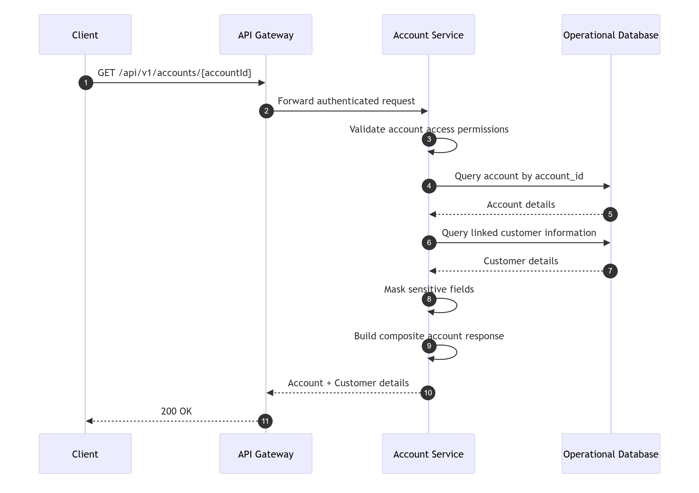
TraceabilityBRD: 6.5.1Architecture: 10.3.1

4.6.2 PUT /api/v1/accounts/{accountId}
API NameUpdate Account Composite API
PurposeUpdate account and linked customer information in one logical operation.
EndpointPUT /api/v1/accounts/{accountId}
AuthenticationRequired
AuthorizationUser with account update permission
HeadersAuthorizationContent-TypeX-Request-IdIf-Match optional
Request Body Schema
{
"type": "object",
"required": ["account", "customer", "accountRowVersion", "customerRowVersion"],
"properties": {
"account": {
"type": "object",
"properties": {
"accountStatus": { "type": "string", "maxLength": 30 },
"creditLimit": { "type": "number", "minimum": 0 },
"cashCreditLimit": { "type": "number", "minimum": 0 },
"expirationDate": { "type": "string", "format": "date" },
"reissueDate": { "type": "string", "format": "date" },
"groupId": { "type": "string", "maxLength": 64 }
},
"additionalProperties": true
},
"customer": {
"type": "object",
"properties": {
"firstName": { "type": "string", "minLength": 1, "maxLength": 100 },
"middleName": { "type": "string", "maxLength": 100 },
"lastName": { "type": "string", "minLength": 1, "maxLength": 100 },
"addressLine1": { "type": "string", "maxLength": 255 },
"addressLine2": { "type": "string", "maxLength": 255 },
"city": { "type": "string", "maxLength": 100 },
"state": { "type": "string", "maxLength": 50 },
"zip": { "type": "string", "maxLength": 20 },
"country": { "type": "string", "maxLength": 100 },
"phone1": { "type": "string", "maxLength": 20 },
"phone2": { "type": "string", "maxLength": 20 },
"creditScore": { "type": "integer", "minimum": 0, "maximum": 999 },
"dateOfBirth": { "type": "string", "format": "date" },
"governmentId": { "type": "string", "maxLength": 50 },
"electronicFundsAccountRef": { "type": "string", "maxLength": 64 },
"primaryCardHolderIndicator": { "type": "string", "enum": ["Y", "N"] }
},
"additionalProperties": true
},
"accountRowVersion": { "type": "integer", "minimum": 0 },
"customerRowVersion": { "type": "integer", "minimum": 0 }
},
"additionalProperties": false
}
Example
{
"account": {
"accountStatus": "ACTIVE",
"creditLimit": 6000.00,
"cashCreditLimit": 1200.00,
"expirationDate": "2028-12-31"
},
"customer": {
"firstName": "Jane",
"lastName": "Doe",
"addressLine1": "New Street",
"city": "Dallas",
"state": "TX",
"zip": "75001",
"phone1": "1112223333",
"primaryCardHolderIndicator": "Y"
},
"accountRowVersion": 8,
"customerRowVersion": 3
}
Success Response
{
"success": true,
"message": "Changes committed",
"data": {
"accountId": "12345678901",
"accountRowVersion": 9,
"customerRowVersion": 4
},
"meta": {
"requestId": "req-4002",
"timestamp": "2026-08-05T11:30:00Z"
}
}
Business Error - No Change
{
"success": false,
"errorType": "BUSINESS_RULE_ERROR",
"errorCode": "ACC-400-002",
"message": "No change detected",
"meta": {
"requestId": "req-4002",
"timestamp": "2026-08-05T11:30:00Z"
}
}
Conflict Error
{
"success": false,
"errorType": "CONFLICT",
"errorCode": "ACC-409-001",
"message": "Record changed by someone else",
"meta": {
"requestId": "req-4002",
"timestamp": "2026-08-05T11:30:00Z"
}
}
Server Error
{
"success": false,
"errorType": "PROCESSING_ERROR",
"errorCode": "ACC-500-001",
"message": "Changes unsuccessful",
"meta": {
"requestId": "req-4002",
"timestamp": "2026-08-05T11:30:00Z"
}
}
Status Codes200400401403404409500
Validation RulesaccountId valid 11-digit numericrow versions requiredall changed fields validatedprimaryCardHolderIndicator Y/Ndates validcredit score range validfinancial values non-negative where applicable
Business Logic FlowValidate accountId and request bodyLoad existing account and customerVerify both existCompare row versionsDetect no change after normalizationValidate business rules and field formatsStart DB transactionUpdate account rowUpdate customer rowCommitAudit updateReturn new versions
Service Layer Logic
text
updateAccountComposite(accountId, req, principal):
validateAccountId(accountId)
validate(req)
existingAccount = accountRepository.findById(accountId)
existingCustomer = customerRepository.findByAccountId(accountId)
ensureExists(existingAccount, existingCustomer)
ensureVersion(existingAccount.rowVersion, req.accountRowVersion)
ensureVersion(existingCustomer.rowVersion, req.customerRowVersion)
normalizedRequest = normalize(req)
if noChange(existingAccount, existingCustomer, normalizedRequest):
raise BusinessRuleException("No change detected")
validateBusinessFields(normalizedRequest)
transaction:
accountRepository.update(...)
customerRepository.update(...)
audit("ACCOUNT_UPDATE", principal.userId, accountId)
return success
Database OperationsRead ACCOUNTSRead linked CUSTOMERSUpdate ACCOUNTSUpdate CUSTOMERS
Exception Handlingrecord not found → 404row version mismatch → 409no change → 400 or 409; recommended 400 business ruleDB partial failure → rollback and 500
Retry LogicClient retry only after re-fetch on conflict
IdempotencyNot required; optimistic locking protects correctness
Rate LimitingStandard authenticated write
Loggingtrack accountId masked/partially masked, actor, duration
Audit EventsACCOUNT_UPDATE
Performance Considerationskeep transaction narrowuse optimistic locking to avoid long locks
Security Considerationsfield-level access policy may apply to sensitive customer dataaudit changes to PII-bearing fields
API Sequence Diagram
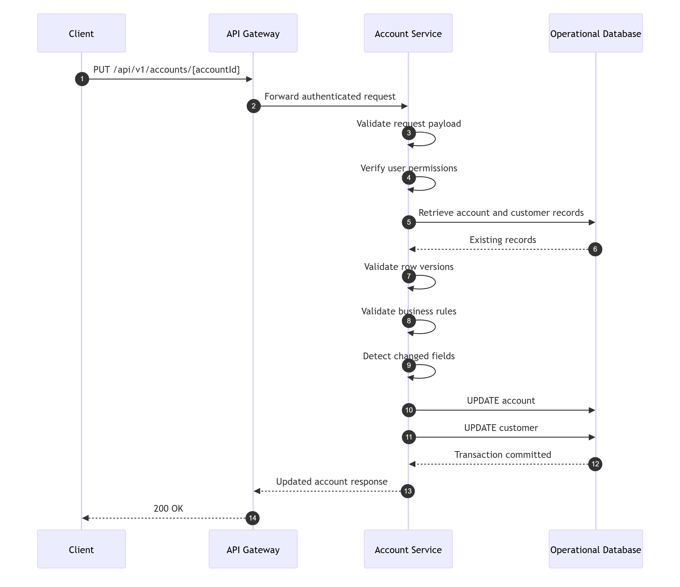
TraceabilityBRD: 6.5.2Architecture: 10.3.2

4.7 Bill Payment APIs

4.7.1 GET /api/v1/payments/bill-payments/preview/{accountId}
API NameBill Payment Preview API
PurposeReturn payable balance and payment eligibility for an account.
EndpointGET /api/v1/payments/bill-payments/preview/{accountId}
AuthenticationRequired
AuthorizationUser with bill payment access
Success Response
{
"success": true,
"message": "Payment preview retrieved",
"data": {
"accountId": "12345678901",
"currentBalance": 450.75,
"payable": true
},
"meta": {
"requestId": "req-5001",
"timestamp": "2026-08-05T11:40:00Z"
}
}
Business Error
{
"success": false,
"errorType": "BUSINESS_RULE_ERROR",
"errorCode": "PAY-400-001",
"message": "You have nothing to pay",
"meta": {
"requestId": "req-5001",
"timestamp": "2026-08-05T11:40:00Z"
}
}
Validation RulesaccountId valid 11-digit numeric
Database OperationsRead ACCOUNTS.current_balance
Retry LogicSafe GET retry
TraceabilityBRD: 6.5.3Architecture: 10.4.1

4.7.2 POST /api/v1/payments/bill-payments
API NameBill Payment Create API
PurposeCreate full-balance bill payment and update account balance.
EndpointPOST /api/v1/payments/bill-payments
AuthenticationRequired
AuthorizationUser with bill payment access
HeadersAuthorizationContent-TypeX-Request-IdX-Idempotency-Key required
Request Body Schema
{
"type": "object",
"required": ["accountId", "confirmation"],
"properties": {
"accountId": {
"type": "string",
"pattern": "^[1-9][0-9]{10}$"
},
"confirmation": {
"type": "string",
"enum": ["Y"]
}
},
"additionalProperties": false
}
Example
{
"accountId": "12345678901",
"confirmation": "Y"
}
Success Response
{
"success": true,
"message": "Payment successful",
"data": {
"accountId": "12345678901",
"paymentAmount": 450.75,
"transactionId": "TXN900001",
"remainingBalance": 0.00
},
"meta": {
"requestId": "req-5002",
"timestamp": "2026-08-05T11:45:00Z"
}
}
Validation Error
{
"success": false,
"errorType": "VALIDATION_ERROR",
"errorCode": "PAY-VAL-001",
"message": "Validation failed",
"fieldErrors": [
{
"field": "confirmation",
"code": "ENUM",
"message": "Invalid confirmation value"
}
],
"meta": {
"requestId": "req-5002",
"timestamp": "2026-08-05T11:45:00Z"
}
}
Business Error
{
"success": false,
"errorType": "BUSINESS_RULE_ERROR",
"errorCode": "PAY-400-002",
"message": "You have nothing to pay",
"meta": {
"requestId": "req-5002",
"timestamp": "2026-08-05T11:45:00Z"
}
}
Server Error
{
"success": false,
"errorType": "PROCESSING_ERROR",
"errorCode": "PAY-500-001",
"message": "Unable to update account",
"meta": {
"requestId": "req-5002",
"timestamp": "2026-08-05T11:45:00Z"
}
}
Status Codes201400401403404409500
Validation RulesaccountId required and validconfirmation must be Yidempotency key required
Business Logic FlowValidate requestCheck idempotency keyLoad accountEnsure account existsEnsure current balance > 0Determine payment amount = current balanceBegin transactionCreate payment transaction rowUpdate account balanceCommitStore idempotency resultAudit paymentReturn success
Service Layer Logic
text
createBillPayment(req, principal, idemKey):
validate(req)
prior = idempotencyStore.lookup(idemKey)
if prior exists:
return prior.response
account = accountRepository.findById(req.accountId)
if account is null:
raise NotFoundException("Account not found")
if account.currentBalance <= 0:
raise BusinessRuleException("You have nothing to pay")
paymentAmount = account.currentBalance
transaction:
txnId = transactionRepository.insertPaymentTransaction(...)
accountRepository.updateBalance(req.accountId, 0.00)
response = buildSuccess(txnId, paymentAmount)
idempotencyStore.save(idemKey, response)
audit("BILL_PAYMENT", principal.userId, req.accountId, paymentAmount)
return response
Database OperationsRead ACCOUNTSInsert TRANSACTIONSUpdate ACCOUNTS.current_balanceOptional insert/read IDEMPOTENCY_STORE
Exception Handlingduplicate idempotency key same payload → return stored responseduplicate key conflicting payload → 409partial write failure → rollback
Retry LogicSafe only with idempotency key
IdempotencyMandatory
Rate LimitingModerate, stricter on financial writes
Logginginclude account masked, transactionId, amount
Audit EventsBILL_PAYMENT
Performance Considerationsshort DB transactionbalance read/update in same transactionindex on accountId
Security Considerationsfinancial operation requires full authprotect against replay via idempotency key and token/session validation
API Sequence Diagram
mermaid
sequenceDiagram
participant Client
participant Gateway
participant Pay as Payment Service
participant DB as Database
Client->>Gateway: POST /api/v1/payments/bill-payments
Gateway->>Pay: Authenticated request + idempotency key
Pay->>DB: Check idempotency record
DB-->>Pay: No prior result
Pay->>DB: SELECT account balance
DB-->>Pay: Account row
Pay->>DB: INSERT payment transaction
Pay->>DB: UPDATE account balance
DB-->>Pay: Commit success
Pay->>DB: Save idempotency result
Pay-->>Gateway: 201 Created
Gateway-->>Client: Payment success
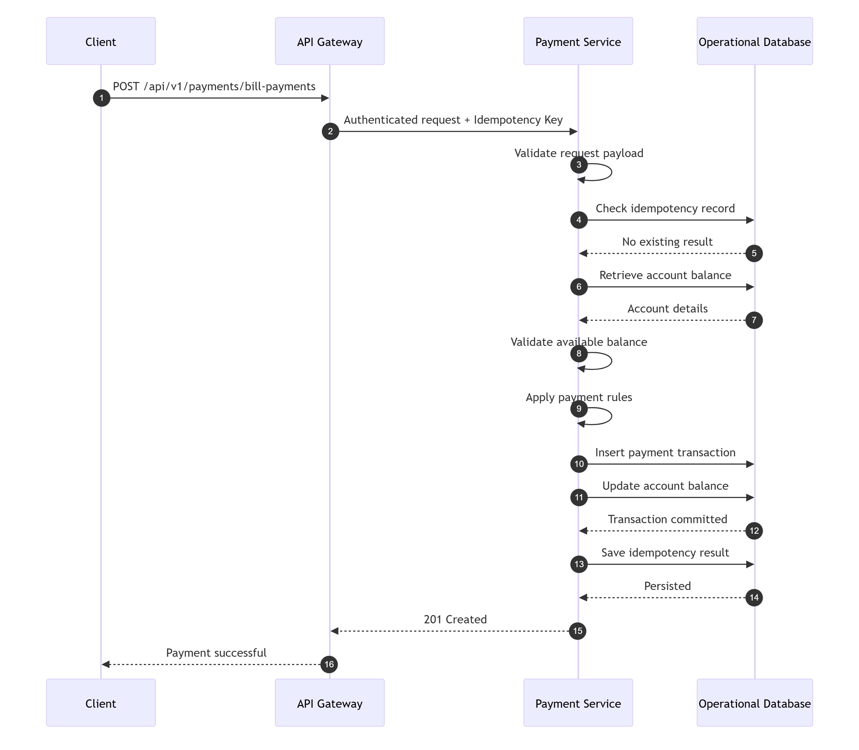
TraceabilityBRD: 6.5.3Architecture: 10.4.2

4.8 Card APIs

4.8.1 GET /api/v1/cards
API NameSearch Cards API
PurposeSearch and paginate card records using optional account/card filters.
EndpointGET /api/v1/cards
AuthenticationRequired
AuthorizationAuthenticated user with card inquiry/update access
Query Parameters
Name | Type | Required | Notes
accountId | string | No | 11-digit numeric
cardNumber | string | No | 16-digit numeric
page | integer | No | default 1
pageSize | integer | No | default 20, max 100

Success Response
{
"success": true,
"message": "Cards retrieved",
"data": {
"items": [
{
"accountId": "12345678901",
"cardNumberMasked": "************1111",
"cardStatus": "ACTIVE"
}
],
"pagination": {
"page": 1,
"pageSize": 20,
"hasNext": false,
"hasPrevious": false
}
},
"meta": {
"requestId": "req-6001",
"timestamp": "2026-08-05T12:00:00Z"
}
}
Validation Rulesif accountId present, 11-digit numericif cardNumber present, 16-digit numericpage/pageSize valid
Database OperationsRead CARDS with optional filters and pagination
Security Considerationsmask card numbers in list responses
TraceabilityBRD: 6.6.1Architecture: 10.5.1

4.8.2 GET /api/v1/cards/{cardNumber}
API NameGet Card Detail API
PurposeRetrieve one card detail record.
EndpointGET /api/v1/cards/{cardNumber}
Path ParameterscardNumber 16-digit numeric
Query ParametersaccountId optional but recommended when enforcing account-card match
Success Response
{
"success": true,
"message": "Card retrieved",
"data": {
"accountId": "12345678901",
"cardNumberMasked": "************1111",
"cardName": "JANE DOE",
"expiryMonth": 12,
"expiryYear": 2028,
"cardStatus": "ACTIVE",
"activeStatus": "Y",
"rowVersion": 2
},
"meta": {
"requestId": "req-6002",
"timestamp": "2026-08-05T12:02:00Z"
}
}
Validation RulescardNumber required, 16-digit numeric
Database OperationsRead CARDS by card_number
TraceabilityBRD: 6.6.2Architecture: 10.5.2

4.8.3 PUT /api/v1/cards/{cardNumber}
API NameUpdate Card API
PurposeUpdate editable card fields.
EndpointPUT /api/v1/cards/{cardNumber}
AuthenticationRequired
AuthorizationUser with card update permission
Request Body Schema
{
"type": "object",
"required": ["accountId", "cardName", "activeStatus", "expiryMonth", "expiryYear", "rowVersion"],
"properties": {
"accountId": {
"type": "string",
"pattern": "^[1-9][0-9]{10}$"
},
"cardName": {
"type": "string",
"minLength": 1,
"maxLength": 100,
"pattern": "^[A-Za-z ]+$"
},
"activeStatus": {
"type": "string",
"enum": ["Y", "N"]
},
"expiryMonth": {
"type": "integer",
"minimum": 1,
"maximum": 12
},
"expiryYear": {
"type": "integer",
"minimum": 1900,
"maximum": 9999
},
"rowVersion": {
"type": "integer",
"minimum": 0
}
},
"additionalProperties": false
}
Example
{
"accountId": "12345678901",
"cardName": "JANE DOE",
"activeStatus": "Y",
"expiryMonth": 12,
"expiryYear": 2028,
"rowVersion": 2
}
Success Response
{
"success": true,
"message": "Changes committed to database",
"data": {
"cardNumberMasked": "************1111",
"rowVersion": 3
},
"meta": {
"requestId": "req-6003",
"timestamp": "2026-08-05T12:05:00Z"
}
}
Validation Error
{
"success": false,
"errorType": "VALIDATION_ERROR",
"errorCode": "CARD-VAL-001",
"message": "Validation failed",
"fieldErrors": [
{
"field": "cardName",
"code": "PATTERN",
"message": "Card name can only contain alphabets and spaces"
}
],
"meta": {
"requestId": "req-6003",
"timestamp": "2026-08-05T12:05:00Z"
}
}
Business Error
{
"success": false,
"errorType": "BUSINESS_RULE_ERROR",
"errorCode": "CARD-400-001",
"message": "No change detected",
"meta": {
"requestId": "req-6003",
"timestamp": "2026-08-05T12:05:00Z"
}
}
Conflict Error
{
"success": false,
"errorType": "CONFLICT",
"errorCode": "CARD-409-001",
"message": "Record changed by someone else",
"meta": {
"requestId": "req-6003",
"timestamp": "2026-08-05T12:05:00Z"
}
}
Status Codes:200 400 401 403 404 409 500
Validation Rules accountId valid cardName alphabets and spaces only active Status Y/N expiryMonth 1..12valid expiryYearrowVersion required
Business Logic FlowValidate path and bodyLoad cardValidate account-card match if accountId suppliedCheck rowVersionDetect no changeUpdate cardAudit updateReturn new rowVersion
Database OperationsRead CARDSUpdate CARDS
Retry LogicRetry after refetch on conflict only
Audit EventsCARD_UPDATE
TraceabilityBRD: 6.6.3Architecture: 10.5.3

4.9 Transaction APIs

4.9.1 GET /api/v1/transactions
API NameList Transactions API
PurposeRetrieve paginated transaction summary list.
EndpointGET /api/v1/transactions
Query ParametersstartTransactionId optional numeric/string IDpage default 1pageSize default 20 max 100
Success Response
{
"success": true,
"message": "Transactions retrieved",
"data": {
"items": [
{
"transactionId": "TXN1001",
"date": "2026-08-05",
"description": "Store purchase",
"amount": 100.50
}
],
"pagination": {
"page": 1,
"pageSize": 20,
"hasNext": true,
"hasPrevious": false
}
},
"meta": {
"requestId": "req-7001",
"timestamp": "2026-08-05T12:20:00Z"
}
}
Validation Rulespage/pageSize validstartTransactionId numeric/alphanumeric according to ID format policy
Database OperationsRead TRANSACTIONS
TraceabilityBRD: 6.7.1Architecture: 10.6.1

4.9.2 GET /api/v1/transactions/{transactionId}
API NameGet Transaction Detail API
PurposeRetrieve full transaction detail.
EndpointGET /api/v1/transactions/{transactionId}
Success Response
{
"success": true,
"message": "Transaction retrieved",
"data": {
"transactionId": "TXN1001",
"cardNumberMasked": "************1111",
"typeCode": "PURCHASE",
"categoryCode": "RETAIL",
"source": "MANUAL",
"amount": 100.50,
"description": "Store purchase",
"originalTimestamp": "2026-08-05T10:00:00Z",
"processedTimestamp": "2026-08-05T10:01:00Z",
"merchantId": "M001",
"merchantName": "ABC STORE",
"merchantCity": "Austin",
"merchantZip": "78701"
},
"meta": {
"requestId": "req-7002",
"timestamp": "2026-08-05T12:22:00Z"
}
}
TraceabilityBRD: 6.7.2Architecture: 10.6.2

4.9.3 POST /api/v1/transactions
API NameAdd Transaction API
PurposeCreate a manual transaction.
EndpointPOST /api/v1/transactions
AuthenticationRequired
AuthorizationUser with transaction add permission
HeadersAuthorizationContent-TypeX-Request-IdX-Idempotency-Key required
Request Body Schema
{
"type": "object",
"required": ["transactionType", "categoryType", "source", "amount", "description", "originalDate", "processDate", "confirmation"],
"properties": {
"accountId": {
"type": "string",
"pattern": "^[1-9][0-9]{10}$"
},
"cardNumber": {
"type": "string",
"pattern": "^[0-9]{16}$"
},
"transactionType": {
"type": "string",
"minLength": 1,
"maxLength": 50
},
"categoryType": {
"type": "string",
"minLength": 1,
"maxLength": 50
},
"source": {
"type": "string",
"minLength": 1,
"maxLength": 50
},
"amount": {
"type": "number",
"exclusiveMinimum": 0
},
"description": {
"type": "string",
"minLength": 1,
"maxLength": 255
},
"originalDate": {
"type": "string",
"format": "date"
},
"processDate": {
"type": "string",
"format": "date"
},
"merchantId": {
"type": "string",
"maxLength": 64
},
"merchantName": {
"type": "string",
"maxLength": 255
},
"merchantCity": {
"type": "string",
"maxLength": 100
},
"merchantZip": {
"type": "string",
"maxLength": 20
},
"confirmation": {
"type": "string",
"enum": ["Y"]
}
},
"additionalProperties": false,
"anyOf": [
{ "required": ["accountId"] },
{ "required": ["cardNumber"] }
]
}
Example
{
"accountId": "12345678901",
"cardNumber": "4444333322221111",
"transactionType": "PURCHASE",
"categoryType": "RETAIL",
"source": "MANUAL",
"amount": 100.50,
"description": "Store purchase",
"originalDate": "2026-08-05",
"processDate": "2026-08-05",
"merchantId": "M001",
"merchantName": "ABC STORE",
"merchantCity": "Austin",
"merchantZip": "78701",
"confirmation": "Y"
}
Success Response
{
"success": true,
"message": "Transaction added successfully",
"data": {
"transactionId": "TXN2001"
},
"meta": {
"requestId": "req-7003",
"timestamp": "2026-08-05T12:25:00Z"
}
}
Validation Error
{
"success": false,
"errorType": "VALIDATION_ERROR",
"errorCode": "TXN-VAL-001",
"message": "Validation failed",
"fieldErrors": [
{
"field": "amount",
"code": "MIN",
"message": "Amount must be greater than zero"
}
],
"meta": {
"requestId": "req-7003",
"timestamp": "2026-08-05T12:25:00Z"
}
}
Business Error
{
"success": false,
"errorType": "BUSINESS_RULE_ERROR",
"errorCode": "TXN-400-001",
"message": "Account/card linkage not found",
"meta": {
"requestId": "req-7003",
"timestamp": "2026-08-05T12:25:00Z"
}
}
Status Codes201400401403404409500
Validation Rulesat least accountId or cardNumber requiredamount > 0dates validconfirmation Ytransaction type/category/source non-emptymerchant fields length constraintsif both accountId and cardNumber provided, they must match linkage
Business Logic FlowValidate request bodyCheck idempotency keyResolve missing account or card via linkage if allowedValidate linkage consistencyValidate type/category/source referencesGenerate transaction IDInsert transactionAudit createSave idempotency resultReturn 201
Service Layer Logic
text
createTransaction(req, principal, idemKey):
validate(req)
prior = idempotencyStore.lookup(idemKey)
if prior exists:
return prior
relation = linkageResolver.resolve(req.accountId, req.cardNumber)
if relation is invalid:
raise BusinessRuleException("Account/card linkage not found")
validateReferences(req.transactionType, req.categoryType, req.source)
txnId = transactionIdGenerator.next()
transactionRepository.insert(txnId, relation.accountId, relation.cardNumber, ...)
audit("TRANSACTION_ADD", principal.userId, txnId)
idempotencyStore.save(idemKey, response)
return response
Database OperationsRead ACCOUNT_CARD_LINKRead TRANSACTION_TYPES / reference dataInsert TRANSACTIONSOptional idempotency store read/write
Retry LogicSafe only with idempotency key
Audit EventsTRANSACTION_ADD
Security Considerationsmask card in logsvalidate actor entitlement to add transactions
API Sequence Diagram
mermaid
sequenceDiagram
participant Client
participant Gateway
participant Txn as Transaction Service
participant DB as Database
Client->>Gateway: POST /api/v1/transactions
Gateway->>Txn: Authenticated request + idempotency key
Txn->>DB: Check idempotency
DB-->>Txn: No prior record
Txn->>DB: Resolve account/card linkage
DB-->>Txn: Linkage found
Txn->>DB: Validate reference data
DB-->>Txn: Valid references
Txn->>DB: INSERT transaction
DB-->>Txn: Success
Txn->>DB: Save idempotency result
Txn-->>Gateway: 201 Created
Gateway-->>Client: Success response
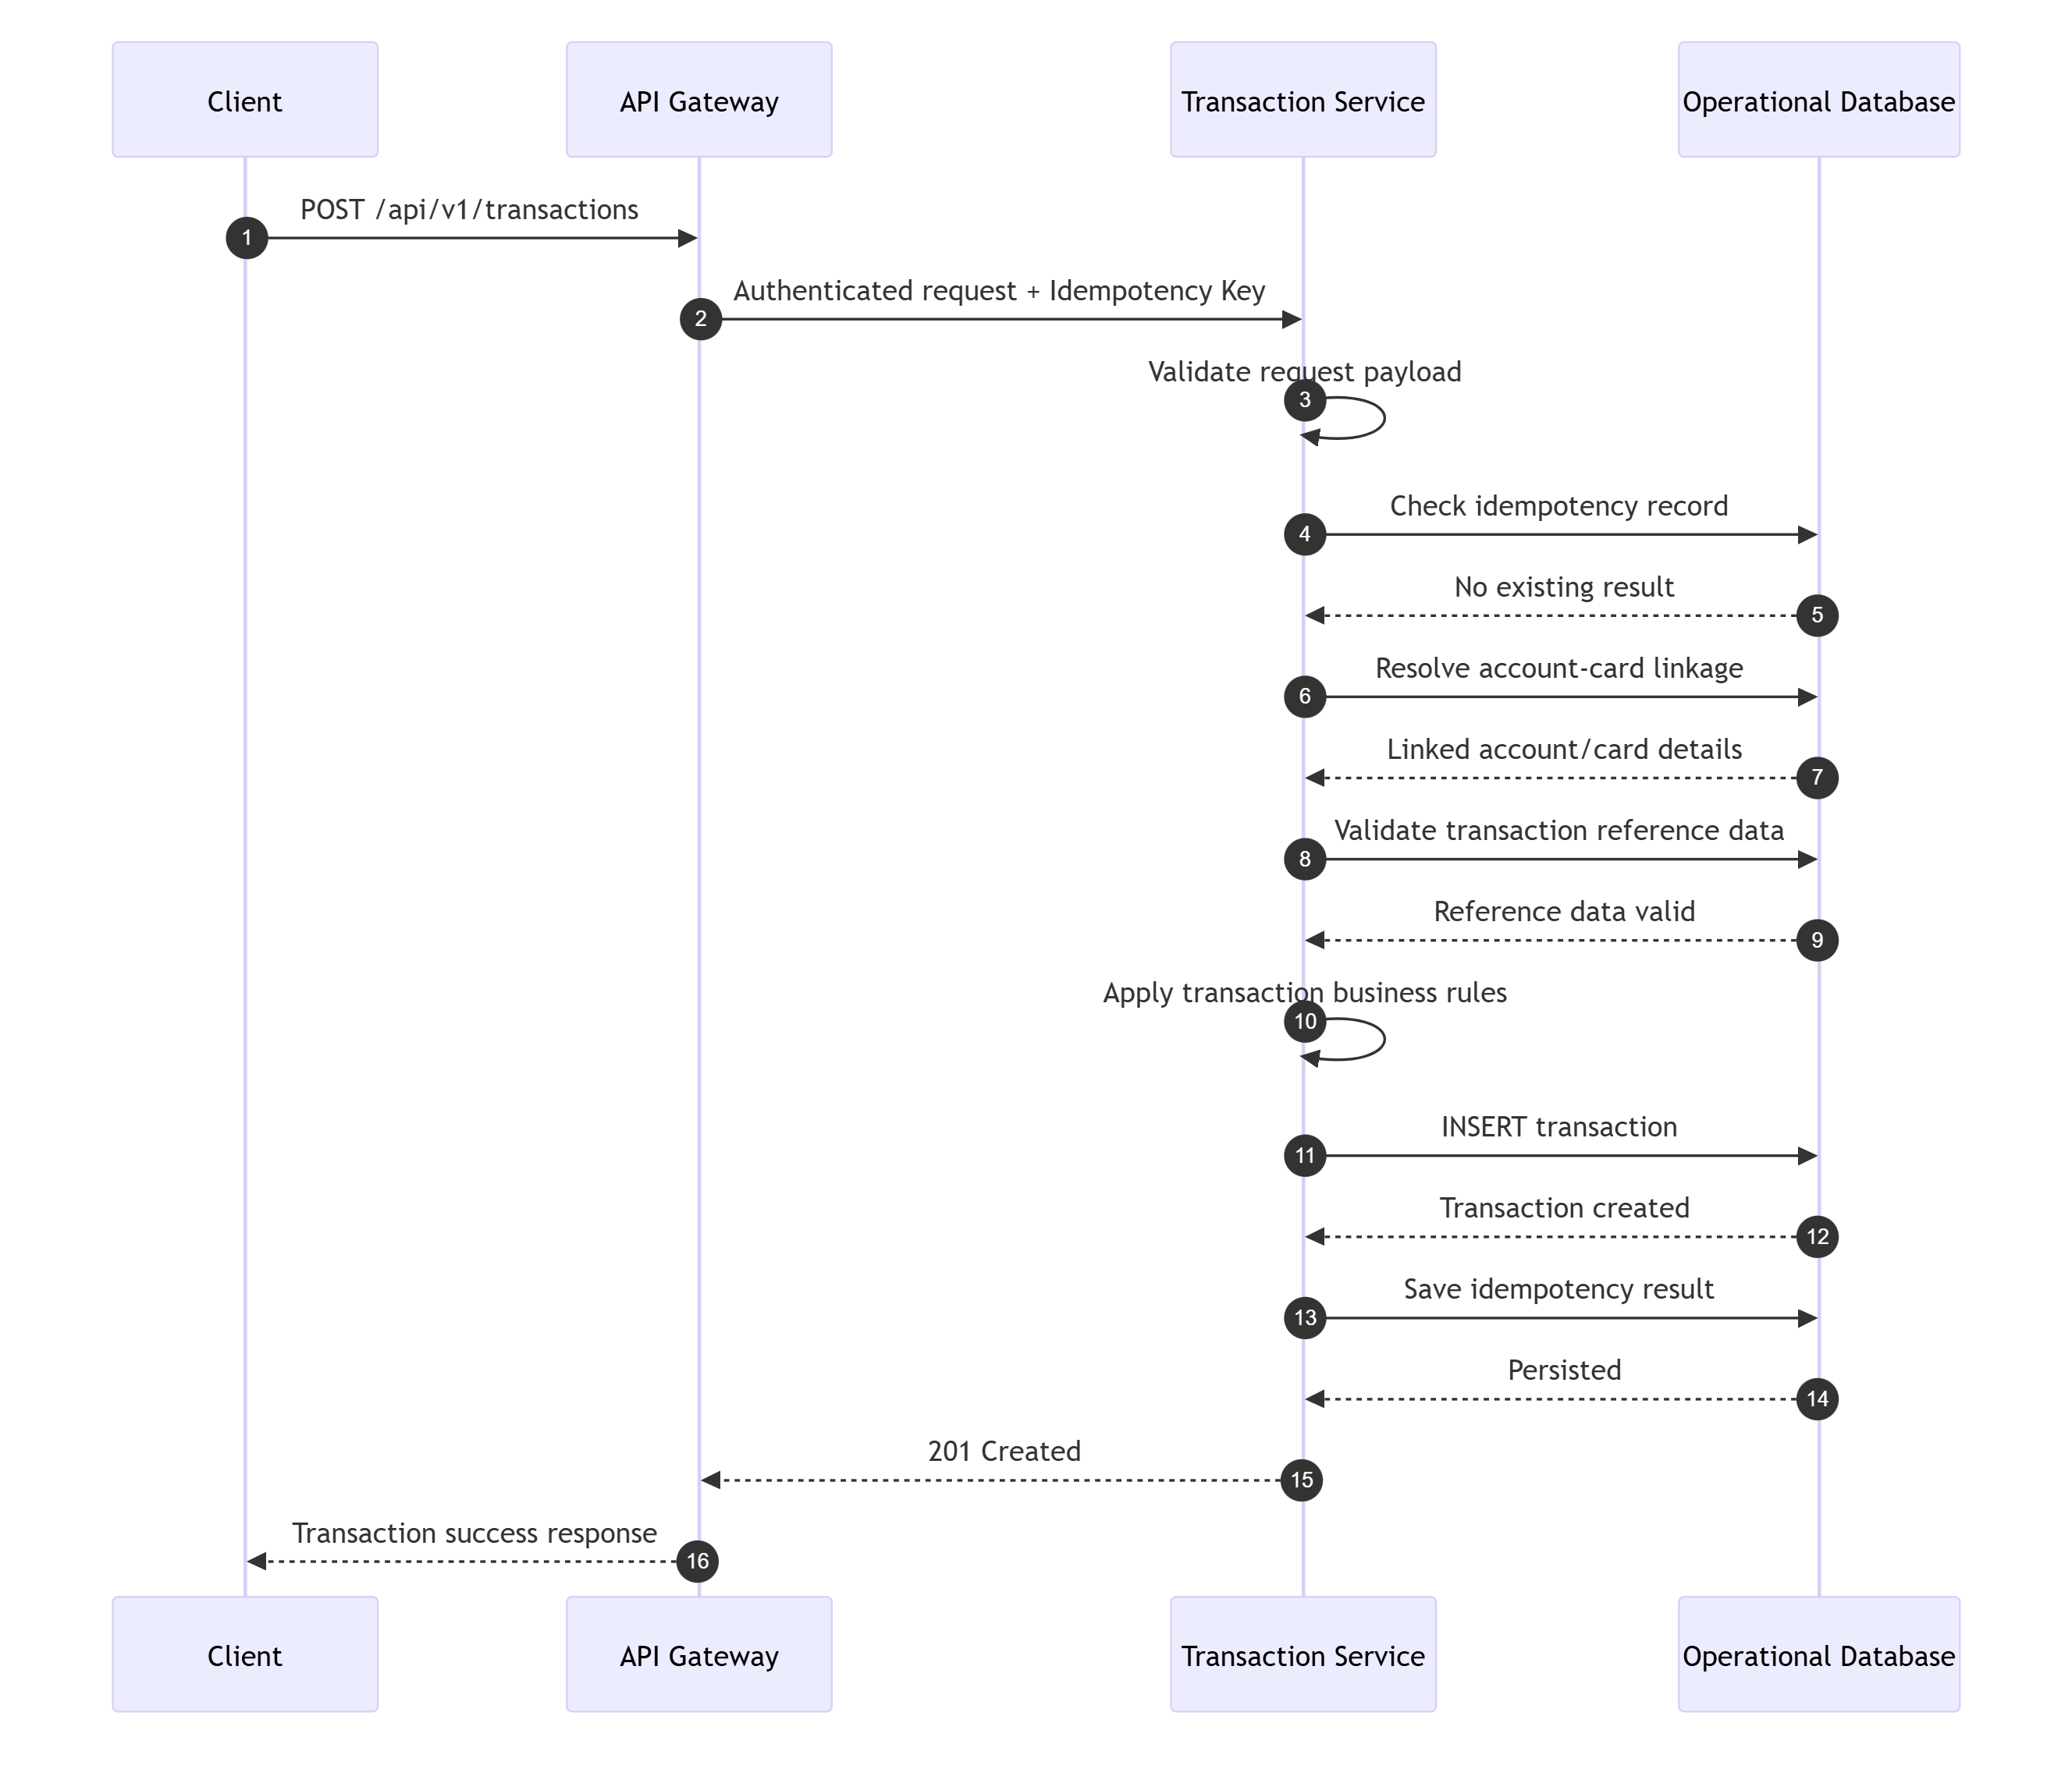
TraceabilityBRD: 6.7.3Architecture: 10.6.3

4.9.4 POST /api/v1/transactions/copy-last
API NameCopy Last Transaction API
PurposeReturn a transaction template derived from the user's last relevant transaction.
EndpointPOST /api/v1/transactions/copy-last
NoteBehavior is only partially evidenced in BRD; this API is a convenience endpoint.
Request Example
{
"accountId": "12345678901"
}
Success Response
{
"success": true,
"message": "Last transaction copied",
"data": {
"transactionType": "PURCHASE",
"categoryType": "RETAIL",
"source": "MANUAL",
"amount": 100.50,
"description": "Store purchase",
"merchantId": "M001",
"merchantName": "ABC STORE",
"merchantCity": "Austin",
"merchantZip": "78701"
},
"meta": {
"requestId": "req-7004",
"timestamp": "2026-08-05T12:27:00Z"
}
}
TraceabilityBRD: 6.7.3Architecture: 10.6.4

4.10 Transaction Type / Reference APIs

4.10.1 GET /api/v1/reference/transaction-types
API NameList Transaction Types API
PurposeRetrieve transaction type reference records.
EndpointGET /api/v1/reference/transaction-types
AuthenticationRequired
AuthorizationADMIN
Query ParameterstypeCode optionaldescription optionalpagepageSize
Success Example
{
"success": true,
"message": "Transaction types retrieved",
"data": {
"items": [
{
"typeCode": "PURCHASE",
"description": "Retail Purchase",
"rowVersion": 1
}
],
"pagination": {
"page": 1,
"pageSize": 20,
"hasNext": false,
"hasPrevious": false
}
},
"meta": {
"requestId": "req-8001",
"timestamp": "2026-08-05T12:40:00Z"
}
}
TraceabilityBRD: 6.8.1Architecture: 10.7.1

4.10.2 GET /api/v1/reference/transaction-types/{typeCode}
PurposeRetrieve one transaction type record.
TraceabilityBRD: 6.8.2Architecture: 10.7.2

4.10.3 POST /api/v1/reference/transaction-types
API NameCreate Transaction Type API
Request Example
{
"typeCode": "PURCHASE",
"description": "Retail Purchase"
}
Success Example
{
"success": true,
"message": "Transaction type created successfully",
"data": {
"typeCode": "PURCHASE"
},
"meta": {
"requestId": "req-8002",
"timestamp": "2026-08-05T12:42:00Z"
}
}
RulestypeCode required and uniquedescription required
Database OperationsRead TRANSACTION_TYPESInsert TRANSACTION_TYPES
Audit EventsTXN_TYPE_CREATE
TraceabilityBRD: 6.8.2Architecture: 10.7.3

4.10.4 PUT /api/v1/reference/transaction-types/{typeCode}
PurposeUpdate transaction type description.
Example Request
{
"description": "Retail Purchase Updated",
"rowVersion": 1
}
Conflict RulerowVersion mismatch → 409
Audit EventsTXN_TYPE_UPDATE
TraceabilityBRD: 6.8.2Architecture: 10.7.4

4.10.5 DELETE /api/v1/reference/transaction-types/{typeCode}
PurposeDelete a transaction type record.
Rulesfail if referenced by transaction history and policy disallows delete
Audit EventsTXN_TYPE_DELETE
TraceabilityBRD: 6.8.2Architecture: 10.7.5

4.11 Pending Authorization and Fraud APIs

4.11.1 GET /api/v1/pending-authorizations/accounts/{accountId}
API NamePending Authorization Summary API
PurposeRetrieve account summary, customer summary, pending auth summary, and pending auth items for an account.
EndpointGET /api/v1/pending-authorizations/accounts/{accountId}
Success Example
{
"success": true,
"message": "Pending authorizations retrieved",
"data": {
"accountSummary": {
"accountId": "12345678901",
"accountStatus": "ACTIVE"
},
"customerSummary": {
"customerId": "CUST001",
"firstName": "Jane",
"lastName": "Doe"
},
"pendingAuthorizationSummary": {
"count": 2,
"totalAmount": 150.75
},
"items": [
{
"authorizationId": "AUTH001",
"amount": 100.50,
"merchantName": "ABC STORE",
"status": "PENDING",
"fraudFlag": "N"
}
],
"pagination": {
"page": 1,
"pageSize": 20,
"hasNext": false,
"hasPrevious": false
}
},
"meta": {
"requestId": "req-9001",
"timestamp": "2026-08-05T13:00:00Z"
}
}
Validation RulesaccountId valid 11-digit numeric
Database OperationsRead ACCOUNTSRead linked CUSTOMERSRead PENDING_AUTH_SUMMARYRead PENDING_AUTH_DETAIL
TraceabilityBRD: 6.9.1Architecture: 10.8.1

4.11.2 GET /api/v1/pending-authorizations/{authorizationId}
API NamePending Authorization Detail API
PurposeRetrieve one pending authorization detail record.
Success Example
{
"success": true,
"message": "Pending authorization retrieved",
"data": {
"authorizationId": "AUTH001",
"accountId": "12345678901",
"cardNumberMasked": "************1111",
"amount": 100.50,
"merchantId": "M001",
"merchantName": "ABC STORE",
"merchantCity": "Austin",
"merchantZip": "78701",
"status": "PENDING",
"fraudFlag": "N"
},
"meta": {
"requestId": "req-9002",
"timestamp": "2026-08-05T13:02:00Z"
}
}
TraceabilityBRD: 6.9.2Architecture: 10.8.2

4.11.3 GET /api/v1/pending-authorizations/{authorizationId}/next
API NameNext Pending Authorization API
PurposeReturn next authorization in current context/order.
NoteTraversal context is an implementation concern; if required, pass current accountId and current page context.
TraceabilityBRD: 6.9.2Architecture: 10.8.3

4.11.4 POST /api/v1/fraud/authorizations/{authorizationId}/mark
API NameMark Fraud API
PurposeMark a pending authorization as fraud.
EndpointPOST /api/v1/fraud/authorizations/{authorizationId}/mark
AuthenticationRequired
AuthorizationUser with fraud action permission
HeadersAuthorizationX-Request-IdX-Idempotency-Key required
Request Body
{
"type": "object",
"properties": {
"notes": {
"type": "string",
"maxLength": 500
}
},
"additionalProperties": false
}
Example:
{
"notes": "Suspicious merchant activity"
}
Success Response
{
"success": true,
"message": "Fraud marked successfully",
"data": {
"authorizationId": "AUTH001",
"fraudFlag": "Y"
},
"meta": {
"requestId": "req-9003",
"timestamp": "2026-08-05T13:05:00Z"
}
}
Business Logic FlowValidate authz and idempotency keyEnsure authorization existsIf already marked, return idempotent success or current stateInsert/update fraud recordAudit actionReturn updated state
Database OperationsRead PENDING_AUTH_DETAILInsert or update FRAUD_RECORDS
IdempotencyRequired
Audit EventsFRAUD_MARK
TraceabilityBRD: 6.9.2, 6.9.3Architecture: 10.8.4

4.11.5 POST /api/v1/fraud/authorizations/{authorizationId}/unmark
Same design as mark, but sets fraud flag to N.
Audit EventsFRAUD_UNMARK
TraceabilityBRD: 6.9.2, 6.9.3Architecture: 10.8.5

4.11.6 GET /api/v1/fraud/records/{authorizationId}
PurposeRetrieve fraud record/state for a pending authorization.
TraceabilityArchitecture: 10.8.6

4.12 Report Request APIs

4.12.1 POST /api/v1/reports/requests
API NameCreate Report Request API
PurposeSubmit a monthly, yearly, or custom report request.
EndpointPOST /api/v1/reports/requests
AuthenticationRequired
AuthorizationAuthenticated user with report request access
HeadersAuthorizationContent-TypeX-Request-IdX-Idempotency-Key required
Request Body Schema
{
"type": "object",
"required": ["reportType", "confirmation"],
"properties": {
"reportType": {
"type": "string",
"enum": ["MONTHLY", "YEARLY", "CUSTOM"]
},
"startDate": {
"type": "string",
"format": "date"
},
"endDate": {
"type": "string",
"format": "date"
},
"confirmation": {
"type": "string",
"enum": ["Y"]
}
},
"additionalProperties": false
}
Example
{
"reportType": "CUSTOM",
"startDate": "2026-08-01",
"endDate": "2026-08-31",
"confirmation": "Y"
}
Success Response
{
"success": true,
"message": "Report request submitted successfully",
"data": {
"requestId": "RPT001",
"status": "SUBMITTED",
"resolvedStartDate": "2026-08-01",
"resolvedEndDate": "2026-08-31"
},
"meta": {
"requestId": "req-10001",
"timestamp": "2026-08-05T13:20:00Z"
}
}
Validation Error
{
"success": false,
"errorType": "VALIDATION_ERROR",
"errorCode": "RPT-VAL-001",
"message": "Validation failed",
"fieldErrors": [
{
"field": "startDate",
"code": "REQUIRED",
"message": "Start date is required for custom report"
}
],
"meta": {
"requestId": "req-10001",
"timestamp": "2026-08-05T13:20:00Z"
}
}
Business Error
{
"success": false,
"errorType": "BUSINESS_RULE_ERROR",
"errorCode": "RPT-400-001",
"message": "Invalid confirmation",
"meta": {
"requestId": "req-10001",
"timestamp": "2026-08-05T13:20:00Z"
}
}
Status Codes201400401403409500
Validation RulesreportType requiredcustom requires startDate and endDatedates must be validstartDate <= endDateconfirmation must be Yidempotency required
Business Logic FlowValidate requestCheck idempotencyResolve derived date range for MONTHLY or YEARLYValidate custom date range if CUSTOMPersist request or enqueue workAudit submissionReturn requestId and status
Database OperationsInsert REPORT_REQUESTSOptional idempotency store write
Audit EventsREPORT_REQUEST_SUBMIT
TraceabilityBRD: 6.10Architecture: 10.9.1

4.12.2 GET /api/v1/reports/requests/{requestId}
PurposeRetrieve submitted report request status.
Success Example
{
"success": true,
"message": "Report request retrieved",
"data": {
"requestId": "RPT001",
"status": "SUBMITTED",
"reportType": "CUSTOM",
"startDate": "2026-08-01",
"endDate": "2026-08-31"
},
"meta": {
"requestId": "req-10002",
"timestamp": "2026-08-05T13:21:00Z"
}
}
TraceabilityArchitecture: 10.9.2

4.13 Request/Response Service APIs

4.13.1 POST /api/v1/services/authorizations/decide
API NameAuthorization Decision API
PurposeReceive authorization request and return approve/decline response while updating pending authorization data.
EndpointPOST /api/v1/services/authorizations/decide
AuthenticationRequired
AuthorizationSYSTEM or trusted upstream caller
HeadersAuthorizationContent-TypeX-Request-IdX-Idempotency-Key required
Request Body Example
{
"accountId": "12345678901",
"cardNumber": "4444333322221111",
"amount": 100.50,
"merchantId": "M001",
"merchantName": "ABC STORE",
"merchantCity": "Austin",
"merchantZip": "78701",
"requestTimestamp": "2026-08-05T10:00:00Z"
}
Success Response
{
"success": true,
"message": "Authorization processed",
"data": {
"decision": "APPROVE",
"responseCode": "00",
"authorizationId": "AUTH001"
},
"meta": {
"requestId": "req-11001",
"timestamp": "2026-08-05T13:30:00Z"
}
}
Business Error
{
"success": false,
"errorType": "BUSINESS_RULE_ERROR",
"errorCode": "AUTHZ-400-001",
"message": "Authorization declined",
"data": {
"decision": "DECLINE",
"responseCode": "51"
},
"meta": {
"requestId": "req-11001",
"timestamp": "2026-08-05T13:30:00Z"
}
}
Status Codes200400401403409500503
Validation RulesaccountId validcardNumber validamount > 0requestTimestamp valididempotency required
Business Logic FlowValidate request and idempotency keyResolve account/card/customer linkageEvaluate eligibility/financial controlsDecide approve or declinePersist/update pending auth summaryPersist pending auth detailStore idempotency resultReturn decision and response code
Service Layer Logic
text
decideAuthorization(req, idemKey):
prior = idempotencyStore.lookup(idemKey)
if prior exists:
return prior
validate(req)
linkage = linkageService.validate(req.accountId, req.cardNumber)
decision = eligibilityEngine.evaluate(linkage, req.amount)
transaction:
pendingAuthSummaryRepository.updateForDecision(...)
pendingAuthDetailRepository.insert(...)
response = mapDecision(decision)
idempotencyStore.save(idemKey, response)
return response
Database OperationsRead account/card/linkageUpsert PENDING_AUTH_SUMMARYInsert PENDING_AUTH_DETAILidempotency read/write
Exception Handlinglinkage missing → decline or business error per policypending auth update failure → 500/503 depending failure mode
Retry LogicAllowed only with idempotency key
Audit EventsAUTHORIZATION_DECISION
Security Considerationsmutual trust/authentication with upstreamstrict throttling and allowlisting recommended
API Sequence Diagram
mermaid
sequenceDiagram
participant Caller
participant Gateway
participant Authz as Authorization Decision Service
participant DB as Database
Caller->>Gateway: POST /api/v1/services/authorizations/decide
Gateway->>Authz: Authenticated SYSTEM request
Authz->>DB: Check idempotency
DB-->>Authz: No prior result
Authz->>DB: Validate account/card/linkage
DB-->>Authz: Linkage data
Authz->>Authz: Evaluate approve/decline
Authz->>DB: UPSERT pending auth summary
Authz->>DB: INSERT pending auth detail
DB-->>Authz: Commit success
Authz->>DB: Save idempotency result
Authz-->>Gateway: Decision response
Gateway-->>Caller: 200 Response
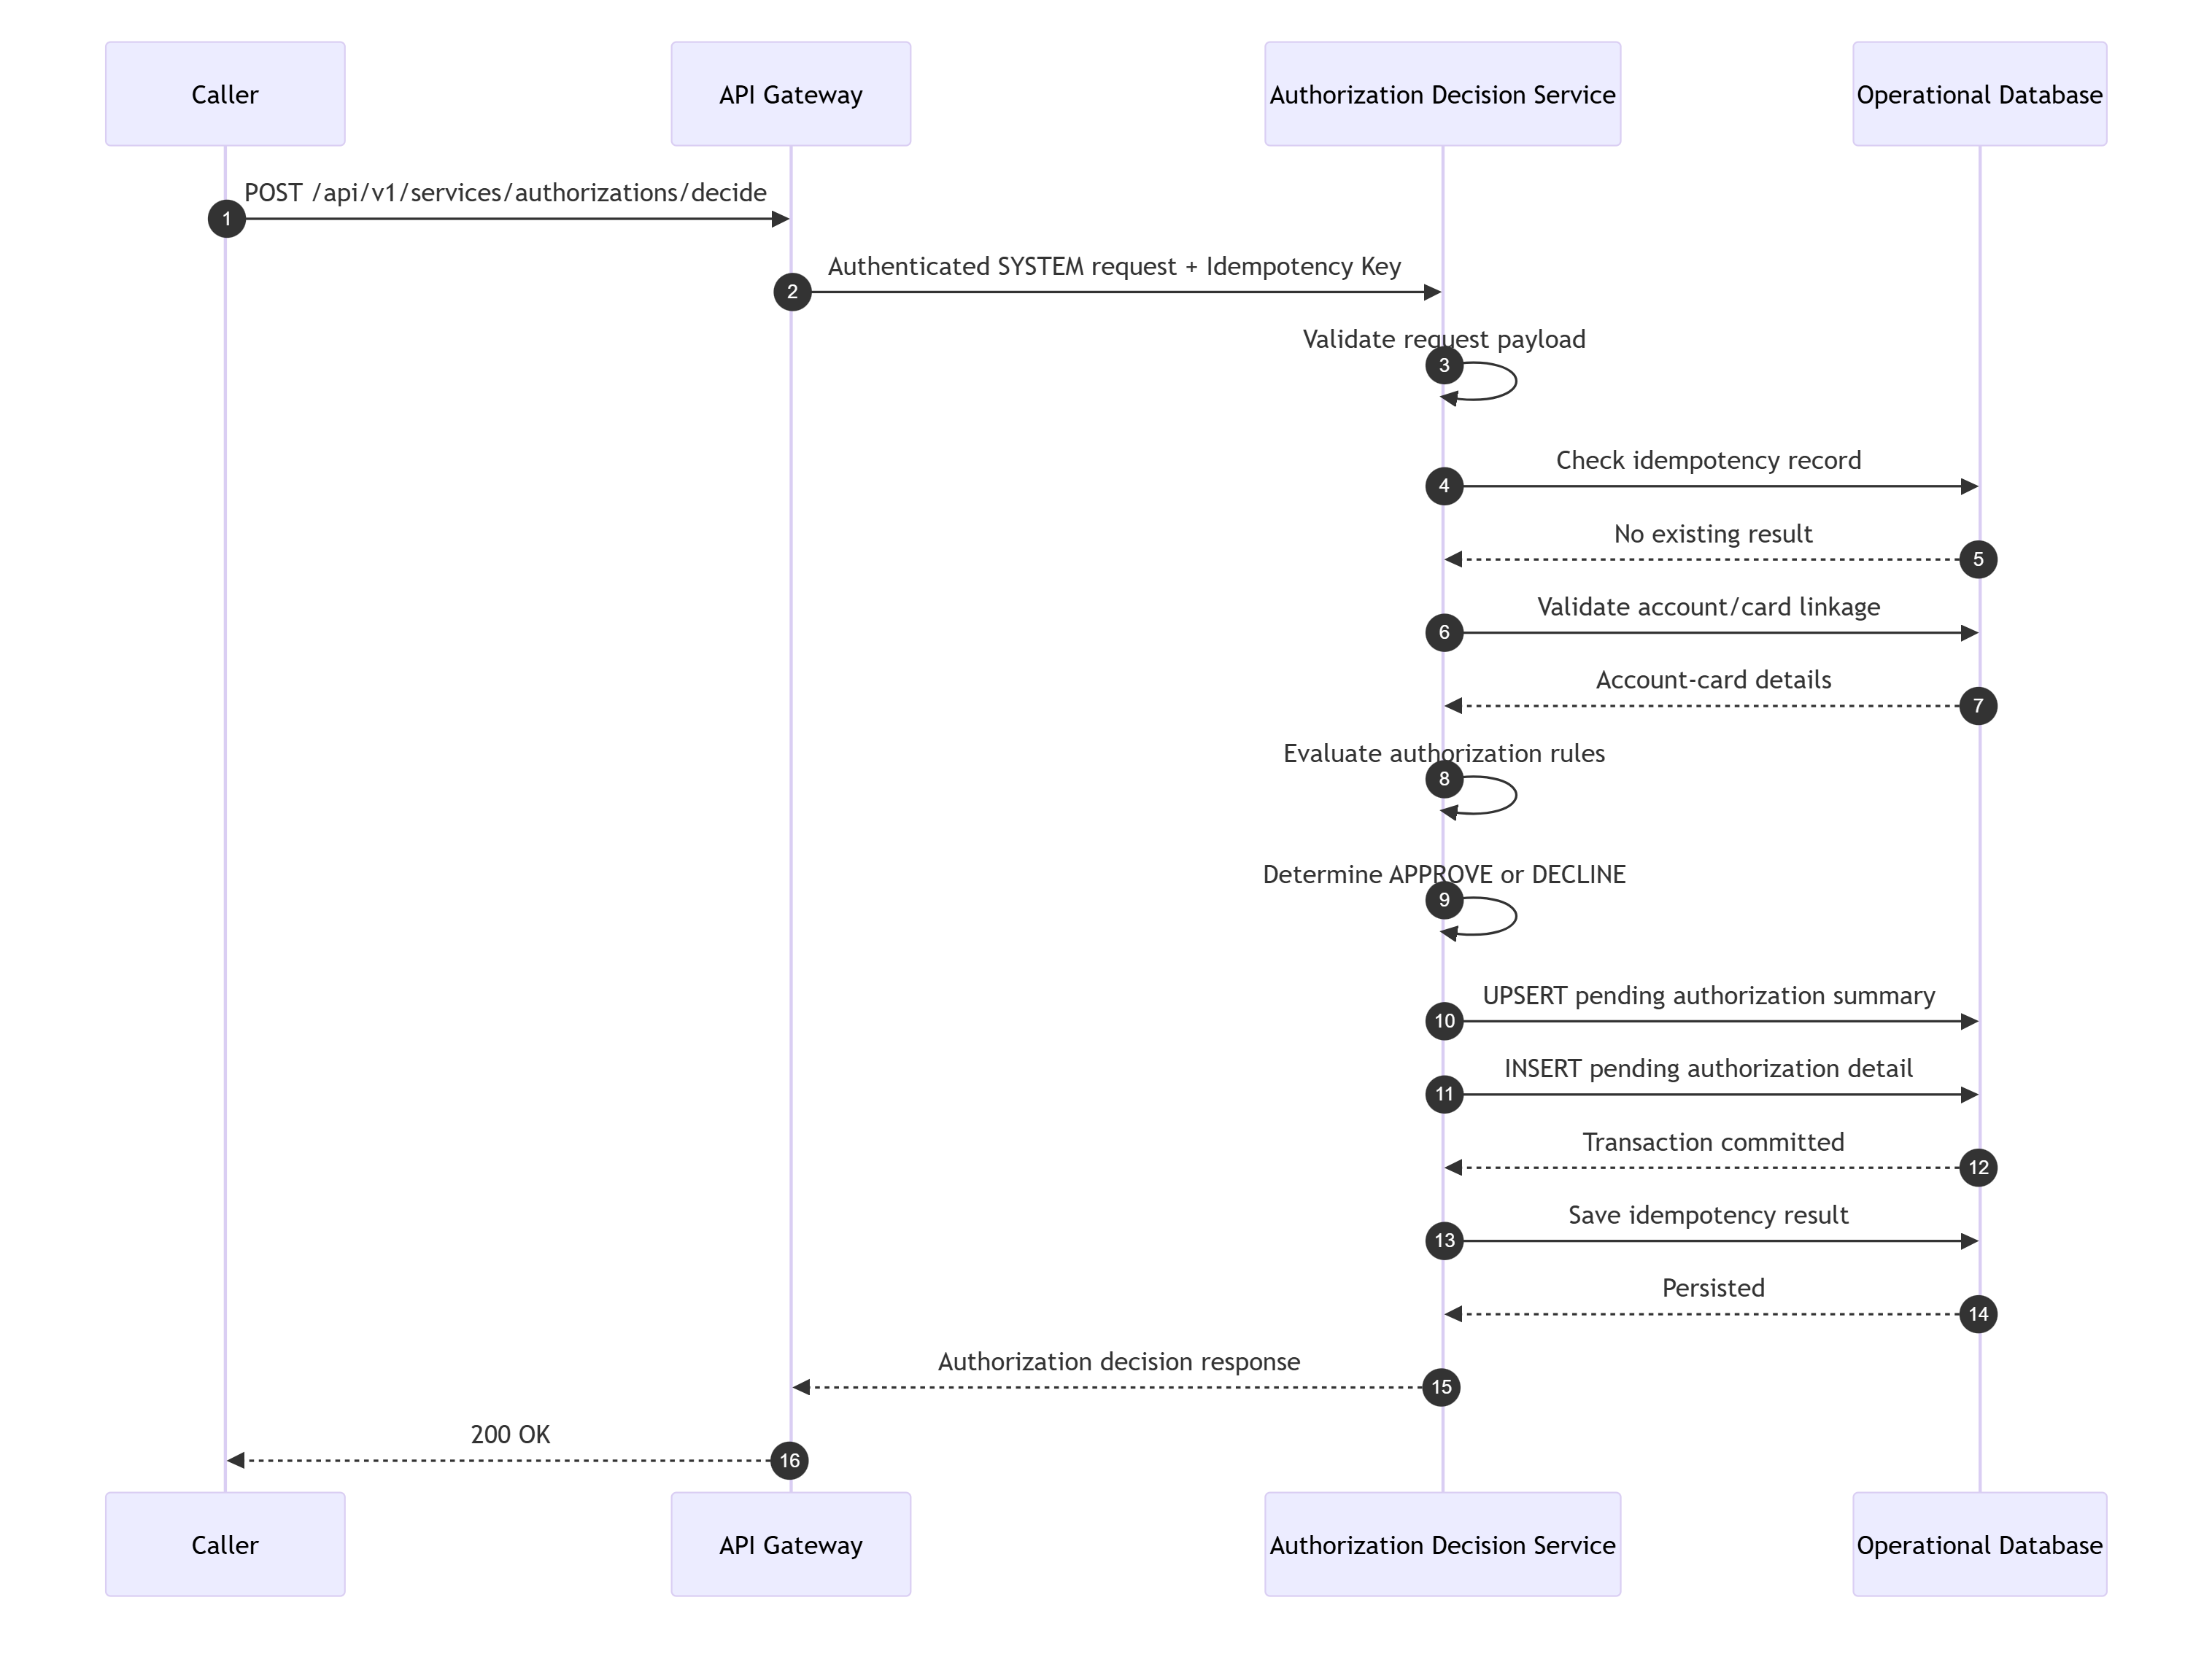
TraceabilityBRD: 6.11Architecture: 10.10.1

4.13.2 POST /api/v1/services/accounts/inquiry
API NameAccount Inquiry Service API
PurposeReturn account information for other channels/processes.
EndpointPOST /api/v1/services/accounts/inquiry
Request Example
{
"accountId": "12345678901"
}
Success Response
{
"success": true,
"message": "Account inquiry processed",
"data": {
"accountId": "12345678901",
"accountStatus": "ACTIVE",
"currentBalance": 450.75
},
"meta": {
"requestId": "req-11002",
"timestamp": "2026-08-05T13:32:00Z"
}
}
TraceabilityBRD: 6.12Architecture: 10.10.2

4.13.3 GET /api/v1/services/datetime/current
API NameCurrent DateTime API
PurposeReturn current date and time.
EndpointGET /api/v1/services/datetime/current
Success Response
{
"success": true,
"message": "Current date time retrieved",
"data": {
"currentDateTime": "2026-08-05T13:33:00Z"
},
"meta": {
"requestId": "req-11003",
"timestamp": "2026-08-05T13:33:00Z"
}
}
TraceabilityBRD: 6.13Architecture: 10.10.3

4.14 Operational / Background Job Trigger APIs
These are implementation-support APIs and may be internal only.
- 4.14.1 POST /api/v1/ops/jobs/daily-transaction-validation
- 4.14.2 POST /api/v1/ops/jobs/daily-transaction-posting
- 4.14.3 POST /api/v1/ops/jobs/interest-processing
- 4.14.4 POST /api/v1/ops/jobs/account-transformation
- 4.14.5 POST /api/v1/ops/jobs/export
- 4.14.6 POST /api/v1/ops/jobs/import
- 4.14.7 POST /api/v1/ops/jobs/statements
- 4.14.8 POST /api/v1/ops/jobs/transaction-report
- 4.14.9 POST /api/v1/ops/jobs/pending-auth-cleanup
- 4.14.10 POST /api/v1/ops/jobs/pending-auth-migration
- 4.14.11 POST /api/v1/ops/jobs/transaction-type-maintenance
Common API NameJob Trigger API
PurposeStart an operational background job.
Common Endpoint PatternPOST /api/v1/ops/jobs/{jobName}
AuthenticationRequired
AuthorizationOPS or SYSTEM
HeadersAuthorizationX-Request-IdX-Idempotency-Key recommended
Request Body Example
{
"runMode": "ON_DEMAND",
"parameters": {
"businessDate": "2026-08-05"
}
}
Success Response
{
"success": true,
"message": "Job accepted",
"data": {
"jobName": "daily-transaction-validation",
"jobRunId": "JOB1001",
"status": "ACCEPTED"
},
"meta": {
"requestId": "req-12001",
"timestamp": "2026-08-05T13:40:00Z"
}
}
Status Codes202400401403409500
Validation RulesjobName must be supportedparameters must match job contractduplicate running job may return 409 depending policy
Database Operationsinsert JOB_RUNS or equivalentenqueue background execution
IdempotencyRecommended
Audit EventsJOB_TRIGGER
TraceabilityBRD: 6.14–6.18Architecture: 10.11

4.15 API Error Code Catalog
Code | Meaning | HTTP
AUTH-VAL-001 | Login validation failure | 400
AUTH-401-001 | User not found | 401
AUTH-401-002 | Wrong password | 401
AUTH-500-001 | Unable to verify user | 500
NAV-400-002 | Invalid menu option | 400
USR-409-001 | User already exists | 409
USR-409-002 | User row version conflict | 409
ACC-VAL-001 | Invalid account ID | 400
ACC-400-002 | No change detected | 400
ACC-409-001 | Account/customer version conflict | 409
PAY-400-001 | Nothing to pay | 400
PAY-500-001 | Unable to update account | 500
CARD-VAL-001 | Invalid card update fields | 400
CARD-409-001 | Card version conflict | 409
TXN-VAL-001 | Invalid transaction input | 400
TXN-400-001 | Account/card linkage not found | 400
RPT-VAL-001 | Invalid report request input | 400
AUTHZ-400-001 | Authorization declined | 200/400 policy dependent
JOB-409-001 | Duplicate/running job conflict | 409

4.16 API Traceability Matrix
API | BRD | Architecture
POST /auth/login | 6.1 | 10.1.1
POST /auth/logout | Assumption | 10.1.2
GET /auth/me | Assumption | 10.1.3
GET /navigation/main-menu | 6.2 | 10.1.4
GET /navigation/admin-menu | 6.3 | 10.1.5
POST /navigation/validate-option | 6.2, 6.3 | 10.1.6
GET /admin/users | 6.4.1 | 10.2.1
GET /admin/users/{userId} | 6.4.3, 6.4.4 | 10.2.2
POST /admin/users | 6.4.2 | 10.2.3
PUT /admin/users/{userId} | 6.4.3 | 10.2.4
DELETE /admin/users/{userId} | 6.4.4 | 10.2.5
GET /accounts/{accountId} | 6.5.1 | 10.3.1
PUT /accounts/{accountId} | 6.5.2 | 10.3.2
GET /payments/bill-payments/preview/{accountId} | 6.5.3 | 10.4.1
POST /payments/bill-payments | 6.5.3 | 10.4.2
GET /cards | 6.6.1 | 10.5.1
GET /cards/{cardNumber} | 6.6.2 | 10.5.2
PUT /cards/{cardNumber} | 6.6.3 | 10.5.3
GET /transactions | 6.7.1 | 10.6.1
GET /transactions/{transactionId} | 6.7.2 | 10.6.2
POST /transactions | 6.7.3 | 10.6.3
POST /transactions/copy-last | 6.7.3 | 10.6.4
GET /reference/transaction-types | 6.8.1 | 10.7.1
GET /reference/transaction-types/{typeCode} | 6.8.2 | 10.7.2
POST /reference/transaction-types | 6.8.2 | 10.7.3
PUT /reference/transaction-types/{typeCode} | 6.8.2 | 10.7.4
DELETE /reference/transaction-types/{typeCode} | 6.8.2 | 10.7.5
GET /pending-authorizations/accounts/{accountId} | 6.9.1 | 10.8.1
GET /pending-authorizations/{authorizationId} | 6.9.2 | 10.8.2
GET /pending-authorizations/{authorizationId}/next | 6.9.2 | 10.8.3
POST /fraud/authorizations/{authorizationId}/mark | 6.9.2, 6.9.3 | 10.8.4
POST /fraud/authorizations/{authorizationId}/unmark | 6.9.2, 6.9.3 | 10.8.5
GET /fraud/records/{authorizationId} | 6.9.3 implied | 10.8.6
POST /reports/requests | 6.10 | 10.9.1
GET /reports/requests/{requestId} | Assumption | 10.9.2
POST /services/authorizations/decide | 6.11 | 10.10.1
POST /services/accounts/inquiry | 6.12 | 10.10.2
GET /services/datetime/current | 6.13 | 10.10.3
POST /ops/jobs/* | 6.14–6.18 | 10.11

Low-Level Design — Part 3
Sections 5–6: Database Design and ERD.

5. Database Design

5.1 Database Design Principles

5.1.1 Source Alignment
This schema is derived from:
- BRD business entities and flows
- Architecture logical database model and ERD

5.1.2 Design Goals
- support transactional online workloads
- support composite inquiry/update flows
- support background processing
- support optimistic locking
- support auditability
- support pagination and reporting queries
- avoid unnecessary denormalization unless justified by performance

5.1.3 Normalization Strategy
- core OLTP tables normalized to approximately 3NF
- selective derived/summary tables used where directly evidenced:pending_auth_summary
- operational/job tables may be denormalized for runtime efficiency
- masking is an application concern; raw sensitive data storage must be protected

5.1.4 Naming Convention
Recommended physical naming:
- lowercase snake_case
- singular vs plural: choose one standard consistently.
This LLD uses singular business names in narrative and plural table names physically for readability.

5.1.5 Audit Column Standard
Every mutable operational table should include:
- created_at
- created_by
- updated_at
- updated_by
- version

5.1.6 Data Type Assumptions
The physical types below are RDBMS-neutral recommendations. Final type syntax may vary slightly by DB vendor.

5.2 Entity Inventory
Table Name | Purpose | Source
users | authentication and access records | BRD 6.1, 6.4
customers | customer profile data | BRD 6.5
accounts | account financial/lifecycle data | BRD 6.5
account_customers | optional account-customer relationship bridge | Architecture assumption
cards | card details | BRD 6.6
account_card_links | account-card linkage | BRD 9
transaction_types | transaction reference data | BRD 6.8
transactions | transaction history | BRD 6.7
pending_auth_summaries | per-account pending auth summary | BRD 6.9
pending_auth_details | pending authorization detail items | BRD 6.9
fraud_records | fraud mark/unmark state/history | BRD 6.9
report_requests | report request submission | BRD 6.10
statement_runs | statement generation run metadata | Architecture support
statement_outputs | statement output metadata | BRD 6.16.1
job_runs | background job execution tracking | Architecture support
idempotency_keys | idempotent request tracking | LLD implementation support

5.3 Table Design

5.3.1 Table: users
Purpose
Store user authentication and access records used for login and administration.
Columns
Column Name | Data Type | Length | Nullable | Default | Constraints / Notes
user_id | varchar | 64 | No | — | primary business key
first_name | varchar | 100 | No | — | required
last_name | varchar | 100 | No | — | required
password_hash | varchar | 255 | No | — | hashed credential only
user_type | varchar | 20 | No | — | ADMIN or STANDARD
status | varchar | 20 | No | 'ACTIVE' | optional technical state
created_at | timestamp | — | No | current_timestamp | audit
created_by | varchar | 64 | No | 'SYSTEM' | audit
updated_at | timestamp | — | No | current_timestamp | audit
updated_by | varchar | 64 | No | 'SYSTEM' | audit
version | bigint | — | No | 0 | optimistic locking

Primary Keyuser_id
Foreign Keysnone
Indexes
Index Name | Columns | Type | Purpose
idx_users_type | user_type | non-unique | admin/user filtering
idx_users_status | status | non-unique | active user lookup if used

Unique Constraintspk_users on user_id
Check Constraintschk_users_user_type → user_type in ('ADMIN','STANDARD')chk_users_status → status in ('ACTIVE','INACTIVE','LOCKED') if status retained
Relationshipsno mandatory FK relationships
Cardinalityindependent entity
Normalization3NF
Partitioning Strategynot required
Audit ColumnsIncluded: yes
Sample Records
user_id | first_name | last_name | user_type | status | version
USR001 | John | Doe | ADMIN | ACTIVE | 5
USR002 | Mary | Smith | STANDARD | ACTIVE | 2

TraceabilityBRD 6.1, 6.4Architecture 16.3.1

5.3.2 Table: customers
Purpose
Store customer identity, profile, address, and related servicing fields.
Columns
Column Name | Data Type | Length | Nullable | Default | Constraints / Notes
customer_id | varchar | 32 | No | — | primary key
ssn | varchar | 11 | Yes | — | sensitive
credit_score | integer | — | Yes | — | evidenced
date_of_birth | date | — | Yes | — | evidenced
first_name | varchar | 100 | No | — | required
middle_name | varchar | 100 | Yes | — | optional
last_name | varchar | 100 | No | — | required
address_line1 | varchar | 255 | Yes | — | evidenced
address_line2 | varchar | 255 | Yes | — | optional
city | varchar | 100 | Yes | — | evidenced
state | varchar | 50 | Yes | — | evidenced
zip | varchar | 20 | Yes | — | evidenced
country | varchar | 100 | Yes | — | evidenced
phone1 | varchar | 20 | Yes | — | evidenced
phone2 | varchar | 20 | Yes | — | optional
government_id | varchar | 50 | Yes | — | sensitive
electronic_funds_account_ref | varchar | 64 | Yes | — | evidenced
primary_card_holder_indicator | char | 1 | Yes | — | Y/N
created_at | timestamp | — | No | current_timestamp | audit
created_by | varchar | 64 | No | 'SYSTEM' | audit
updated_at | timestamp | — | No | current_timestamp | audit
updated_by | varchar | 64 | No | 'SYSTEM' | audit
version | bigint | — | No | 0 | optimistic locking

Primary Keycustomer_id
Foreign Keysnone directly if using bridge relationshipoptional direct relationship from accounts.customer_id
Indexes
Index Name | Columns | Type | Purpose
idx_customers_last_name | last_name, first_name | non-unique | customer search support
idx_customers_ssn | ssn | non-unique / unique only if business guarantees | lookup/integration
idx_customers_phone1 | phone1 | non-unique | contact support

Unique Constraintspk_customers on customer_idoptional unique on ssn only if business confirms uniqueness across all customers
Check Constraintschk_customers_credit_score → credit_score between 0 and 999chk_customers_primary_holder_ind → primary_card_holder_indicator in ('Y','N')
Relationshipsone customer may relate to one or more accounts, depending final cardinality
Cardinalitycustomer to account = assumed 1:N candidate
Normalization3NF
Partitioning Strategynot required
Audit ColumnsIncluded: yes
Sample Records
customer_id | first_name | last_name | credit_score | primary_card_holder_indicator | version
CUST001 | Jane | Doe | 710 | Y | 3

TraceabilityBRD 6.5.1, 6.5.2Architecture 16.3.2

5.3.3 Table: accounts
Purpose
Store account lifecycle and financial data.
Columns
Column Name | Data Type | Length | Nullable | Default | Constraints / Notes
account_id | varchar | 11 | No | — | PK, 11-digit business ID
customer_id | varchar | 32 | Yes | — | direct FK if direct relationship model used
account_status | varchar | 30 | No | — | evidenced
current_balance | decimal | 18,2 | No | 0.00 | financial
credit_limit | decimal | 18,2 | No | 0.00 | evidenced
cash_credit_limit | decimal | 18,2 | No | 0.00 | evidenced
current_cycle_credit | decimal | 18,2 | No | 0.00 | evidenced
current_cycle_debit | decimal | 18,2 | No | 0.00 | evidenced
open_date | date | — | Yes | — | evidenced
expiration_date | date | — | Yes | — | evidenced
reissue_date | date | — | Yes | — | evidenced
group_id | varchar | 64 | Yes | — | evidenced
created_at | timestamp | — | No | current_timestamp | audit
created_by | varchar | 64 | No | 'SYSTEM' | audit
updated_at | timestamp | — | No | current_timestamp | audit
updated_by | varchar | 64 | No | 'SYSTEM' | audit
version | bigint | — | No | 0 | optimistic locking

Primary Keyaccount_id
Foreign Keysoptional fk_accounts_customer → customers(customer_id)
Indexes
Index Name | Columns | Type | Purpose
idx_accounts_customer_id | customer_id | non-unique | linked retrieval
idx_accounts_status | account_status | non-unique | operational filtering
idx_accounts_group_id | group_id | non-unique | group-based lookup

Unique Constraintspk_accounts on account_id
Check Constraintschk_accounts_id_numeric → account ID matches numeric 11-digit pattern where supportedchk_accounts_current_balance_nonneg → optional if negative balances disallowed; leave unrestricted unless business confirmschk_accounts_credit_limit_nonnegchk_accounts_cash_credit_limit_nonnegchk_accounts_cycle_credit_nonnegchk_accounts_cycle_debit_nonneg
Relationshipsaccount belongs to customeraccount links to many cardsaccount has many transactionsaccount has one summary record and many pending auth details
Cardinalitycustomer to accounts = 1:N candidateaccount to cards = 1:Naccount to transactions = 1:Naccount to pending_auth_summaries = 1:1account to pending_auth_details = 1:N
Normalization3NF
Partitioning Strategyoptional range/hash partitioning not required initially
Audit ColumnsIncluded: yes
Sample Records
account_id | customer_id | account_status | current_balance | credit_limit | version
12345678901 | CUST001 | ACTIVE | 450.75 | 5000.00 | 8

TraceabilityBRD 6.5Architecture 16.3.3

5.3.4 Table: account_customers
Purpose
Optional bridge table to support many-to-many or future-flexible account/customer relationships if direct FK is insufficient.
Design Recommendation
If business confirms exactly one customer per account, this table may be omitted and accounts.customer_id is sufficient.
Because the architecture flagged cardinality as an open question, this bridge is retained as a flexible design option.
Columns
Column Name | Data Type | Length | Nullable | Default | Constraints / Notes
account_id | varchar | 11 | No | — | FK
customer_id | varchar | 32 | No | — | FK
relationship_type | varchar | 30 | Yes | — | optional technical/business descriptor
created_at | timestamp | — | No | current_timestamp | audit
created_by | varchar | 64 | No | 'SYSTEM' | audit
updated_at | timestamp | — | No | current_timestamp | audit
updated_by | varchar | 64 | No | 'SYSTEM' | audit
version | bigint | — | No | 0 | optimistic locking

Primary Keycomposite: (account_id, customer_id)
Foreign Keysaccount_id → accounts(account_id)customer_id → customers(customer_id)
Indexes
Index Name | Columns | Type | Purpose
idx_account_customers_customer | customer_id | non-unique | reverse lookup

Unique ConstraintsPK composite only
Check Constraintsoptional relationship_type value check if formalized
Relationshipsbridge between accounts and customers
Cardinalitysupports M:N, though current evidence suggests likely 1:N
Normalization3NF
Partitioning Strategynone
Sample Records
account_id | customer_id | relationship_type
12345678901 | CUST001 | PRIMARY

TraceabilityArchitecture 16.3.4Open question Q16

5.3.5 Table: cards
Purpose
Store card data linked to an account.
Columns
Column Name | Data Type | Length | Nullable | Default | Constraints / Notes
card_number | varchar | 16 | No | — | PK, sensitive
account_id | varchar | 11 | No | — | FK
card_name | varchar | 100 | No | — | editable
expiry_month | smallint | — | No | — | 1..12
expiry_year | integer | — | No | — | valid year
card_status | varchar | 30 | No | — | evidenced
active_status | char | 1 | No | 'Y' | Y/N
created_at | timestamp | — | No | current_timestamp | audit
created_by | varchar | 64 | No | 'SYSTEM' | audit
updated_at | timestamp | — | No | current_timestamp | audit
updated_by | varchar | 64 | No | 'SYSTEM' | audit
version | bigint | — | No | 0 | optimistic locking

Primary Keycard_number
Foreign Keysaccount_id → accounts(account_id)
Indexes
Index Name | Columns | Type | Purpose
idx_cards_account_id | account_id | non-unique | account card list
idx_cards_status | card_status | non-unique | status filtering
idx_cards_active_status | active_status | non-unique | active/inactive filtering

Unique Constraintspk_cards on card_number
Check Constraintschk_cards_expiry_month → expiry_month between 1 and 12chk_cards_active_status → active_status in ('Y','N')chk_cards_card_number_numeric where supported
Relationshipsmany cards to one accountmany transactions may reference one cardpending auth detail may reference one card
Cardinalityaccount to cards = 1:N
Normalization3NF
Partitioning Strategynot required initially
Audit ColumnsIncluded: yes
Sample Records
card_number | account_id | card_name | expiry_month | expiry_year | active_status | version
4444333322221111 | 12345678901 | JANE DOE | 12 | 2028 | Y | 2

TraceabilityBRD 6.6Architecture 16.3.5

5.3.6 Table: account_card_links
Purpose
Represent account-card linkage explicitly for lookup and derivation logic.
Why Keep This Table If cards.account_id Exists?
Because the BRD explicitly names Account-Card Linkage as a business entity.
If the physical implementation uses cards.account_id only, this table may be redundant.
However, keeping it enables:
- explicit linkage processing
- import/export compatibility
- background linkage review support
- historical/future extensibility
Columns
Column Name | Data Type | Length | Nullable | Default | Constraints / Notes
account_id | varchar | 11 | No | — | FK
card_number | varchar | 16 | No | — | FK
created_at | timestamp | — | No | current_timestamp | audit
created_by | varchar | 64 | No | 'SYSTEM' | audit
updated_at | timestamp | — | No | current_timestamp | audit
updated_by | varchar | 64 | No | 'SYSTEM' | audit
version | bigint | — | No | 0 | optimistic locking

Primary Keycomposite: (account_id, card_number)
Foreign Keysaccount_id → accounts(account_id)card_number → cards(card_number)
Indexes
Index Name | Columns | Type | Purpose
idx_account_card_links_card | card_number | non-unique | reverse lookup

Unique Constraintscomposite PK
Check Constraintsnone beyond FK and numeric pattern if supported
Relationshipsbridge entity between accounts and cards
Cardinalitysupports 1:N or M:N, though likely 1:N in current domain
Sample Records
account_id | card_number
12345678901 | 4444333322221111

TraceabilityBRD 9Architecture 16.3.6

5.3.7 Table: transaction_types
Purpose
Store transaction type reference data.
Columns
Column Name | Data Type | Length | Nullable | Default | Constraints / Notes
type_code | varchar | 50 | No | — | PK
description | varchar | 255 | No | — | required
status | varchar | 20 | No | 'ACTIVE' | optional lifecycle
created_at | timestamp | — | No | current_timestamp | audit
created_by | varchar | 64 | No | 'SYSTEM' | audit
updated_at | timestamp | — | No | current_timestamp | audit
updated_by | varchar | 64 | No | 'SYSTEM' | audit
version | bigint | — | No | 0 | optimistic locking

Primary Keytype_code
Indexes
Index Name | Columns | Type | Purpose
idx_transaction_types_description | description | non-unique | list/filter support
idx_transaction_types_status | status | non-unique | active filtering

Check Constraintsoptional chk_transaction_types_status → status in ('ACTIVE','INACTIVE')
Relationshipsone transaction type to many transactions
Cardinality1:N
Sample Records
type_code | description | status | version
PURCHASE | Retail Purchase | ACTIVE | 1

TraceabilityBRD 6.8Architecture 16.3.7

5.3.8 Table: transactions
Purpose
Store transaction history, including manually added, payment, interest, and posted transactions.
Columns
Column Name | Data Type | Length | Nullable | Default | Constraints / Notes
transaction_id | varchar | 32 | No | — | PK
account_id | varchar | 11 | No | — | FK
card_number | varchar | 16 | Yes | — | FK; may be nullable if some account-level transactions exist
type_code | varchar | 50 | No | — | FK to transaction types
category_code | varchar | 50 | Yes | — | evidenced, reference optional
source | varchar | 50 | No | — | MANUAL, SYSTEM, etc.
amount | decimal | 18,2 | No | — | must be > 0 in most user-created flows
description | varchar | 255 | Yes | — | evidenced
original_timestamp | timestamp | — | Yes | — | evidenced
processed_timestamp | timestamp | — | Yes | — | evidenced
merchant_id | varchar | 64 | Yes | — | evidenced
merchant_name | varchar | 255 | Yes | — | evidenced
merchant_city | varchar | 100 | Yes | — | evidenced
merchant_zip | varchar | 20 | Yes | — | evidenced
created_at | timestamp | — | No | current_timestamp | audit
created_by | varchar | 64 | No | 'SYSTEM' | audit
updated_at | timestamp | — | No | current_timestamp | audit
updated_by | varchar | 64 | No | 'SYSTEM' | audit
version | bigint | — | No | 0 | optimistic locking, though mostly append-only

Primary Keytransaction_id
Foreign Keysaccount_id → accounts(account_id)card_number → cards(card_number)type_code → transaction_types(type_code)
Indexes
Index Name | Columns | Type | Purpose
idx_transactions_account_id | account_id | non-unique | account reporting
idx_transactions_card_number | card_number | non-unique | card linkage
idx_transactions_processed_ts | processed_timestamp | non-unique | reporting/date queries
idx_transactions_type_code | type_code | non-unique | reporting/ref use
idx_transactions_original_ts | original_timestamp | non-unique | operational query
idx_transactions_account_processed | account_id, processed_timestamp | composite | statement/reporting

Unique Constraintspk_transactions on transaction_id
Check Constraintschk_transactions_amount_positive → amount > 0optional source enum check if source vocabulary is fixed
Relationshipsmany transactions belong to one accountmany transactions may relate to one cardmany transactions reference one type
Cardinalityaccount to transactions = 1:Ncard to transactions = 1:Ntransaction type to transactions = 1:N
Normalization3NFcategory reference table not introduced because BRD did not explicitly define it as master data
Partitioning StrategyRecommended if volume becomes high:range partition by processed_timestamp monthly or quarterly
Audit ColumnsIncluded: yes
Sample Records
transaction_id | account_id | card_number | type_code | source | amount | description
TXN1001 | 12345678901 | 4444333322221111 | PURCHASE | MANUAL | 100.50 | Store purchase
TXN900001 | 12345678901 | 4444333322221111 | PAYMENT | SYSTEM | 450.75 | Bill payment

TraceabilityBRD 6.7Architecture 16.3.8

5.3.9 Table: pending_auth_summaries
Purpose
Store per-account summary data for pending authorizations.
Columns
Column Name | Data Type | Length | Nullable | Default | Constraints / Notes
account_id | varchar | 11 | No | — | PK and FK
pending_count | integer | — | No | 0 | summary count
pending_total_amount | decimal | 18,2 | No | 0.00 | summary amount
last_updated_at | timestamp | — | No | current_timestamp | operational
created_at | timestamp | — | No | current_timestamp | audit
created_by | varchar | 64 | No | 'SYSTEM' | audit
updated_at | timestamp | — | No | current_timestamp | audit
updated_by | varchar | 64 | No | 'SYSTEM' | audit
version | bigint | — | No | 0 | optimistic locking

Primary Keyaccount_id
Foreign Keysaccount_id → accounts(account_id)
Indexes
Index Name | Columns | Type | Purpose
idx_pending_auth_summaries_updated | last_updated_at | non-unique | maintenance/cleanup

Check Constraintschk_pending_auth_summary_count_nonnegchk_pending_auth_summary_total_nonneg
Relationshipsone account to one summary row
Cardinality1:1
Sample Records
account_id | pending_count | pending_total_amount
12345678901 | 2 | 150.75

TraceabilityBRD 6.9.1Architecture 16.3.9

5.3.10 Table: pending_auth_details
Purpose
Store individual pending authorization items.
Columns
Column Name | Data Type | Length | Nullable | Default | Constraints / Notes
authorization_id | varchar | 32 | No | — | PK
account_id | varchar | 11 | No | — | FK
card_number | varchar | 16 | Yes | — | FK candidate
amount | decimal | 18,2 | No | — | evidenced
merchant_id | varchar | 64 | Yes | — | optional
merchant_name | varchar | 255 | Yes | — | evidenced
merchant_city | varchar | 100 | Yes | — | optional
merchant_zip | varchar | 20 | Yes | — | optional
auth_status | varchar | 30 | No | 'PENDING' | pending/approved/declined/etc.
fraud_flag | char | 1 | No | 'N' | denormalized current flag for quick read
original_timestamp | timestamp | — | Yes | — | optional
processed_timestamp | timestamp | — | Yes | — | optional
created_at | timestamp | — | No | current_timestamp | audit
created_by | varchar | 64 | No | 'SYSTEM' | audit
updated_at | timestamp | — | No | current_timestamp | audit
updated_by | varchar | 64 | No | 'SYSTEM' | audit
version | bigint | — | No | 0 | optimistic locking

Primary Keyauthorization_id
Foreign Keysaccount_id → accounts(account_id)card_number → cards(card_number)
Indexes
Index Name | Columns | Type | Purpose
idx_pending_auth_details_account | account_id | non-unique | account review
idx_pending_auth_details_card | card_number | non-unique | card linkage
idx_pending_auth_details_status | auth_status | non-unique | workflow cleanup
idx_pending_auth_details_created | created_at | non-unique | retention/cleanup
idx_pending_auth_details_account_status | account_id, auth_status | composite | summary/list query

Check Constraintschk_pending_auth_details_amount_positivechk_pending_auth_details_fraud_flag → fraud_flag in ('Y','N')
Relationshipsmany pending auth details belong to one accountmany fraud records may reference one pending auth detail
Cardinalityaccount to pending auth details = 1:Npending auth detail to fraud records = 1:N candidate
Normalizationfraud_flag is controlled denormalization for fast list displayhistory remains in fraud_records
Partitioning StrategyRecommended if auth volume high:partition by created_at or processed_timestamp
Sample Records
authorization_id | account_id | amount | merchant_name | auth_status | fraud_flag
AUTH001 | 12345678901 | 100.50 | ABC STORE | PENDING | N

TraceabilityBRD 6.9Architecture 16.3.10

5.3.11 Table: fraud_records
Purpose
Store fraud mark/unmark actions and/or current fraud state per authorization.
Design Note
This table can support either:
- history model: one row per action
- current state model: one row per authorization updated in place
Recommended design: history-capable model plus pending_auth_details.fraud_flag for current state.
Columns
Column Name | Data Type | Length | Nullable | Default | Constraints / Notes
fraud_record_id | varchar | 32 | No | — | PK
authorization_id | varchar | 32 | No | — | FK
fraud_flag | char | 1 | No | — | Y or N result of action
action_type | varchar | 20 | No | — | MARK / UNMARK
action_by | varchar | 64 | No | — | actor user/system
action_at | timestamp | — | No | current_timestamp | action time
notes | varchar | 500 | Yes | — | optional
created_at | timestamp | — | No | current_timestamp | audit
created_by | varchar | 64 | No | 'SYSTEM' | audit
updated_at | timestamp | — | No | current_timestamp | audit
updated_by | varchar | 64 | No | 'SYSTEM' | audit
version | bigint | — | No | 0 | optimistic locking

Primary Keyfraud_record_id
Foreign Keysauthorization_id → pending_auth_details(authorization_id)
Indexes
Index Name | Columns | Type | Purpose
idx_fraud_records_authorization | authorization_id | non-unique | auth lookup
idx_fraud_records_action_at | action_at | non-unique | audit history
idx_fraud_records_action_by | action_by | non-unique | actor audit

Check Constraintschk_fraud_records_flag → fraud_flag in ('Y','N')chk_fraud_records_action_type → action_type in ('MARK','UNMARK')
Relationshipsmany fraud records may reference one authorization if history kept
Cardinalitypending_auth_detail 1:N fraud_records
Normalization3NF, with current-state denormalization in parent table
Sample Records
fraud_record_id | authorization_id | fraud_flag | action_type | action_by
FRD001 | AUTH001 | Y | MARK | USR001

TraceabilityBRD 6.9.3Architecture 16.3.11

5.3.12 Table: report_requests
Purpose
Store submitted report requests.
Columns
Column Name | Data Type | Length | Nullable | Default | Constraints / Notes
request_id | varchar | 32 | No | — | PK
requested_by | varchar | 64 | No | — | actor
report_type | varchar | 20 | No | — | MONTHLY/YEARLY/CUSTOM
start_date | date | — | Yes | — | required for custom, resolved for monthly/yearly
end_date | date | — | Yes | — | required for custom, resolved for monthly/yearly
confirmation_value | char | 1 | No | — | should be Y for submitted rows
status | varchar | 20 | No | 'SUBMITTED' | lifecycle
created_at | timestamp | — | No | current_timestamp | audit
created_by | varchar | 64 | No | 'SYSTEM' | audit
updated_at | timestamp | — | No | current_timestamp | audit
updated_by | varchar | 64 | No | 'SYSTEM' | audit
version | bigint | — | No | 0 | optimistic locking

Primary Keyrequest_id
Foreign Keysoptional requested_by → users(user_id)
Indexes
Index Name | Columns | Type | Purpose
idx_report_requests_status | status | non-unique | processing queue
idx_report_requests_created_at | created_at | non-unique | operations
idx_report_requests_requested_by | requested_by | non-unique | user history

Check Constraintschk_report_requests_type → report_type in ('MONTHLY','YEARLY','CUSTOM')chk_report_requests_confirmation → confirmation_value in ('Y')chk_report_requests_status → e.g. status in ('SUBMITTED','PROCESSING','COMPLETED','FAILED')chk_report_requests_date_range → start_date <= end_date where both present
Relationshipsmany requests may be submitted by one user
Cardinalityuser to report requests = 1:N
Sample Records
request_id | requested_by | report_type | start_date | end_date | status
RPT001 | USR002 | CUSTOM | 2026-08-01 | 2026-08-31 | SUBMITTED

TraceabilityBRD 6.10Architecture 16.3.12

5.3.13 Table: statement_runs
Purpose
Track statement generation execution metadata.
Columns
Column Name | Data Type | Length | Nullable | Default | Constraints / Notes
statement_run_id | varchar | 32 | No | — | PK
run_date | timestamp | — | No | current_timestamp | runtime timestamp
status | varchar | 20 | No | — | RUNNING/COMPLETED/FAILED
parameters | text | — | Yes | — | serialized run params
created_at | timestamp | — | No | current_timestamp | audit
created_by | varchar | 64 | No | 'SYSTEM' | audit
updated_at | timestamp | — | No | current_timestamp | audit
updated_by | varchar | 64 | No | 'SYSTEM' | audit
version | bigint | — | No | 0 | optimistic locking

Primary Keystatement_run_id
Indexes
Index Name | Columns | Purpose
idx_statement_runs_status | status | operations
idx_statement_runs_run_date | run_date | run history

Check Constraintsstatus in ('RUNNING','COMPLETED','FAILED')
TraceabilityBRD 6.16.1Architecture 16.3.13

5.3.14 Table: statement_outputs
Purpose
Track generated statement output metadata.
Columns
Column Name | Data Type | Length | Nullable | Default | Constraints / Notes
statement_output_id | varchar | 32 | No | — | PK
statement_run_id | varchar | 32 | No | — | FK
account_id | varchar | 11 | No | — | FK
output_format | varchar | 20 | No | — | PDF/CSV/TXT/etc.
output_location | varchar | 500 | No | — | storage/file path
created_at | timestamp | — | No | current_timestamp | audit
created_by | varchar | 64 | No | 'SYSTEM' | audit
updated_at | timestamp | — | No | current_timestamp | audit
updated_by | varchar | 64 | No | 'SYSTEM' | audit
version | bigint | — | No | 0 | optimistic locking

Primary Keystatement_output_id
Foreign Keysstatement_run_id → statement_runs(statement_run_id)account_id → accounts(account_id)
Indexes
Index Name | Columns | Purpose
idx_statement_outputs_run | statement_run_id | join
idx_statement_outputs_account | account_id | account trace
idx_statement_outputs_format | output_format | filtering

Check Constraintsoptional format enum
TraceabilityBRD 6.16.1Architecture 16.3.14

5.3.15 Table: job_runs
Purpose
Track background job execution status and references.
Columns
Column Name | Data Type | Length | Nullable | Default | Constraints / Notes
job_run_id | varchar | 32 | No | — | PK
job_name | varchar | 100 | No | — | job identifier
start_time | timestamp | — | No | current_timestamp | execution start
end_time | timestamp | — | Yes | — | execution end
status | varchar | 20 | No | — | ACCEPTED/RUNNING/COMPLETED/FAILED
input_reference | varchar | 500 | Yes | — | optional
output_reference | varchar | 500 | Yes | — | optional
error_reference | varchar | 500 | Yes | — | optional
created_at | timestamp | — | No | current_timestamp | audit
created_by | varchar | 64 | No | 'SYSTEM' | audit
updated_at | timestamp | — | No | current_timestamp | audit
updated_by | varchar | 64 | No | 'SYSTEM' | audit
version | bigint | — | No | 0 | optimistic locking

Primary Keyjob_run_id
Indexes
Index Name | Columns | Purpose
idx_job_runs_name | job_name | operations
idx_job_runs_status | status | monitoring
idx_job_runs_start_time | start_time | history
idx_job_runs_name_status | job_name, status | duplicate running job checks

Check Constraintsstatus in ('ACCEPTED','RUNNING','COMPLETED','FAILED','CANCELLED')
TraceabilityArchitecture 16.3.15Job trigger APIs

5.3.16 Table: idempotency_keys
Purpose
Support safe retries for write APIs.
Design Justification
Required by LLD for:
- bill payment
- transaction add
- fraud mark/unmark
- report request
- authorization decision
- job trigger APIs
Columns
Column Name | Data Type | Length | Nullable | Default | Constraints / Notes
idempotency_key | varchar | 128 | No | — | PK/client-supplied
api_name | varchar | 100 | No | — | logical operation
request_hash | varchar | 128 | No | — | detects conflicting reuse
response_status | integer | — | No | — | HTTP status returned
response_body | text | — | No | — | serialized response snapshot
created_at | timestamp | — | No | current_timestamp | creation time
expires_at | timestamp | — | No | — | retention/cleanup
created_by | varchar | 64 | No | 'SYSTEM' | actor/system
version | bigint | — | No | 0 | for operational safety

Primary Keyidempotency_key
Indexes
Index Name | Columns | Purpose
idx_idempotency_api_name | api_name | operational reporting
idx_idempotency_expires_at | expires_at | cleanup

Check Constraintsresponse_status between 100 and 599
Relationshipsnone required
Partitioning StrategyOptional time-based purge/partitioning if very high volume
Sample Records
idempotency_key | api_name | response_status
0f8fad5b-d9cb-469f-a165-70867728950e | BILL_PAYMENT_CREATE | 201

TraceabilityLLD implementation supportAPI section 4

5.4 Primary Key Summary
Table | Primary Key
users | user_id
customers | customer_id
accounts | account_id
account_customers | (account_id, customer_id)
cards | card_number
account_card_links | (account_id, card_number)
transaction_types | type_code
transactions | transaction_id
pending_auth_summaries | account_id
pending_auth_details | authorization_id
fraud_records | fraud_record_id
report_requests | request_id
statement_runs | statement_run_id
statement_outputs | statement_output_id
job_runs | job_run_id
idempotency_keys | idempotency_key

5.5 Foreign Key Summary
Child Table | Foreign Key Column | Parent Table | Parent Column
accounts | customer_id | customers | customer_id
account_customers | account_id | accounts | account_id
account_customers | customer_id | customers | customer_id
cards | account_id | accounts | account_id
account_card_links | account_id | accounts | account_id
account_card_links | card_number | cards | card_number
transactions | account_id | accounts | account_id
transactions | card_number | cards | card_number
transactions | type_code | transaction_types | type_code
pending_auth_summaries | account_id | accounts | account_id
pending_auth_details | account_id | accounts | account_id
pending_auth_details | card_number | cards | card_number
fraud_records | authorization_id | pending_auth_details | authorization_id
report_requests | requested_by | users | user_id
statement_outputs | statement_run_id | statement_runs | statement_run_id
statement_outputs | account_id | accounts | account_id

5.6 Unique Constraints Summary
Table | Unique Constraint
users | user_id
customers | customer_id
accounts | account_id
cards | card_number
transaction_types | type_code
transactions | transaction_id
pending_auth_details | authorization_id
fraud_records | fraud_record_id
report_requests | request_id
statement_runs | statement_run_id
statement_outputs | statement_output_id
job_runs | job_run_id
idempotency_keys | idempotency_key

Optional:
- customers.ssn if stakeholder-approved
- users may optionally enforce unique on (first_name,last_name,...)? Not recommended

5.7 Check Constraints Summary
Table | Constraint
users | valid user_type, valid status
customers | credit_score range, primary_card_holder_indicator
accounts | non-negative financial fields as applicable
cards | expiry_month, active_status
transactions | amount > 0
pending_auth_summaries | count/amount non-negative
pending_auth_details | amount positive, fraud_flag enum
fraud_records | fraud_flag enum, action_type enum
report_requests | report_type enum, confirmation enum, valid date range
statement_runs | status enum
job_runs | status enum
idempotency_keys | valid response status range

5.8 Relationship and Cardinality Summary
Parent | Child | Cardinality | Notes
customers | accounts | 1:N candidate | if direct FK retained
accounts | cards | 1:N | evidenced
accounts | transactions | 1:N | evidenced
cards | transactions | 1:N | evidenced
transaction_types | transactions | 1:N | evidenced
accounts | pending_auth_summaries | 1:1 | summary by account
accounts | pending_auth_details | 1:N | evidenced
pending_auth_details | fraud_records | 1:N candidate | history model
users | report_requests | 1:N | by requester
statement_runs | statement_outputs | 1:N | generated outputs

5.9 Normalization Notes

5.9.1 Core Normalized Design
The following are fully normalized operational entities:
- users
- customers
- accounts
- cards
- transaction_types
- transactions

5.9.2 Intentional Denormalization
- pending_auth_summaries.pending_count
- pending_auth_summaries.pending_total_amount
- pending_auth_details.fraud_flag
These support fast UI and service reads.

5.9.3 Deferred/Not Introduced Reference Entities
The BRD mentions:
- category type/code
- source values
- account status values
- card status values
Because the BRD does not clearly define them as formal master-data domains, separate reference tables are not mandated in this LLD. They may be added later if governance requires centrally managed vocabularies.

5.10 Partitioning Strategy
Table | Strategy | Recommendation
transactions | range partition by processed_timestamp | recommended if volume high
pending_auth_details | range partition by created_at | recommended if authorization volume high
job_runs | optional time-based partition | optional
idempotency_keys | TTL purge / time partition | optional
all others | none | start unpartitioned

5.11 Retention and Purge Considerations
Table | Retention Guidance
idempotency_keys | purge after configured retention, e.g. 7–30 days
job_runs | retain operational history per compliance/ops needs
statement_outputs | retain metadata longer than file artifact availability if needed
pending_auth_details | cleanup via pending auth cleanup process
fraud_records | retain longer for audit review
report_requests | retain per reporting/audit policy

5.12 Concurrency Design

5.12.1 Optimistic Locking
Use version for:
- users
- accounts
- customers
- cards
- transaction_types
- pending_auth_summaries
- pending_auth_details
- report_requests
- operational tables as needed

5.12.2 Update Pattern
UPDATE accounts
SET credit_limit = ?,
updated_at = current_timestamp,
updated_by = ?,
version = version + 1
WHERE account_id = ?
AND version = ?;
If affected row count = 0:
- either record missing or version conflict

5.12.3 No-Change Detection
Performed in service layer before update.

5.13 Sensitive Data Design
Sensitive Columns
- users.password_hash
- customers.ssn
- customers.government_id
- cards.card_number
- possibly accounts.account_id depending masking policy
Protection Recommendations
- encryption at rest where available
- column-level masking in non-prod
- do not expose raw sensitive values unnecessarily
- audit access to sensitive entities

5.14 Suggested DDL Skeletons
Below are vendor-neutral SQL-style sketches.

5.14.1 users
CREATE TABLE users (
user_id VARCHAR(64) PRIMARY KEY,
first_name VARCHAR(100) NOT NULL,
last_name VARCHAR(100) NOT NULL,
password_hash VARCHAR(255) NOT NULL,
user_type VARCHAR(20) NOT NULL,
status VARCHAR(20) NOT NULL DEFAULT 'ACTIVE',
created_at TIMESTAMP NOT NULL DEFAULT CURRENT_TIMESTAMP,
created_by VARCHAR(64) NOT NULL DEFAULT 'SYSTEM',
updated_at TIMESTAMP NOT NULL DEFAULT CURRENT_TIMESTAMP,
updated_by VARCHAR(64) NOT NULL DEFAULT 'SYSTEM',
version BIGINT NOT NULL DEFAULT 0,
CONSTRAINT chk_users_user_type CHECK (user_type IN ('ADMIN','STANDARD'))
);

5.14.2 accounts
CREATE TABLE accounts (
account_id VARCHAR(11) PRIMARY KEY,
customer_id VARCHAR(32),
account_status VARCHAR(30) NOT NULL,
current_balance DECIMAL(18,2) NOT NULL DEFAULT 0.00,
credit_limit DECIMAL(18,2) NOT NULL DEFAULT 0.00,
cash_credit_limit DECIMAL(18,2) NOT NULL DEFAULT 0.00,
current_cycle_credit DECIMAL(18,2) NOT NULL DEFAULT 0.00,
current_cycle_debit DECIMAL(18,2) NOT NULL DEFAULT 0.00,
open_date DATE,
expiration_date DATE,
reissue_date DATE,
group_id VARCHAR(64),
created_at TIMESTAMP NOT NULL DEFAULT CURRENT_TIMESTAMP,
created_by VARCHAR(64) NOT NULL DEFAULT 'SYSTEM',
updated_at TIMESTAMP NOT NULL DEFAULT CURRENT_TIMESTAMP,
updated_by VARCHAR(64) NOT NULL DEFAULT 'SYSTEM',
version BIGINT NOT NULL DEFAULT 0,
CONSTRAINT fk_accounts_customer FOREIGN KEY (customer_id)
REFERENCES customers(customer_id),
CONSTRAINT chk_accounts_credit_limit_nonneg CHECK (credit_limit >= 0),
CONSTRAINT chk_accounts_cash_credit_limit_nonneg CHECK (cash_credit_limit >= 0)
);

5.14.3 cards
CREATE TABLE cards (
card_number VARCHAR(16) PRIMARY KEY,
account_id VARCHAR(11) NOT NULL,
card_name VARCHAR(100) NOT NULL,
expiry_month SMALLINT NOT NULL,
expiry_year INTEGER NOT NULL,
card_status VARCHAR(30) NOT NULL,
active_status CHAR(1) NOT NULL DEFAULT 'Y',
created_at TIMESTAMP NOT NULL DEFAULT CURRENT_TIMESTAMP,
created_by VARCHAR(64) NOT NULL DEFAULT 'SYSTEM',
updated_at TIMESTAMP NOT NULL DEFAULT CURRENT_TIMESTAMP,
updated_by VARCHAR(64) NOT NULL DEFAULT 'SYSTEM',
version BIGINT NOT NULL DEFAULT 0,
CONSTRAINT fk_cards_account FOREIGN KEY (account_id)
REFERENCES accounts(account_id),
CONSTRAINT chk_cards_expiry_month CHECK (expiry_month BETWEEN 1 AND 12),
CONSTRAINT chk_cards_active_status CHECK (active_status IN ('Y','N'))
);

5.14.4 transactions
CREATE TABLE transactions (
transaction_id VARCHAR(32) PRIMARY KEY,
account_id VARCHAR(11) NOT NULL,
card_number VARCHAR(16),
type_code VARCHAR(50) NOT NULL,
category_code VARCHAR(50),
source VARCHAR(50) NOT NULL,
amount DECIMAL(18,2) NOT NULL,
description VARCHAR(255),
original_timestamp TIMESTAMP,
processed_timestamp TIMESTAMP,
merchant_id VARCHAR(64),
merchant_name VARCHAR(255),
merchant_city VARCHAR(100),
merchant_zip VARCHAR(20),
created_at TIMESTAMP NOT NULL DEFAULT CURRENT_TIMESTAMP,
created_by VARCHAR(64) NOT NULL DEFAULT 'SYSTEM',
updated_at TIMESTAMP NOT NULL DEFAULT CURRENT_TIMESTAMP,
updated_by VARCHAR(64) NOT NULL DEFAULT 'SYSTEM',
version BIGINT NOT NULL DEFAULT 0,
CONSTRAINT fk_transactions_account FOREIGN KEY (account_id)
REFERENCES accounts(account_id),
CONSTRAINT fk_transactions_card FOREIGN KEY (card_number)
REFERENCES cards(card_number),
CONSTRAINT fk_transactions_type FOREIGN KEY (type_code)
REFERENCES transaction_types(type_code),
CONSTRAINT chk_transactions_amount_positive CHECK (amount > 0)
);

6. Entity Relationship Diagram (ERD)

6.1 Mermaid ER Diagram
Not supported language -246 lines
mermaid
erDiagram
USERS {
varchar user_id PK
varchar first_name
varchar last_name
varchar password_hash
varchar user_type
varchar status
timestamp created_at
varchar created_by
timestamp updated_at
varchar updated_by
bigint version
}
CUSTOMERS {
varchar customer_id PK
varchar ssn
int credit_score
date date_of_birth
varchar first_name
varchar middle_name
varchar last_name
varchar address_line1
varchar address_line2
varchar city
varchar state
varchar zip
varchar country
varchar phone1
varchar phone2
varchar government_id
varchar electronic_funds_account_ref
char primary_card_holder_indicator
timestamp created_at
varchar created_by
timestamp updated_at
varchar updated_by
bigint version
}
ACCOUNTS {
varchar account_id PK
varchar customer_id FK
varchar account_status
decimal current_balance
decimal credit_limit
decimal cash_credit_limit
decimal current_cycle_credit
decimal current_cycle_debit
date open_date
date expiration_date
date reissue_date
varchar group_id
timestamp created_at
varchar created_by
timestamp updated_at
varchar updated_by
bigint version
}
ACCOUNT_CUSTOMERS {
varchar account_id PK,FK
varchar customer_id PK,FK
varchar relationship_type
timestamp created_at
varchar created_by
timestamp updated_at
varchar updated_by
bigint version
}
CARDS {
varchar card_number PK
varchar account_id FK
varchar card_name
int expiry_month
int expiry_year
varchar card_status
char active_status
timestamp created_at
varchar created_by
timestamp updated_at
varchar updated_by
bigint version
}
ACCOUNT_CARD_LINKS {
varchar account_id PK,FK
varchar card_number PK,FK
timestamp created_at
varchar created_by
timestamp updated_at
varchar updated_by
bigint version
}
TRANSACTION_TYPES {
varchar type_code PK
varchar description
varchar status
timestamp created_at
varchar created_by
timestamp updated_at
varchar updated_by
bigint version
}
TRANSACTIONS {
varchar transaction_id PK
varchar account_id FK
varchar card_number FK
varchar type_code FK
varchar category_code
varchar source
decimal amount
varchar description
timestamp original_timestamp
timestamp processed_timestamp
varchar merchant_id
varchar merchant_name
varchar merchant_city
varchar merchant_zip
timestamp created_at
varchar created_by
timestamp updated_at
varchar updated_by
bigint version
}
PENDING_AUTH_SUMMARIES {
varchar account_id PK,FK
int pending_count
decimal pending_total_amount
timestamp last_updated_at
timestamp created_at
varchar created_by
timestamp updated_at
varchar updated_by
bigint version
}
PENDING_AUTH_DETAILS {
varchar authorization_id PK
varchar account_id FK
varchar card_number FK
decimal amount
varchar merchant_id
varchar merchant_name
varchar merchant_city
varchar merchant_zip
varchar auth_status
char fraud_flag
timestamp original_timestamp
timestamp processed_timestamp
timestamp created_at
varchar created_by
timestamp updated_at
varchar updated_by
bigint version
}
FRAUD_RECORDS {
varchar fraud_record_id PK
varchar authorization_id FK
char fraud_flag
varchar action_type
varchar action_by
timestamp action_at
varchar notes
timestamp created_at
varchar created_by
timestamp updated_at
varchar updated_by
bigint version
}
REPORT_REQUESTS {
varchar request_id PK
varchar requested_by FK
varchar report_type
date start_date
date end_date
char confirmation_value
varchar status
timestamp created_at
varchar created_by
timestamp updated_at
varchar updated_by
bigint version
}
STATEMENT_RUNS {
varchar statement_run_id PK
timestamp run_date
varchar status
text parameters
timestamp created_at
varchar created_by
timestamp updated_at
varchar updated_by
bigint version
}
STATEMENT_OUTPUTS {
varchar statement_output_id PK
varchar statement_run_id FK
varchar account_id FK
varchar output_format
varchar output_location
timestamp created_at
varchar created_by
timestamp updated_at
varchar updated_by
bigint version
}
JOB_RUNS {
varchar job_run_id PK
varchar job_name
timestamp start_time
timestamp end_time
varchar status
varchar input_reference
varchar output_reference
varchar error_reference
timestamp created_at
varchar created_by
timestamp updated_at
varchar updated_by
bigint version
}
IDEMPOTENCY_KEYS {
varchar idempotency_key PK
varchar api_name
varchar request_hash
int response_status
text response_body
timestamp created_at
timestamp expires_at
varchar created_by
bigint version
}
CUSTOMERS ||--o{ ACCOUNTS : "owns or links"
CUSTOMERS ||--o{ ACCOUNT_CUSTOMERS : "linked through"
ACCOUNTS ||--o{ ACCOUNT_CUSTOMERS : "linked through"
ACCOUNTS ||--o{ CARDS : "has"
ACCOUNTS ||--o{ ACCOUNT_CARD_LINKS : "maps"
CARDS ||--o{ ACCOUNT_CARD_LINKS : "maps"
ACCOUNTS ||--o{ TRANSACTIONS : "posts"
CARDS ||--o{ TRANSACTIONS : "used by"
TRANSACTION_TYPES ||--o{ TRANSACTIONS : "classifies"
ACCOUNTS ||--|| PENDING_AUTH_SUMMARIES : "summarized by"
ACCOUNTS ||--o{ PENDING_AUTH_DETAILS : "has pending auth"
CARDS ||--o{ PENDING_AUTH_DETAILS : "used by"
PENDING_AUTH_DETAILS ||--o{ FRAUD_RECORDS : "fraud actions"
USERS ||--o{ REPORT_REQUESTS : "submits"
STATEMENT_RUNS ||--o{ STATEMENT_OUTPUTS : "produces"
ACCOUNTS ||--o{ STATEMENT_OUTPUTS : "statement for"
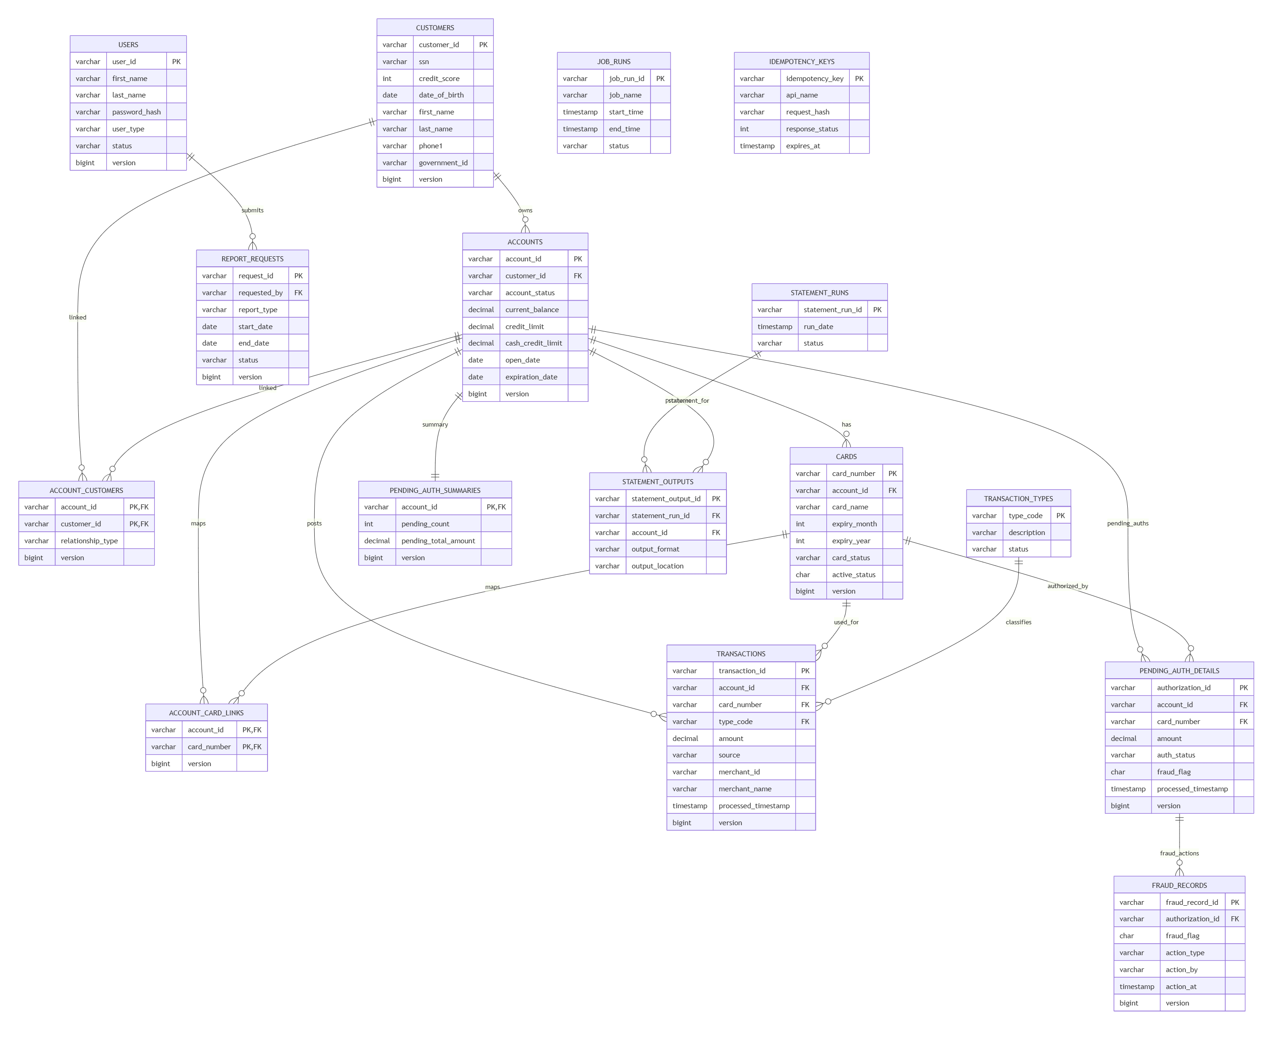

6.2 Relationship Explanation

6.2.1 Users
users is independent and supports:
- login
- admin CRUD
- report request submission attribution
- fraud and update audit attribution

6.2.2 Customer and Account
Two models are supported:
- direct relationship via accounts.customer_id
- bridge via account_customers
Recommended implementation choice:
Use accounts.customer_id for simplicity unless stakeholder confirmation requires multiple customers per account.

6.2.3 Account and Card
An account may have multiple cards.This is represented by:
- cards.account_id
- optionally account_card_links for explicit linkage domain support

6.2.4 Transactions
Each transaction:
- belongs to an account
- may reference a card
- must reference a transaction type
This supports:
- manual add transaction
- bill payment transaction
- interest transaction
- background-posted transactions

6.2.5 Pending Authorization
Pending authorization data is split into:
- pending_auth_summaries: per-account summary
- pending_auth_details: individual authorization rows
This supports:
- fast account-level review
- detailed inquiry
- cleanup/migration processes

6.2.6 Fraud
Fraud actions are stored in fraud_records.
Current list/detail status is surfaced quickly using pending_auth_details.fraud_flag.

6.2.7 Reporting and Statements
- report_requests tracks user-submitted report jobs
- statement_runs and statement_outputs track generated statements
- job_runs tracks operational batch execution

6.2.8 Idempotency
idempotency_keys is a technical support table enabling safe retries for write APIs.

6.3 Database Traceability Matrix
DB Table | BRD Source | Architecture Source
users | 6.1, 6.4 | 16.3.1
customers | 6.5 | 16.3.2
accounts | 6.5 | 16.3.3
account_customers | implied/open | 16.3.4
cards | 6.6 | 16.3.5
account_card_links | 9, 6.7.3 linkage logic | 16.3.6
transaction_types | 6.8 | 16.3.7
transactions | 6.5.3, 6.7, 6.14.2, 6.14.3 | 16.3.8
pending_auth_summaries | 6.9 | 16.3.9
pending_auth_details | 6.9, 6.11, 6.17 | 16.3.10
fraud_records | 6.9.3 | 16.3.11
report_requests | 6.10 | 16.3.12
statement_runs | 6.16.1 implied | 16.3.13
statement_outputs | 6.16.1 | 16.3.14
job_runs | 6.14–6.18 implied ops | 16.3.15
idempotency_keys | API implementation support | LLD Part 2

Low-Level Design — Part 4
Sections 7–10: Sequence Diagrams, Class Design, Detailed Business Logic, State Transition Diagrams

7. Sequence Diagrams
This section provides implementation-oriented sequence diagrams for the key online and background flows. Diagrams follow the architecture and API behaviors already defined.

7.1 Happy Path — User Login
Not supported language -25 lines
mermaid
sequenceDiagram
autonumber
participant U as User
participant UI as Sign-on UI
participant GW as API Gateway
participant AUTH as Authentication Service
participant UR as UserRepository
participant TOK as TokenProvider
participant AUD as Audit Logger
U->>UI: Enter userId + password
UI->>UI: Client-side required field validation
UI->>GW: POST /api/v1/auth/login
GW->>AUTH: Forward request with requestId
AUTH->>AUTH: Validate payload
AUTH->>UR: findByUserId(userId)
UR-->>AUTH: User record
AUTH->>AUTH: Verify password hash
AUTH->>TOK: Issue token/session
TOK-->>AUTH: token + expiry
AUTH->>AUD: Log LOGIN_SUCCESS
AUTH-->>GW: 200 success + role + landing page
GW-->>UI: Response
UI->>UI: Store auth context
UI->>U: Route to Main Menu / Admin Menu
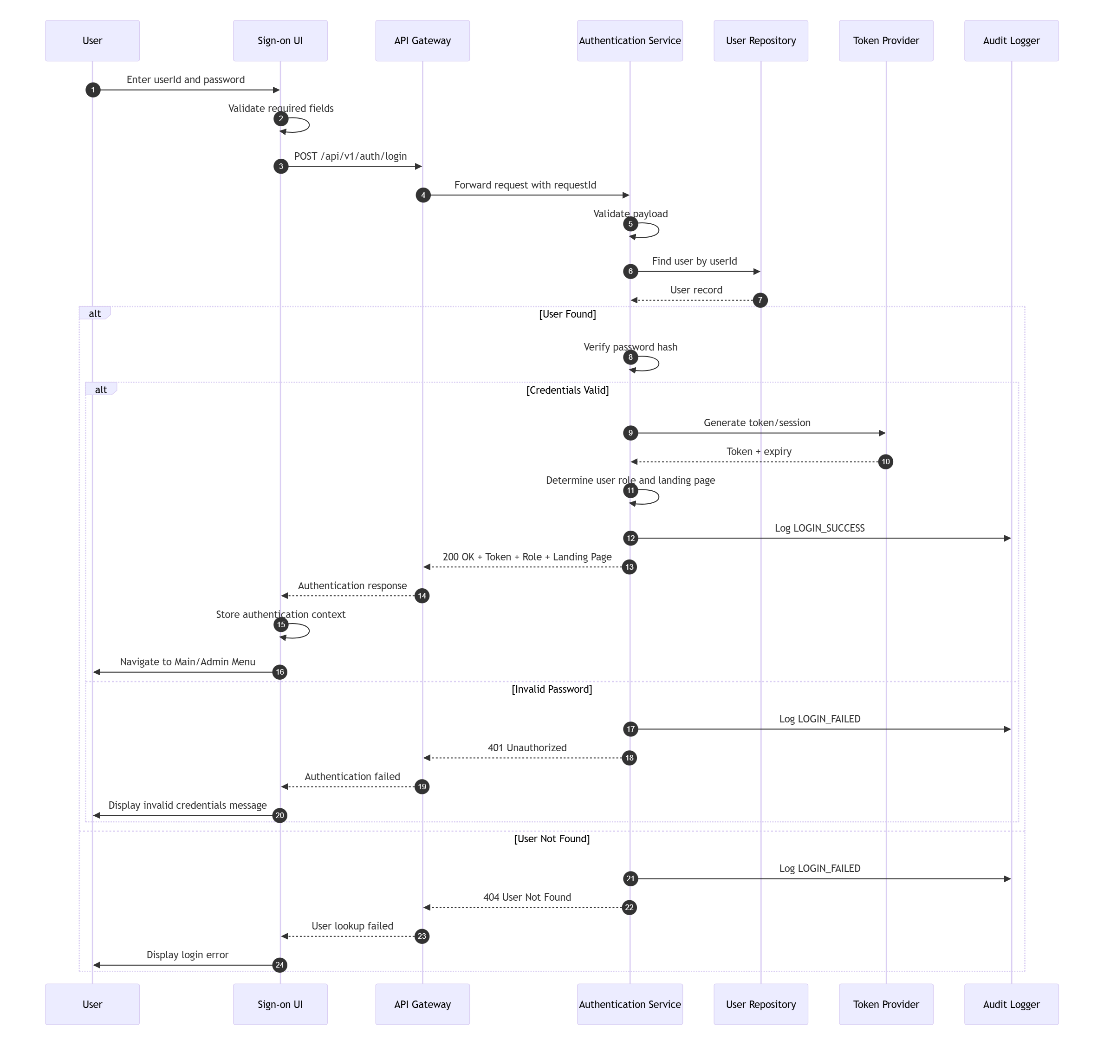
TraceabilityBRD 6.1Architecture 13.1

7.2 Validation Failure — Login Missing Password
Not supported language -17 lines
mermaid
sequenceDiagram
autonumber
participant U as User
participant UI as Sign-on UI
participant GW as API Gateway
participant AUTH as Authentication Service
U->>UI: Submit userId without password
UI->>UI: Client validation fails
UI->>U: Show "Password required"
Note over UI,GW: If client validation is bypassed
UI->>GW: POST /api/v1/auth/login
GW->>AUTH: Forward request
AUTH->>AUTH: Validate payload
AUTH-->>GW: 400 VALIDATION_ERROR
GW-->>UI: Error response
UI->>U: Display field error
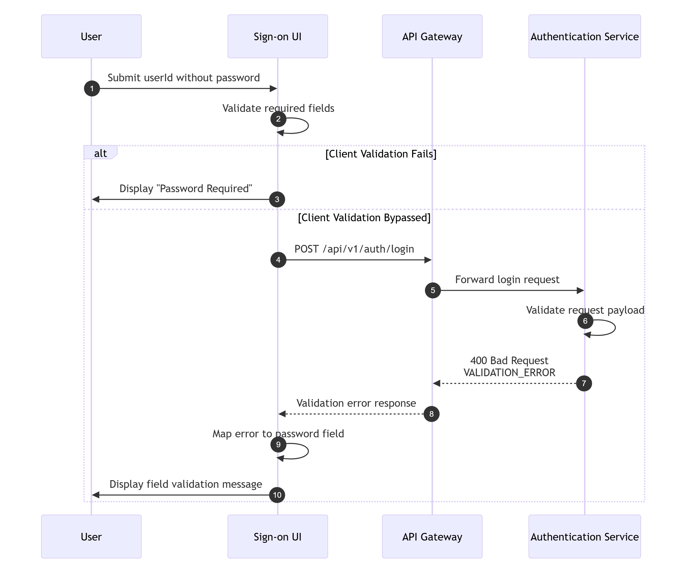
TraceabilityBRD 6.1.6Part 2 login API

7.3 Business Rule Failure — Wrong Password
Not supported language -17 lines
mermaid
sequenceDiagram
autonumber
participant UI as Sign-on UI
participant GW as API Gateway
participant AUTH as Authentication Service
participant UR as UserRepository
participant AUD as Audit Logger
UI->>GW: POST /api/v1/auth/login
GW->>AUTH: Forward request
AUTH->>UR: findByUserId(userId)
UR-->>AUTH: User found
AUTH->>AUTH: Verify password
AUTH->>AUD: Log LOGIN_FAILURE (WRONG_PASSWORD)
AUTH-->>GW: 401 AUTHENTICATION_ERROR
GW-->>UI: Error response
UI->>UI: Map error
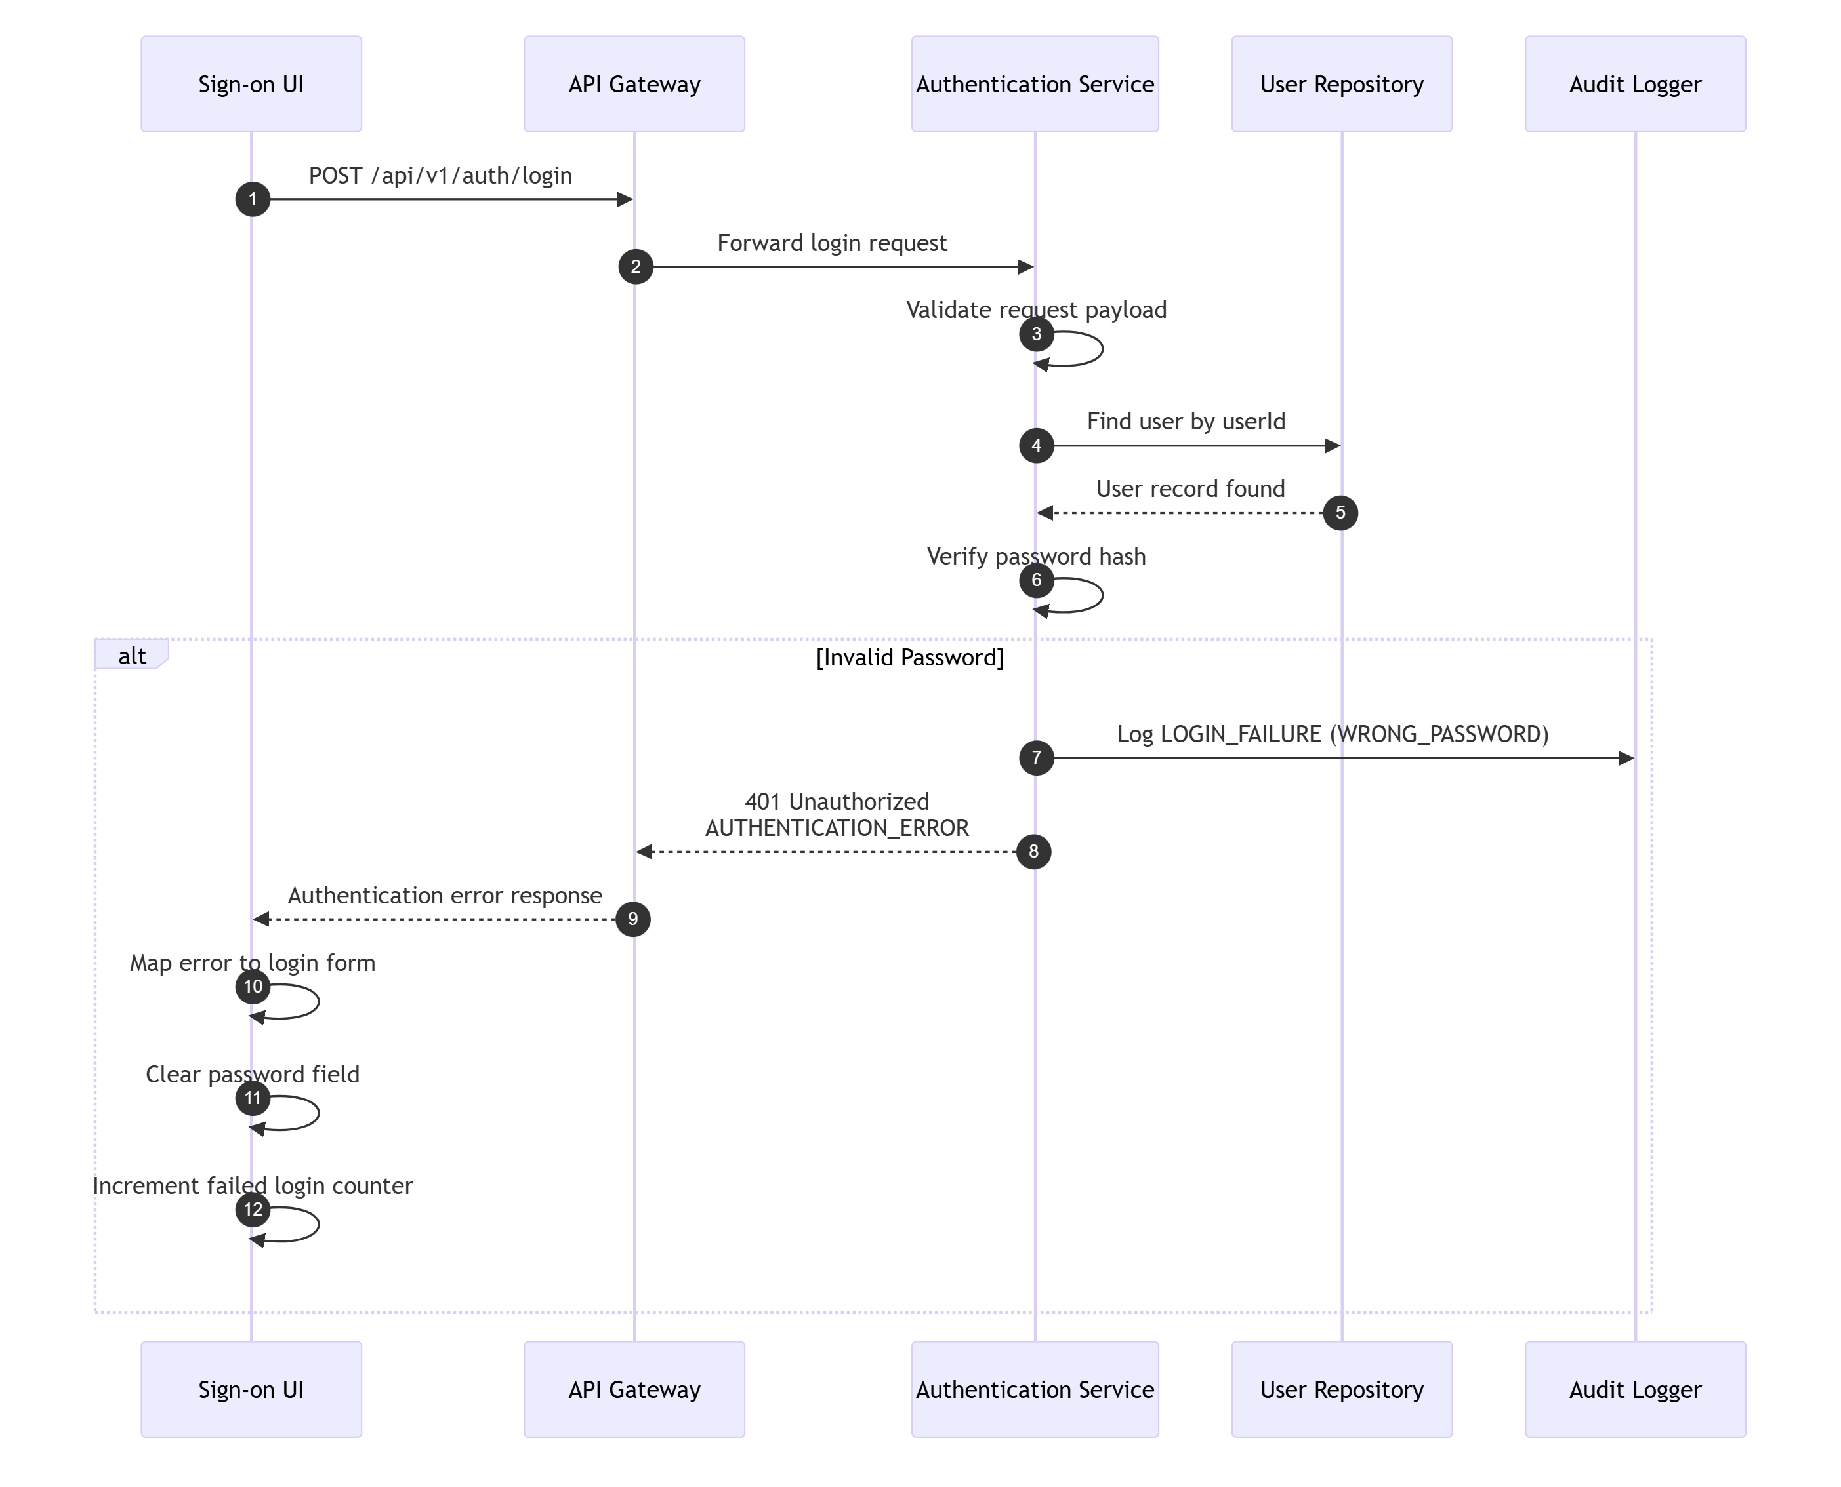

7.4 Happy Path — Get Account Inquiry
Not supported language -22 lines
mermaid
sequenceDiagram
autonumber
participant U as User
participant UI as Account Inquiry UI
participant GW as API Gateway
participant ACCT as Account Service
participant AR as AccountRepository
participant CR as CustomerRepository
U->>UI: Enter accountId
UI->>UI: Validate 11-digit format
UI->>GW: GET /api/v1/accounts/{accountId}
GW->>ACCT: Forward authenticated request
ACCT->>ACCT: Validate accountId
ACCT->>AR: findById(accountId)
AR-->>ACCT: Account row
ACCT->>CR: findByAccountId(accountId)
CR-->>ACCT: Customer row
ACCT->>ACCT: Mask sensitive fields
ACCT-->>GW: Composite response
GW-->>UI: 200 success
UI->>U: Render account + customer details
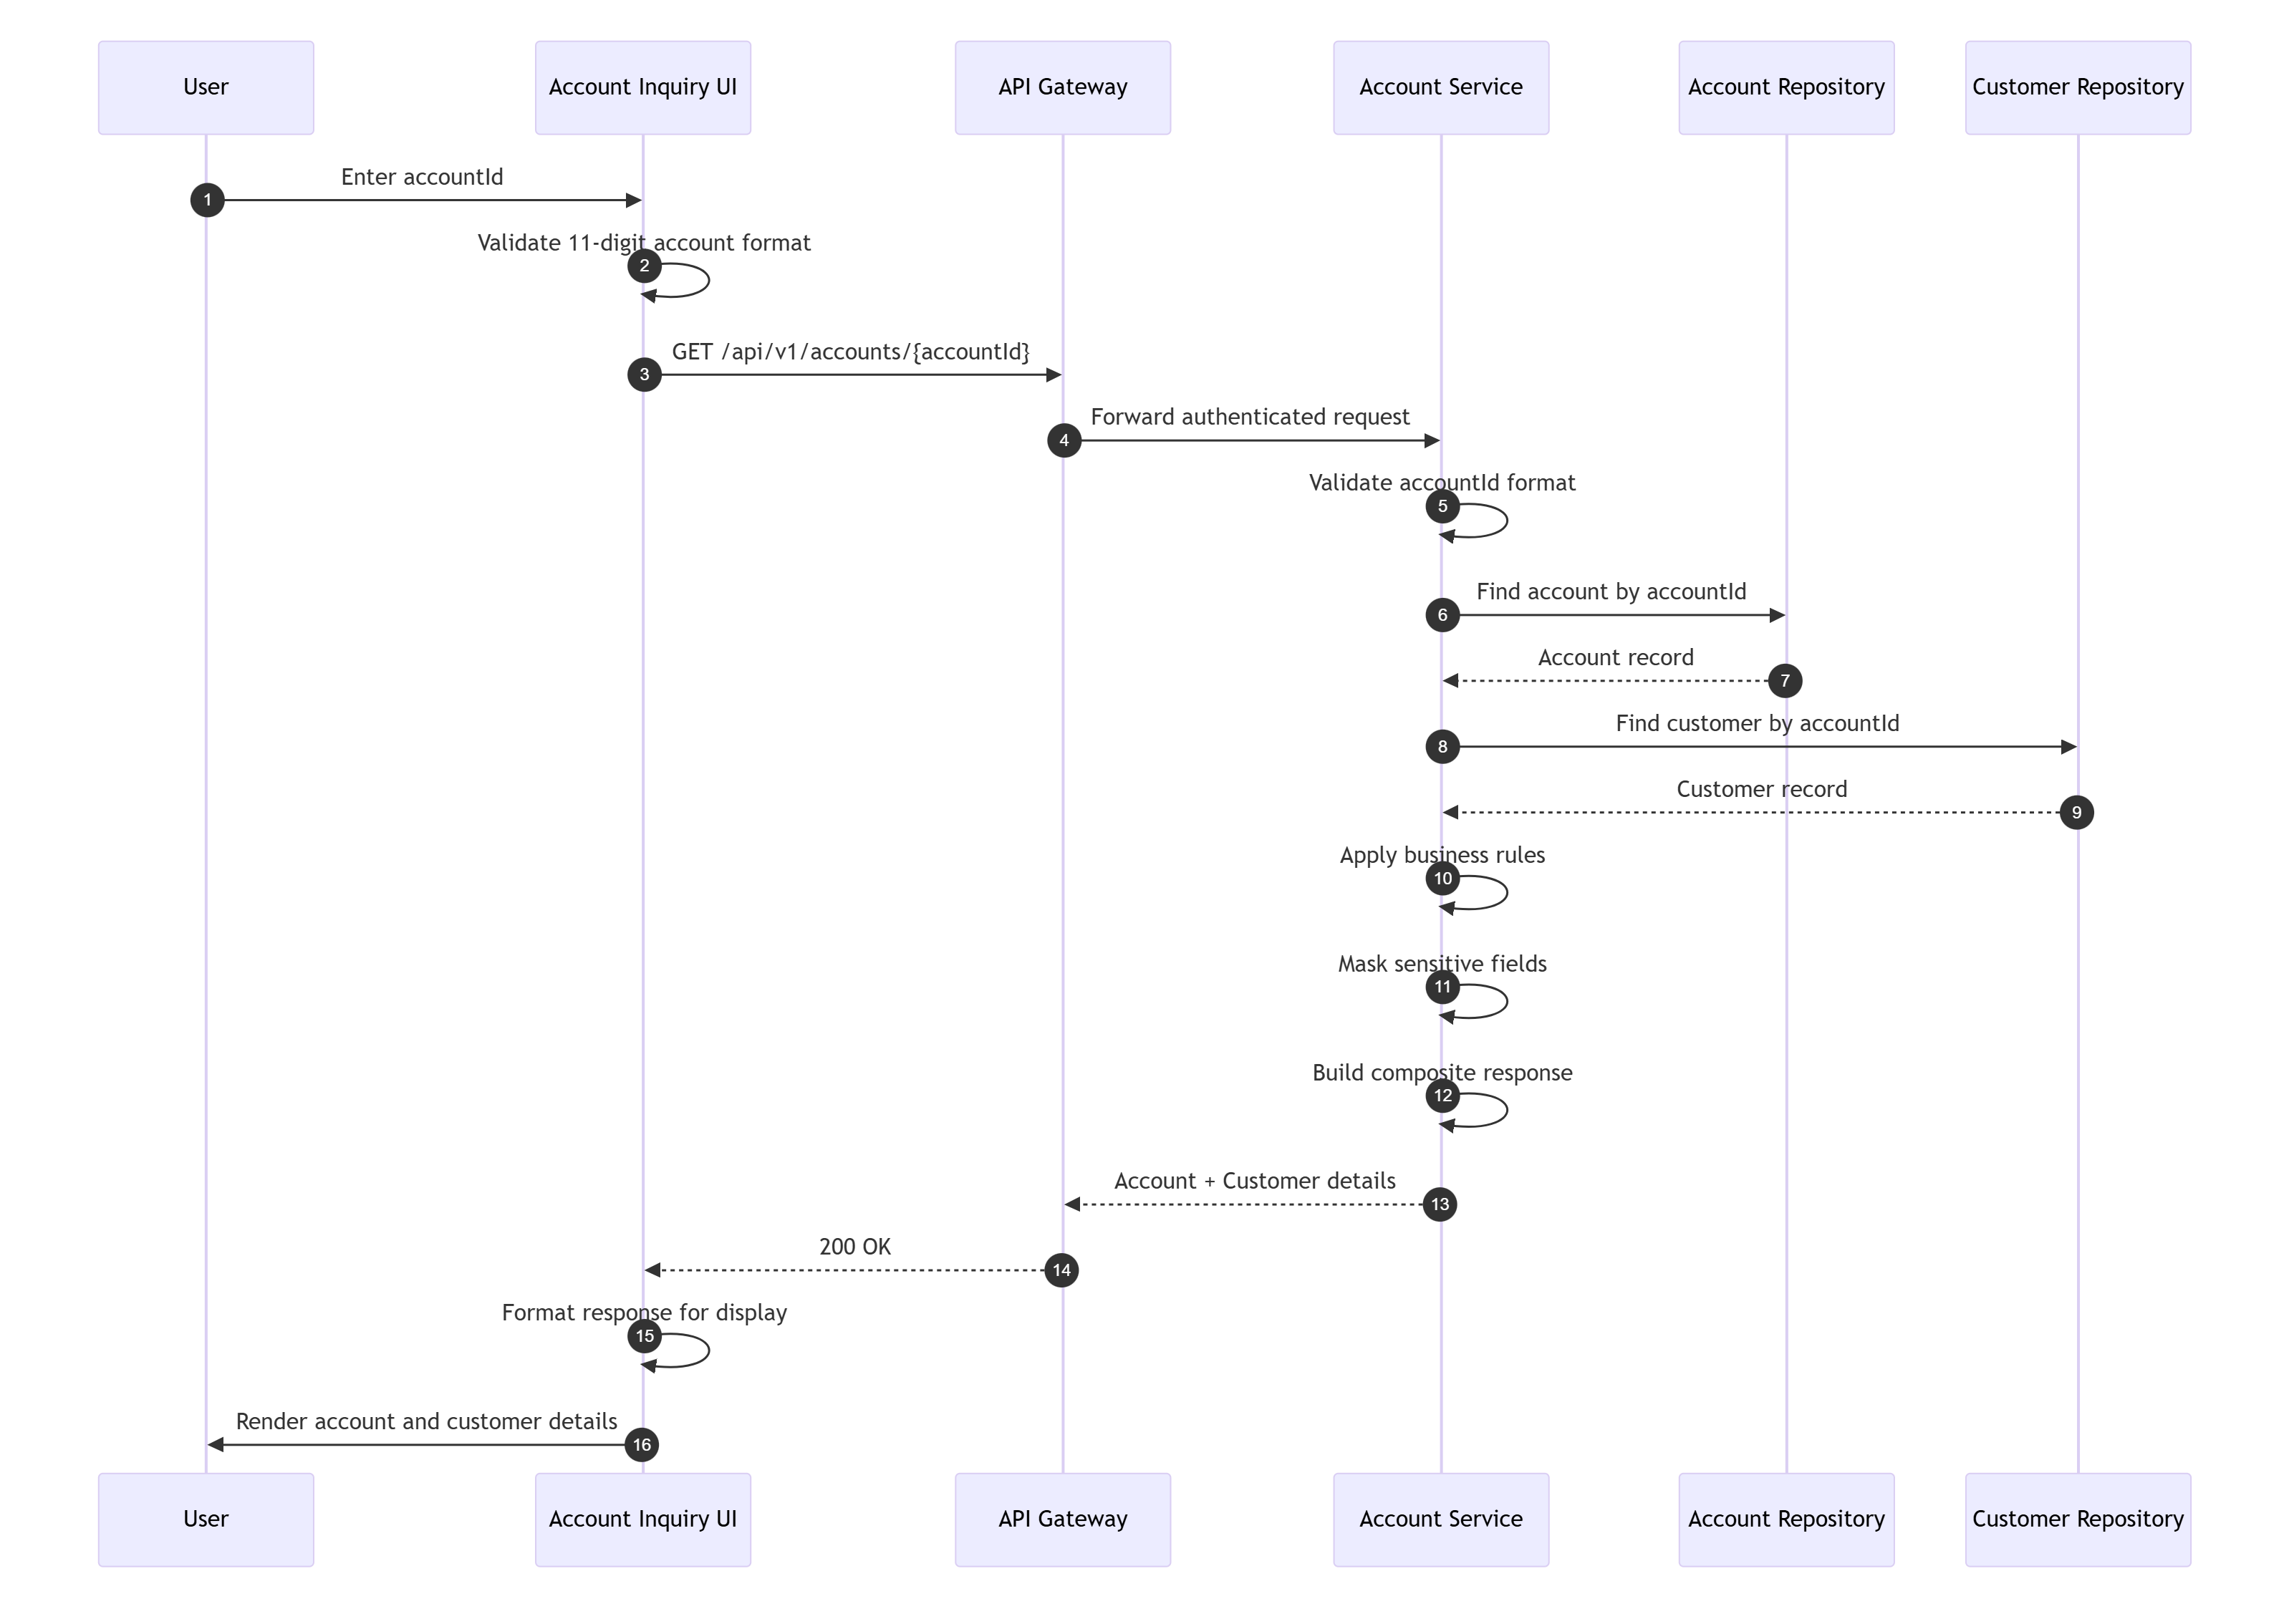
TraceabilityBRD 6.5.1Architecture 13.2

7.5 Happy Path — Account Update
Not supported language -31 lines
mermaid
sequenceDiagram
autonumber
participant U as User
participant UI as Account Update UI
participant GW as API Gateway
participant ACCT as Account Service
participant VAL as Validation Utility
participant AR as AccountRepository
participant CR as CustomerRepository
participant AUD as Audit Logger
U->>UI: Modify account/customer fields and click Save
UI->>UI: Perform client validations
UI->>GW: PUT /api/v1/accounts/{accountId}
GW->>ACCT: Forward request
ACCT->>VAL: Validate payload fields
VAL-->>ACCT: Validation OK
ACCT->>AR: findById(accountId)
AR-->>ACCT: Existing account
ACCT->>CR: findByAccountId(accountId)
CR-->>ACCT: Existing customer
ACCT->>ACCT: Check row versions
ACCT->>ACCT: Detect no-change
ACCT->>AR: update account where version matches
AR-->>ACCT: 1 row updated
ACCT->>CR: update customer where version matches
CR-->>ACCT: 1 row updated
ACCT->>AUD: Log ACCOUNT_UPDATE
ACCT-->>GW: 200 success + new versions
GW-->>UI: Success response
UI->>U: Show "Changes committed"
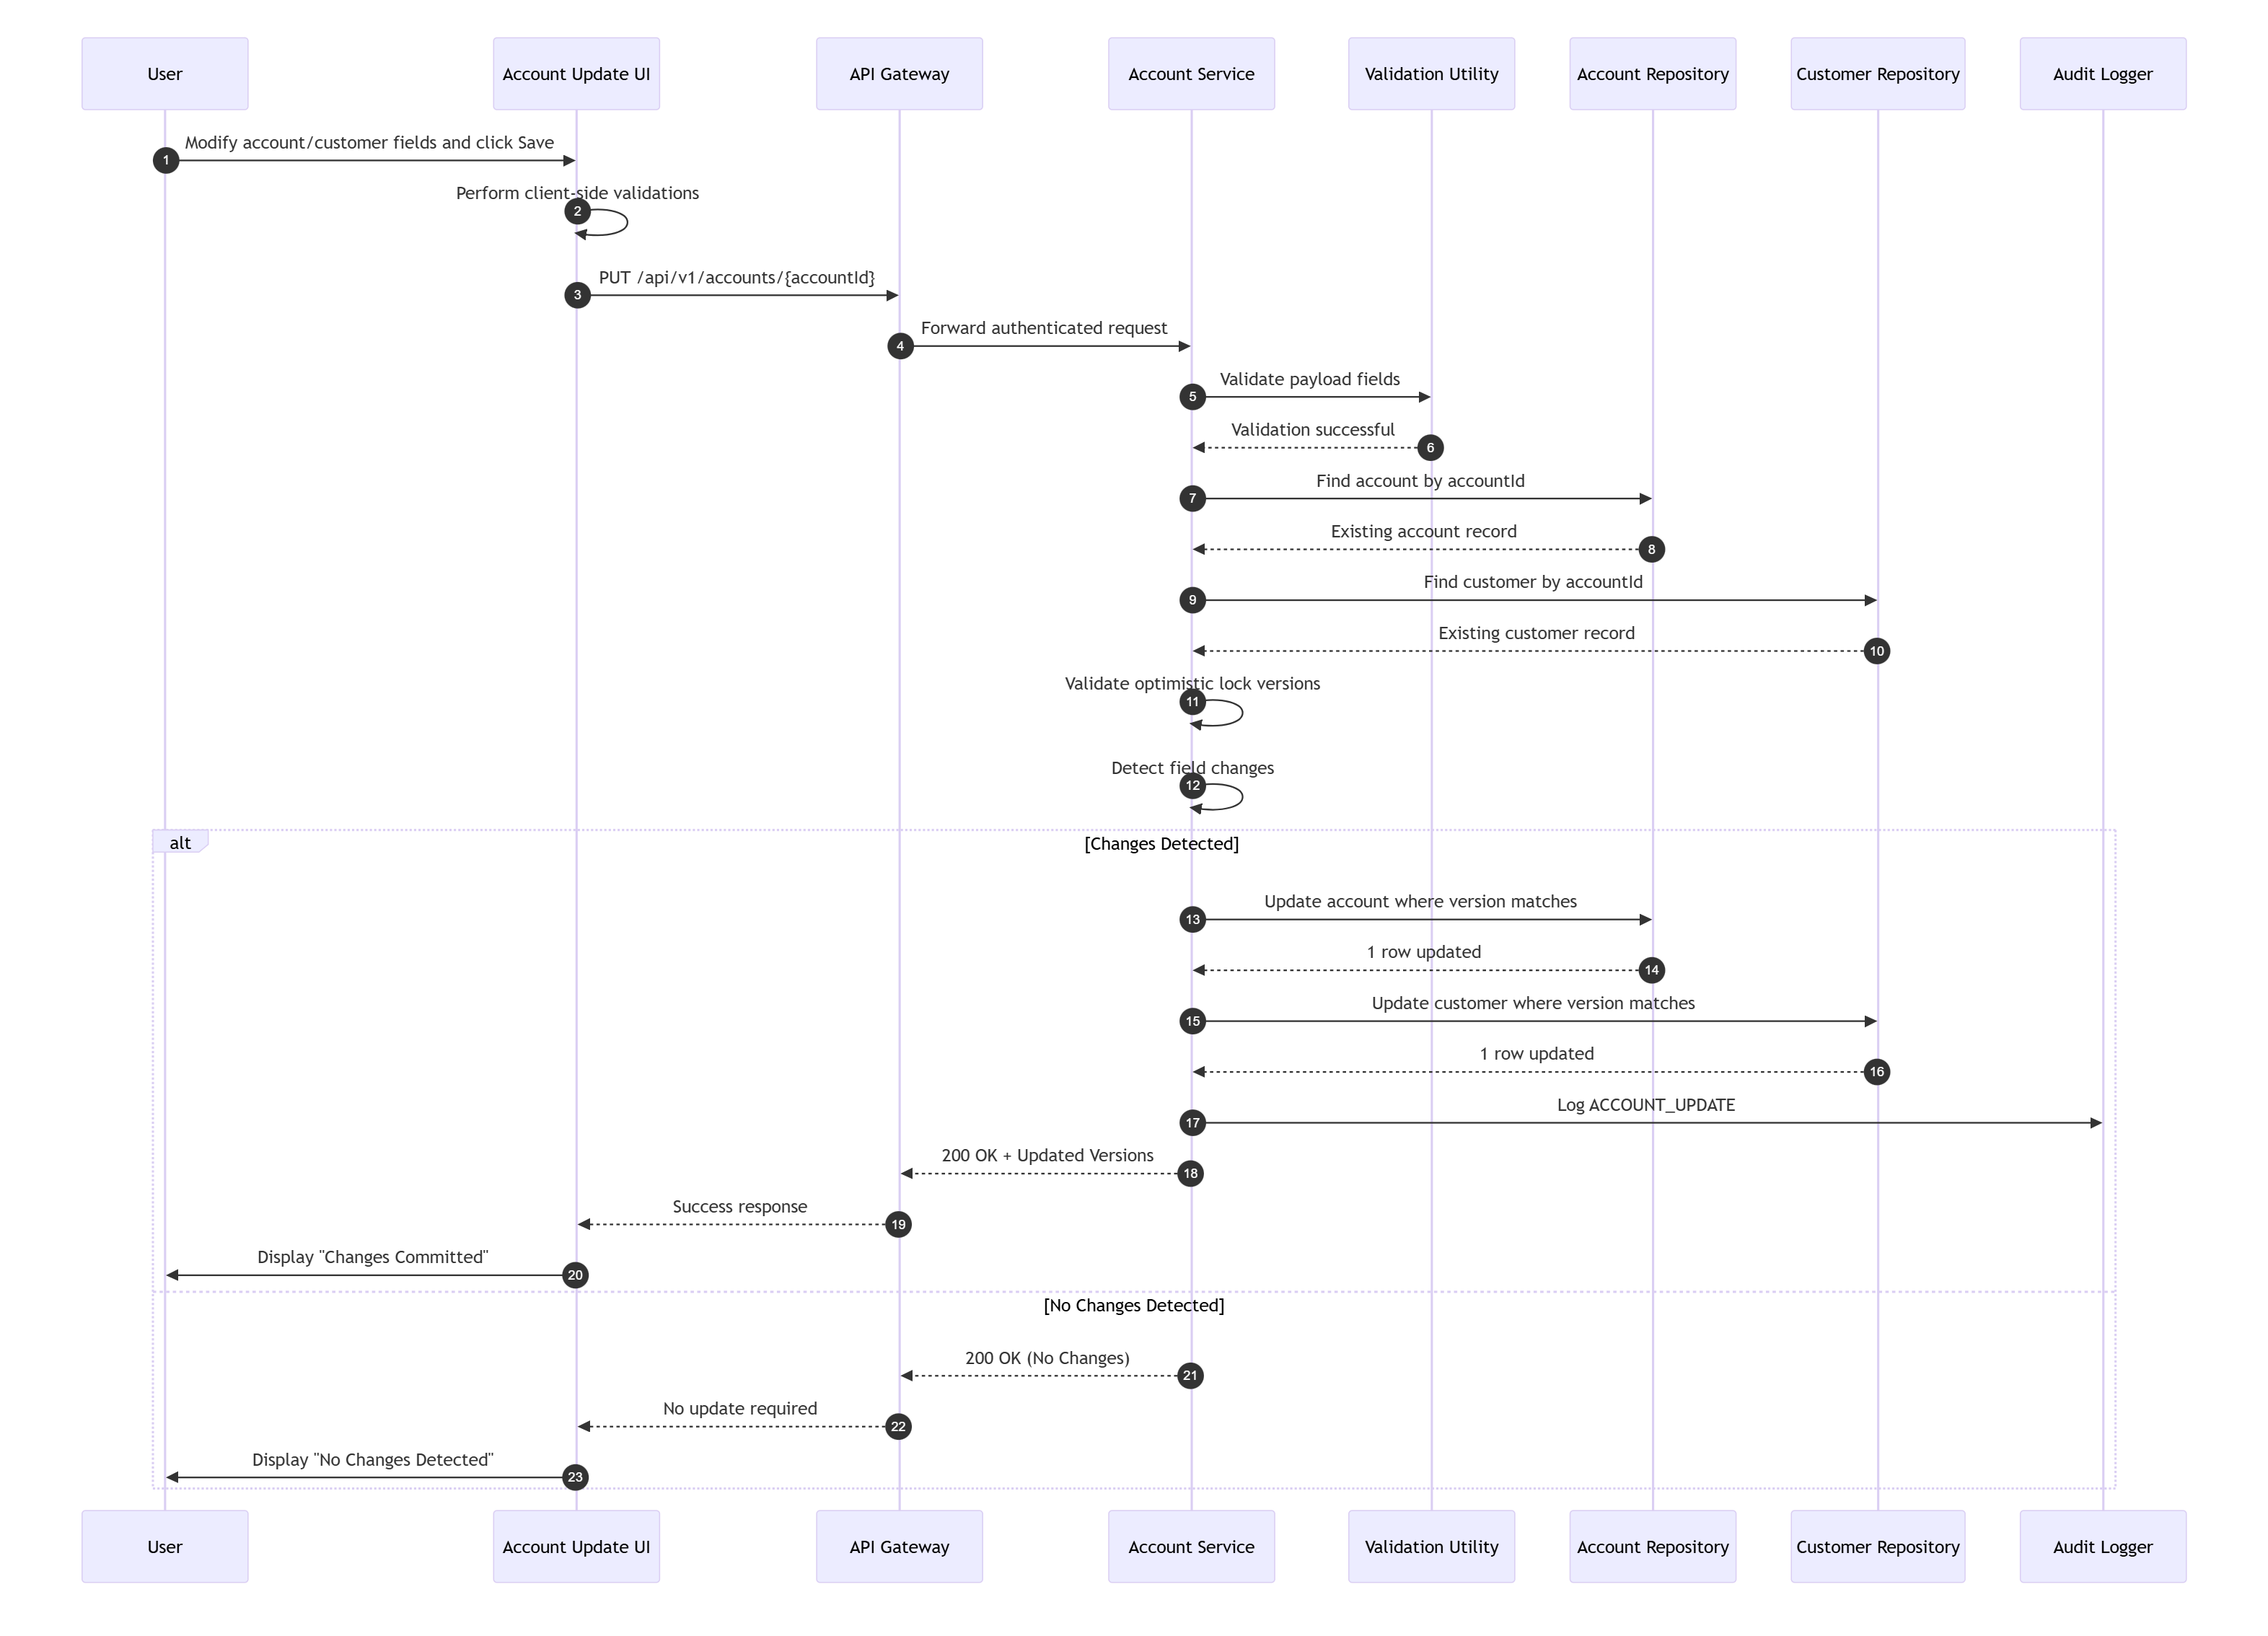
TraceabilityBRD 6.5.2Architecture 13.3

7.6 Validation Failure — Account Update Invalid Field
Not supported language -14 lines
mermaid
sequenceDiagram
autonumber
participant UI as Account Update UI
participant GW as API Gateway
participant ACCT as Account Service
participant VAL as Validation Utility
UI->>GW: PUT /api/v1/accounts/{accountId}
GW->>ACCT: Forward request
ACCT->>VAL: Validate fields
VAL-->>ACCT: creditScore invalid / date invalid / field format invalid
ACCT-->>GW: 400 VALIDATION_ERROR
GW-->>UI: Validation error response
UI->>UI: Bind field errors
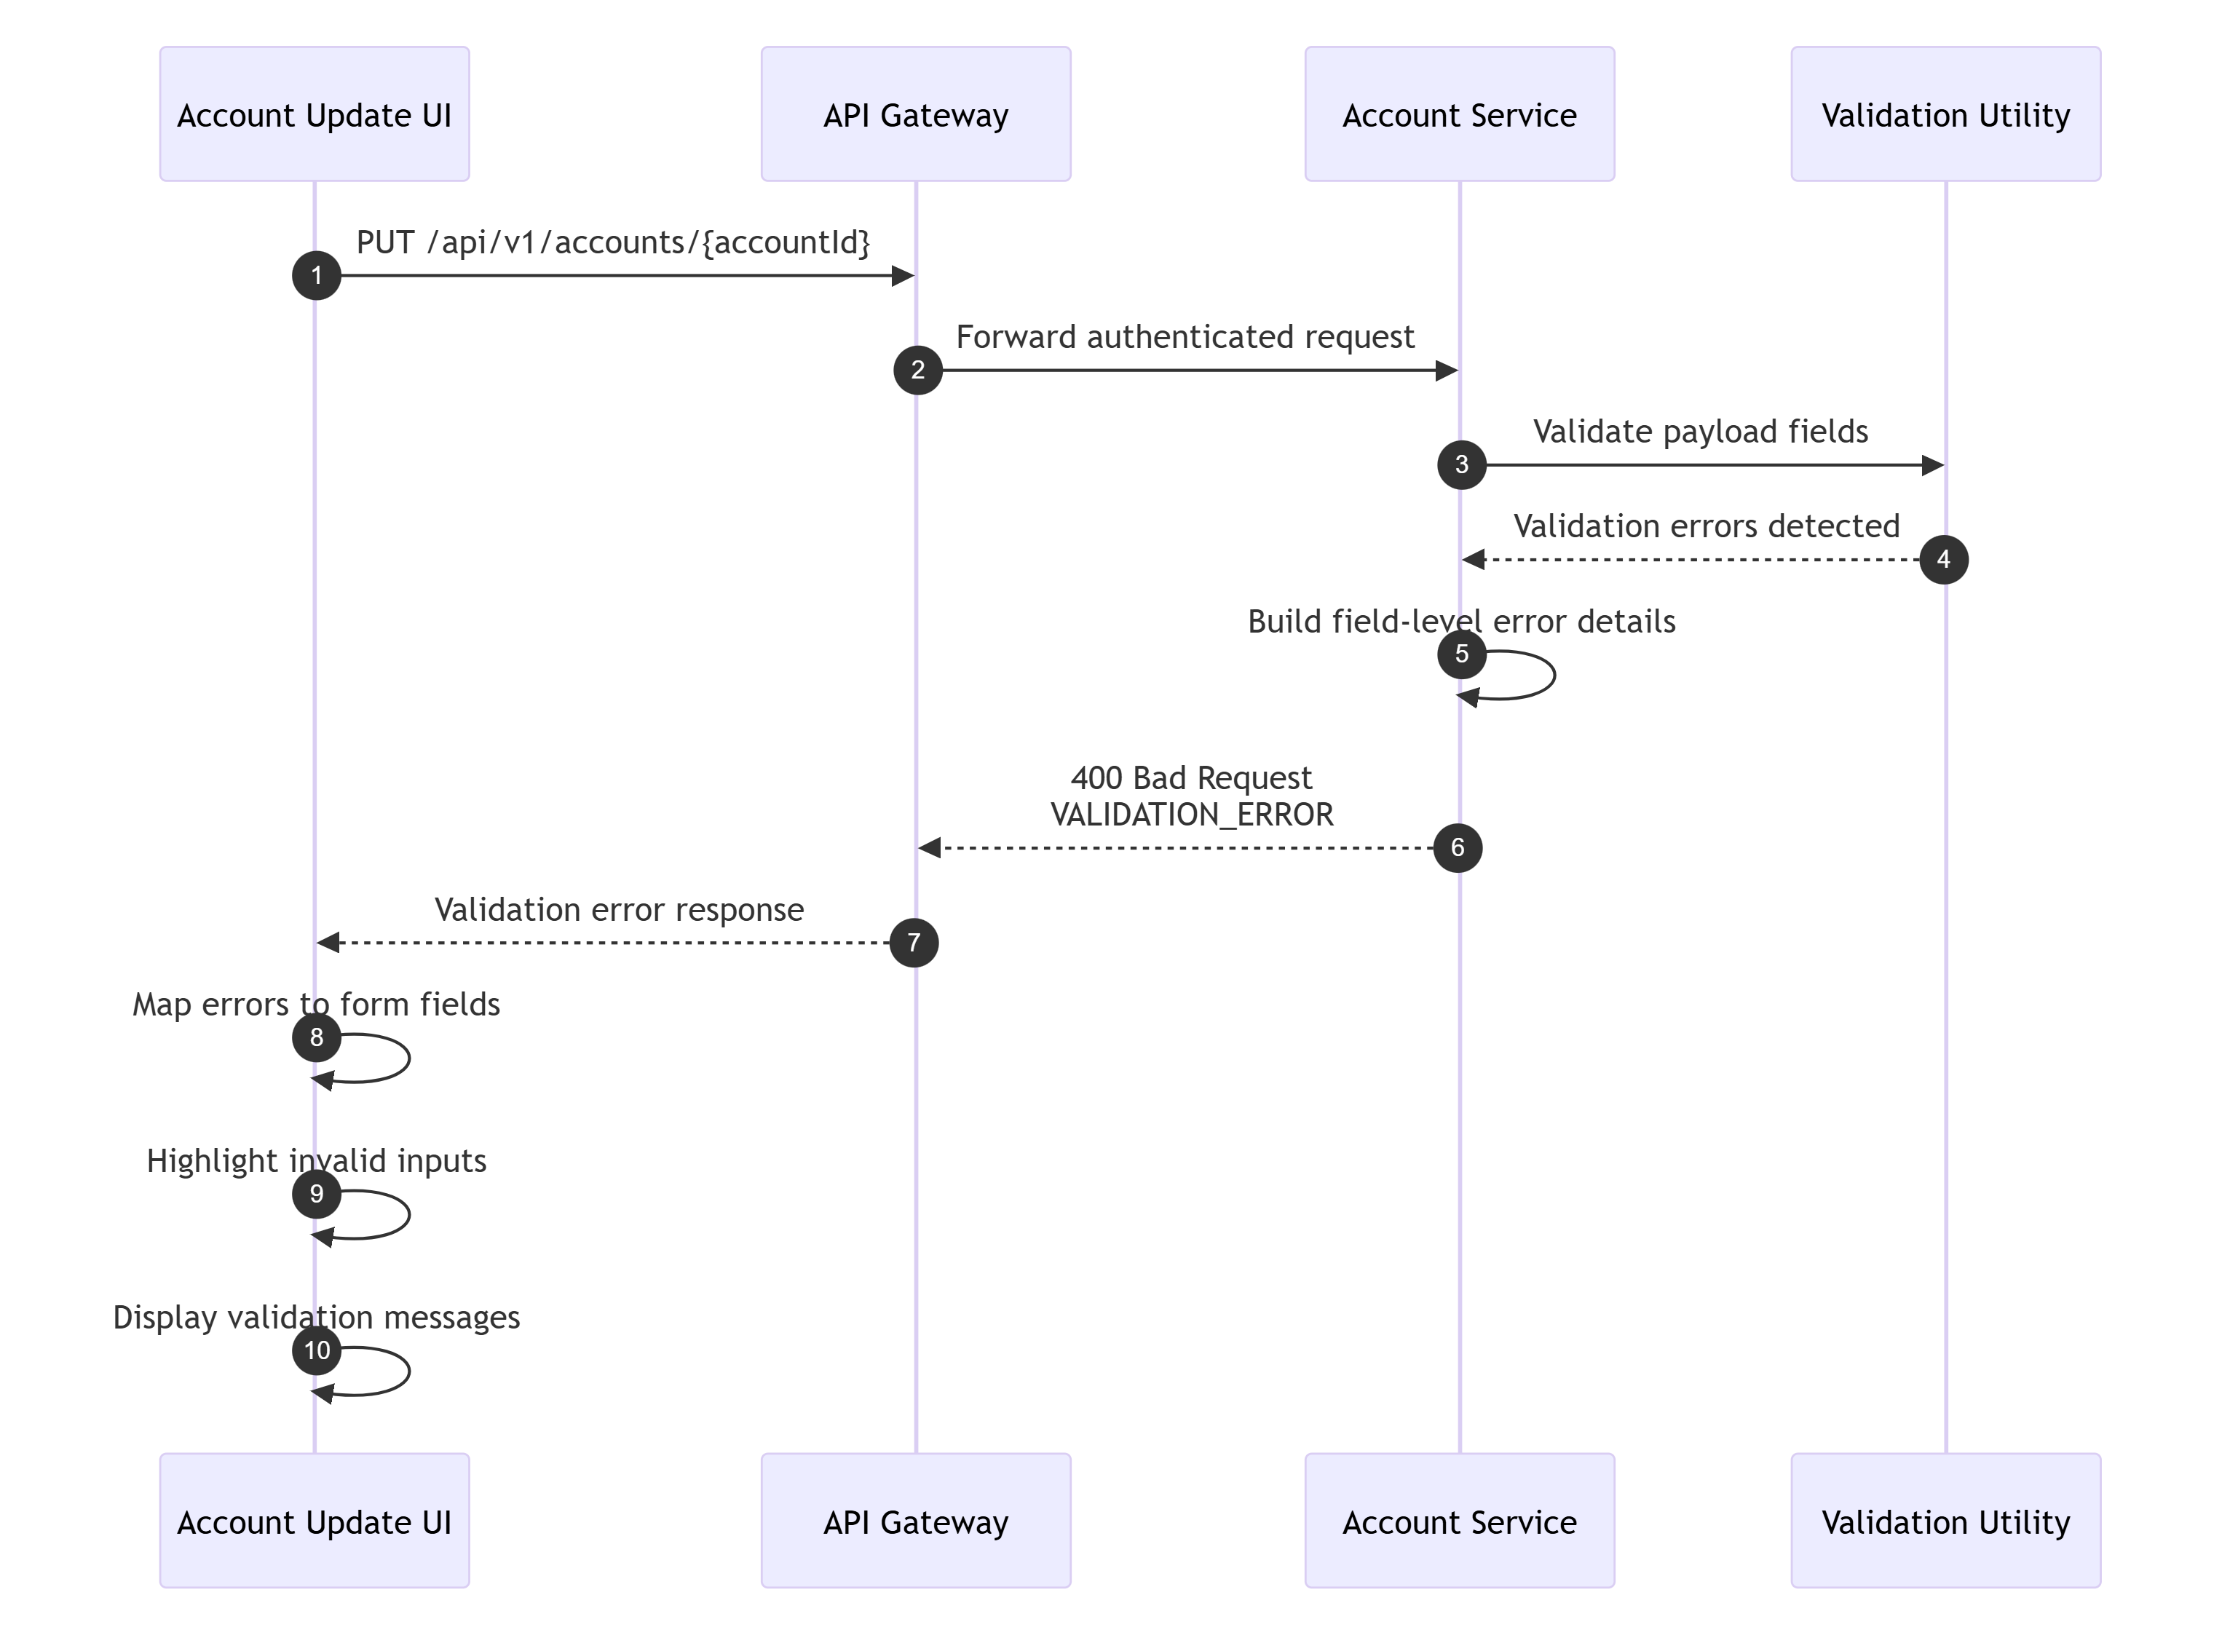

7.7 Business Rule Failure — Account Update No Change
Not supported language -18 lines
mermaid
sequenceDiagram
autonumber
participant UI as Account Update UI
participant GW as API Gateway
participant ACCT as Account Service
participant AR as AccountRepository
participant CR as CustomerRepository
UI->>GW: PUT /api/v1/accounts/{accountId}
GW->>ACCT: Forward request
ACCT->>AR: findById(accountId)
AR-->>ACCT: Existing account
ACCT->>CR: findByAccountId(accountId)
CR-->>ACCT: Existing customer
ACCT->>ACCT: Normalize and compare values
ACCT-->>GW: 400 BUSINESS_RULE_ERROR (No change detected)
GW-->>UI: Error response
UI->>UI: Show informational message
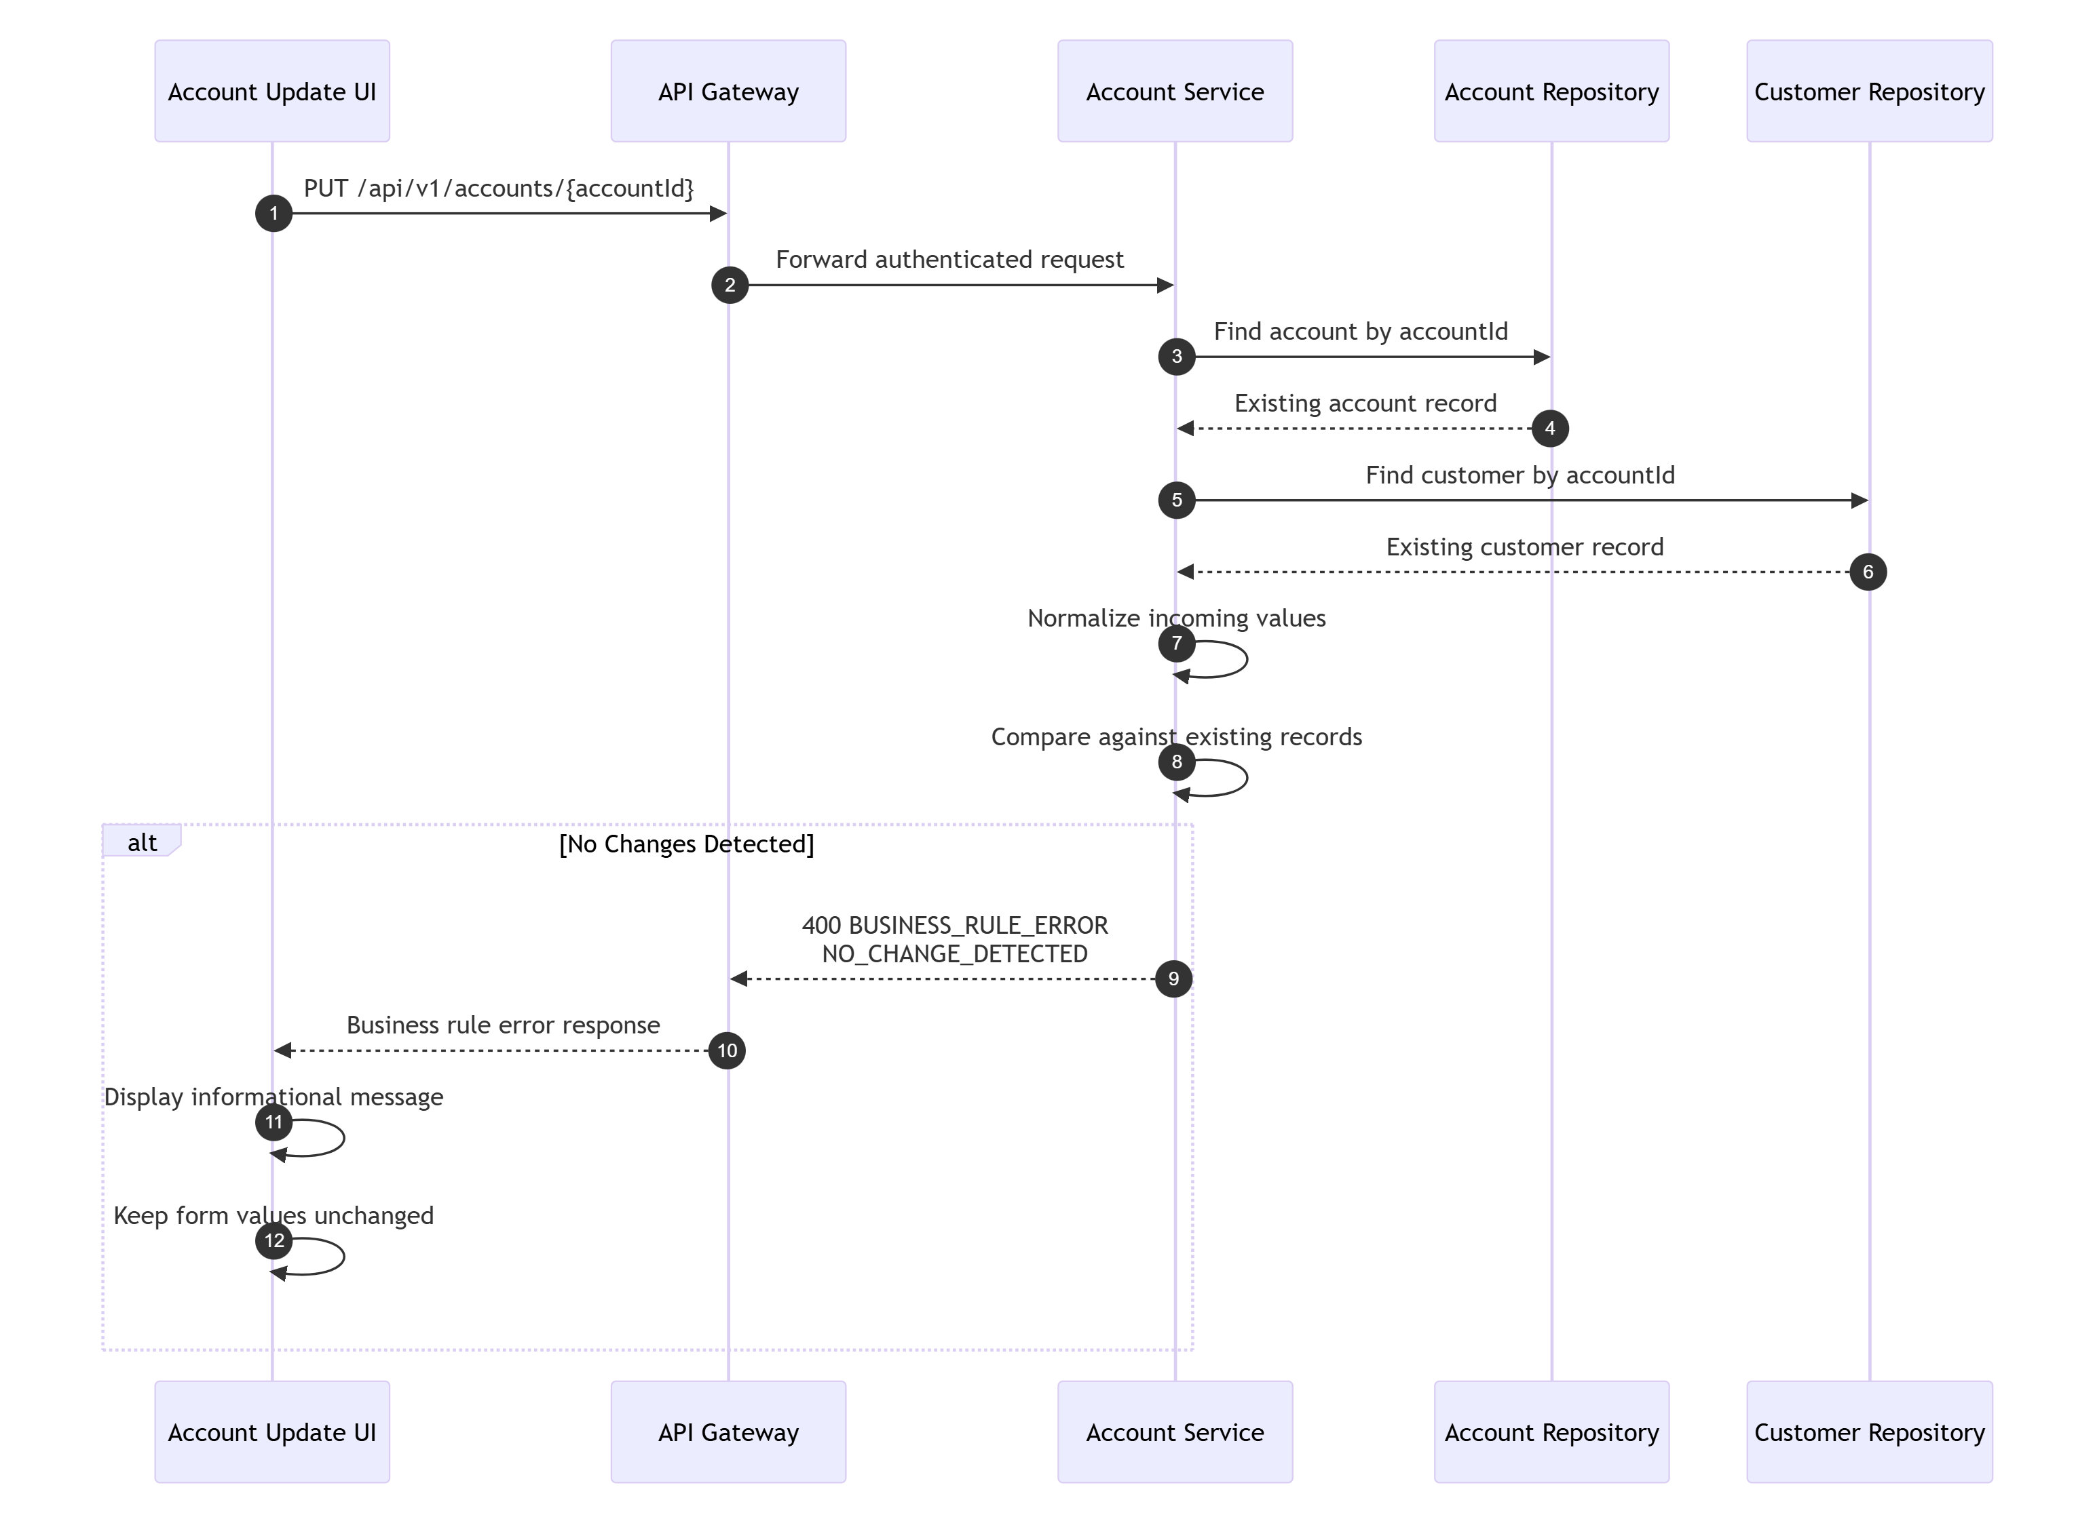

7.8 External/Conflict Failure — Account Update Version Conflict
Not supported language -18 lines
mermaid
sequenceDiagram
autonumber
participant UI as Account Update UI
participant GW as API Gateway
participant ACCT as Account Service
participant AR as AccountRepository
participant CR as CustomerRepository
UI->>GW: PUT /api/v1/accounts/{accountId}
GW->>ACCT: Forward request
ACCT->>AR: findById(accountId)
AR-->>ACCT: Existing account version=9
ACCT->>CR: findByAccountId(accountId)
CR-->>ACCT: Existing customer version=4
ACCT->>ACCT: Compare request versions (8,3)
ACCT-->>GW: 409 CONFLICT
GW-->>UI: Conflict response
UI->>UI: Prompt reload of latest data
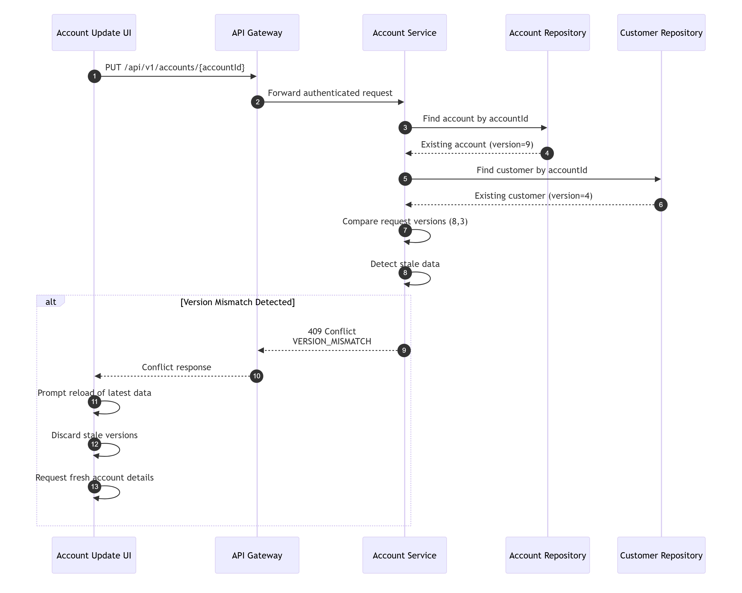

7.9 Happy Path — Bill Payment
Not supported language -28 lines
mermaid
sequenceDiagram
autonumber
participant U as User
participant UI as Bill Payment UI
participant GW as API Gateway
participant PAY as Payment Service
participant IDEM as Idempotency Store
participant AR as AccountRepository
participant TR as TransactionRepository
participant AUD as Audit Logger
U->>UI: Confirm bill payment
UI->>GW: POST /api/v1/payments/bill-payments
GW->>PAY: Forward request + idempotency key
PAY->>IDEM: Lookup idempotency key
IDEM-->>PAY: Not found
PAY->>AR: findById(accountId)
AR-->>PAY: Account currentBalance=450.75
PAY->>PAY: Validate payable balance > 0
PAY->>TR: insert payment transaction
TR-->>PAY: transactionId=TXN900001
PAY->>AR: update balance to 0.00
AR-->>PAY: update success
PAY->>IDEM: Save success response
PAY->>AUD: Log BILL_PAYMENT
PAY-->>GW: 201 Created
GW-->>UI: Success response
UI->>U: Show payment success
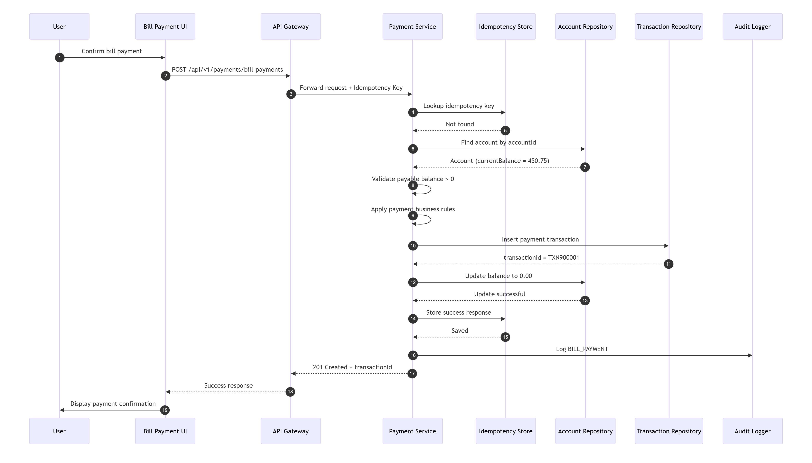
TraceabilityBRD 6.5.3Architecture 13.4

7.10 Retry Scenario — Bill Payment Idempotent Retry
Not supported language -13 lines
mermaid
sequenceDiagram
autonumber
participant Client
participant GW as API Gateway
participant PAY as Payment Service
participant IDEM as Idempotency Store
Client->>GW: POST payment with X-Idempotency-Key=K1
GW->>PAY: Request
PAY->>IDEM: lookup(K1)
IDEM-->>PAY: Existing success response
PAY-->>GW: Return stored response
GW-->>Client: Same 201 response, no duplicate payment
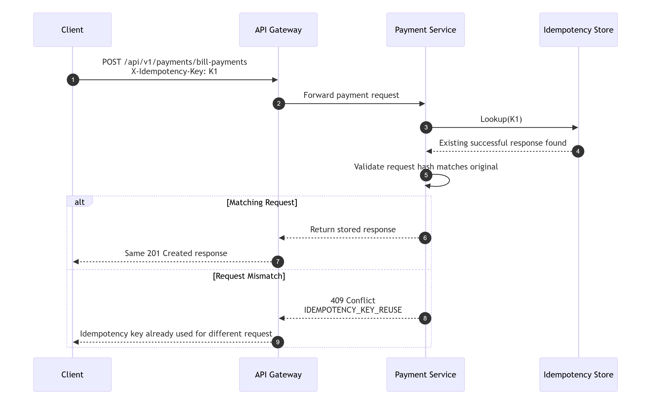

7.11 Business Rule Failure — Bill Payment Nothing to Pay
Not supported language -13 lines
mermaid
sequenceDiagram
autonumber
participant UI as Bill Payment UI
participant GW as API Gateway
participant PAY as Payment Service
participant AR as AccountRepository
UI->>GW: POST /payments/bill-payments
GW->>PAY: Forward request
PAY->>AR: findById(accountId)
AR-->>PAY: currentBalance = 0.00
PAY-->>GW: 400 BUSINESS_RULE_ERROR
GW-->>UI: "You have nothing to pay"
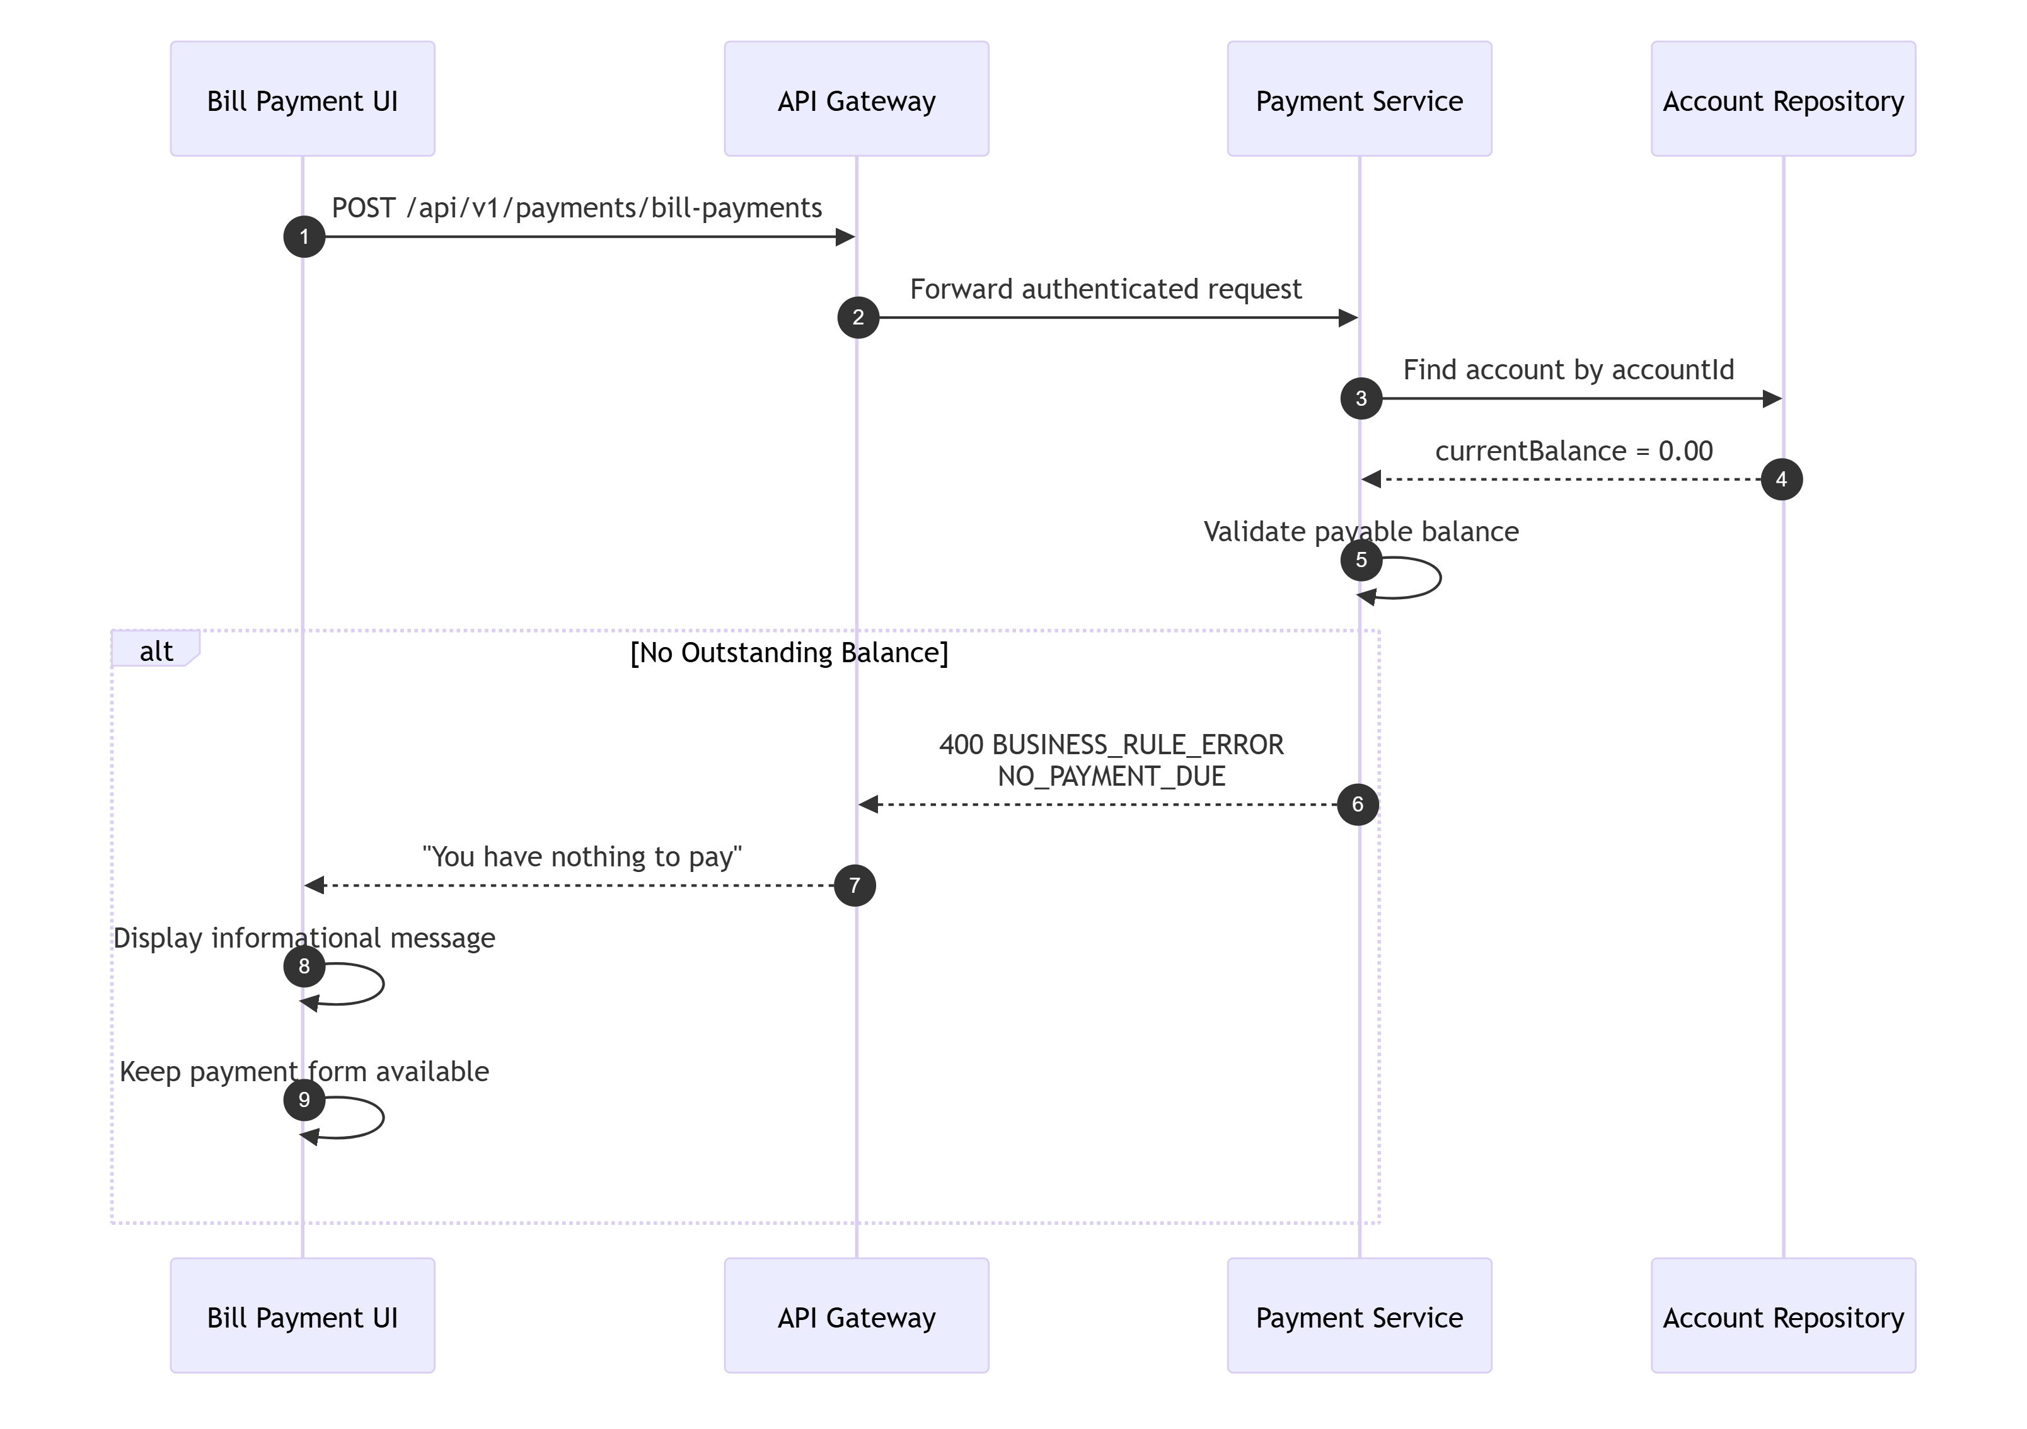

7.12 Happy Path — Card Update
Not supported language -25 lines
mermaid
sequenceDiagram
autonumber
participant U as User
participant UI as Card Update UI
participant GW as API Gateway
participant CARD as Card Service
participant VAL as Validation Utility
participant CR as CardRepository
participant AUD as Audit Logger
U->>UI: Update card fields and Save
UI->>UI: Client validation
UI->>GW: PUT /api/v1/cards/{cardNumber}
GW->>CARD: Forward request
CARD->>VAL: Validate card data
VAL-->>CARD: OK
CARD->>CR: findByCardNumber(cardNumber)
CR-->>CARD: Existing card row
CARD->>CARD: Check account match, version, no-change
CARD->>CR: update card where version matches
CR-->>CARD: 1 row updated
CARD->>AUD: Log CARD_UPDATE
CARD-->>GW: 200 Success
GW-->>UI: Update response
UI->>U: Show success
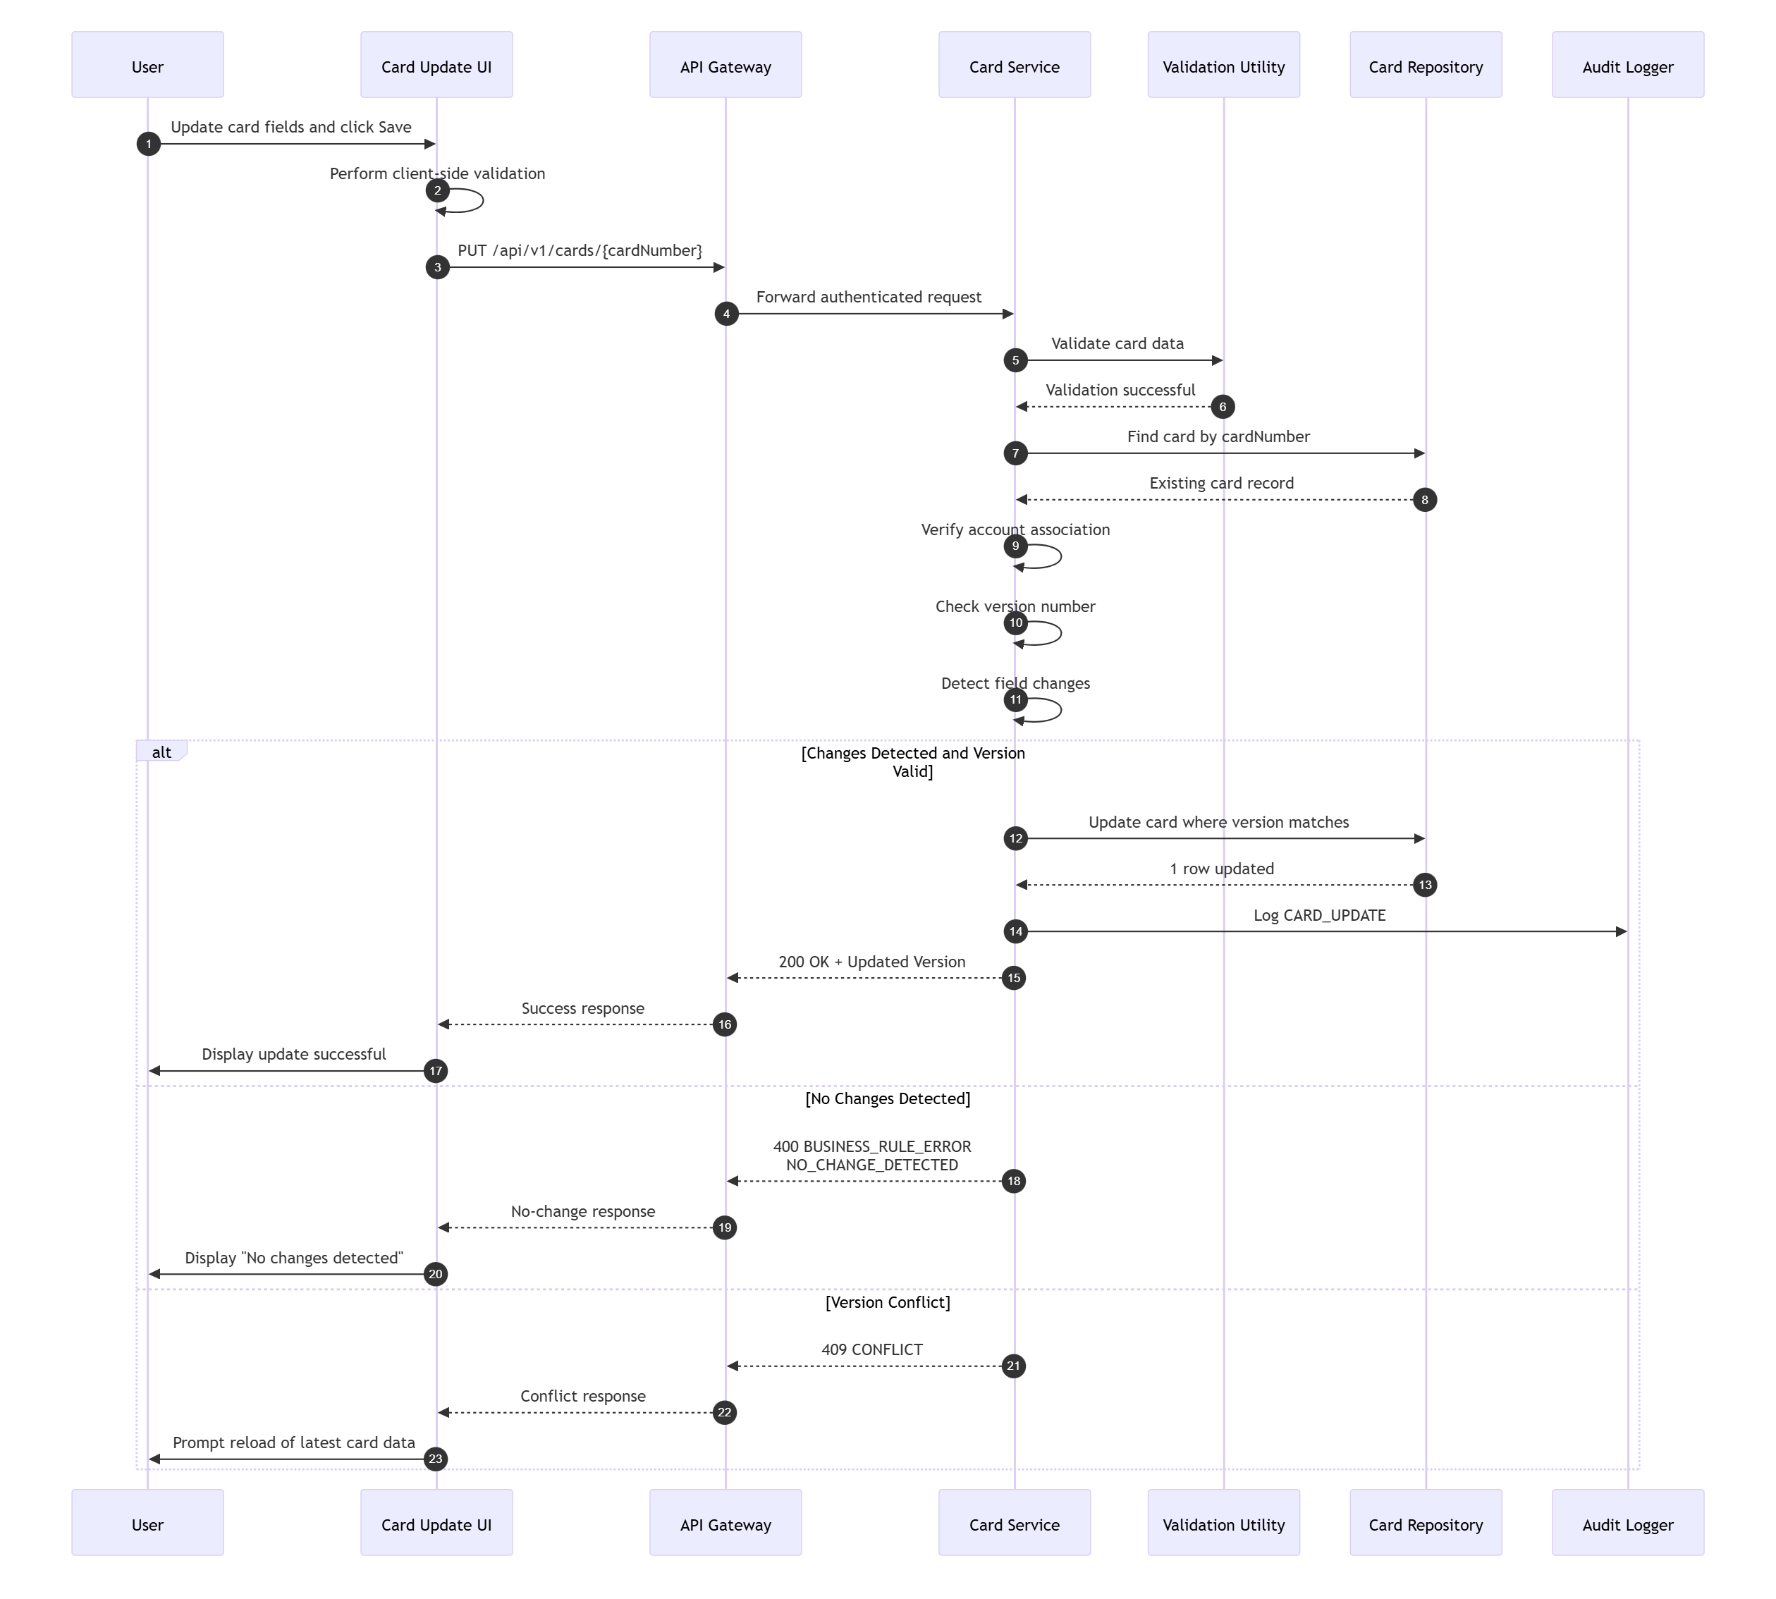
TraceabilityBRD 6.6.3Architecture 13.5

7.13 Happy Path — Add Transaction
Not supported language -29 lines
mermaid
sequenceDiagram
autonumber
participant U as User
participant UI as Add Transaction UI
participant GW as API Gateway
participant TXN as Transaction Service
participant IDEM as Idempotency Store
participant LINK as AccountCardLinkRepository
participant REF as TransactionTypeRepository
participant TR as TransactionRepository
participant AUD as Audit Logger
U->>UI: Submit transaction
UI->>GW: POST /api/v1/transactions
GW->>TXN: Forward request + idempotency key
TXN->>IDEM: Lookup key
IDEM-->>TXN: Not found
TXN->>LINK: Resolve account/card relation
LINK-->>TXN: Relation found
TXN->>REF: Validate transaction type exists
REF-->>TXN: Type valid
TXN->>TXN: Generate transaction ID
TXN->>TR: Insert transaction
TR-->>TXN: Insert success
TXN->>IDEM: Save response
TXN->>AUD: Log TRANSACTION_ADD
TXN-->>GW: 201 Created
GW-->>UI: Success response
UI->>U: Display new transaction ID
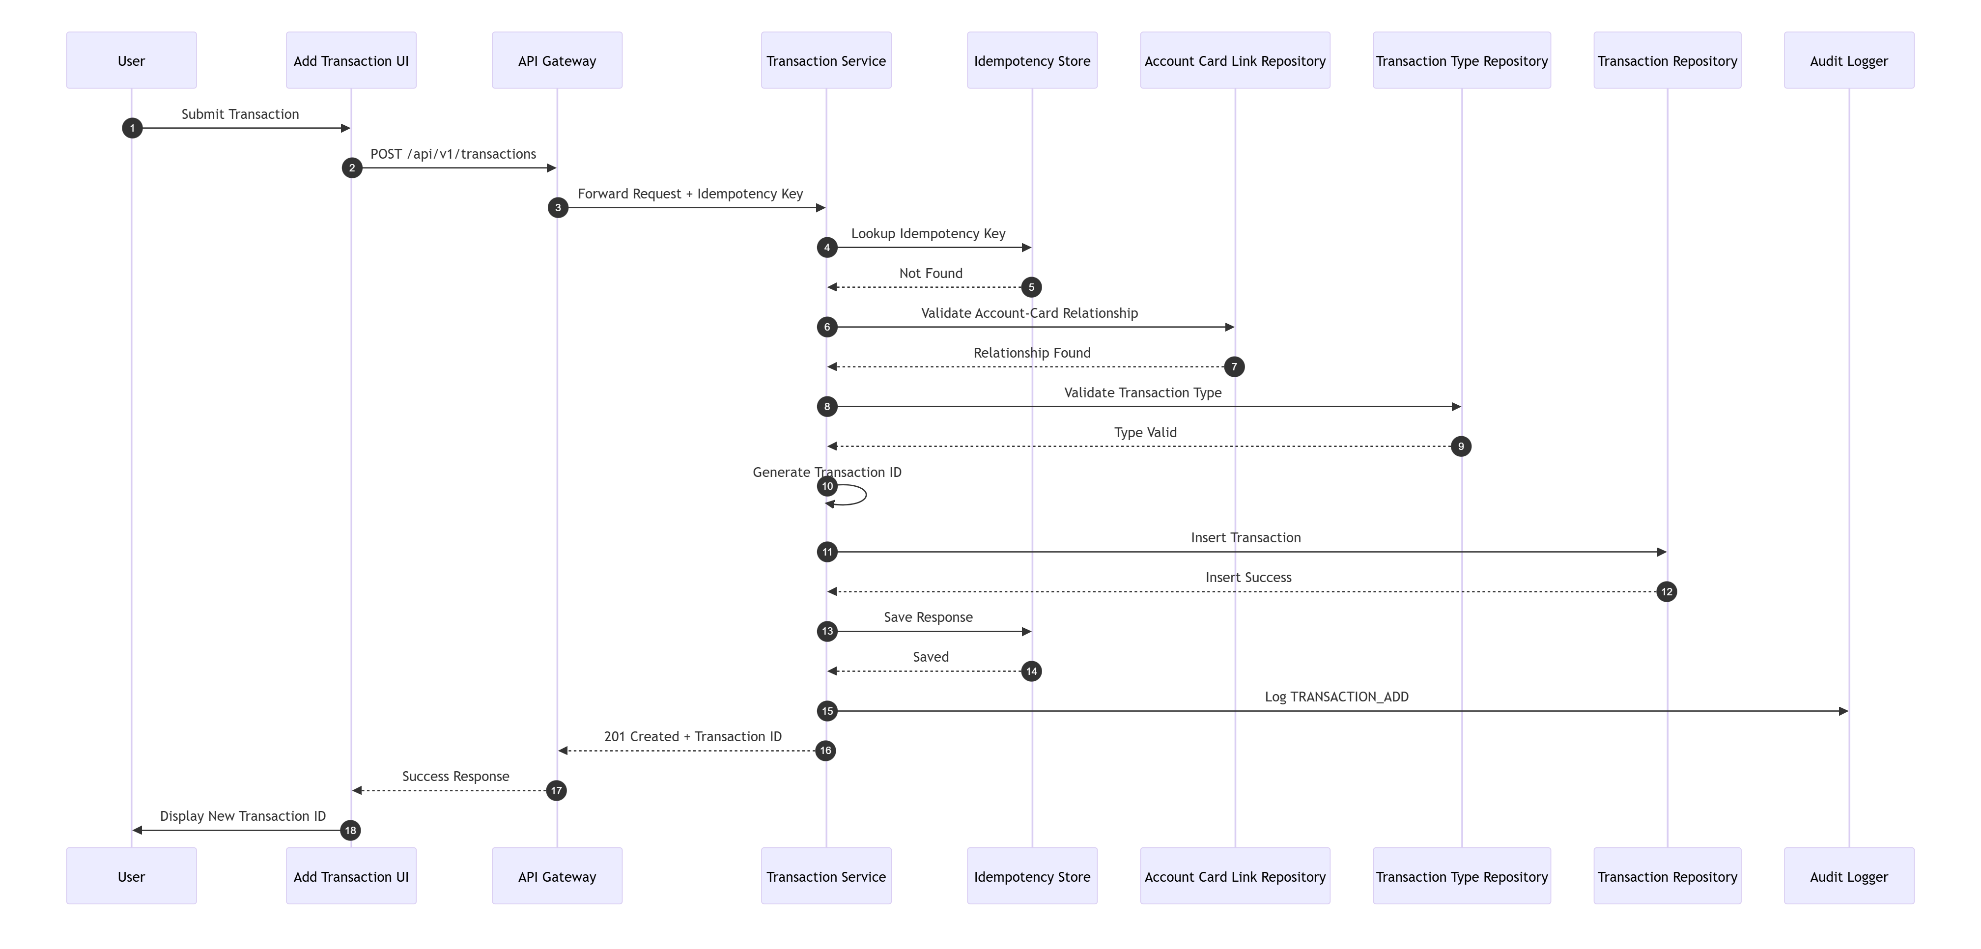
TraceabilityBRD 6.7.3Architecture 13.6

7.14 Validation Failure — Add Transaction Invalid Date
Not supported language -13 lines
mermaid
sequenceDiagram
autonumber
participant UI as Add Transaction UI
participant GW as API Gateway
participant TXN as Transaction Service
participant VAL as Validation Utility
UI->>GW: POST /api/v1/transactions
GW->>TXN: Forward request
TXN->>VAL: Validate request body
VAL-->>TXN: originalDate invalid
TXN-->>GW: 400 VALIDATION_ERROR
GW-->>UI: Error response
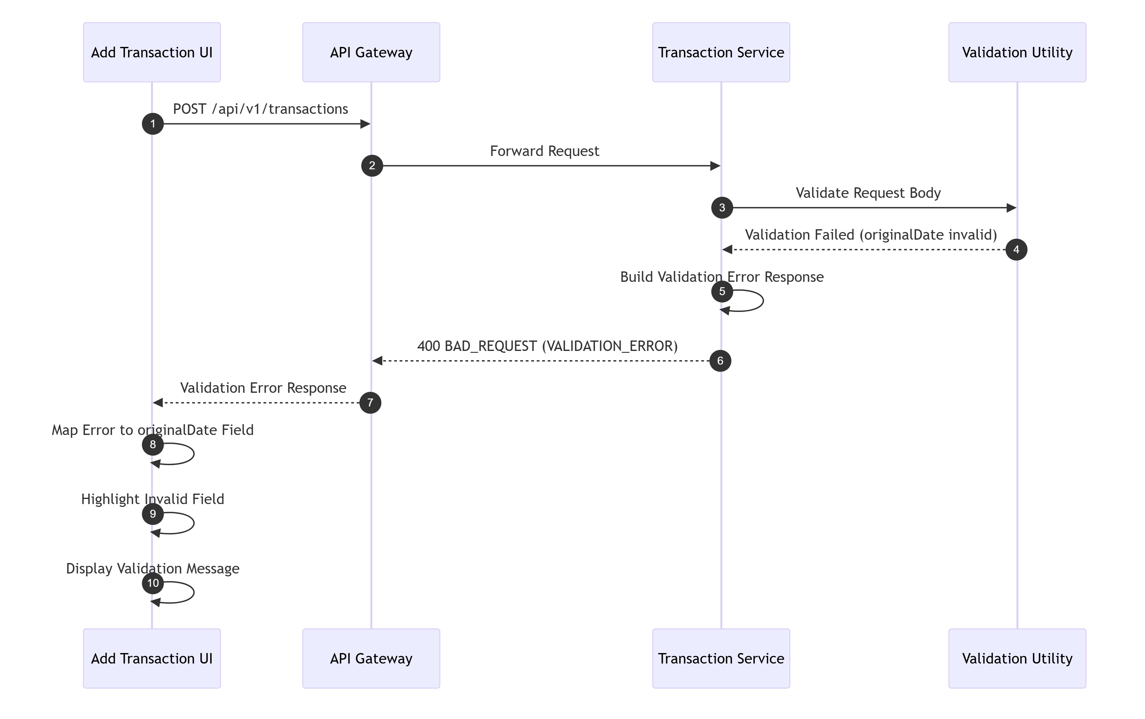

7.15 Business Rule Failure — Account/Card Linkage Not Found
Not supported language -13 lines
mermaid
sequenceDiagram
autonumber
participant UI as Add Transaction UI
participant GW as API Gateway
participant TXN as Transaction Service
participant LINK as AccountCardLinkRepository
UI->>GW: POST /api/v1/transactions
GW->>TXN: Forward request
TXN->>LINK: Resolve account/card relation
LINK-->>TXN: No linkage found
TXN-->>GW: 400 BUSINESS_RULE_ERROR
GW-->>UI: "Account/card linkage not found"
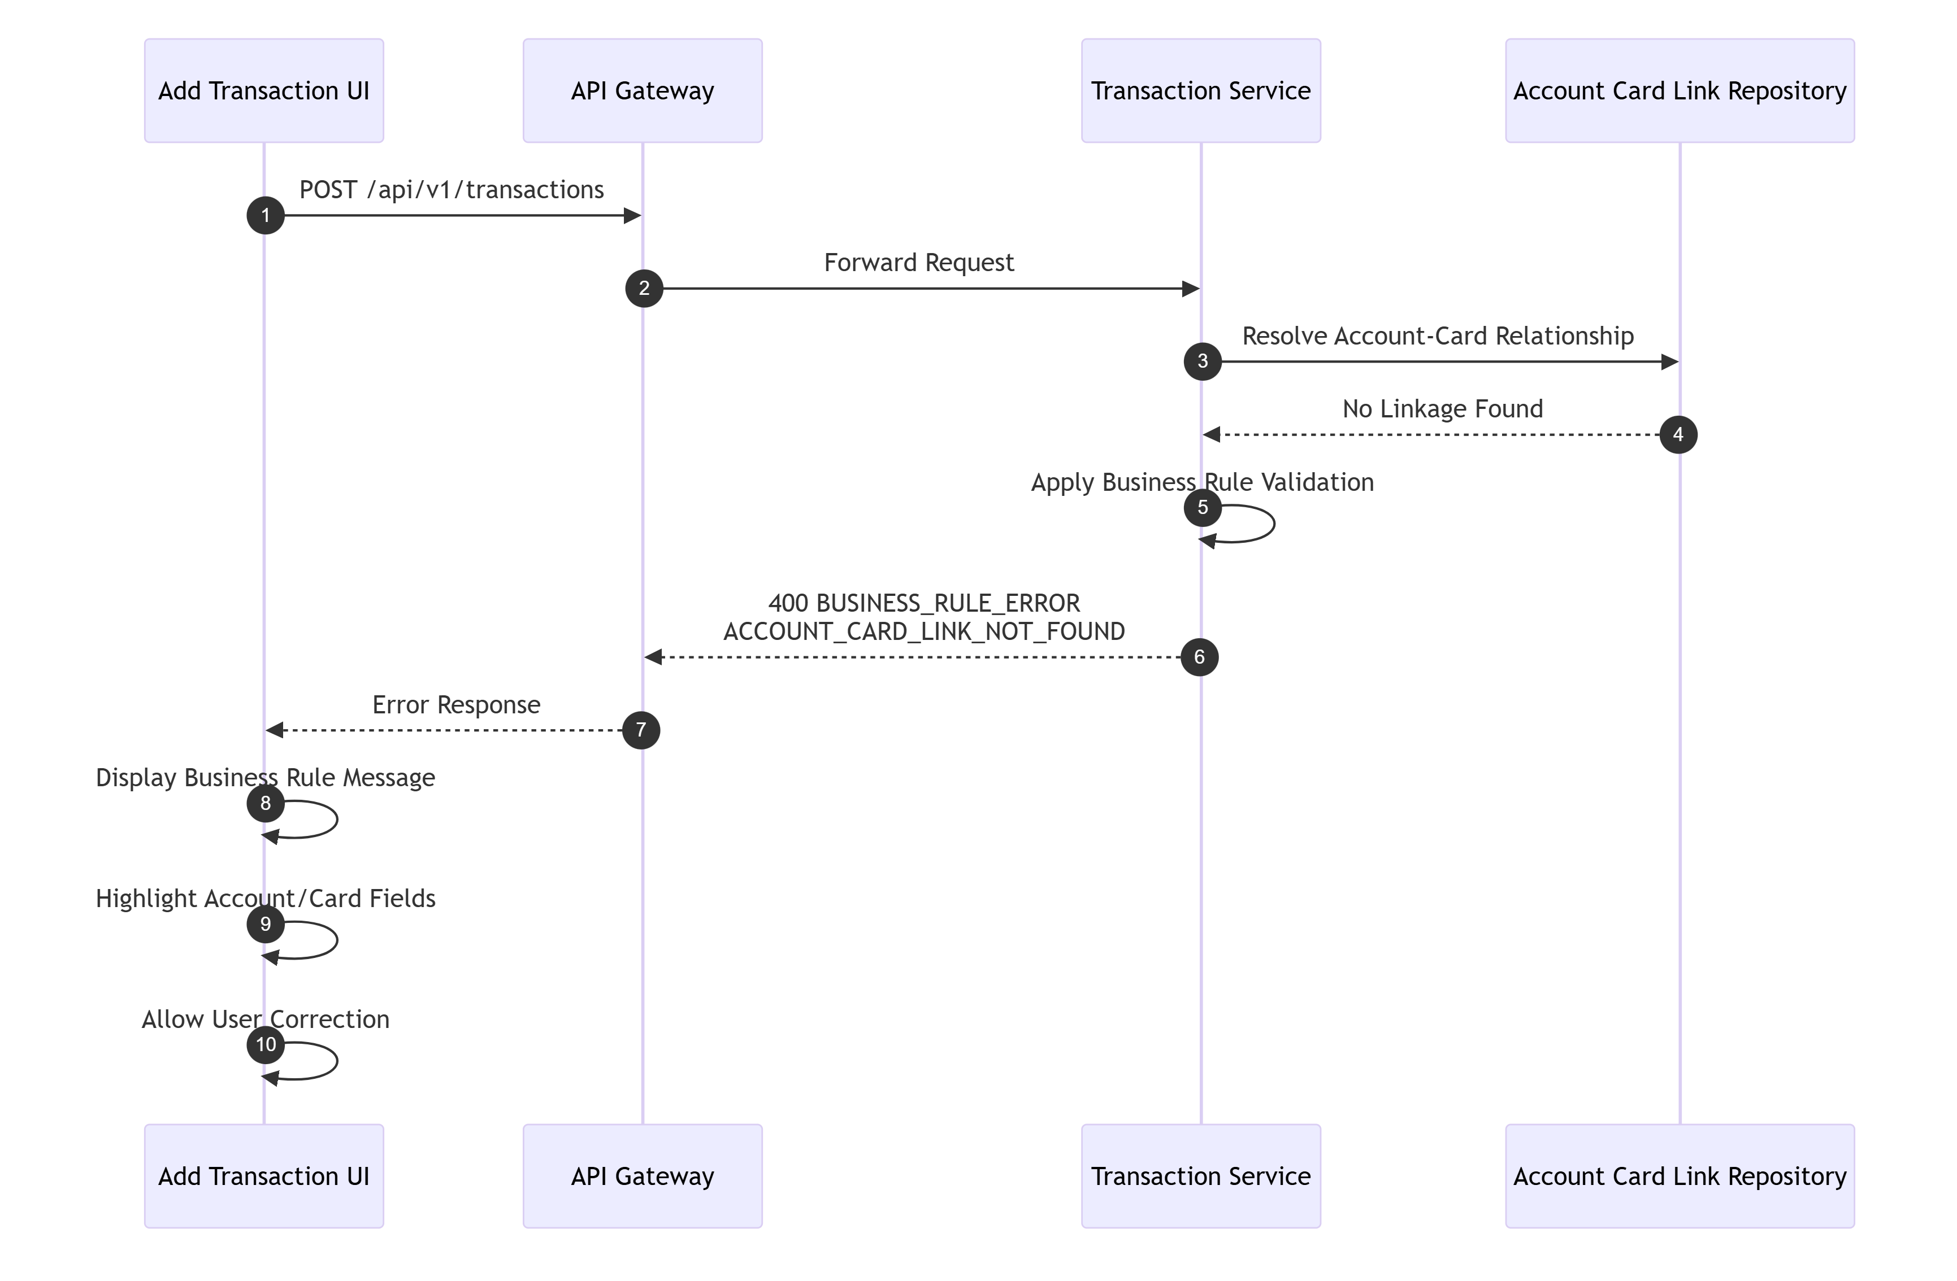

7.16 Happy Path — Pending Authorization Fraud Mark
Not supported language -27 lines
mermaid
sequenceDiagram
autonumber
participant U as User
participant UI as Pending Auth Detail UI
participant GW as API Gateway
participant FRAUD as Fraud Service
participant IDEM as Idempotency Store
participant PAD as PendingAuthDetailRepository
participant FR as FraudRepository
participant AUD as Audit Logger
U->>UI: Click Mark Fraud
UI->>GW: POST /api/v1/fraud/authorizations/{authorizationId}/mark
GW->>FRAUD: Forward request + idempotency key
FRAUD->>IDEM: Lookup key
IDEM-->>FRAUD: Not found
FRAUD->>PAD: findByAuthorizationId
PAD-->>FRAUD: Pending auth row
FRAUD->>FR: insert fraud record (MARK)
FR-->>FRAUD: insert success
FRAUD->>PAD: update fraud_flag='Y'
PAD-->>FRAUD: update success
FRAUD->>IDEM: Save response
FRAUD->>AUD: Log FRAUD_MARK
FRAUD-->>GW: 200 Success
GW-->>UI: Success response
UI->>U: Show fraud marked
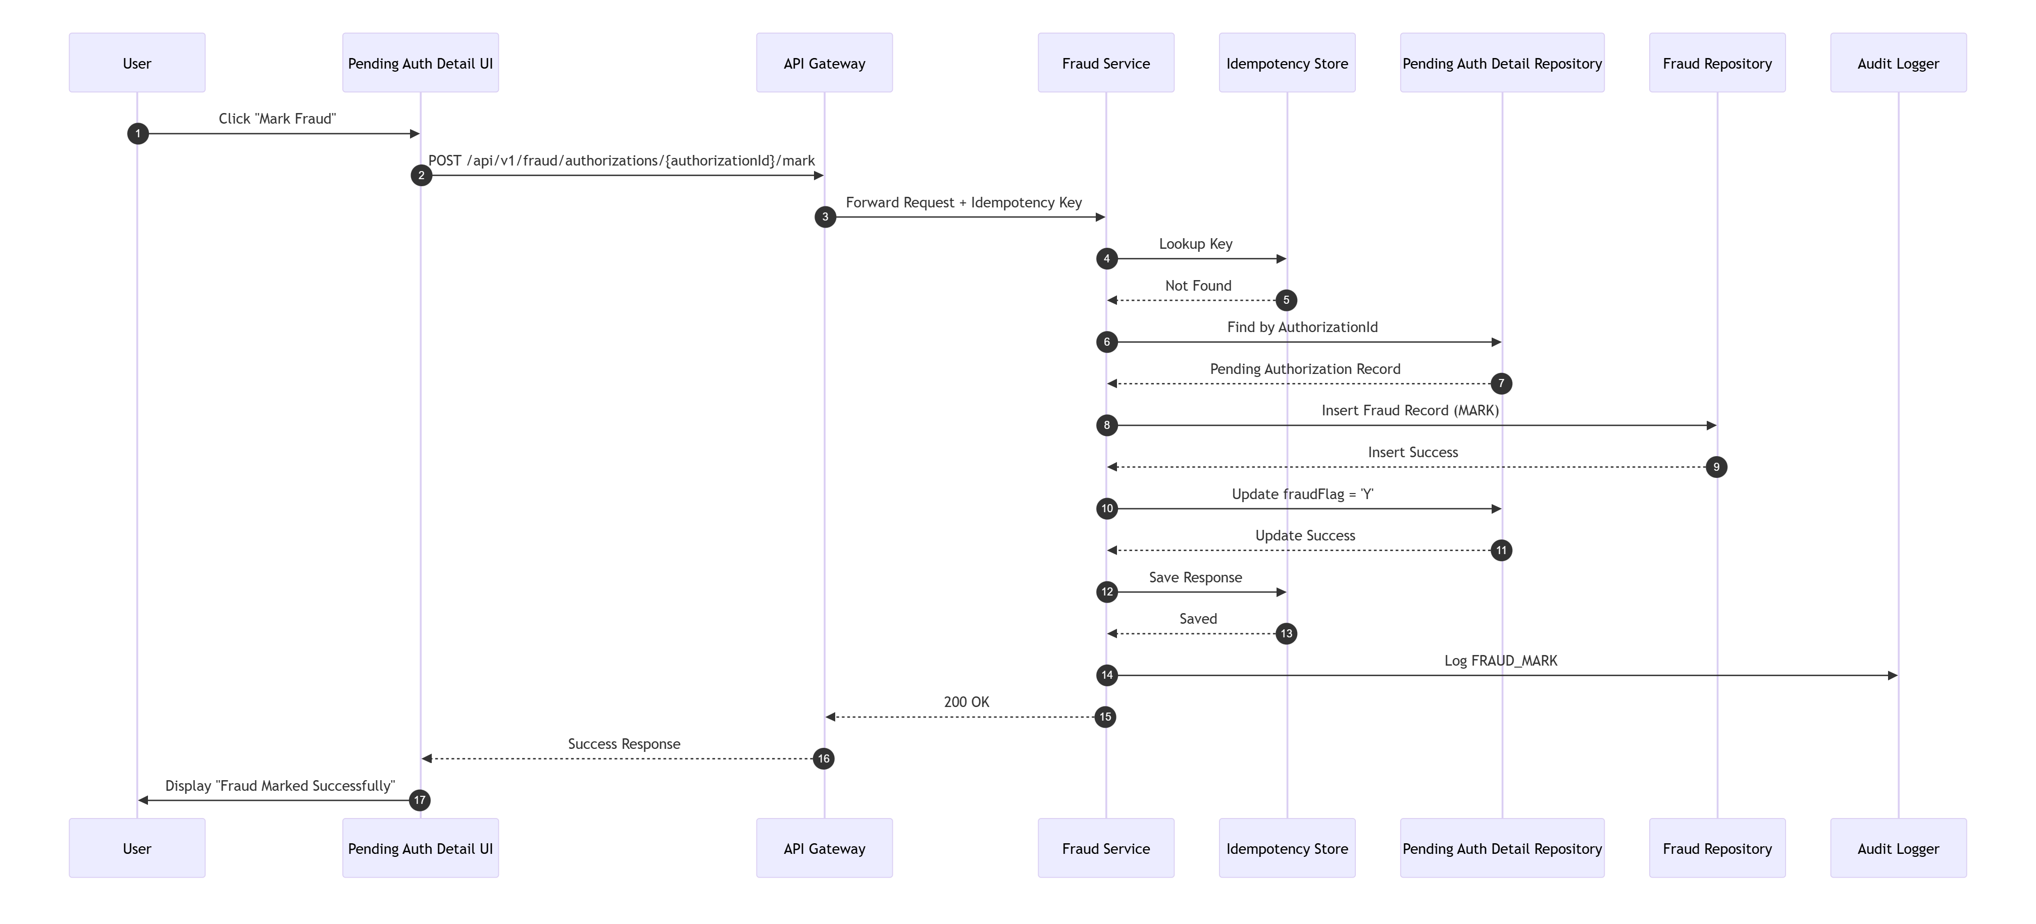
TraceabilityBRD 6.9.2, 6.9.3Architecture 13.7

7.17 External Service Failure — Authorization Decision Pending Auth Write Failure
Not supported language -20 lines
mermaid
sequenceDiagram
autonumber
participant CALLER as Upstream Caller
participant GW as API Gateway
participant ADEC as Authorization Decision Service
participant IDEM as Idempotency Store
participant DB as Database
CALLER->>GW: POST /services/authorizations/decide
GW->>ADEC: Forward request
ADEC->>IDEM: Lookup key
IDEM-->>ADEC: Not found
ADEC->>ADEC: Validate linkage and evaluate decision
ADEC->>DB: UPSERT pending_auth_summaries
DB-->>ADEC: Success
ADEC->>DB: INSERT pending_auth_details
DB-->>ADEC: Failure / timeout
ADEC->>ADEC: Roll back transaction
ADEC-->>GW: 503 EXTERNAL_SERVICE_ERROR or 500 PROCESSING_ERROR
GW-->>CALLER: Failure response
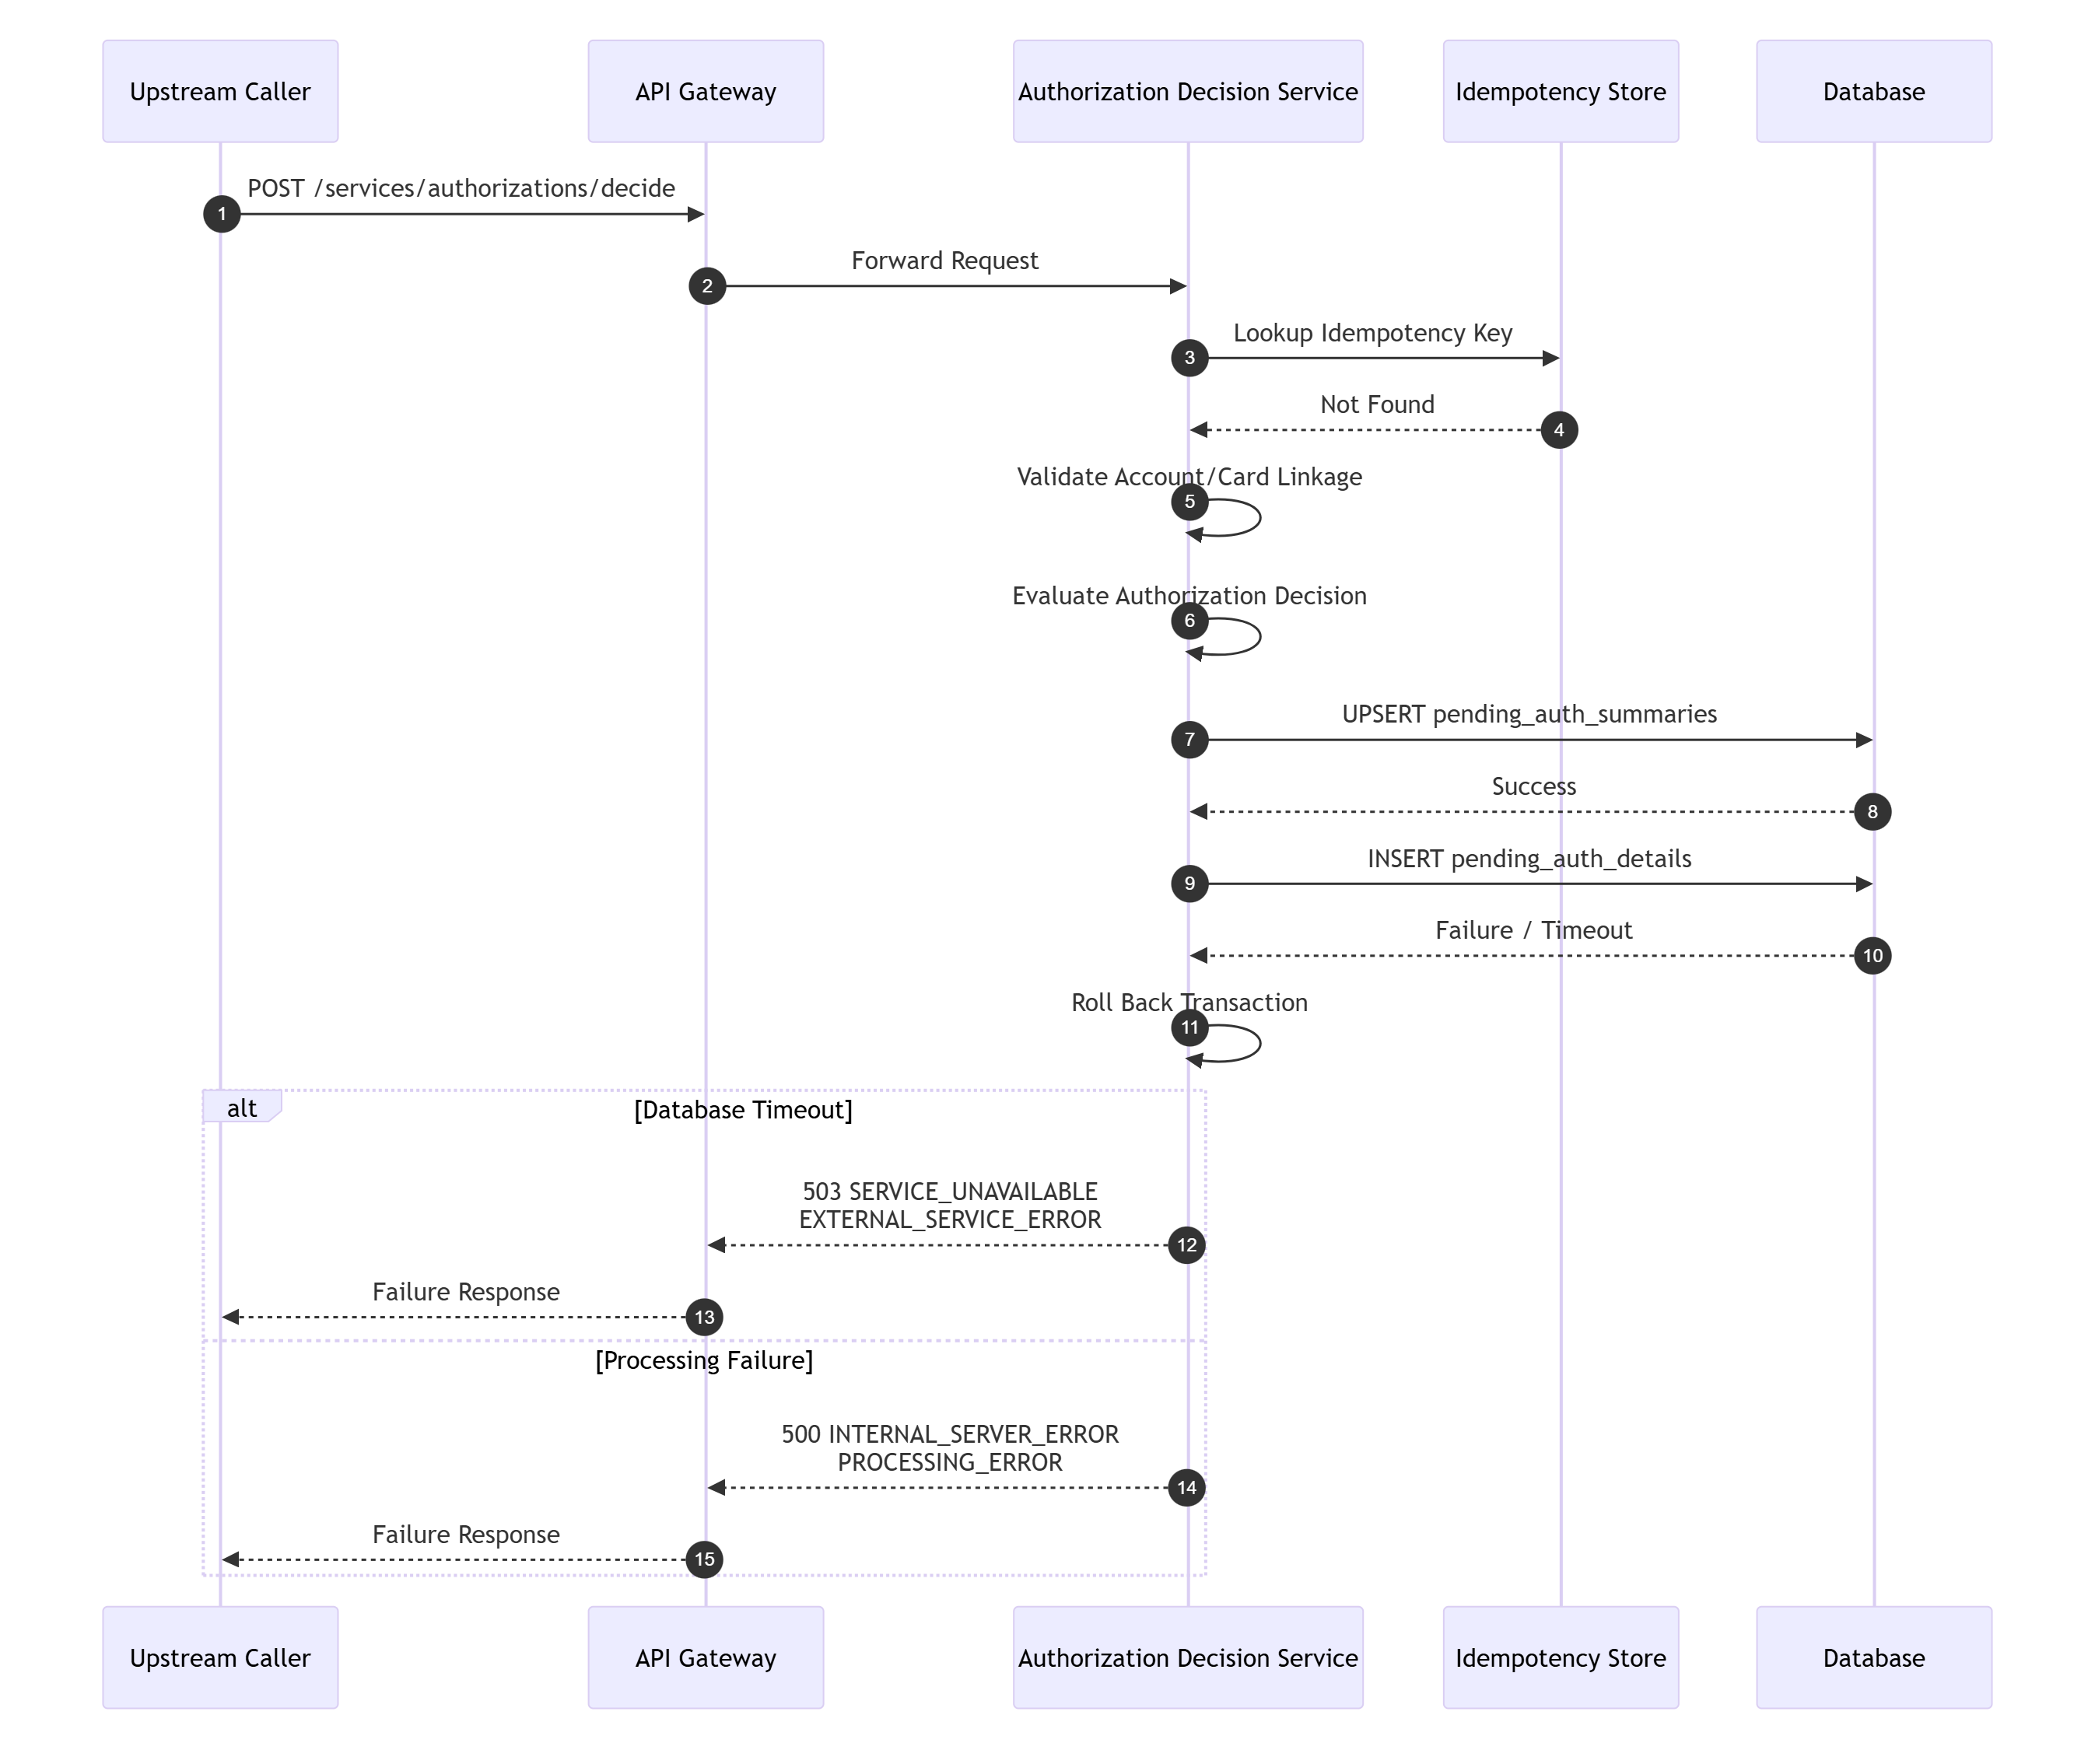

7.18 Retry Scenario — Authorization Decision Safe Retry
Not supported language -13 lines
mermaid
sequenceDiagram
autonumber
participant CALLER as Upstream Caller
participant GW as API Gateway
participant ADEC as Authorization Decision Service
participant IDEM as Idempotency Store
CALLER->>GW: POST /services/authorizations/decide (Key=K1)
GW->>ADEC: Forward request
ADEC->>IDEM: lookup(K1)
IDEM-->>ADEC: Existing result
ADEC-->>GW: Return stored decision
GW-->>CALLER: Same authorization response
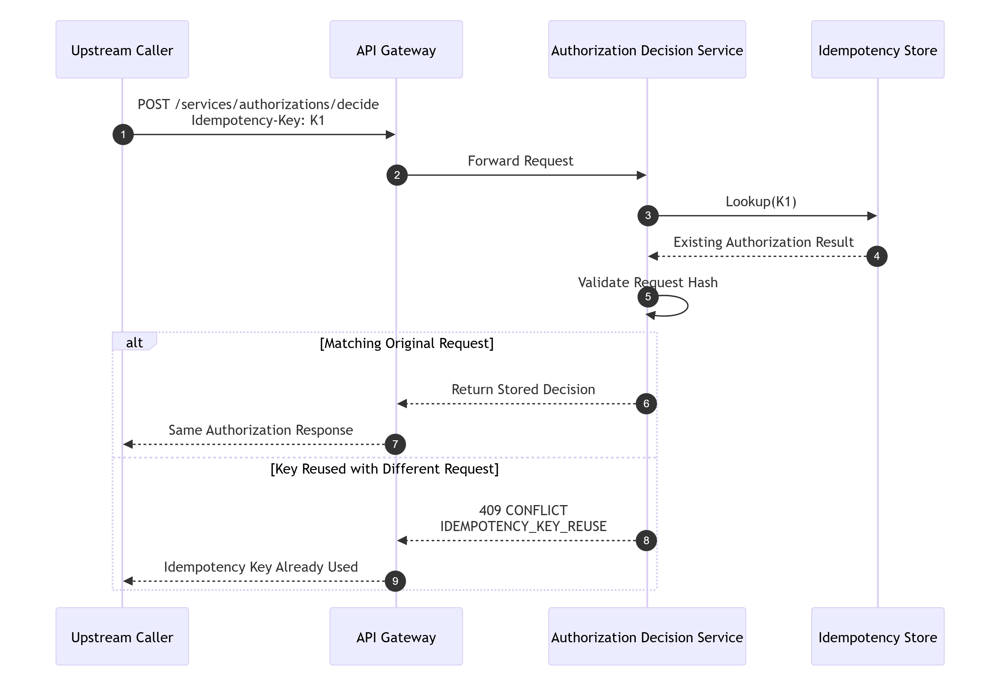

7.19 Timeout Scenario — Account Inquiry Service Timeout
Not supported language -14 lines
mermaid
sequenceDiagram
autonumber
participant CALLER as External Caller
participant GW as API Gateway
participant AINQ as Account Inquiry Service
participant AR as AccountRepository
CALLER->>GW: POST /services/accounts/inquiry
GW->>AINQ: Forward request
AINQ->>AR: findById(accountId)
Note over AINQ,AR: Repository/database timeout exceeded
AR--xAINQ: Timeout
AINQ-->>GW: 503 SYSTEM/EXTERNAL error
GW-->>CALLER: Timeout failure response
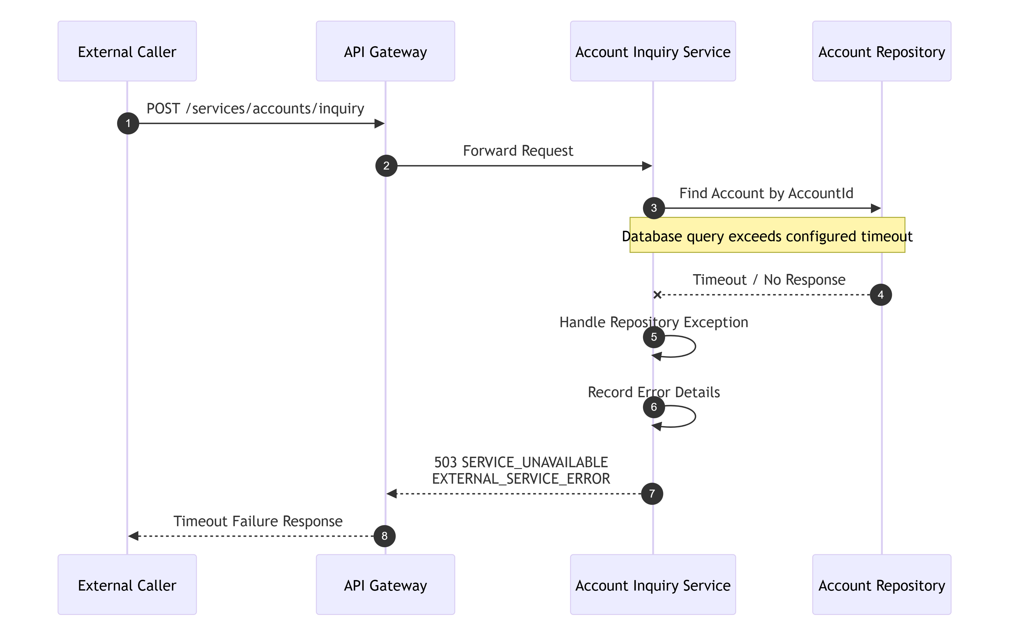

7.20 Async Processing — Report Request Submission
Not supported language -22 lines
mermaid
sequenceDiagram
autonumber
participant U as User
participant UI as Report Request UI
participant GW as API Gateway
participant RPT as Report Request Service
participant RR as ReportRequestRepository
participant JOB as Job Scheduler/Queue
participant AUD as Audit Logger
U->>UI: Submit report request
UI->>GW: POST /api/v1/reports/requests
GW->>RPT: Forward request
RPT->>RPT: Validate type and dates
RPT->>RR: Insert report request (SUBMITTED)
RR-->>RPT: requestId
RPT->>JOB: Enqueue reporting work
JOB-->>RPT: Accepted
RPT->>AUD: Log REPORT_REQUEST_SUBMIT
RPT-->>GW: 201 Created
GW-->>UI: Success response
UI->>U: Show request submitted
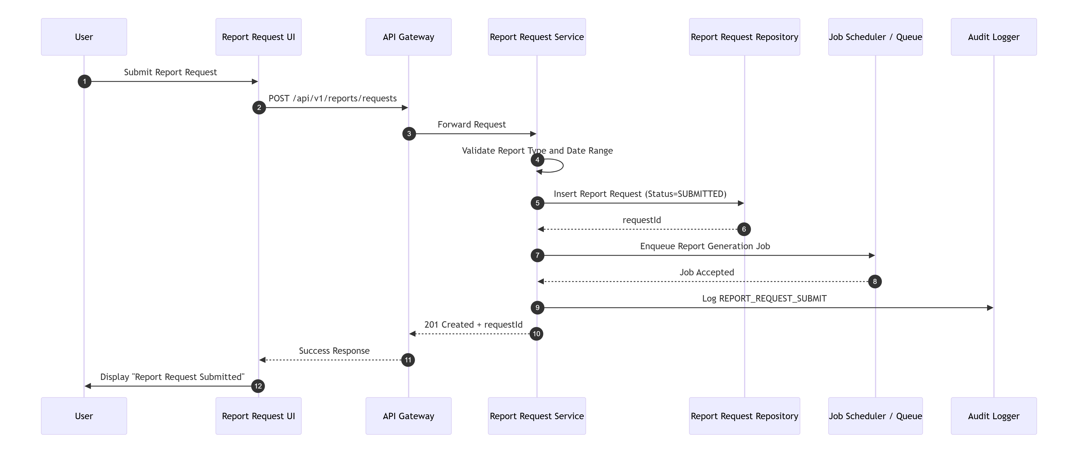

7.21 Notification/Status Flow — Report Request Status Check
Not supported language -16 lines
mermaid
sequenceDiagram
autonumber
participant U as User
participant UI as Report Status UI
participant GW as API Gateway
participant RPT as Report Request Service
participant RR as ReportRequestRepository
U->>UI: Open report request status
UI->>GW: GET /api/v1/reports/requests/{requestId}
GW->>RPT: Forward request
RPT->>RR: findByRequestId(requestId)
RR-->>RPT: Request row
RPT-->>GW: 200 Success
GW-->>UI: Status response
UI->>U: Display request status
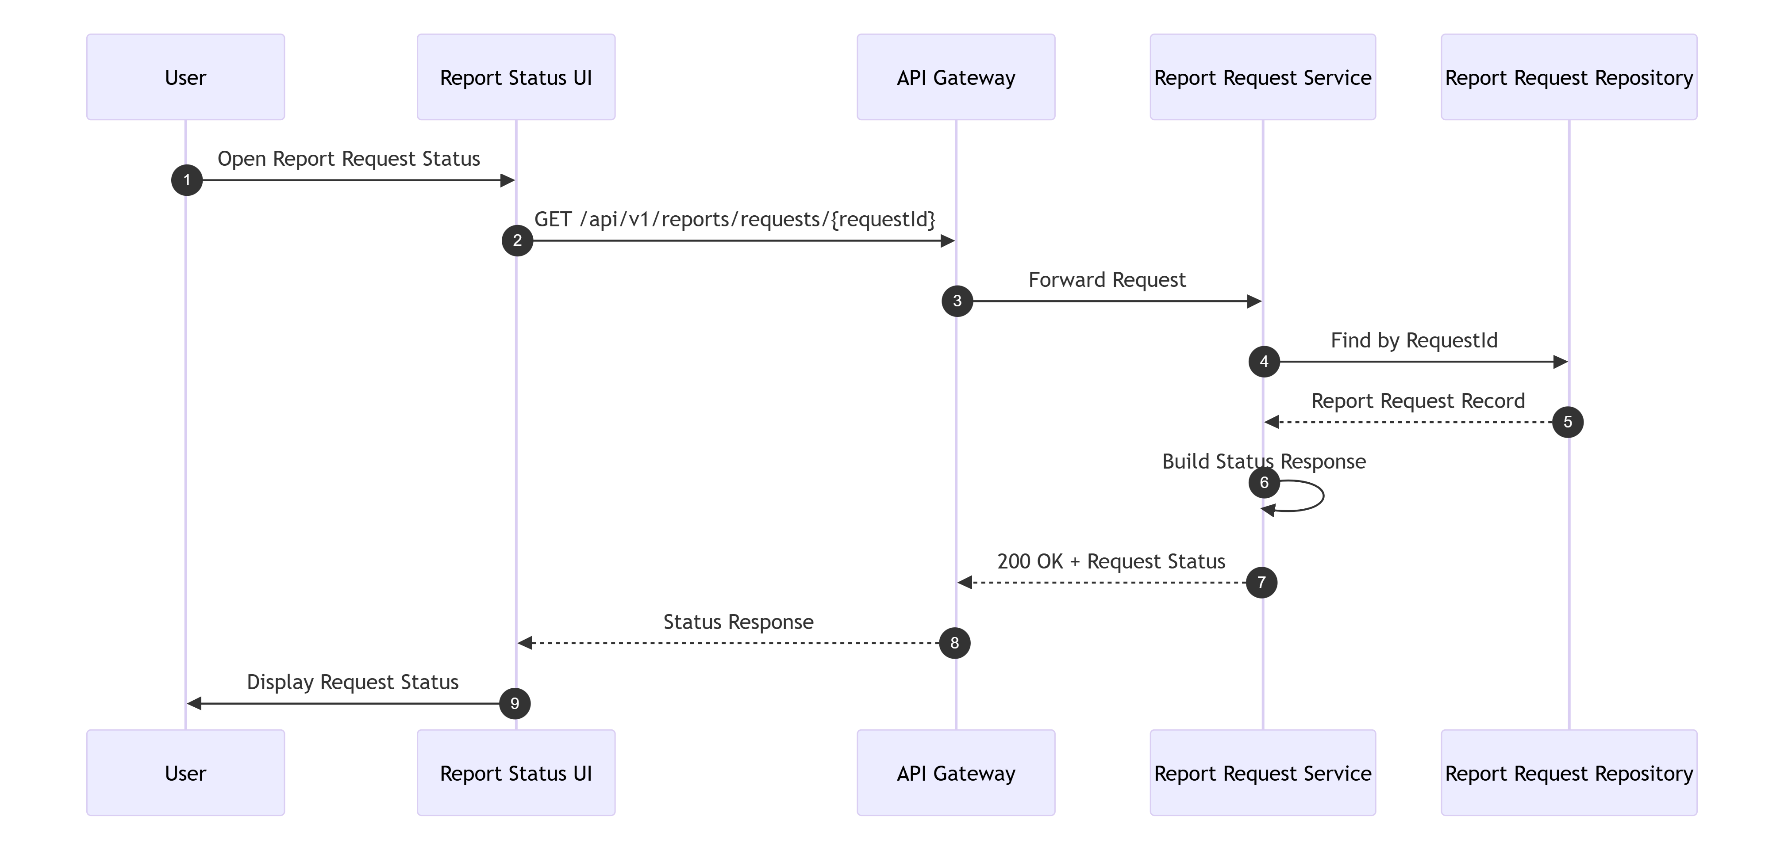

7.22 Batch Processing — Daily Transaction Validation and Posting
Not supported language -26 lines
mermaid
sequenceDiagram
autonumber
participant OPS as Scheduler/Ops
participant JOB as Job Runtime
participant SRC as Daily Input Source
participant DTV as Daily Transaction Validation Processor
participant STG as Valid Transaction Staging
participant ERR as Error Output
participant DTP as Daily Transaction Posting Processor
participant DB as Database
OPS->>JOB: Trigger daily validation
JOB->>DTV: Start validation job
DTV->>SRC: Read daily transactions
SRC-->>DTV: Transaction stream
DTV->>DTV: Validate structure and linkage
DTV->>STG: Write valid records
DTV->>ERR: Write invalid records
OPS->>JOB: Trigger posting
JOB->>DTP: Start posting job
DTP->>STG: Read valid records
STG-->>DTP: Valid batch
DTP->>DB: Update account balances
DTP->>DB: Update category balances / transaction rows
DB-->>DTP: Commit success
DTP-->>JOB: Job completed
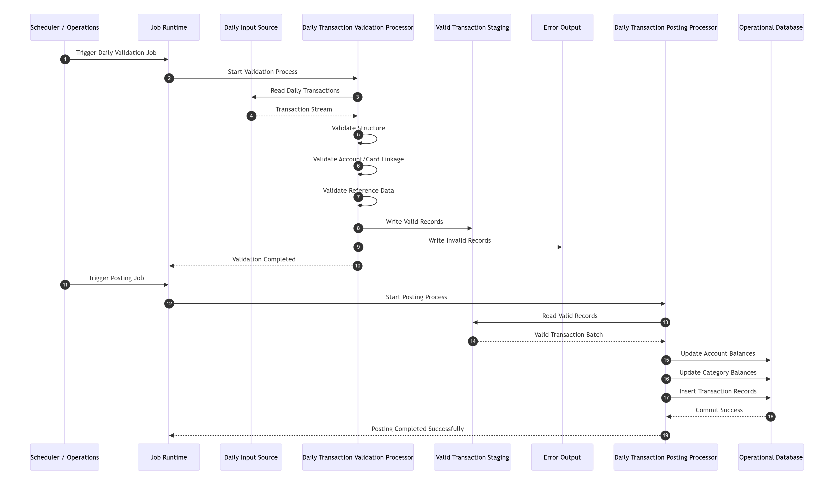
TraceabilityBRD 6.14.1, 6.14.2Architecture 13.9

7.23 Batch Processing — Interest Processing
Not supported language -21 lines
mermaid
sequenceDiagram
autonumber
participant OPS as Scheduler/Ops
participant JOB as Job Runtime
participant INT as Interest Processing Service
participant AR as AccountRepository
participant REF as Rate Reference Store
participant TR as TransactionRepository
OPS->>JOB: Trigger interest processing
JOB->>INT: Start job
INT->>AR: Read eligible accounts
AR-->>INT: Account set
loop For each account
INT->>REF: Resolve interest rate
REF-->>INT: Specific or default rate
INT->>INT: Compute interest
INT->>TR: Insert interest transaction
INT->>AR: Update balance and cycle values
end
INT-->>JOB: Completed
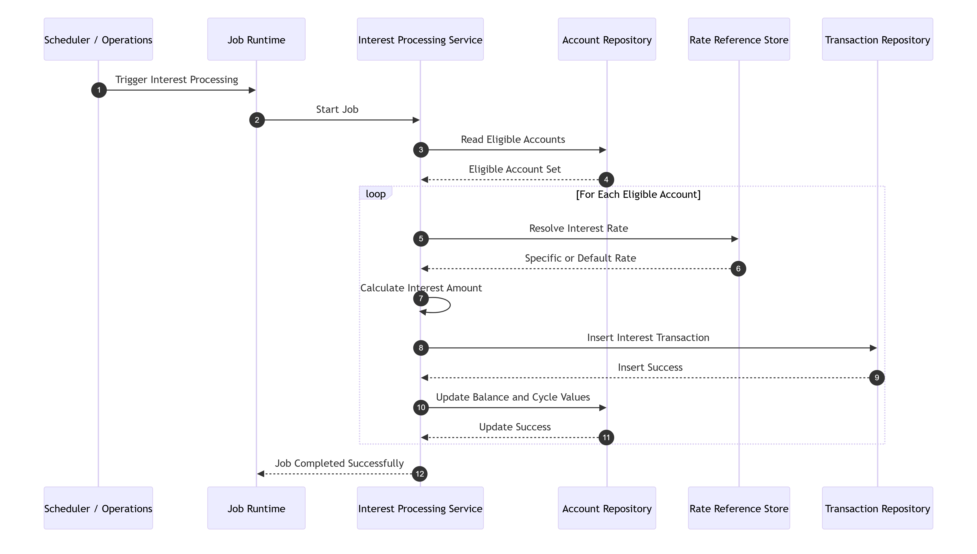

7.24 Batch Processing — Export / Import
Not supported language -23 lines
mermaid
sequenceDiagram
autonumber
participant OPS as Scheduler/Ops
participant EXP as Export Service
participant DB as Database
participant OUT as Consolidated Export File
participant IMP as Import Service
participant IN as Consolidated Import File
participant ERR as Error Output
OPS->>EXP: Trigger export
EXP->>DB: Read customer/account/linkage/card/transaction data
DB-->>EXP: Source rows
EXP->>OUT: Write consolidated export records
OPS->>IMP: Trigger import
IMP->>IN: Read consolidated records
IN-->>IMP: Record stream
IMP->>IMP: Determine record type
alt Known type
IMP->>DB: Write to target entity output/staging
else Unknown type
IMP->>ERR: Write invalid record
end
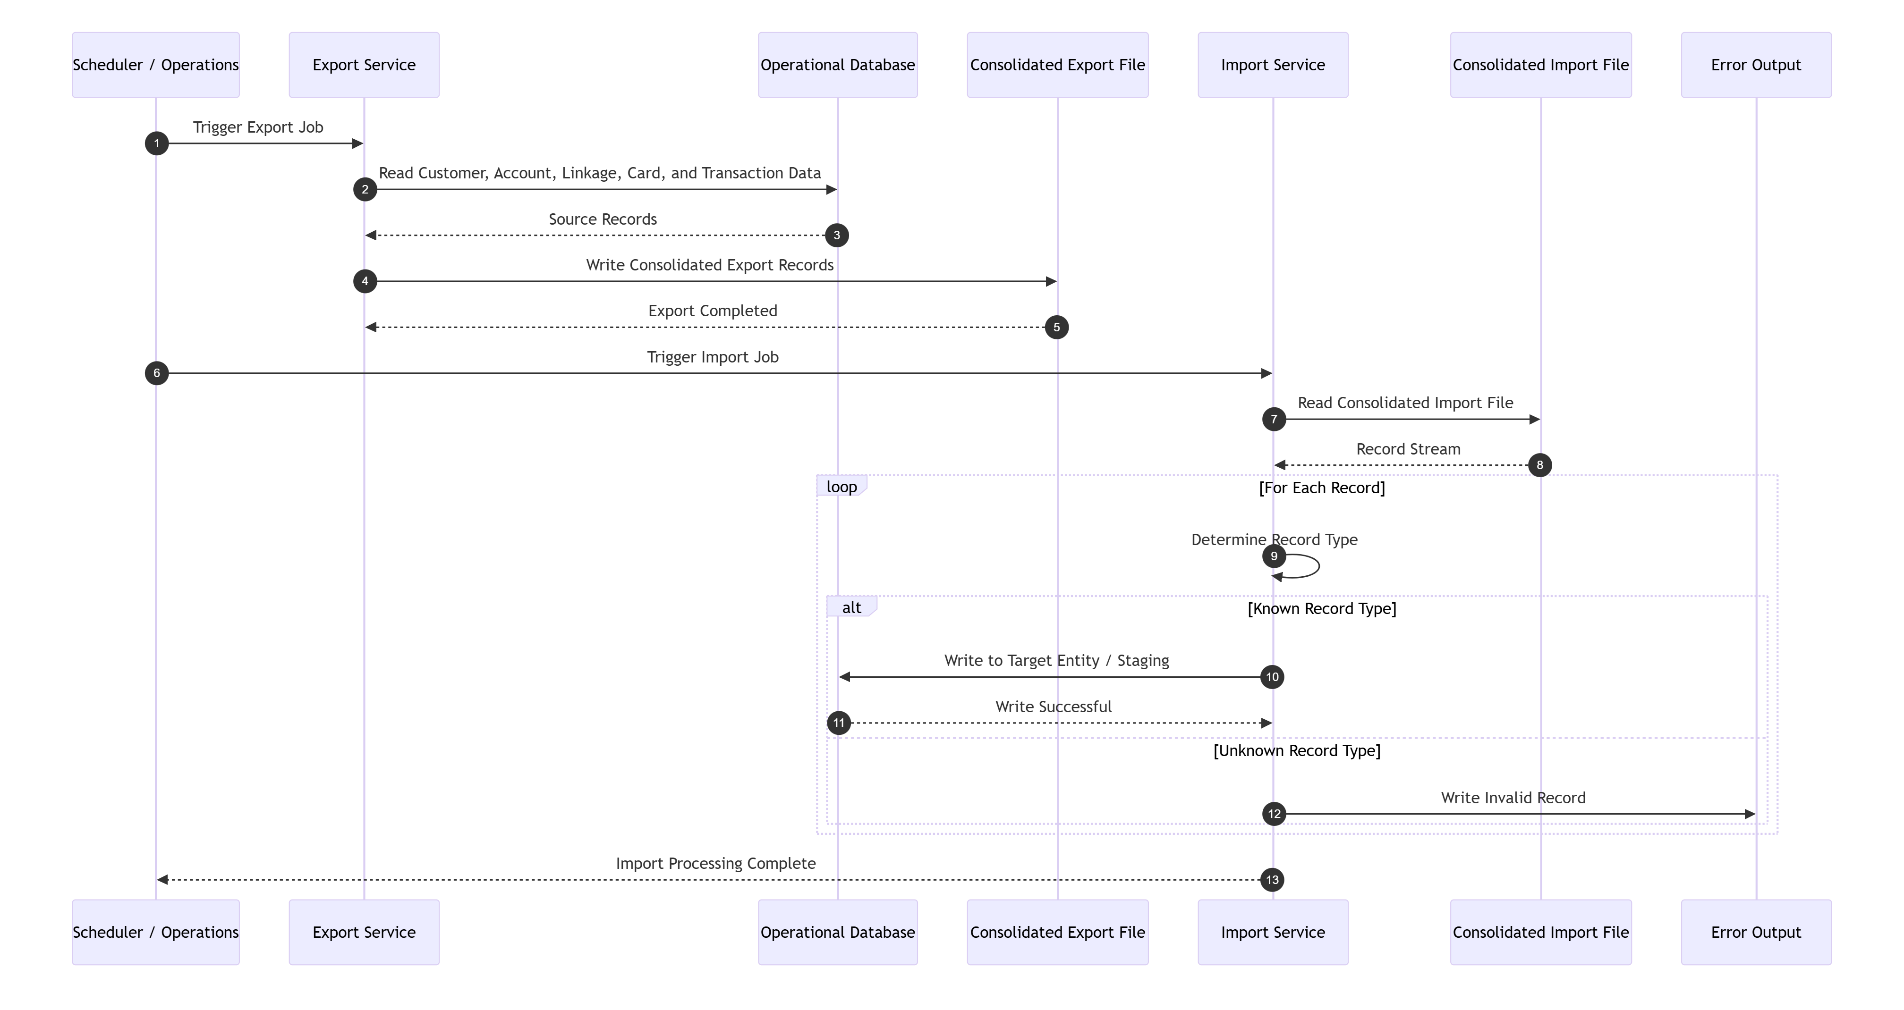

8. Class Design
This section provides the logical class model for the application. The design is layered and aligned with the API and DB sections.

8.1 Layered Class Model
LayersController layerService layerRepository layerDomain model layerDTO/Mapper layerShared utilities

8.2 Key Design Patterns
Pattern | Usage
Controller-Service-Repository | standard request handling
DTO Mapper | request/response to domain conversion
Optimistic Locking | update conflict detection
Idempotency Guard | duplicate submit protection
Validator | central validation logic
Strategy/Policy | authorization decision or report date range resolution
Factory | response/error object construction

8.3 Core Class Inventory
Authentication DomainAuthControllerAuthServiceTokenProviderPasswordVerifierUserRepositoryLoginRequestLoginResponseAuthPrincipal
Navigation DomainNavigationControllerNavigationServiceMenuProviderMenuItemDto
User Administration DomainUserAdminControllerUserAdminServiceUserRepositoryUserCreateUserRequestUpdateUserRequestUserResponse
Account DomainAccountControllerAccountServiceAccountRepositoryCustomerRepositoryAccountCustomerAccountCompositeResponseUpdateAccountRequest
Payment DomainPaymentControllerPaymentServiceAccountRepositoryTransactionRepositoryIdempotencyServiceBillPaymentRequestBillPaymentResponse
Card DomainCardControllerCardServiceCardRepositoryCardCardSearchResponseUpdateCardRequest
Transaction DomainTransactionControllerTransactionServiceTransactionRepositoryAccountCardLinkRepositoryTransactionTypeRepositoryTransactionCreateTransactionRequest
Reference DomainTransactionTypeControllerTransactionTypeServiceTransactionTypeRepositoryTransactionType
Pending Authorization / Fraud DomainPendingAuthorizationControllerPendingAuthorizationServiceFraudControllerFraudServicePendingAuthSummaryRepositoryPendingAuthDetailRepositoryFraudRepositoryPendingAuthorizationDetailFraudRecord
Report DomainReportRequestControllerReportRequestServiceReportRequestRepositoryReportDateRangeResolverReportRequest
External/Request-Response DomainAuthorizationDecisionControllerAuthorizationDecisionServiceEligibilityEngineAccountInquiryControllerAccountInquiryServiceDateTimeControllerDateTimeService
Batch DomainJobControllerJobOrchestratorServiceDailyTransactionValidationJobDailyTransactionPostingJobInterestProcessingJobExportJobImportJobStatementGenerationJobTransactionReportJob
SharedValidationServiceIdempotencyServiceAuditServiceErrorMapperMaskingUtilDateValidatorPaginationRequestPageResponse<T>

8.4 Mermaid UML Class Diagram
Not supported language -277 lines
mermaid
classDiagram
class AuthController {
+login(LoginRequest): ApiResponse<LoginResponse>
+logout(): ApiResponse<Void>
+me(): ApiResponse<AuthContextResponse>
}
class AuthService {
+login(LoginRequest): LoginResponse
+logout(AuthPrincipal): void
+getCurrentUser(AuthPrincipal): AuthContextResponse
}
class TokenProvider {
+issueToken(User): TokenDetails
+invalidate(String): void
}
class PasswordVerifier {
+matches(String, String): boolean
+encode(String): String
}
class NavigationController {
+getMainMenu(): ApiResponse<MenuResponse>
+getAdminMenu(): ApiResponse<MenuResponse>
+validateOption(MenuOptionRequest): ApiResponse<MenuOptionResponse>
}
class NavigationService {
+getMainMenu(AuthPrincipal): MenuResponse
+getAdminMenu(AuthPrincipal): MenuResponse
+validateOption(AuthPrincipal, String): MenuOptionResponse
}
class UserAdminController {
+listUsers(PageQuery): ApiResponse<PageResponse<UserResponse>>
+getUser(String): ApiResponse<UserResponse>
+createUser(CreateUserRequest): ApiResponse<CreateUserResponse>
+updateUser(String, UpdateUserRequest): ApiResponse<UpdateUserResponse>
+deleteUser(String): ApiResponse<DeleteUserResponse>
}
class UserAdminService {
+listUsers(PageQuery): PageResponse<User>
+getUser(String): User
+createUser(CreateUserRequest, AuthPrincipal): User
+updateUser(String, UpdateUserRequest, AuthPrincipal): User
+deleteUser(String, AuthPrincipal): void
}
class AccountController {
+getAccount(String): ApiResponse<AccountCompositeResponse>
+updateAccount(String, UpdateAccountRequest): ApiResponse<UpdateAccountResponse>
}
class AccountService {
+getAccountComposite(String): AccountComposite
+updateAccountComposite(String, UpdateAccountRequest, AuthPrincipal): UpdateAccountResult
}
class PaymentController {
+previewBillPayment(String): ApiResponse<PaymentPreviewResponse>
+createBillPayment(BillPaymentRequest): ApiResponse<BillPaymentResponse>
}
class PaymentService {
+preview(String): PaymentPreview
+createBillPayment(BillPaymentRequest, String, AuthPrincipal): BillPaymentResult
}
class CardController {
+searchCards(CardSearchQuery): ApiResponse<PageResponse<CardSummaryResponse>>
+getCard(String): ApiResponse<CardResponse>
+updateCard(String, UpdateCardRequest): ApiResponse<UpdateCardResponse>
}
class CardService {
+searchCards(CardSearchQuery): PageResponse<Card>
+getCard(String): Card
+updateCard(String, UpdateCardRequest, AuthPrincipal): Card
}
class TransactionController {
+listTransactions(TransactionQuery): ApiResponse<PageResponse<TransactionSummaryResponse>>
+getTransaction(String): ApiResponse<TransactionResponse>
+createTransaction(CreateTransactionRequest): ApiResponse<CreateTransactionResponse>
+copyLast(CopyLastTransactionRequest): ApiResponse<CopyLastTransactionResponse>
}
class TransactionService {
+listTransactions(TransactionQuery): PageResponse<Transaction>
+getTransaction(String): Transaction
+createTransaction(CreateTransactionRequest, String, AuthPrincipal): Transaction
+copyLast(CopyLastTransactionRequest, AuthPrincipal): TransactionTemplate
}
class TransactionTypeController {
+listTypes(TypeQuery): ApiResponse<PageResponse<TransactionTypeResponse>>
+getType(String): ApiResponse<TransactionTypeResponse>
+createType(CreateTransactionTypeRequest): ApiResponse<TransactionTypeResponse>
+updateType(String, UpdateTransactionTypeRequest): ApiResponse<TransactionTypeResponse>
+deleteType(String): ApiResponse<Void>
}
class TransactionTypeService {
+listTypes(TypeQuery): PageResponse<TransactionType>
+getType(String): TransactionType
+createType(CreateTransactionTypeRequest, AuthPrincipal): TransactionType
+updateType(String, UpdateTransactionTypeRequest, AuthPrincipal): TransactionType
+deleteType(String, AuthPrincipal): void
}
class PendingAuthorizationController {
+getByAccount(String, PageQuery): ApiResponse<PendingAuthorizationSummaryResponse>
+getDetail(String): ApiResponse<PendingAuthorizationDetailResponse>
+getNext(String): ApiResponse<PendingAuthorizationDetailResponse>
}
class PendingAuthorizationService {
+getByAccount(String, PageQuery): PendingAuthorizationSummary
+getDetail(String): PendingAuthorizationDetail
+getNext(String): PendingAuthorizationDetail
}
class FraudController {
+markFraud(String, FraudActionRequest): ApiResponse<FraudActionResponse>
+unmarkFraud(String, FraudActionRequest): ApiResponse<FraudActionResponse>
+getFraudRecord(String): ApiResponse<FraudRecordResponse>
}
class FraudService {
+markFraud(String, FraudActionRequest, String, AuthPrincipal): FraudActionResult
+unmarkFraud(String, FraudActionRequest, String, AuthPrincipal): FraudActionResult
+getFraudRecord(String): FraudRecord
}
class ReportRequestController {
+createRequest(CreateReportRequest): ApiResponse<ReportRequestResponse>
+getRequest(String): ApiResponse<ReportRequestResponse>
}
class ReportRequestService {
+createRequest(CreateReportRequest, String, AuthPrincipal): ReportRequest
+getRequest(String): ReportRequest
}
class AuthorizationDecisionController {
+decide(AuthorizationDecisionRequest): ApiResponse<AuthorizationDecisionResponse>
}
class AuthorizationDecisionService {
+decide(AuthorizationDecisionRequest, String): AuthorizationDecisionResponse
}
class AccountInquiryController {
+inquire(AccountInquiryRequest): ApiResponse<AccountInquiryResponse>
}
class AccountInquiryService {
+inquire(AccountInquiryRequest): AccountInquiryResponse
}
class DateTimeController {
+current(): ApiResponse<DateTimeResponse>
}
class DateTimeService {
+current(): DateTimeResponse
}
class ValidationService {
+validate(Object): void
+validateAccountId(String): void
+validateCardNumber(String): void
+validateDateRange(LocalDate, LocalDate): void
}
class IdempotencyService {
+lookup(String, String): Optional<ApiResponse>
+save(String, String, String, ApiResponse): void
+validateRequestHash(String, String): void
}
class AuditService {
+audit(String, String, String, String): void
}
class ErrorMapper {
+toApiError(Exception): ApiErrorResponse
}
class UserRepository {
+findByUserId(String): User
+findPaged(PageQuery): Page~User~
+insert(User): void
+update(User, long): int
+deleteByUserId(String): int
}
class AccountRepository {
+findById(String): Account
+update(Account, long): int
+updateBalance(String, decimal): int
}
class CustomerRepository {
+findByAccountId(String): Customer
+update(Customer, long): int
}
class CardRepository {
+findByCardNumber(String): Card
+search(CardSearchQuery): Page~Card~
+update(Card, long): int
}
class TransactionRepository {
+findById(String): Transaction
+findPaged(TransactionQuery): Page~Transaction~
+insert(Transaction): void
+insertPaymentTransaction(Transaction): void
}
class TransactionTypeRepository {
+findByTypeCode(String): TransactionType
+findPaged(TypeQuery): Page~TransactionType~
+insert(TransactionType): void
+update(TransactionType, long): int
+deleteByTypeCode(String): int
}
class AccountCardLinkRepository {
+findByAccountIdAndCardNumber(String, String): AccountCardLink
+findByAccountId(String): List~AccountCardLink~
+findByCardNumber(String): AccountCardLink
}
class PendingAuthSummaryRepository {
+findByAccountId(String): PendingAuthSummary
+upsert(PendingAuthSummary): void
}
class PendingAuthDetailRepository {
+findByAuthorizationId(String): PendingAuthDetail
+findByAccountId(String, PageQuery): Page~PendingAuthDetail~
+insert(PendingAuthDetail): void
+updateFraudFlag(String, String): int
}
class FraudRepository {
+findLatestByAuthorizationId(String): FraudRecord
+insert(FraudRecord): void
}
class ReportRequestRepository {
+findByRequestId(String): ReportRequest
+insert(ReportRequest): void
}
AuthController --> AuthService
AuthService --> UserRepository
AuthService --> TokenProvider
AuthService --> PasswordVerifier
AuthService --> AuditService
NavigationController --> NavigationService
UserAdminController --> UserAdminService
UserAdminService --> UserRepository
UserAdminService --> ValidationService
UserAdminService --> AuditService
UserAdminService --> PasswordVerifier
AccountController --> AccountService
AccountService --> AccountRepository
AccountService --> CustomerRepository
AccountService --> ValidationService
AccountService --> AuditService
PaymentController --> PaymentService
PaymentService --> AccountRepository
PaymentService --> TransactionRepository
PaymentService --> IdempotencyService
PaymentService --> AuditService
CardController --> CardService
CardService --> CardRepository
CardService --> ValidationService
CardService --> AuditService
TransactionController --> TransactionService
TransactionService --> TransactionRepository
TransactionService --> AccountCardLinkRepository
TransactionService --> TransactionTypeRepository
TransactionService --> ValidationService
TransactionService --> IdempotencyService
TransactionService --> AuditService
TransactionTypeController --> TransactionTypeService
TransactionTypeService --> TransactionTypeRepository
TransactionTypeService --> ValidationService
TransactionTypeService --> AuditService
PendingAuthorizationController --> PendingAuthorizationService
PendingAuthorizationService --> PendingAuthSummaryRepository
PendingAuthorizationService --> PendingAuthDetailRepository
PendingAuthorizationService --> AccountRepository
PendingAuthorizationService --> CustomerRepository
FraudController --> FraudService
FraudService --> FraudRepository
FraudService --> PendingAuthDetailRepository
FraudService --> IdempotencyService
FraudService --> AuditService
ReportRequestController --> ReportRequestService
ReportRequestService --> ReportRequestRepository
ReportRequestService --> ValidationService
ReportRequestService --> IdempotencyService
ReportRequestService --> AuditService
AuthorizationDecisionController --> AuthorizationDecisionService
AuthorizationDecisionService --> AccountRepository
AuthorizationDecisionService --> CardRepository
AuthorizationDecisionService --> AccountCardLinkRepository
AuthorizationDecisionService --> PendingAuthSummaryRepository
AuthorizationDecisionService --> PendingAuthDetailRepository
AuthorizationDecisionService --> IdempotencyService
AccountInquiryController --> AccountInquiryService
AccountInquiryService --> AccountRepository
DateTimeController --> DateTimeService
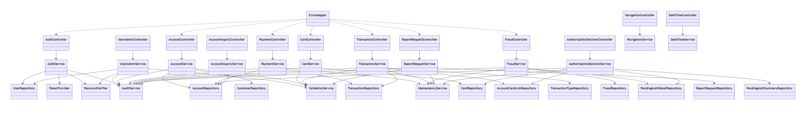

8.5 DTO Design
Common DTOsApiResponse<T>ApiErrorResponsePageResponse<T>FieldErrorMetaInfo
Auth DTOsLoginRequestLoginResponseAuthContextResponse
User DTOsCreateUserRequestUpdateUserRequestUserResponse
Account DTOsUpdateAccountRequestAccountDtoCustomerDtoAccountCompositeResponseUpdateAccountResponse
Payment DTOsBillPaymentRequestPaymentPreviewResponseBillPaymentResponse
Card DTOsCardSearchQueryCardSummaryResponseCardResponseUpdateCardRequestUpdateCardResponse
Transaction DTOsCreateTransactionRequestCreateTransactionResponseTransactionSummaryResponseTransactionResponseCopyLastTransactionRequestCopyLastTransactionResponse
Pending Auth / Fraud DTOsPendingAuthorizationSummaryResponsePendingAuthorizationDetailResponseFraudActionRequestFraudActionResponseFraudRecordResponse
Report DTOsCreateReportRequestReportRequestResponse

8.6 Domain Model Notes
Mutable AggregatesUserAccountCustomerCardTransactionTypePendingAuthDetailReportRequest
Append-Only / Mostly ImmutableTransactionFraudRecordJobRunStatementOutput
Composite Read ModelsAccountCompositePendingAuthorizationSummaryView

9. Detailed Business Logic
This section gives step-by-step processing rules and conditional branches.

9.1 Authentication Logic
StepsAccept userId and passwordTrim and validate both are presentLookup user by userIdIf not found → authentication failureCompare password using secure hash verificationIf mismatch → authentication failureValidate user typeGenerate token/sessionResolve landing page:ADMIN → Admin MenuSTANDARD → Main MenuReturn response
Decision Pointsuser exists?password matches?user type valid?
State Effectsaudit success/failureauthenticated context created only on success
Edge Handlingif user type invalid, return system/business error and deny login

9.2 Main/Admin Menu Validation Logic
StepsRead current authenticated roleLoad menu configurationValidate option exists in role menuValidate user has permissionReturn route target
Decision Pointsvalid option?authorized?installed/available?
Failure Outcomesinvalid optionno accessoption unavailable

9.3 User Create Logic
StepsValidate all required fieldsNormalize first/last name and userIdVerify userType in {ADMIN, STANDARD}Query existing user by userIdIf exists → conflictHash passwordInsert row with audit columnsReturn created userId
Decision Pointsduplicate user?valid user type?password policy extension applicable?
Edge Casesduplicate submissionwhitespace-only names after trim

9.4 User Update Logic
StepsValidate path userId and request bodyLoad current userIf not found → 404Compare versionIf mismatch → conflictNormalize incoming valuesCompare against existing valuesIf unchanged → no-change business errorRe-hash passwordUpdate rowIncrement versionAudit update
Decision Pointsexists?version match?no change?

9.5 Account Inquiry Logic
StepsValidate accountId formatLoad accountIf not found → 404Load linked customerIf customer missing → composite not found/incompleteMask sensitive fieldsReturn composite response
Decision Pointsaccount exists?customer exists?

9.6 Account Update Logic
StepsValidate accountId and request bodyLoad account and customerVerify both existVerify versions match current recordsNormalize request valuesDetect no changeValidate each changed fieldBegin transactionUpdate accountUpdate customerCommit transactionReturn new versions
Validation Areasaccount financial valuesaccount datescustomer namescustomer address fieldscredit scoreDOBphone valuesprimary card holder indicator
Decision Pointsversion conflict?no change?field validation failures?DB update partial failure?
Recoveryrollback on any write failure

9.7 Bill Payment Logic
StepsValidate accountId and confirmationEnsure confirmation = YCheck idempotency keyLoad accountIf not found → 404If currentBalance <= 0 → business errorpaymentAmount = currentBalanceBegin transactionInsert payment transactionUpdate account balance to zero or reduced valueCommitStore idempotent responseAudit payment
Decision Pointsidempotency hit?payable balance positive?transaction insert success?account update success?
Edge Casesduplicate submitsbalance changed between preview and submitdownstream DB timeout after insert before commit

9.8 Card Search Logic
StepsValidate optional accountId/cardNumber filtersBuild search criteriaExecute paginated queryMask card number in list resultsReturn list
Decision Pointsboth filters supplied?no result?page boundary?

9.9 Card Update Logic
StepsValidate cardNumber path and request bodyValidate accountId matchLoad cardIf not found → 404Compare versionDetect no changeValidate:cardName alphabet + spacesactiveStatus Y/NexpiryMonth 1..12expiryYear validUpdate cardIncrement versionAudit
Decision Pointsversion conflict?no change?invalid cardName?invalid expiry?

9.10 Transaction Add Logic
StepsValidate request bodyEnsure confirmation = YEnsure at least accountId or cardNumber is presentCheck idempotency keyResolve missing identifier if neededIf both provided, ensure linkage validValidate transaction type/category/sourceValidate amount > 0Validate datesGenerate transaction IDInsert transactionStore idempotency resultAudit
Decision Pointslinkage found?valid references?valid dates?duplicate request?
Edge Casesambiguous derivationbackdated/future dates

9.11 Transaction Type Maintenance Logic
ListValidate filtersQuery paged reference dataReturn result
CreateValidate typeCode + descriptionCheck uniquenessInsert rowAudit
UpdateLoad rowVersion checkNo-change checkUpdate rowAudit
DeleteCheck existenceCheck reference integrity if enforcedDelete or mark inactiveAudit

9.12 Pending Authorization Inquiry Logic
Summary/ListValidate accountIdLoad accountLoad customerLoad summary rowLoad paged detail rowsReturn combined view
DetailValidate authorizationIdLoad detail rowReturn detail
Next ItemResolve current ordering contextQuery next rowReturn next detail or boundary response

9.13 Fraud Mark/Unmark Logic
Mark FraudValidate authorizationIdCheck idempotency keyLoad pending auth detailIf not found → 404If already marked:return idempotent current-state successInsert fraud record action = MARKUpdate parent fraud_flag = YCommitSave idempotent responseAudit
Unmark FraudSame flow, setting:action = UNMARKfraud_flag = N
Decision Pointsexisting state already same?detail exists?history preserved?

9.14 Report Request Logic
MonthlyValidate reportType = MONTHLYDerive first day and last day of current monthPersist requestEnqueue/report processReturn requestId
YearlyValidate reportType = YEARLYDerive first and last day of current yearPersist/enqueueReturn
CustomValidate startDate and endDate existValidate calendar datesValidate startDate <= endDatePersist/enqueueReturn
Common Decision Pointsconfirmation valid?idempotency hit?queue/persistence available?

9.15 Authorization Decision Logic
StepsValidate request and idempotency keyResolve account/card/customer/linkageIf linkage invalid → decline or reject based on final policyEvaluate amount against eligibility/financial controlsDetermine decision:APPROVEDECLINEBegin transactionUpsert summaryInsert detailCommitSave idempotency responseReturn response code
Decision Pointslinkage valid?available amount sufficient?pending auth write successful?
Recoveryrollback summary/detail writes on failure

9.16 Background Job Logic
Daily Transaction ValidationRead input batchFor each record:validate syntaxvalidate linkageroute to valid staging or error outputUpdate job status
Daily Transaction PostingRead staged valid recordsFor each record:update account balancesupdate category balances if modeledinsert transactionCommit in batchesRecord rejects/failures
Interest ProcessingRead eligible accountsResolve interest rate or fallbackCompute amountInsert interest transactionUpdate account balances and cycle values
ExportRead all source entitiesMap each to common export structureWrite consolidated output
ImportRead consolidated inputDetect record typeRoute to target output/stagingWrite unknown types to error output
CleanupQuery expired pending auth rowsDelete eligible rows in batchesReconcile summaries if required

10. State Transition Diagrams

10.1 User Session State
Not supported language -10 lines
mermaid
stateDiagram-v2
[*] --> Unauthenticated
Unauthenticated --> Authenticating : Submit login
Authenticating --> Authenticated : Login success
Authenticating --> Unauthenticated : Login failure
Authenticated --> SessionExpired : Timeout / token invalid
Authenticated --> LoggedOut : Logout
SessionExpired --> Unauthenticated : Re-login required
LoggedOut --> Unauthenticated
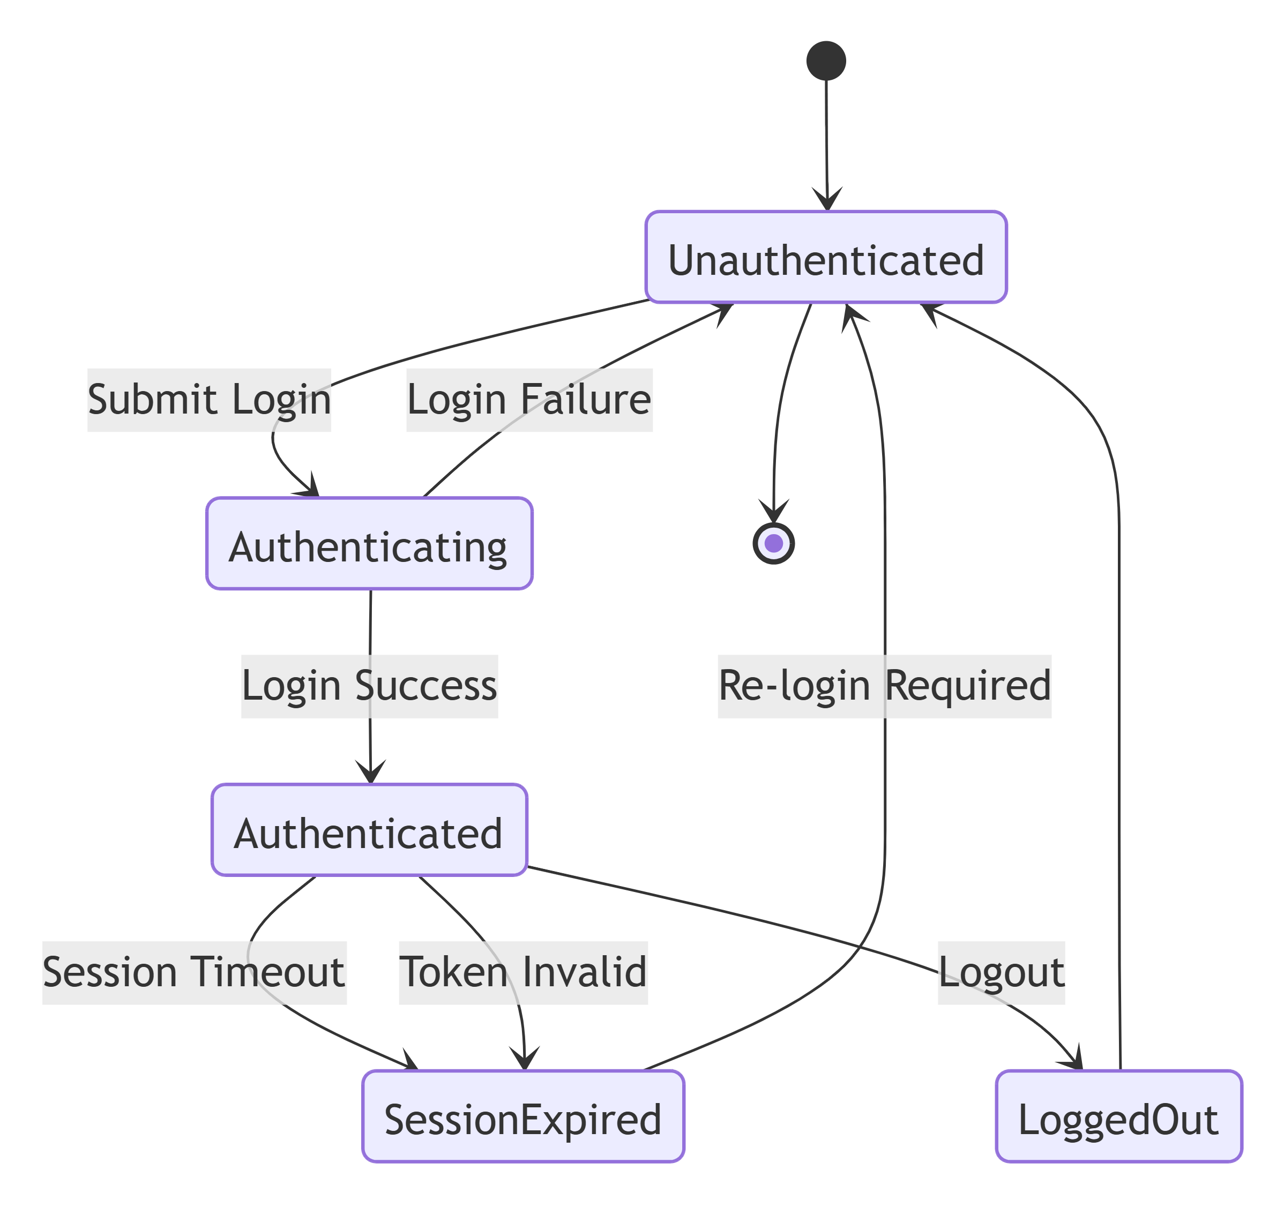
TraceabilityBRD 6.1

10.2 User Record State
Not supported language -7 lines
mermaid
stateDiagram-v2
[*] --> NonExistent
NonExistent --> Active : Create user
Active --> Active : Update user
Active --> Deleted : Delete user
Deleted --> [*]
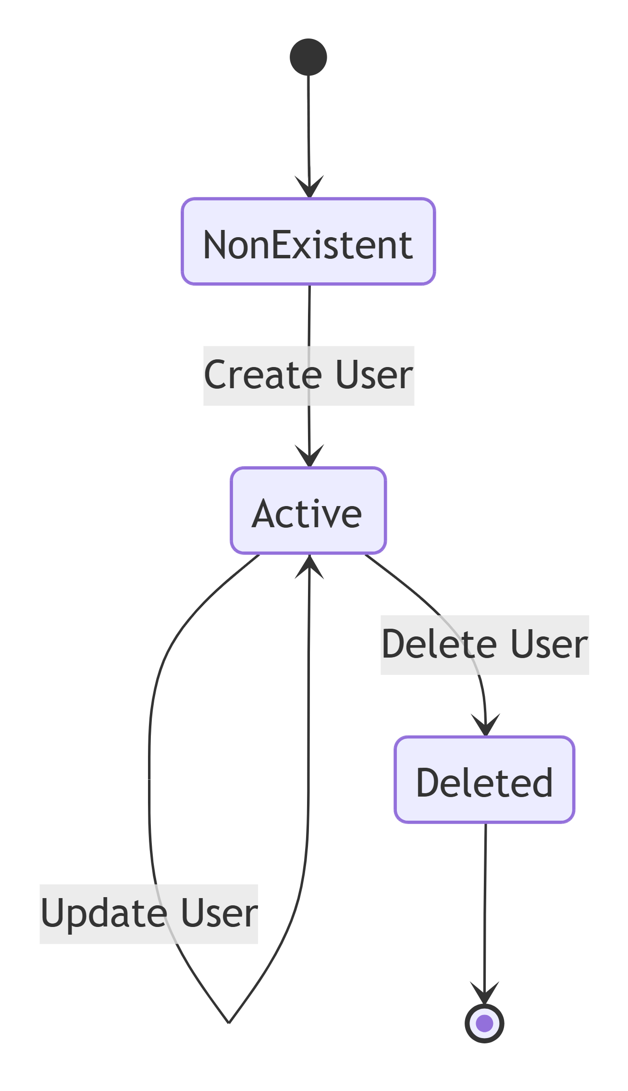
Note: Inactive/Locked are technical extension states if used.

10.3 Account Update Interaction State
Not supported language -16 lines
mermaid
stateDiagram-v2
[*] --> NotLoaded
NotLoaded --> Loaded : Retrieve account
Loaded --> Editing : Modify fields
Editing --> ValidationFailed : Invalid input
ValidationFailed --> Editing : Correct fields
Editing --> NoChange : Save with unchanged data
Editing --> Conflict : Version mismatch
Editing --> Saving : Save valid changes
Saving --> Saved : Commit success
Saving --> SaveFailed : DB failure
NoChange --> Editing : Further modify
Conflict --> Loaded : Reload latest data
SaveFailed --> Editing : Retry after correction
Saved --> [*]
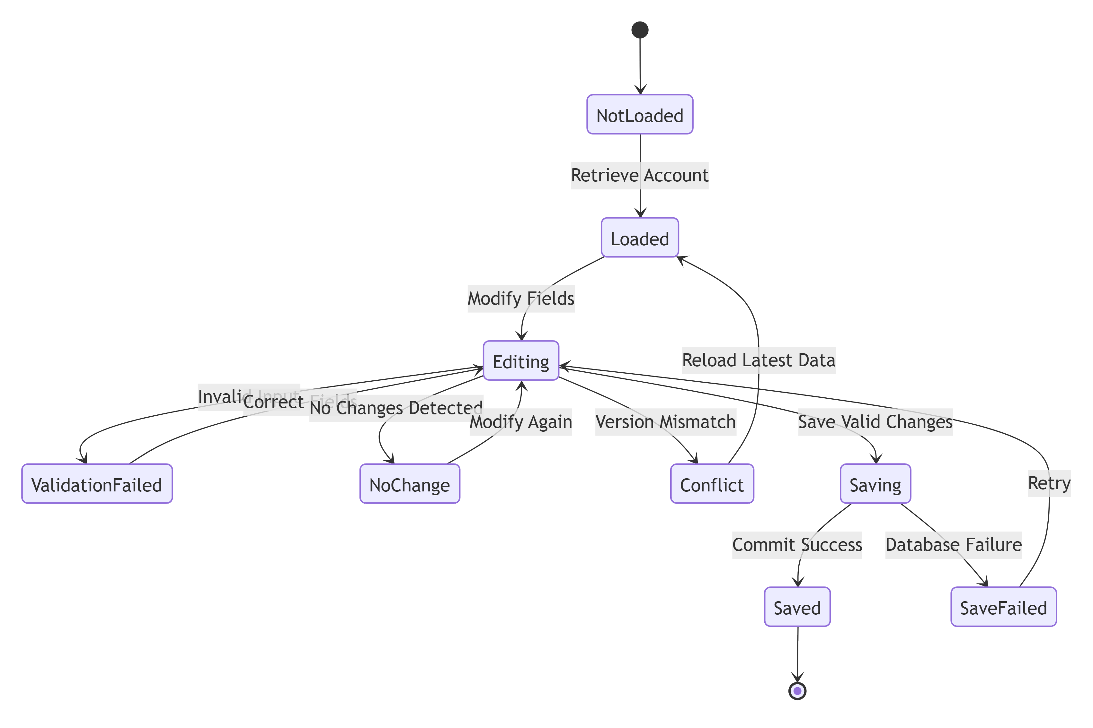
TraceabilityBRD 6.5.2

10.4 Card State
Not supported language -8 lines
mermaid
stateDiagram-v2
[*] --> Active
Active --> Inactive : activeStatus = N
Inactive --> Active : activeStatus = Y
Active --> Expired : expiry date passed
Inactive --> Expired : expiry date passed
Expired --> Active : card renewed/reactivated by valid update
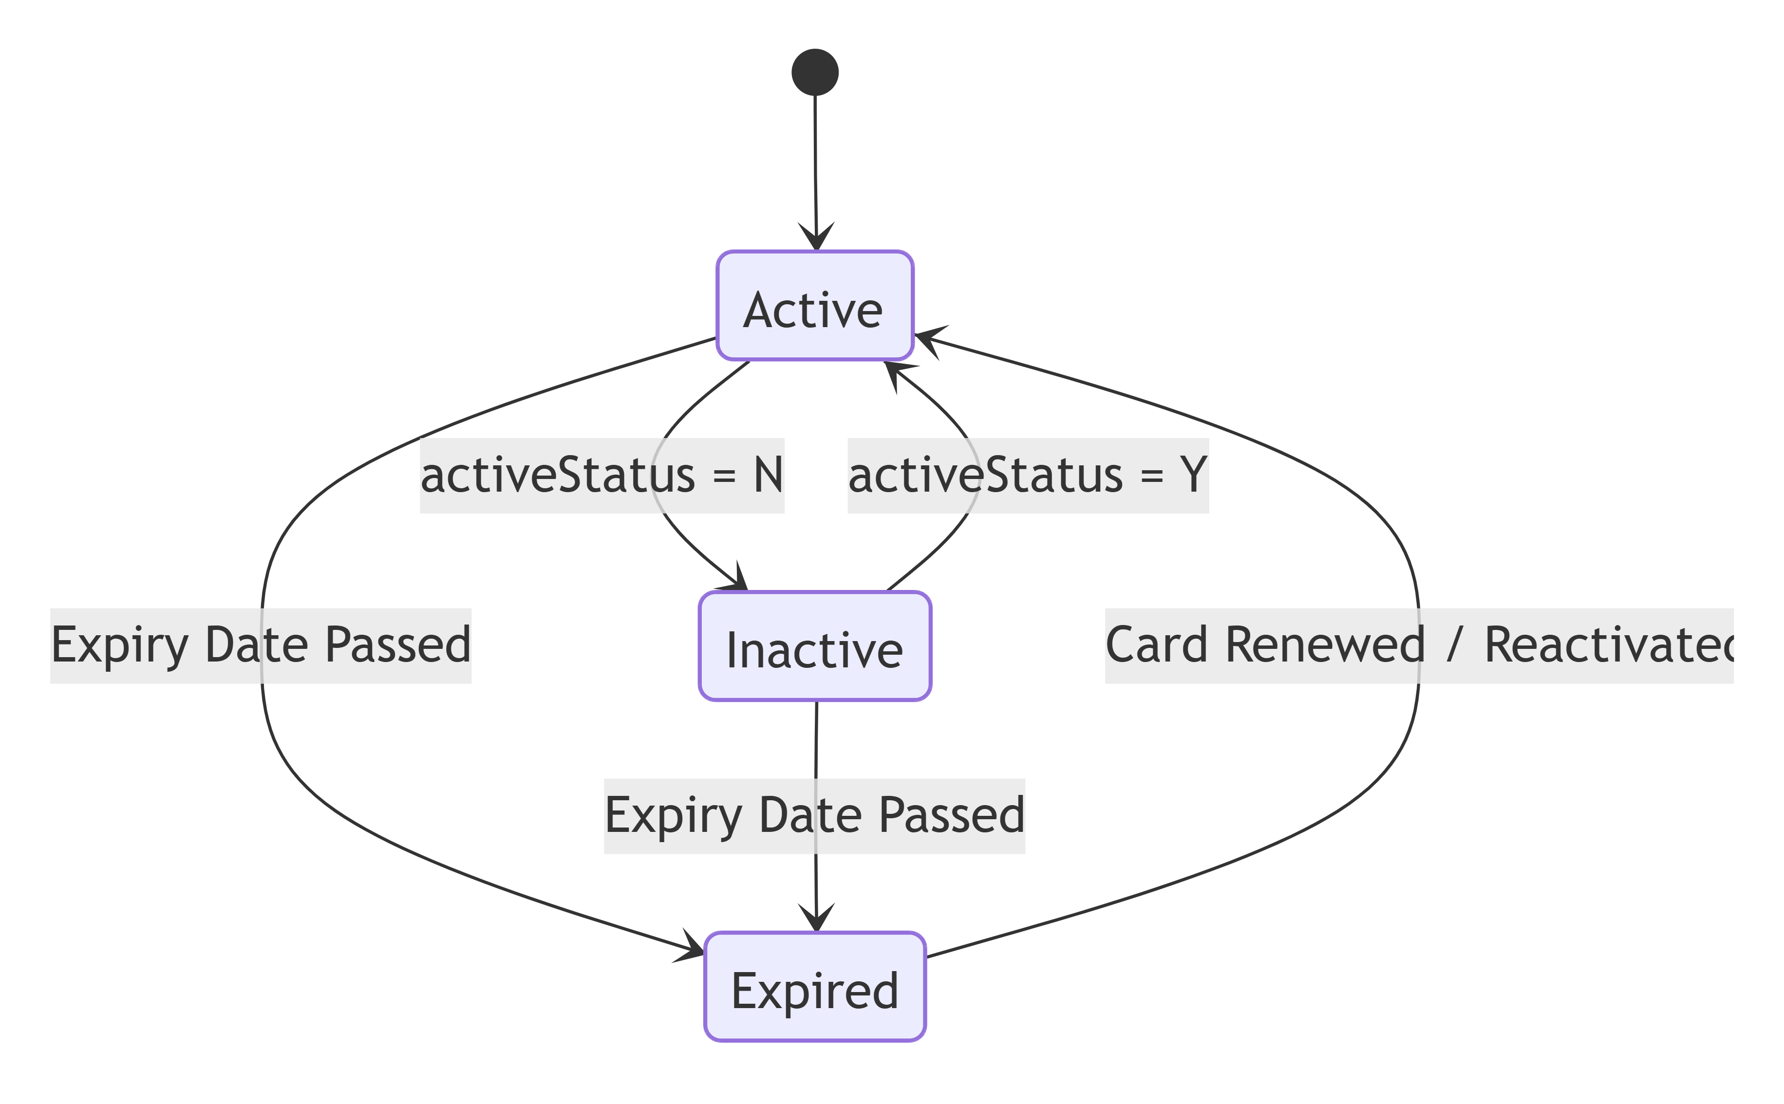
NoteBRD explicitly shows active status and expiry values, but not full operational lifecycle rules. This state model is implementation-supportive.

10.5 Bill Payment Process State
Not supported language -12 lines
mermaid
stateDiagram-v2
[*] --> Initiated
Initiated --> Previewed : Account found and balance loaded
Previewed --> Rejected : Balance <= 0
Previewed --> Confirmed : User confirms payment
Confirmed --> Processing : Create payment
Processing --> Completed : Transaction + balance update success
Processing --> Failed : Processing error
Rejected --> [*]
Failed --> [*]
Completed --> [*]
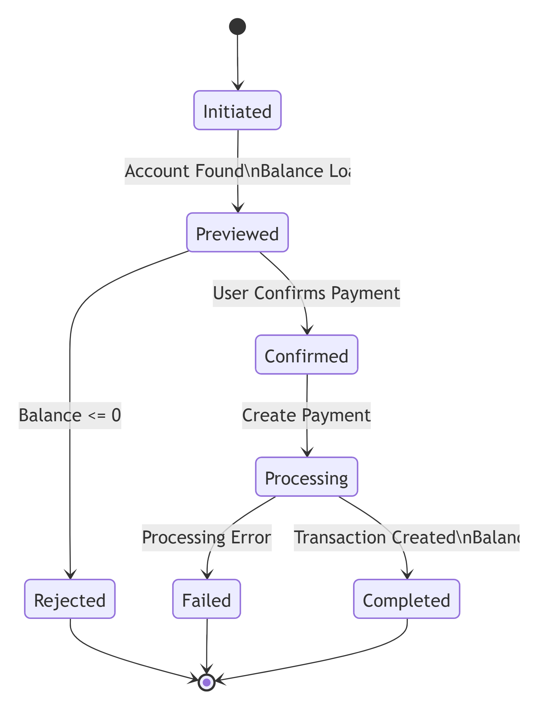
TraceabilityBRD 6.5.3

10.6 Transaction Creation State
Not supported language -14 lines
mermaid
stateDiagram-v2
[*] --> Draft
Draft --> ValidationFailed : Invalid fields
ValidationFailed --> Draft : Correct inputs
Draft --> Confirmed : Confirmation = Y
Confirmed --> ResolvingLinkage : Resolve account/card
ResolvingLinkage --> Rejected : Linkage invalid
ResolvingLinkage --> Creating : Linkage valid
Creating --> Created : Insert success
Creating --> Failed : Insert failure
Rejected --> [*]
Failed --> [*]
Created --> [*]
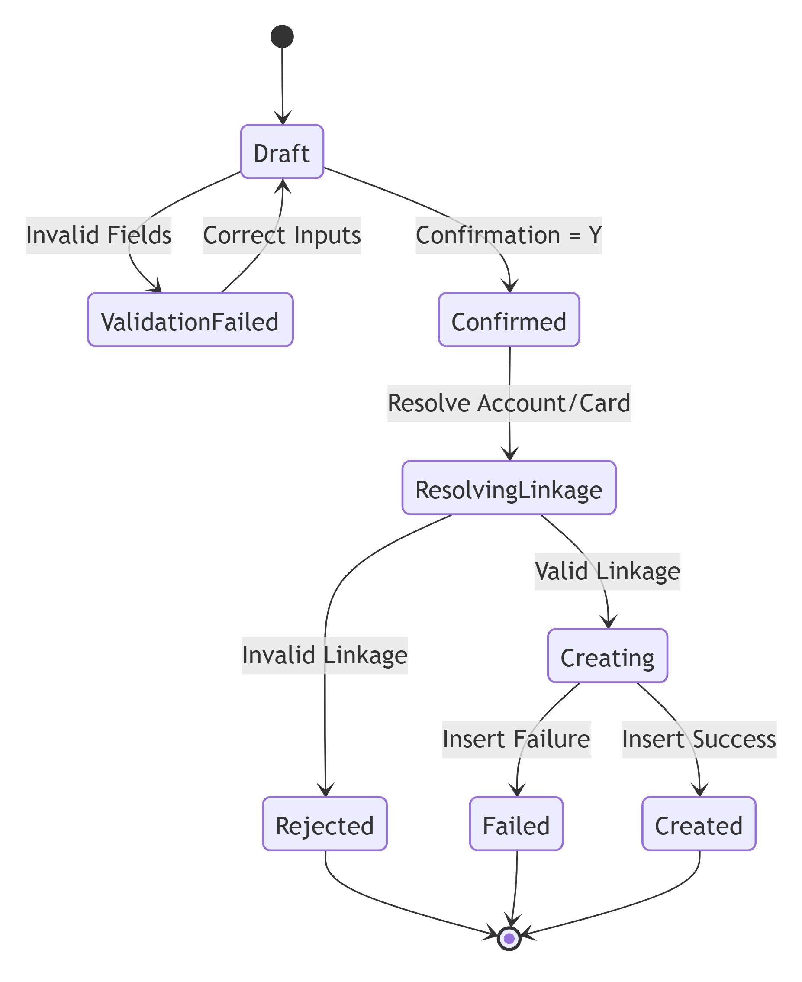
TraceabilityBRD 6.7.3

10.7 Pending Authorization State
Not supported language -11 lines
mermaid
stateDiagram-v2
[*] --> Pending
Pending --> Reviewed : User opens detail
Reviewed --> FraudMarked : Mark fraud
FraudMarked --> FraudUnmarked : Unmark fraud
Reviewed --> Expired : Cleanup retention reached
Pending --> Expired : Cleanup retention reached
FraudMarked --> Expired : Cleanup retention reached
FraudUnmarked --> Expired : Cleanup retention reached
Expired --> [*]
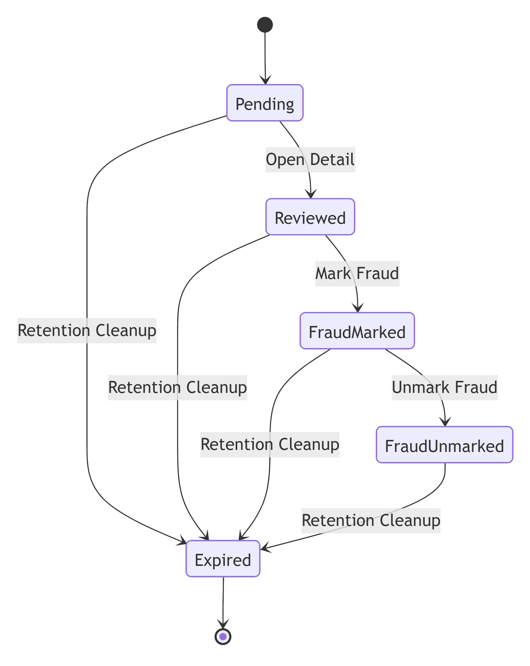
TraceabilityBRD 6.9, 6.17.1

10.8 Fraud Record State
Not supported language -5 lines
mermaid
stateDiagram-v2
[*] --> NotFlagged
NotFlagged --> Flagged : MARK action
Flagged --> NotFlagged : UNMARK action
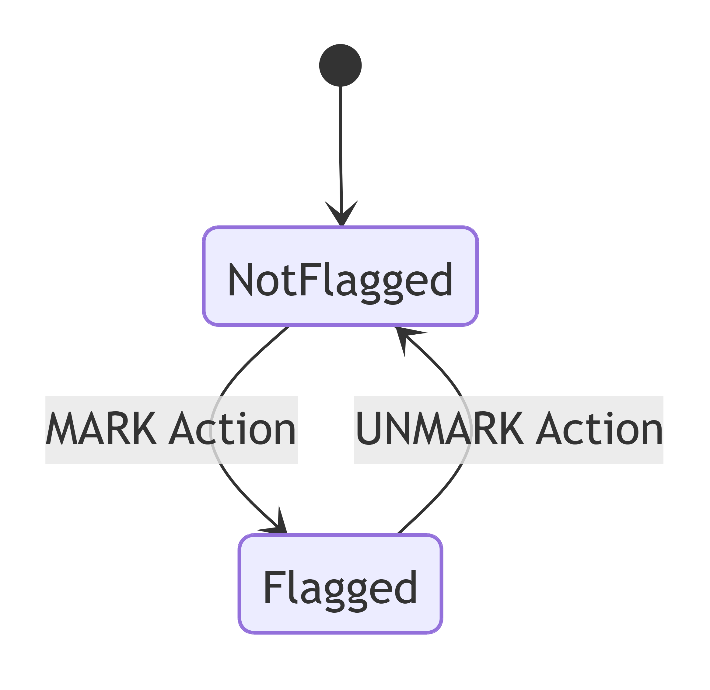

10.9 Report Request State
Not supported language -11 lines
mermaid
stateDiagram-v2
[*] --> Draft
Draft --> ValidationFailed : Invalid type/date/confirmation
ValidationFailed --> Draft : Correct request
Draft --> Submitted : Persist request
Submitted --> Processing : Background processor starts
Processing --> Completed : Output generated
Processing --> Failed : Job failure
Completed --> [*]
Failed --> [*]
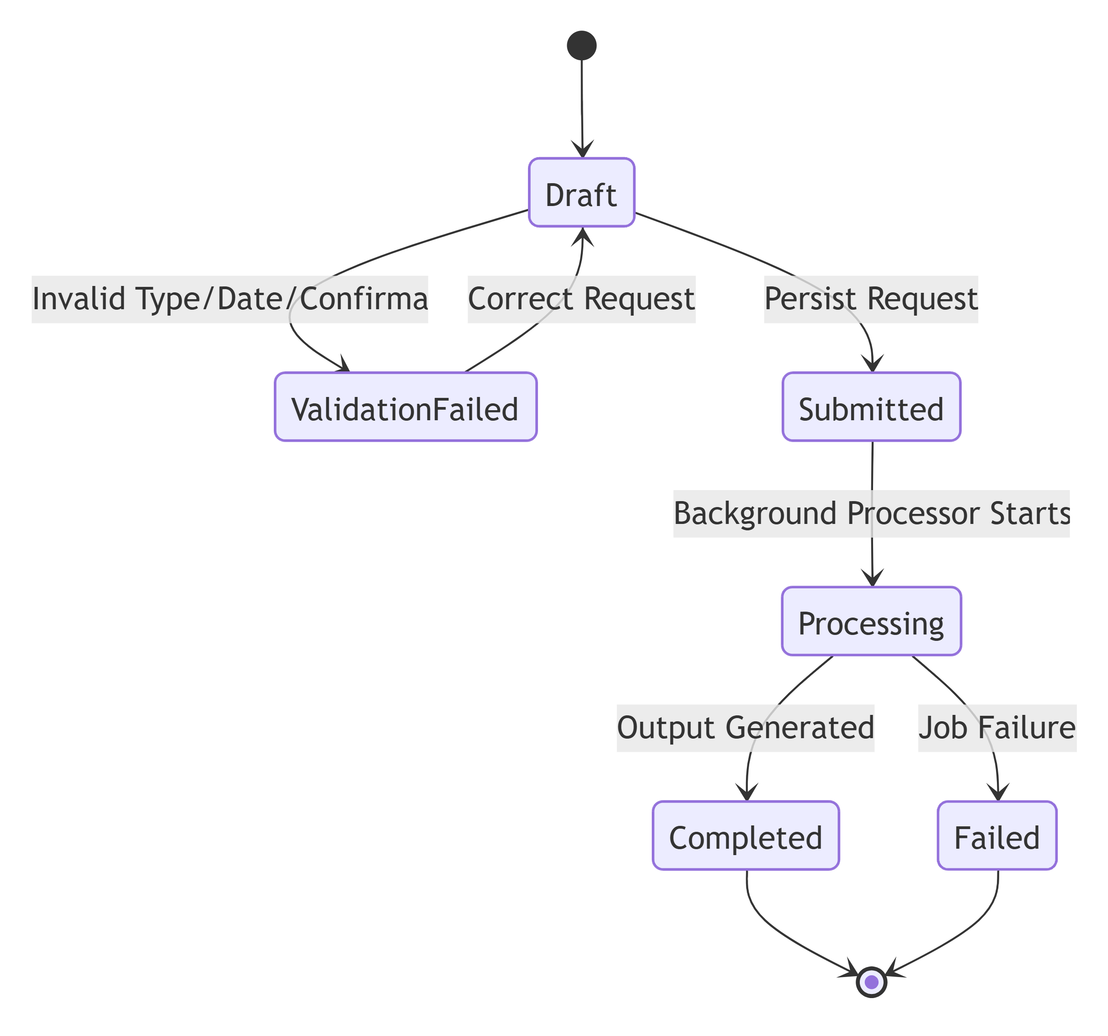
TraceabilityBRD 6.10, 6.16.2

10.10 Background Job Run State
Not supported language -10 lines
mermaid
stateDiagram-v2
[*] --> Accepted
Accepted --> Running : Job starts
Running --> Completed : Success
Running --> Failed : Error
Running --> Cancelled : Ops abort
Completed --> [*]
Failed --> [*]
Cancelled --> [*]
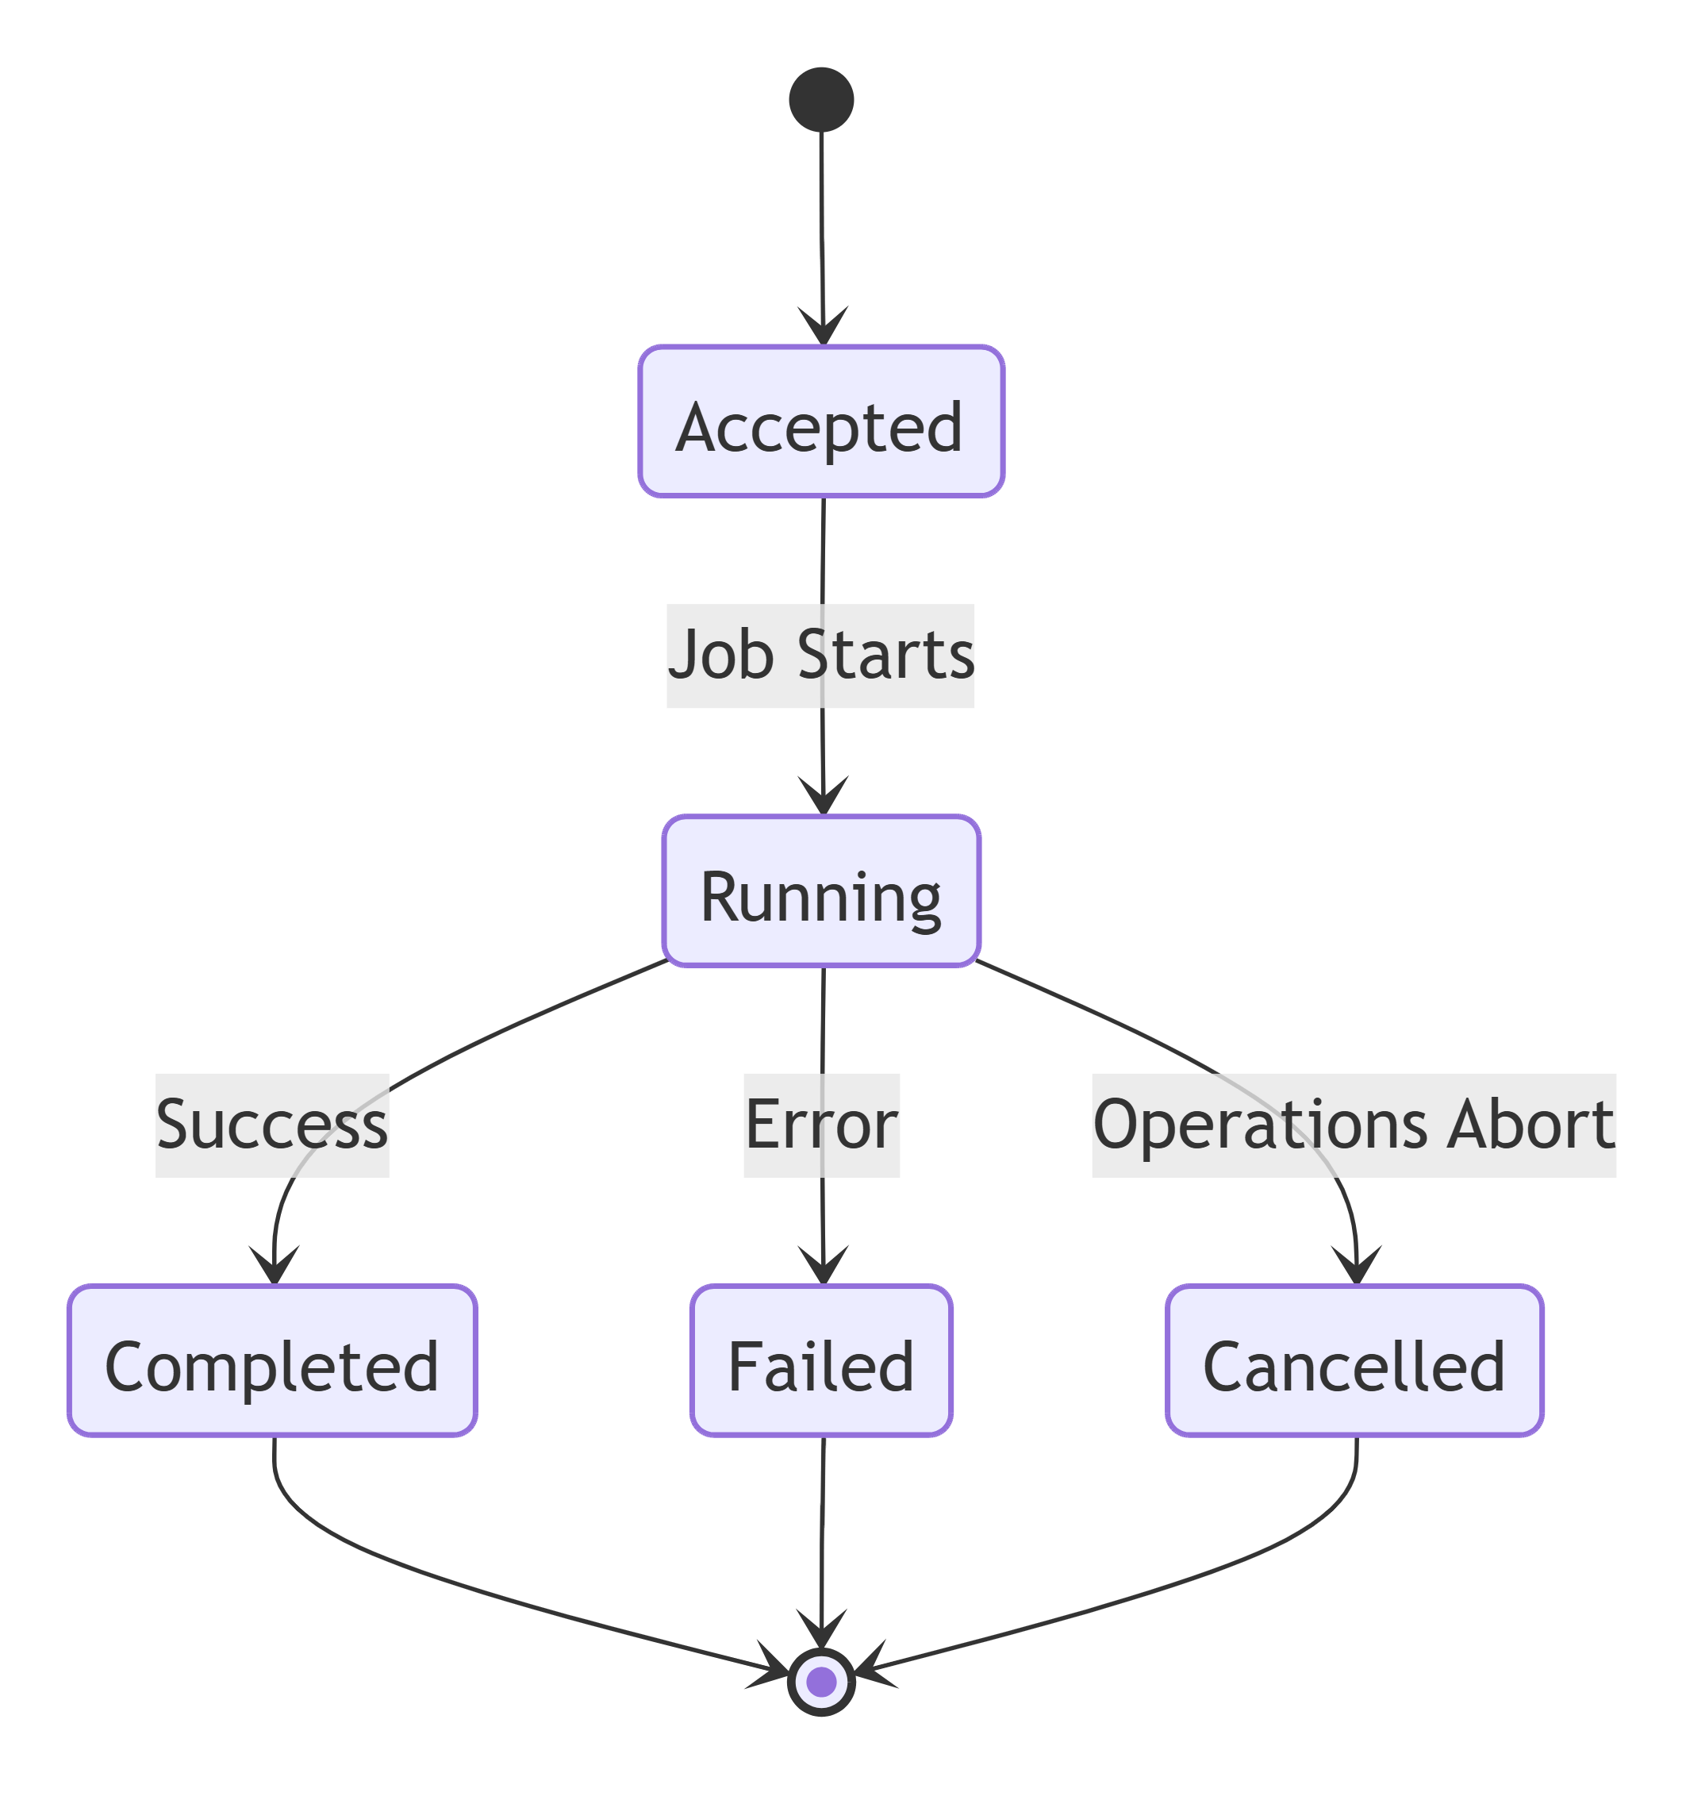
TraceabilityBRD 6.14–6.18job_runs.status

10.11 Authorization Decision State
Not supported language -15 lines
mermaid
stateDiagram-v2
[*] --> Received
Received --> Validating : Parse request
Validating --> Rejected : Invalid request/linkage
Validating --> Evaluating : Validation success
Evaluating --> Approved : Eligibility passed
Evaluating --> Declined : Eligibility failed
Approved --> Persisting : Write summary/detail
Declined --> Persisting : Write summary/detail
Persisting --> Completed : Persist success
Persisting --> Failed : Persist failure
Rejected --> [*]
Completed --> [*]
Failed --> [*]
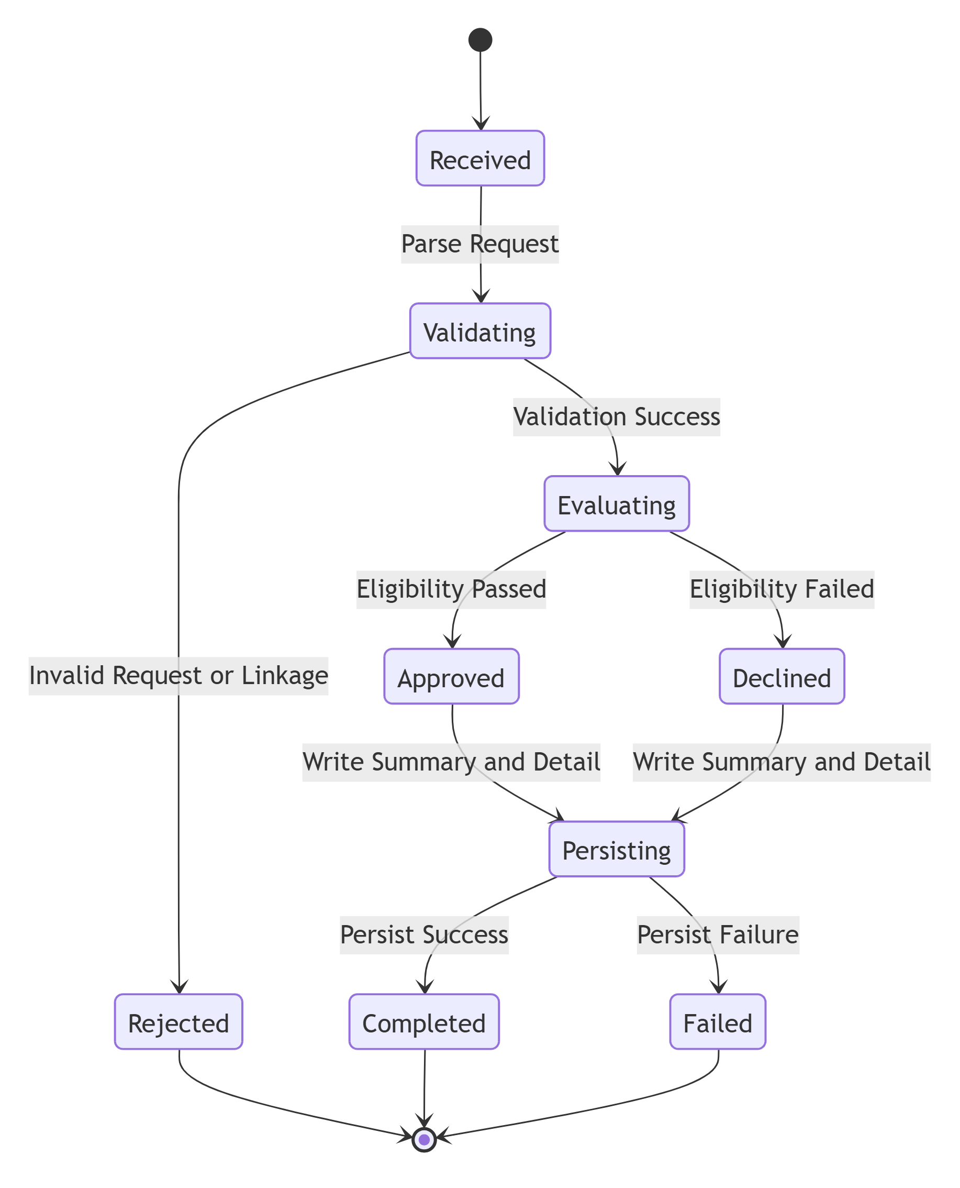

10.12 State Traceability Matrix
State Model | BRD | Architecture
User Session | 6.1 | Auth APIs
User Record | 6.4 | User admin service
Account Update Interaction | 6.5.2 | Account service/update flow
Card State | 6.6.3 | Card update
Bill Payment | 6.5.3 | Payment service
Transaction Creation | 6.7.3 | Transaction service
Pending Authorization | 6.9, 6.17 | Pending auth + cleanup
Fraud Record | 6.9.3 | Fraud service
Report Request | 6.10, 6.16.2 | Report request + reporting runtime
Background Job Run | 6.14–6.18 | job orchestration
Authorization Decision | 6.11 | authorization decision service

Low-Level Design — Part 5
Sections 11–18: Security, Exception Handling, Logging, Performance, Integration, Configuration, NFRs, Deployment

11. Security Design

11.1 Security Objectives
The CardDemo application handles:
- authentication credentials
- customer PII
- financial account data
- card data
- fraud actions
- administrative operations
Therefore the security design must support:
- strong authentication
- role-based authorization
- least privilege
- secure secret handling
- secure data transport
- sensitive data masking
- auditable privileged actions
- protection against replay and duplicate financial actions
TraceabilityBRD 4.2, 6.1, 6.4, 6.5, 6.6, 6.9Architecture 18, 20

11.2 Authentication Flow

11.2.1 Login Model
Because the BRD does not define token/session technology, the LLD recommends:
- HTTPS-only authentication
- credential submission through POST /api/v1/auth/login
- token-based session model using signed bearer token or secure server-side session
- short-lived access token
- optional refresh token/session renewal based on enterprise standards

11.2.2 Recommended Authentication Sequence
- User submits userId and password
- Backend verifies user existence
- Backend verifies password hash
- Backend resolves role and permissions
- Backend issues auth token/session
- UI stores token securely or receives secure cookie
- Protected API calls include auth context

11.2.3 Token/Session Design Recommendation
Preferred:
- short-lived access token
- signed token or opaque session ID
- user ID and role in auth claims
- request correlation ID independent of auth token

11.2.4 Session Timeout
Assumption-based recommendation:
- idle timeout enforced
- absolute timeout enforced
- expired token/session results in 401
- UI redirects to sign-on

11.2.5 Failed Login Protection
Recommended:
- rate limit by IP and userId
- repeated failures trigger temporary throttling
- security audit for repeated failures
Mermaid Authentication FlowNot supported language -20 lines
mermaid
sequenceDiagram
autonumber
participant U as User
participant UI as Sign-on UI
participant GW as API Gateway
participant AUTH as Authentication Service
participant DB as User Store
participant TOK as Token Provider
U->>UI: Enter credentials
UI->>GW: POST /auth/login
GW->>AUTH: Forward request
AUTH->>DB: Lookup user
DB-->>AUTH: User record
AUTH->>AUTH: Verify password
AUTH->>TOK: Generate token/session
TOK-->>AUTH: Token
AUTH-->>GW: Login success
GW-->>UI: Token/session response
UI->>UI: Store auth context
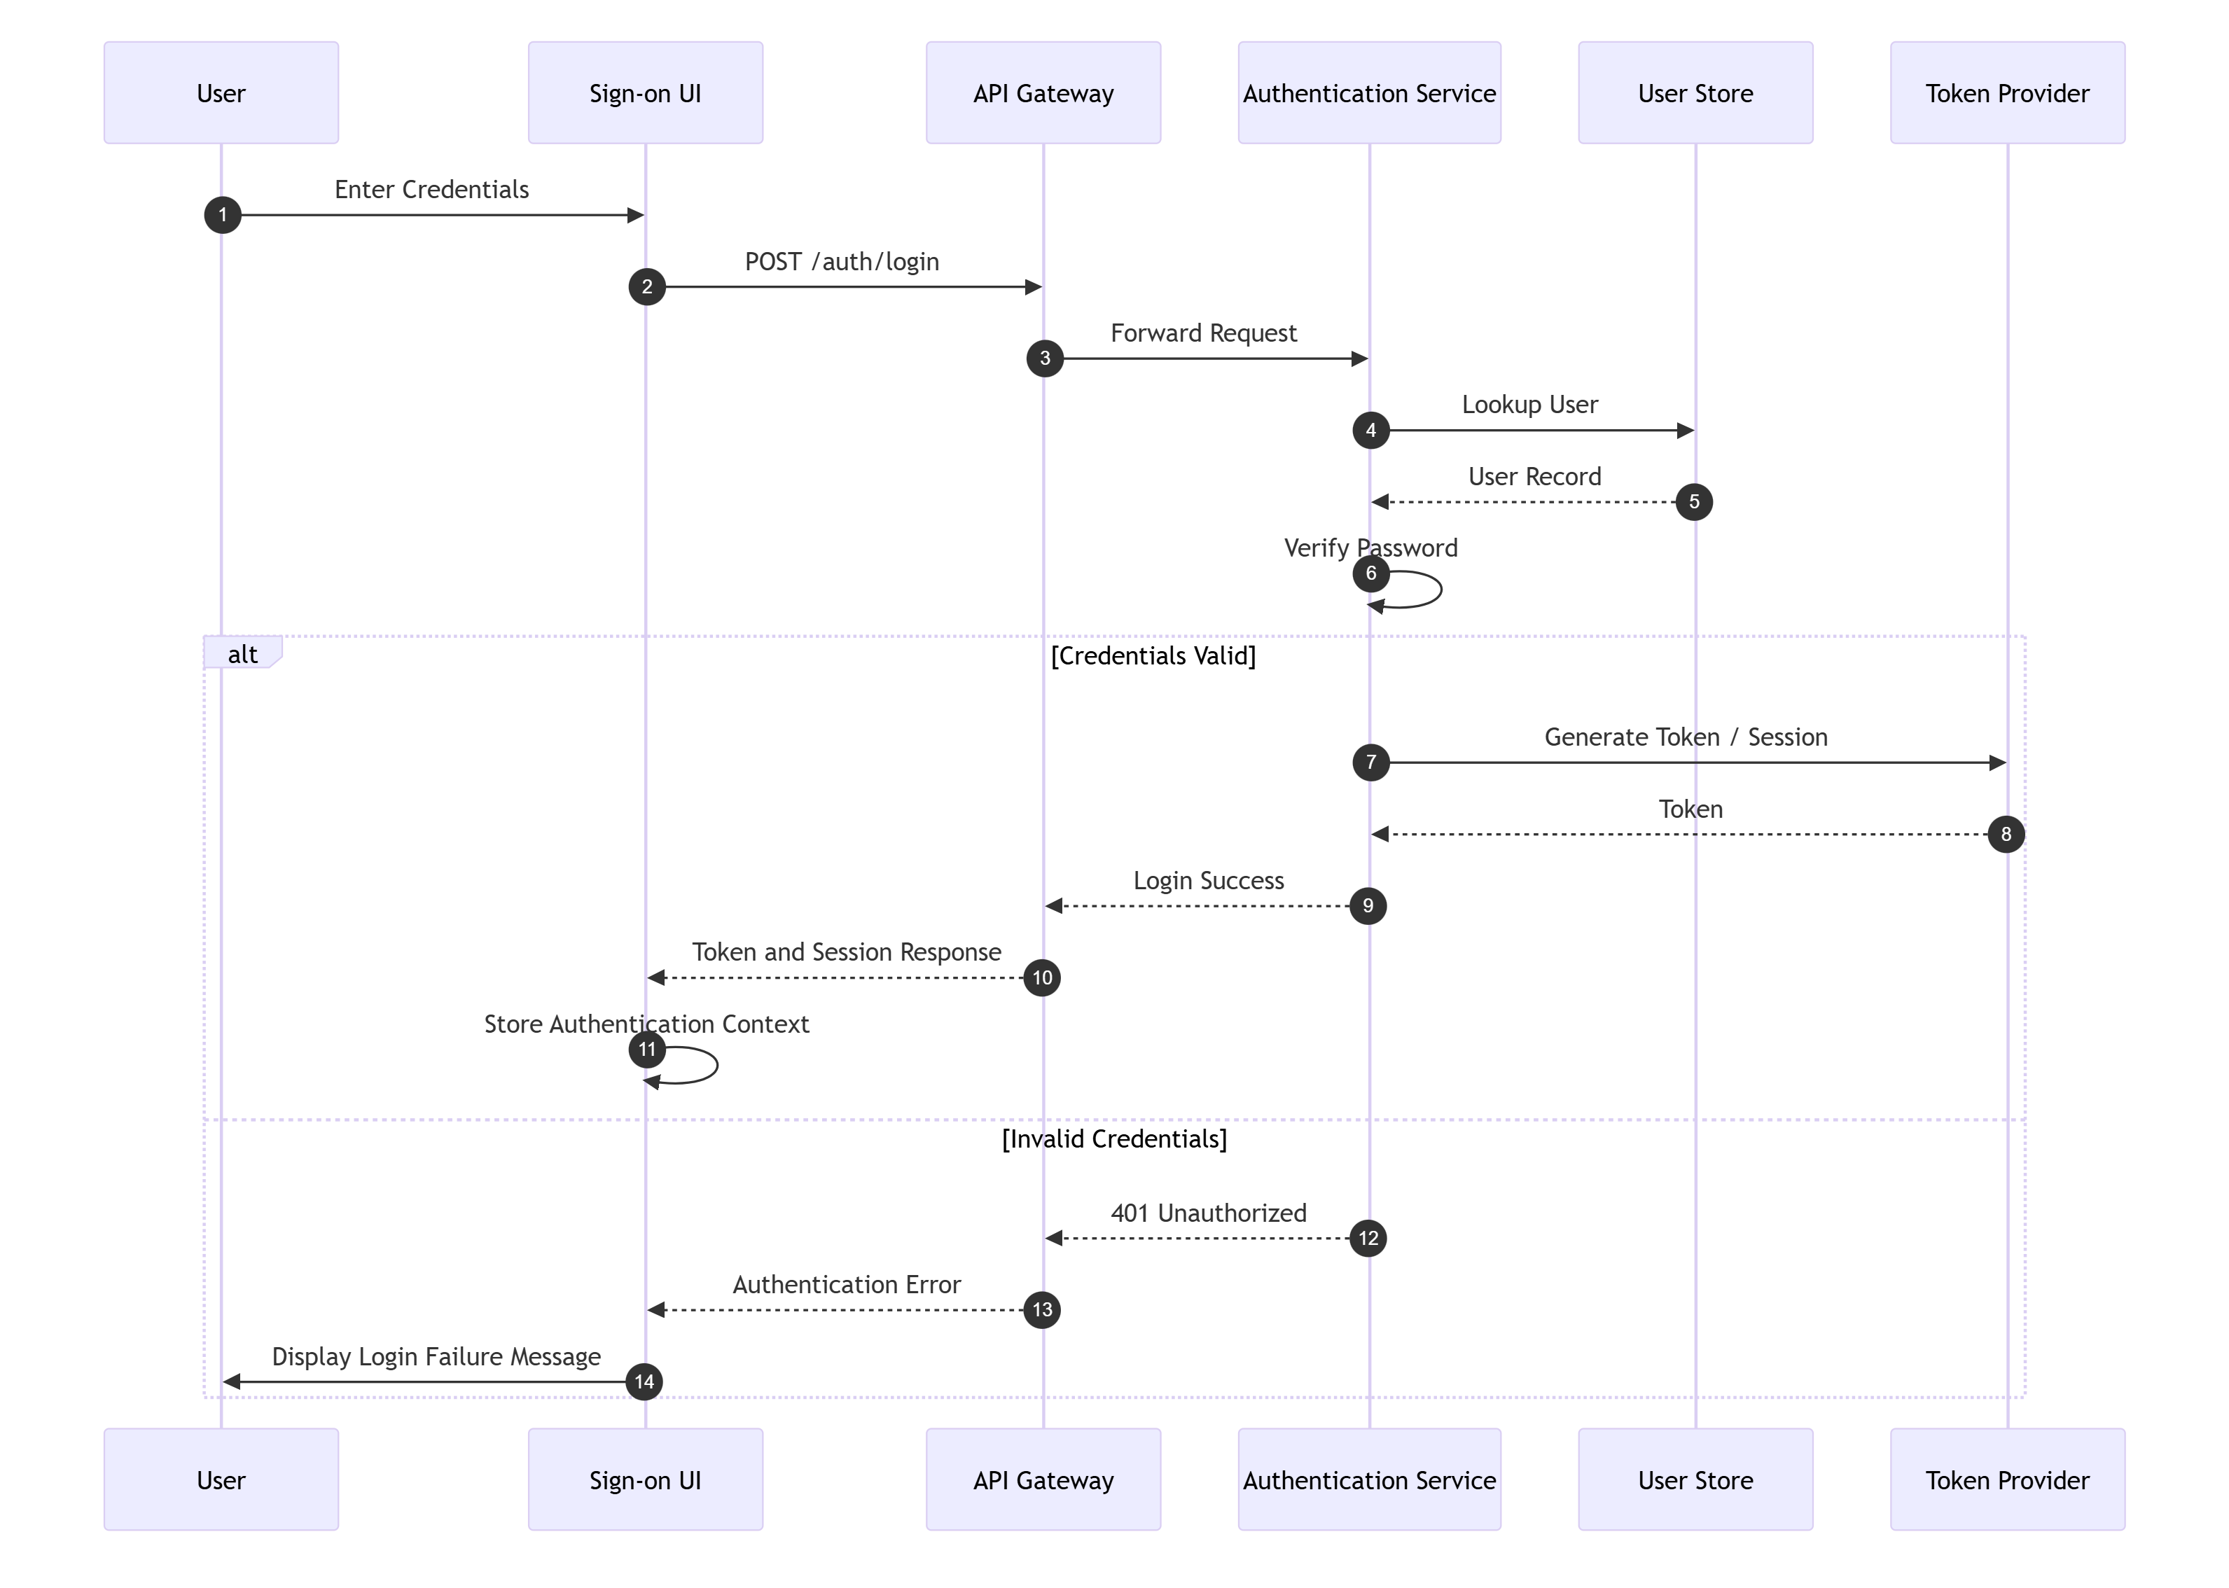

11.3 Authorization Model

11.3.1 Roles
Role | Description
ADMIN | administrative access including user admin and transaction type maintenance
STANDARD | standard operational user
SYSTEM | internal/external trusted service caller
OPS | operations user/service for background jobs

11.3.2 Permission Model
Recommended permission granularity:
Permission | Roles
AUTH_LOGIN | Public
MENU_MAIN_VIEW | STANDARD, ADMIN
MENU_ADMIN_VIEW | ADMIN
USER_LIST_VIEW | ADMIN
USER_CREATE | ADMIN
USER_UPDATE | ADMIN
USER_DELETE | ADMIN
ACCOUNT_VIEW | STANDARD, ADMIN
ACCOUNT_UPDATE | authorized STANDARD/ADMIN
BILL_PAYMENT | authorized STANDARD/ADMIN
CARD_VIEW | STANDARD, ADMIN
CARD_UPDATE | authorized STANDARD/ADMIN
TRANSACTION_VIEW | STANDARD, ADMIN
TRANSACTION_CREATE | authorized STANDARD/ADMIN
TXN_TYPE_VIEW | ADMIN
TXN_TYPE_MAINTAIN | ADMIN
PENDING_AUTH_VIEW | STANDARD, ADMIN
FRAUD_MARK | ADMIN or specially authorized role
REPORT_REQUEST_CREATE | STANDARD, ADMIN
REPORT_REQUEST_VIEW | STANDARD, ADMIN
AUTHZ_DECIDE | SYSTEM
ACCOUNT_INQUIRY_SERVICE | SYSTEM
DATETIME_SERVICE | SYSTEM / INTERNAL
OPS_JOB_TRIGGER | OPS, SYSTEM

NoteThe BRD does not explicitly define who may mark fraud. Conservative recommendation:restrict fraud marking/unmarking to ADMIN or dedicated operational role until clarified.

11.3.3 Authorization Enforcement Points
Authorization must be enforced at:
- UI route/menu level
- API gateway/interceptor level
- service-level method authorization
ExampleA standard user cannot invoke:
- POST /api/v1/admin/users
- PUT /api/v1/reference/transaction-types/{typeCode}

11.4 API Security

11.4.1 Transport Security
- HTTPS required for all environments beyond local development
- TLS termination at ingress/gateway
- internal service-to-service TLS recommended if distributed deployment

11.4.2 Request Security Controls
- validate content type
- maximum request size
- JSON schema validation
- path/query sanitization
- no insecure deserialization behavior
- replay protection for sensitive POSTs using idempotency keys

11.4.3 Sensitive Write Protection
For:
- bill payment
- transaction add
- fraud mark/unmark
- authorization decision
Require:
- authenticated identity
- authorization check
- idempotency key
- audit event
- structured error handling

11.4.4 CSRF Considerations
If cookie/session auth is used for browser flows:
- CSRF protection required on state-changing operations
If bearer tokens in header:
- CSRF less relevant, but XSS prevention becomes more critical

11.5 Data Protection

11.5.1 Sensitive Data Classification
Data | Sensitivity
password hash | highly sensitive
SSN | highly sensitive
government ID | highly sensitive
card number | highly sensitive
account number | sensitive
credit score | sensitive
DOB | sensitive
phone/address | sensitive

11.5.2 Data Masking Rules
Recommended response masking:
Field | Masking Rule
SSN | ***-**-1234
government_id | partial suffix only
card_number | show last 4 only
account_id | mask partially where not required in full
password | never returned

11.5.3 Encryption
Recommended:
- encryption in transit via TLS
- encryption at rest for DB volumes/backups
- column-level encryption for SSN/government ID if platform supports
- secrets stored in centralized secret manager

11.5.4 Data Minimization
- list APIs should not return raw sensitive values
- detail APIs should only return fields needed by UI/business flow
- logs must not contain raw sensitive values

11.6 Secrets Management
Secrets to Manage
- DB credentials
- token signing keys
- encryption keys
- external integration credentials
- service certificates
Storage Recommendations
- no secrets in source control
- inject via vault/secret manager/Kubernetes secret integration
- rotate regularly
- separate secrets by environment

11.7 Database Security
Controls
- dedicated application DB user
- least-privilege DB roles
- separate read/write privileges if applicable
- restrict DDL privileges
- audit access to sensitive tables
- non-prod masking/synthetic data recommended
Sensitive Tables
- users
- customers
- cards
- accounts
- fraud_records

11.8 Security Monitoring
Monitor:
- repeated login failures
- repeated 401/403 spikes
- idempotency conflict anomalies
- unusual fraud mark/unmark volume
- admin writes outside expected time windows
- repeated job trigger failures

11.9 Security Traceability Matrix
Security Area | BRD | Architecture
Login auth | 6.1 | 18
Role-based access | 4.2, 6.2, 6.3 | 18
Sensitive data protection | 6.5.1 | 18
Concurrency safety | 6.5.2, 6.6.3 | 18
Admin restrictions | 6.4, 6.8 | 18
Fraud action protection | 6.9 | 20 Q7

12. Exception Handling

12.1 Exception Handling Objectives
- map business failures consistently
- prevent leakage of internal details
- preserve audit and traceability
- distinguish validation, business, technical, and external failures
- support retry-safe behavior

12.2 Exception Categories
Category | Description | Example
Validation Exception | malformed input | invalid accountId format
Business Exception | valid request but rule violation | no balance to pay
Authentication Exception | invalid credentials | wrong password
Authorization Exception | not permitted | standard user accessing admin API
Not Found Exception | record missing | user not found
Conflict Exception | version/idempotency conflict | record changed by someone else
Technical Exception | internal failure | null pointer, serialization error
Database Exception | DB unavailable / constraint violation | deadlock, timeout
External Service Exception | downstream failure | auth decision dependency timeout

12.3 Standard Error Response Contract
json -11 lines
{
"success": false,
"errorType": "BUSINESS_RULE_ERROR",
"errorCode": "PAY-400-001",
"message": "You have nothing to pay",
"fieldErrors": [],
"meta": {
"requestId": "req-5002",
"timestamp": "2026-08-05T11:45:00Z"
}
}

12.4 Error Code Matrix
Error Code | Type | HTTP | Message | Recovery
AUTH-VAL-001 | Validation | 400 | User ID is required / Password is required | correct input
AUTH-401-001 | Authentication | 401 | User not found | verify userId
AUTH-401-002 | Authentication | 401 | Wrong password | retry with correct password
NAV-400-002 | Business | 400 | Enter a valid option number | choose valid menu option
USR-409-001 | Conflict | 409 | User already exists | use unique userId
USR-404-001 | Not Found | 404 | User not found | refresh selection
USR-409-002 | Conflict | 409 | Record changed by someone else | reload and retry
ACC-VAL-001 | Validation | 400 | Account must be a non-zero 11-digit number | fix accountId
ACC-400-002 | Business | 400 | No change detected | modify data
ACC-409-001 | Conflict | 409 | Record changed by someone else | reload
PAY-400-001 | Business | 400 | You have nothing to pay | no action
PAY-500-001 | Processing | 500 | Unable to update account | retry after support review
CARD-VAL-001 | Validation | 400 | Card name can only contain alphabets and spaces | fix input
CARD-409-001 | Conflict | 409 | Record changed by someone else | reload
TXN-VAL-001 | Validation | 400 | Invalid transaction input | correct input
TXN-400-001 | Business | 400 | Account/card linkage not found | correct linkage
RPT-VAL-001 | Validation | 400 | Start date is required for custom report | add date
AUTHZ-400-001 | Business | 200/400 | Authorization declined | no retry unless caller logic requires
JOB-409-001 | Conflict | 409 | Similar job already running | wait/review

12.5 Recovery Mechanisms by Exception Type
Exception Type | Recovery Strategy
Validation | return field errors, no retry
Business Rule | return explicit business message
Not Found | return 404, UI should refresh or navigate back
Conflict | client must re-fetch latest state
DB Timeout | bounded retry for safe operations
Deadlock | retry transaction internally where safe
External Timeout | retry with backoff if idempotent
Unknown System Error | log, alert, generic 500

12.6 Exception Mapping Design
Global Exception Handler Responsibilities
- map exceptions to standard API envelope
- attach request ID
- suppress stack traces from client responses
- log at correct severity
- route audit-worthy failures to audit logger if needed
PseudocodeNot supported language -19 lines
text
handleException(ex):
if ex is ValidationException:
return 400 errorResponse(...)
if ex is AuthenticationException:
return 401 errorResponse(...)
if ex is AuthorizationException:
return 403 errorResponse(...)
if ex is NotFoundException:
return 404 errorResponse(...)
if ex is ConflictException:
return 409 errorResponse(...)
if ex is BusinessRuleException:
return 400 errorResponse(...)
if ex is ExternalServiceException:
return 503 errorResponse(...)
else:
logError(ex)
return 500 genericErrorResponse(...)

12.7 Database Exception Handling
DB Failure | Handling
unique constraint violation | map to 409 if business duplicate
FK violation | map to 400/409 depending scenario
lock timeout | 409/503 depending context
deadlock | retry internally for safe write transactions
connection unavailable | 503/500

12.8 External Service Exception Handling
Applicable mainly to:
- authorization decision caller context
- account inquiry external/service callers
- background integrations
- file/queue systems
Controls
- timeout threshold
- bounded retries
- circuit breaker for repeated failures
- fallback only where business safe

13. Logging Strategy

13.1 Logging Objectives
- support debugging
- enable production troubleshooting
- correlate across distributed components
- support audit and security monitoring
- avoid leaking sensitive data

13.2 Log Levels
Level | Usage
DEBUG | local/dev troubleshooting, disabled/restricted in prod
INFO | normal request lifecycle, important business milestones
WARN | recoverable issues, validation anomalies, retries
ERROR | processing failures, unhandled exceptions
FATAL | unrecoverable service failure/startup failure if supported

13.3 Correlation and Trace Fields
Every log event should include:
- requestId
- traceId if tracing enabled
- spanId if tracing enabled
- userId where authenticated
- serviceName
- operationName
- durationMs
- statusCode
- errorCode if applicable
Example Structured Logjson -11 lines
{
"timestamp": "2026-08-05T12:25:00Z",
"level": "INFO",
"service": "transaction-service",
"operation": "createTransaction",
"requestId": "req-7003",
"traceId": "trace-abc-123",
"userId": "USR002",
"statusCode": 201,
"durationMs": 142
}

13.4 Request Logging
Log At Request Start
- method
- path
- requestId
- principal
- remote client identifier
- masked business identifiers if present
Log At Request End
- status
- duration
- result type
- errorCode if failed
Do Not Log
- password
- raw SSN
- full card number
- raw token
- unmasked government ID

13.5 Response Logging
- log summary only
- no full payload logging for sensitive APIs in production
- enable sampled payload logging only in controlled lower environments

13.6 Audit Logging
Must Audit
- login success/failure
- logout
- create/update/delete user
- account update
- bill payment
- card update
- transaction add
- transaction type maintenance
- fraud mark/unmark
- report request submission
- job trigger
Audit Event Structure
Field | Description
eventType | business event name
actorId | who performed action
targetId | record/business key affected
timestamp | event time
outcome | SUCCESS / FAILURE
metadata | minimal safe contextual data

13.7 Exception Logging
- include stack trace in internal logs only
- map to error code in client response
- attach requestId and principal
- security-sensitive exceptions should be logged carefully

13.8 Batch Logging
Background jobs should log:
- run start
- input source
- processed count
- success count
- failure count
- elapsed time
- output references
- terminal status

14. Performance Design

14.1 Performance Objectives
- low-latency online inquiry and update flows
- safe, efficient financial writes
- scalable list retrieval
- resilient batch processing
- efficient summary retrieval for pending authorizations and reports

14.2 Caching Strategy
Item | Cache? | Notes
menu configuration | Yes | small, role-based
transaction types | Yes | reference data changes infrequently
date/time | No | trivial to compute
account composite | Limited | short TTL only if consistency acceptable; generally avoid stale cache for updates
card detail | Limited | only if invalidated on update
report request status | Optional | short TTL
user profile/auth context | yes, session-scoped | token/session claim based

Cache Guidelines
- avoid caching mutable financial balances unless strict invalidation exists
- cache reference data aggressively
- use local in-memory or distributed cache depending deployment topology

14.3 Connection Pooling
- DB connection pooling required
- separate pools for online and batch workloads if same DB used
tune pool sizes per service profile:
- auth: moderate
- account/payment: moderate-high
- batch jobs: controlled to avoid starving OLTP

14.4 Database Optimization
Key Optimizations
- indexes defined in Part 3
- avoid N+1 queries in composite reads
- paginated queries with covered indexes
- use targeted updates with optimistic locking
- range partition large transaction-like tables if data volume warrants
Query Patterns to Optimize
- account composite retrieval
- card search by account/card number
- transaction list pagination
- pending auth by account
- report request status lookup
- job status lookup

14.5 API Optimization
Recommendations
- support pagination by default
- enforce max page size
- avoid oversized list payloads
- use projection queries for list screens
- return masked values only where possible
- avoid over-fetching related collections unless needed

14.6 Bulk Processing
Batch Recommendations
- process in chunks
- commit in configurable batches
- separate invalid records early
- support resumability where feasible
- write job summaries
Bulk Job Parameters
- batchSize
- commitInterval
- maxRetry
- fetchSize

14.7 Pagination Design
Standard Defaults
- page = 1
- pageSize = 20
- maxPageSize = 100
Applied To
- user list
- card list
- transaction list
- transaction type list
- pending authorization list

14.8 Lazy Loading vs Eager Loading
Use Case | Strategy
account inquiry | eager load account + linked customer
list screens | projection only
transaction detail | eager load full row only
pending auth summary | eager summary + page of details
fraud history | lazy if separate retrieval

14.9 Parallel Execution Opportunities
Where safe:
- account inquiry can read account and customer in parallel if repositories independent
- pending auth summary flow can read account/customer/summary in parallel
- export job can read sources in parallel if IO and DB limits allow
Do Not Parallelize Blindly
- balance-affecting writes
- same-transaction account/customer updates across separate transactional boundaries unless coordinated carefully

14.10 Timeout Recommendations
Operation | Timeout Recommendation
login | low, e.g. 2–5s
account inquiry | low-medium
bill payment | medium with strict DB timeout
authorization decision | low due to synchronous caller expectations
report submission | low
batch jobs | higher, job-level monitoring not request-level only

14.11 Retry Recommendations
Operation | Retry? | Notes
GET inquiry APIs | Yes | transient only
bill payment | Yes only with idempotency | never blind retry
add transaction | Yes only with idempotency | same
fraud mark/unmark | Yes only with idempotency | same
auth decision | Yes only with idempotency | critical
batch DB writes | selective | retry deadlocks, not business errors

15. Integration Design
The source documents evidence internal and external interfaces. This section formalizes them.

15.1 Integration Inventory
Integration | Direction | Purpose
Authorization request source | Inbound | send auth decision requests
Account inquiry caller | Inbound | request account info
Date/time caller | Inbound/Internal | request current datetime
Daily transaction input source | Inbound | provide daily transactions
Consolidated import input | Inbound | provide import records
Consolidated export consumer | Outbound | receive export file
Statement output consumers | Outbound | consume generated statements
Report output consumers | Outbound | consume report outputs
Pending auth migration files | Both | load/unload pending auth data

15.2 Inbound Integration — Authorization Decision
Interface DescriptionSynchronous API for authorization approval/decline.
Authentication
- service credential / mTLS / signed token
- allowlist trusted callers
PayloadDefined in Part 2:
- accountId
- cardNumber
- amount
- merchant data
- requestTimestamp
Retrycaller may retry only with same idempotency key
Timeoutstrict low timeout
Circuit Breaker
- not usually applied inbound; handled at caller side
- service should shed load gracefully if degraded
Error Handling
- invalid request → 400
- decline business result → business-coded response
- technical failure → 503/500
Monitoring
- latency
- approval/decline rate
- duplicate idempotency hits
- failure rate
Sequence DiagramNot supported language -12 lines
mermaid
sequenceDiagram
participant Caller
participant GW as API Gateway
participant ADEC as Authorization Decision Service
participant DB as Database
Caller->>GW: Authorization request
GW->>ADEC: Forward authenticated request
ADEC->>DB: Validate linkage and write pending auth
DB-->>ADEC: Decision persisted
ADEC-->>GW: Decision response
GW-->>Caller: Approve/Decline
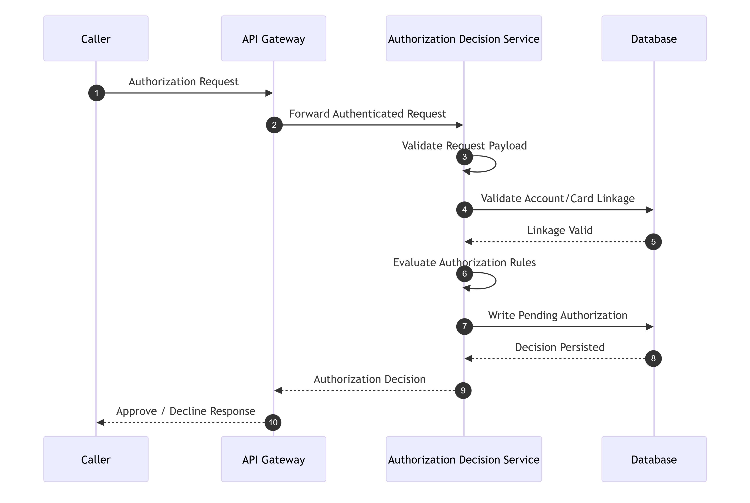

15.3 Inbound Integration — Account Inquiry Service
Interface DescriptionSynchronous service returning account information to another channel/process.
Authenticationservice auth required
PayloadaccountId
Retrysafe retry for transient failures
Timeoutshort-medium
Error Handling
- not found → 404
- invalid request → 400
- timeout → 503

15.4 Inbound/Internal Integration — Date/Time Service
Interface DescriptionReturns current system/application date-time.
Authenticationinternal or trusted service auth
Retrysafe
Timeoutvery low

15.5 Batch File Integration — Daily Transaction Input
Interface DescriptionReceives daily transaction input records for validation/posting.
Authentication
- file location/transport security
- secure storage access controls
Payloadbatch file/stream of transactionsrecord structure validated by validation job
Retry
- retry read on transient IO failure
- prevent duplicate posting by staging control
Timeoutjob-level timeout
Error Handling
- malformed records routed to error output
- job marked failed on unrecoverable source failure
Monitoring
- total records
- valid/invalid counts
- processing duration

15.6 Batch File Integration — Export
Interface DescriptionProduces consolidated export file from multiple sources.
Authenticationsecure outbound storage/write credentials
Payloadentity-typed export records
Retry
- retry write on transient storage issue
- avoid duplicate finalization without run control
Monitoring
- export file count
- bytes written
- completion status

15.7 Batch File Integration — Import
Interface DescriptionConsumes consolidated import data and routes records to entity-specific targets.
Error Handling
- unknown record types → error output
- malformed input → error output or failed job depending severity
Circuit Breakernot typically applicable; use job failure thresholds instead

15.8 Statement / Report Output Integrations
DescriptionGenerated outputs may be written to:
- file system
- object storage
- downstream delivery channel
Security
- secure write credentials
- encryption at rest
- access control on output locations
Monitoring
- completed outputs count
- failed outputs
- consumer pickup lag if applicable

15.9 Pending Auth Migration Integration
DescriptionBidirectional data movement between operational data and file-based forms.
Risks
- duplicate load/unload
- schema drift
- partial transformation
Controls
- run IDs
- checksums/count validation
- controlled load order
- reconciliation reporting

16. Configuration Management

16.1 Configuration Principles
- externalized, environment-specific
- no hard-coded secrets
- support safe overrides
- typed validation on startup

16.2 Configurable Items
Category | Key | Example
API | api.basePath | /api/v1
Security | security.token.ttlMinutes | 60
Security | security.login.maxAttempts | 5
Security | security.masking.enabled | true
DB | db.pool.maxSize | 30
DB | db.pool.minIdle | 5
Timeout | timeout.authDecision.ms | 3000
Timeout | timeout.accountInquiry.ms | 5000
Timeout | timeout.defaultDb.ms | 3000
Retry | retry.db.deadlock.maxAttempts | 3
Retry | retry.external.maxAttempts | 2
Retry | retry.external.backoffMs | 200
Pagination | pagination.defaultPageSize | 20
Pagination | pagination.maxPageSize | 100
Batch | batch.validation.batchSize | 500
Batch | batch.posting.commitInterval | 100
Batch | batch.interest.chunkSize | 1000
Cache | cache.menu.ttlSeconds | 3600
Cache | cache.txnTypes.ttlSeconds | 3600
Job | job.cleanup.retentionDays | 30
Job | job.report.schedulerCron | 0 0 * * *
Idempotency | idempotency.ttlHours | 24
Feature Flag | feature.copyLastTransaction.enabled | true
Feature Flag | feature.fraudHistory.enabled | true
Output | output.export.path | /data/export
Output | output.statement.path | /data/statements
Output | output.report.path | /data/reports

16.3 Feature Flags
Recommended flags:
- feature.copyLastTransaction.enabled
- feature.transactionTypeDeleteHard.enabled
- feature.fraudActionRestricted.enabled
- feature.accountCustomerBridge.enabled
- feature.statementMultiFormat.enabled

16.4 Environment Variables / Secret References
Variable | Purpose
DB_URL | database connection
DB_USERNAME | DB user
DB_PASSWORD_SECRET_REF | DB password secret
TOKEN_SIGNING_KEY_SECRET_REF | auth signing key
EXPORT_STORAGE_SECRET_REF | export storage credentials
IMPORT_STORAGE_SECRET_REF | import storage credentials

16.5 Config Validation on Startup
Application should fail fast if:
- DB config missing
- required secret missing
- page size config invalid
- timeout config malformed
- unsupported feature flag combination detected

17. Non-Functional Requirements

17.1 Performance
Requirements
- login and basic inquiry operations should be low latency
- list operations should paginate efficiently
- financial writes should complete within bounded time
- authorization decision service should respond quickly enough for synchronous caller expectations
Design Support
- indexing
- pagination
- connection pooling
- idempotency
- minimal transaction scope

17.2 Availability
Requirements
- online services should be highly available
- authorization decision and account inquiry services especially important
- batch failures should not necessarily disrupt online operations
Design Support
- stateless services behind load balancer
- health checks
- separate batch runtime
- graceful degradation

17.3 Scalability
Requirements
- scale horizontally for online services
- independently scale batch workloads
- support increasing transaction and pending auth volume
Design Support
- service decomposition
- partitioning for transaction-heavy tables
- caching for reference data
- externalized job runtime

17.4 Reliability
Requirements
- financial operations must avoid duplicate writes
- updates must prevent lost updates
- background jobs must expose terminal status
Design Support
- idempotency
- optimistic locking
- audit logging
- job run tracking

17.5 Security
Requirements
- role-based access
- data masking
- encrypted transport
- secure secret handling
- audit for privileged actions
Design Support
- security section above
- API gateway auth
- least privilege DB access

17.6 Monitoring and Observability
Requirements
- detect failures quickly
- correlate requests across layers
- track business-critical event rates
Metrics to Expose
- request count
- success/error count
- latency percentiles
- DB pool utilization
- idempotency hit rate
- payment success/failure count
- fraud mark/unmark count
- job run statuses
- export/import failures
Tracingdistributed tracing recommended across gateway/service/repository

17.7 Disaster Recovery and Backup
Requirements
- operational database backups
- recovery of critical financial and user data
- retention for generated outputs based on business policy
Design Support
- scheduled DB backups
- tested restore procedures
- encrypted backup storage
- output artifact retention policy

17.8 Backup Considerations
Asset | Backup Need
operational DB | required
statement/report outputs | required per retention policy
import/export artifacts | retain as operational evidence as needed
config repo | required
secrets | managed by secrets platform, not app-level backups

17.9 Observability Matrix
Area | Observable Signal
login | success/failure counts
account inquiry | latency/error rate
bill payment | success/failure, duplicate prevention hit
transaction add | create volume/failures
fraud actions | mark/unmark counts
authorization decision | approval/decline/timeout rate
batch jobs | accepted/running/completed/failed
DB | latency, pool saturation

18. Deployment Considerations

18.1 Deployment Model
Recommended Logical Deployables
- UI application
- Core API services
- External/request-response services
- Background job runtime
- relational database
- optional cache
- optional queue/scheduler
- centralized logging/monitoring stack

18.2 Containerization
RecommendationPackage deployables as containers:
- ui container
- api service container(s)
- batch worker container(s)
Benefits
- consistent environment
- easy scaling
- CI/CD compatibility

18.3 Kubernetes / Orchestration Considerations
If Kubernetes is used:
Objects
- Deployments for online services
- CronJobs or Jobs for scheduled batch
- Services for internal routing
- Ingress/API gateway
- ConfigMaps for non-secret config
- Secrets for secret refs
- HPA for autoscaling where applicable
Online Services
- multiple replicas
- readiness/liveness probes
- rolling updates
Batch Services
- isolated resource requests/limits
- restart policy based on job type
- dead-letter/error artifact handling externally if needed

18.4 Environment Layout
Environment | Purpose
DEV | developer integration
TEST | QA/system testing
UAT | stakeholder/business validation
PERF | load/performance validation
PROD | production

Environment Differences
- masked synthetic data in non-prod preferred
- debug logs limited outside DEV
- scaled-down infrastructure in lower envs
- feature flags may vary by environment

18.5 Environment Variables
Typical injected runtime values:
- DB connection settings
- API base URLs
- auth secret refs
- cache endpoints
- output paths
- scheduler configs
- timeout values

18.6 CI/CD Pipeline Considerations
Pipeline Stages
- source checkout
- static code analysis
- unit tests
- security scanning
- build/package
- integration tests
- container image publish
- deploy to lower env
- smoke tests
- promote to higher env
- production deploy with approval gates
Required Gates
- unit/integration test pass
- vulnerability scan thresholds
- DB migration validation
- API contract compatibility checks

18.7 Database Migration Strategy
Recommendations
- versioned migration scripts
- forward-only migrations preferred
- rollback plan for destructive changes
- migration scripts deployed with application release
Special Care
- large table migrations (transactions, pending_auth_details)
- sensitive data backfills
- new indexes created online if DB supports

18.8 Rollback Strategy
Application Rollback
- blue/green or rolling deployment rollback
- previous container image available
- feature flags to disable risky features
Database Rollback
- avoid destructive irreversible schema changes without phased rollout
- use expand-and-contract migration pattern where possible

18.9 Health Checks
Livenessservice process alive
Readinessdependencies reachable enough to serve requests:
- DB connectivity
- cache connectivity if mandatory
- secret/config loaded
Deep Healthoptional dependency diagnostics for ops dashboards

18.10 Resource Sizing Guidance
Component | Profile
Auth service | low-medium CPU, low memory
Account/payment service | medium CPU, medium DB IO
Transaction service | medium-high IO
Authorization decision service | low latency, stable CPU
Batch runtime | variable, IO-heavy depending job

18.11 Deployment Security
- run as non-root containers
- minimal base images
- read-only filesystem where practical
- network policies between services
- secret injection, never baked into image
- restricted admin endpoints
- mTLS/service identity where platform supports

18.12 Deployment Traceability
Deployment Concern | BRD | Architecture
online + background split | 6.14–6.18 | 19
API runtime | 6.1–6.13 | 19
data runtime | 9 | 19
batch runtime | 6.14–6.18 | 19
service runtime | 6.11–6.13 | 19

Low-Level Design — Part 6
Sections 19–20: Testing Considerations, Risks and Assumptions

19. Testing Considerations
This section provides implementation-ready testing guidance for QA, backend, frontend, integration, security, and performance teams.

19.1 Testing Strategy Overview

19.1.1 Objectives
Ensure that the CardDemo solution is:
- functionally correct
- aligned to BRD behavior
- technically consistent with the architecture
- resilient under failure conditions
- safe for financial and administrative actions
- secure for sensitive data handling

19.1.2 Test Layers
Test Layer | Purpose
Unit Testing | validate isolated service/class logic
Component Testing | verify controller/service/repository integration within module
API Testing | validate request/response contracts and status codes
Integration Testing | validate DB, external service, and batch integration behavior
UI Testing | validate screen behavior and user flows
End-to-End Testing | validate full business workflows
Negative Testing | validate failures and edge cases
Security Testing | validate authn/authz, masking, secrets, abuse cases
Performance Testing | validate latency, throughput, and stability
Batch Testing | validate jobs, reruns, partial failures, output handling

19.2 Unit Test Scenarios

19.2.1 Authentication Service
Test Case ID | Scenario | Expected Result
UT-AUTH-001 | valid user + valid password | login success response returned
UT-AUTH-002 | missing userId | validation exception
UT-AUTH-003 | missing password | validation exception
UT-AUTH-004 | user not found | authentication exception
UT-AUTH-005 | wrong password | authentication exception
UT-AUTH-006 | invalid userType in record | system/business exception
UT-AUTH-007 | token provider fails | technical exception mapped

19.2.2 Navigation Service
Test Case ID | Scenario | Expected Result
UT-NAV-001 | standard user requests main menu | main menu returned
UT-NAV-002 | admin requests admin menu | admin menu returned
UT-NAV-003 | invalid menu option | business rule exception
UT-NAV-004 | unauthorized admin access by standard user | authorization exception

19.2.3 User Administration Service
Test Case ID | Scenario | Expected Result
UT-USER-001 | create user with valid input | user created
UT-USER-002 | create duplicate userId | conflict exception
UT-USER-003 | update user with no changes | business rule exception
UT-USER-004 | update user with version mismatch | conflict exception
UT-USER-005 | delete existing user | success
UT-USER-006 | delete non-existent user | not found
UT-USER-007 | password hashing invoked on create | hashed password stored

19.2.4 Account Service
Test Case ID | Scenario | Expected Result
UT-ACC-001 | get account composite valid | account+customer returned
UT-ACC-002 | invalid accountId format | validation exception
UT-ACC-003 | account not found | not found
UT-ACC-004 | customer missing | not found/incomplete composite error
UT-ACC-005 | update account valid | success
UT-ACC-006 | update no change | business rule exception
UT-ACC-007 | update version conflict | conflict exception
UT-ACC-008 | account update and customer update in one transaction | both updates applied
UT-ACC-009 | customer update fails after account update | rollback occurs

19.2.5 Payment Service
Test Case ID | Scenario | Expected Result
UT-PAY-001 | preview with positive balance | payable=true
UT-PAY-002 | preview with zero balance | business error
UT-PAY-003 | create payment valid | payment transaction created, balance updated
UT-PAY-004 | create payment with invalid confirmation | validation error
UT-PAY-005 | idempotency hit | stored response returned
UT-PAY-006 | transaction insert fails | rollback
UT-PAY-007 | account update fails | rollback

19.2.6 Card Service
Test Case ID | Scenario | Expected Result
UT-CARD-001 | search with valid filters | paged list
UT-CARD-002 | invalid account filter | validation error
UT-CARD-003 | invalid card filter | validation error
UT-CARD-004 | update valid card | success
UT-CARD-005 | invalid card name | validation error
UT-CARD-006 | invalid month | validation error
UT-CARD-007 | version conflict | conflict
UT-CARD-008 | no change | business rule error

19.2.7 Transaction Service
Test Case ID | Scenario | Expected Result
UT-TXN-001 | list transactions paged | page returned
UT-TXN-002 | get detail valid | detail returned
UT-TXN-003 | add with account only and derivable card | success
UT-TXN-004 | add with card only and derivable account | success
UT-TXN-005 | add with mismatched account/card | business rule error
UT-TXN-006 | invalid amount | validation error
UT-TXN-007 | invalid date | validation error
UT-TXN-008 | idempotent retry | stored response returned

19.2.8 Transaction Type Service
Test Case ID | Scenario | Expected Result
UT-TXNTYPE-001 | create valid type | success
UT-TXNTYPE-002 | duplicate typeCode | conflict
UT-TXNTYPE-003 | update no-change | business error
UT-TXNTYPE-004 | delete referenced type when disallowed | business/integrity error

19.2.9 Pending Authorization / Fraud Services
Test Case ID | Scenario | Expected Result
UT-PAUTH-001 | get pending auth summary valid | combined response
UT-PAUTH-002 | get detail missing authId | not found
UT-FRAUD-001 | mark fraud valid | fraud record inserted, flag updated
UT-FRAUD-002 | unmark fraud valid | fraud record inserted, flag reset
UT-FRAUD-003 | mark already marked with same idempotency | same response
UT-FRAUD-004 | pending auth missing | not found

19.2.10 Report Request Service
Test Case ID | Scenario | Expected Result
UT-RPT-001 | monthly request | derived current month range
UT-RPT-002 | yearly request | derived current year range
UT-RPT-003 | custom request valid | request created
UT-RPT-004 | custom missing start date | validation error
UT-RPT-005 | start date after end date | validation/business error
UT-RPT-006 | idempotency hit | stored response returned

19.2.11 Authorization Decision Service
Test Case ID | Scenario | Expected Result
UT-ADEC-001 | valid request eligible | approve
UT-ADEC-002 | valid request not eligible | decline
UT-ADEC-003 | invalid linkage | reject/decline per policy
UT-ADEC-004 | summary upsert fails | rollback and failure
UT-ADEC-005 | idempotency hit | stored response returned

19.3 Integration Test Scenarios

19.3.1 API + Database Integration
Test Case ID | Scenario | Expected Result
IT-DB-001 | create user persists row | DB row inserted
IT-DB-002 | account inquiry returns joined data | account and customer returned
IT-DB-003 | account update increments versions | versions increment
IT-DB-004 | payment writes transaction and updates balance | both persisted atomically
IT-DB-005 | card update persists valid fields only | card row updated
IT-DB-006 | add transaction persists linkage-based record | row inserted
IT-DB-007 | fraud mark inserts fraud record and updates flag | both persisted
IT-DB-008 | report request persists request row | request inserted

19.3.2 Idempotency Integration
Test Case ID | Scenario | Expected Result
IT-IDEM-001 | resend same bill payment with same key | same response, no duplicate
IT-IDEM-002 | resend add transaction with same key | same response
IT-IDEM-003 | same key different payload | conflict
IT-IDEM-004 | same fraud mark repeated | same safe response

19.3.3 Concurrency Integration
Test Case ID | Scenario | Expected Result
IT-CON-001 | two users update same account | one succeeds, one gets conflict
IT-CON-002 | two users update same card | one succeeds, one gets conflict
IT-CON-003 | two admins update same user | one succeeds, one gets conflict

19.3.4 External/System Integration
Test Case ID | Scenario | Expected Result
IT-EXT-001 | authorization decision valid request | response + DB updates
IT-EXT-002 | account inquiry service valid request | expected payload
IT-EXT-003 | date/time service available | current timestamp returned
IT-EXT-004 | auth decision DB timeout | failure code returned

19.4 API Test Cases

19.4.1 Authentication APIs
API | Scenario | Expected
/auth/login | valid login | 200
/auth/login | missing userId | 400
/auth/login | wrong password | 401
/auth/logout | valid session | 200
/auth/me | valid token | 200
/auth/me | invalid token | 401

19.4.2 User APIs
API | Scenario | Expected
GET /admin/users | admin access | 200
GET /admin/users | standard user | 403
POST /admin/users | duplicate userId | 409
PUT /admin/users/{id} | no change | 400
DELETE /admin/users/{id} | unknown user | 404

19.4.3 Account/Payment APIs
API | Scenario | Expected
GET /accounts/{accountId} | valid account | 200
GET /accounts/{accountId} | invalid format | 400
PUT /accounts/{accountId} | conflict | 409
POST /payments/bill-payments | valid | 201
POST /payments/bill-payments | zero balance | 400
POST /payments/bill-payments | duplicate idem key same payload | same 201

19.4.4 Card/Transaction APIs
API | Scenario | Expected
GET /cards | valid filters | 200
PUT /cards/{cardNumber} | invalid cardName | 400
GET /transactions/{id} | missing | 404
POST /transactions | invalid amount | 400
POST /transactions | mismatch linkage | 400

19.4.5 Fraud/Report APIs
API | Scenario | Expected
POST /fraud/.../mark | valid | 200
POST /fraud/.../mark | unauthorized | 403
POST /reports/requests | custom missing dates | 400
POST /reports/requests | valid monthly | 201

19.5 Negative Test Cases
Test Case ID | Scenario | Expected Result
NEG-001 | blank strings in required fields | validation error
NEG-002 | oversized string fields | validation error
NEG-003 | malformed JSON body | 400
NEG-004 | invalid enum values | validation error
NEG-005 | invalid date strings | validation error
NEG-006 | auth header missing on protected endpoint | 401
NEG-007 | standard user calls admin endpoint | 403
NEG-008 | DB unavailable during read | 500/503
NEG-009 | DB unavailable during write | rollback + 500/503
NEG-010 | unknown record type in import | routed to error output

19.6 Boundary Test Cases
Field | Boundary Tests
accountId | 10 digits, 11 digits valid, 12 digits
cardNumber | 15 digits, 16 digits valid, 17 digits
pageSize | 0, 1, 100, 101
expiryMonth | 0, 1, 12, 13
creditScore | -1, 0, 999, 1000
amount | 0, 0.01, max supported value
description | empty, max length, beyond max length
userId | empty, max length, beyond max length
report date range | start=end, start<end, start>end

19.7 UI Test Scenarios

19.7.1 Sign-on and Navigation
- sign-on renders required fields
- field-level validation messages appear
- successful login routes by role
- invalid option shows message
- unauthorized menu option not rendered or blocked

19.7.2 User Admin
- user list paging works
- add user form required fields enforced
- update user no-change message shown
- delete user confirmation flow works

19.7.3 Account/Card/Transaction
- account inquiry displays account + customer
- account update save button path works
- card list supports filters and row actions
- transaction list supports paging
- add transaction supports copy-last if enabled

19.7.4 Pending Auth/Report
- pending auth summary and detail navigation works
- fraud mark/unmark actions reflect current state
- report request date derivation works for monthly/yearly
- custom date validation displayed properly

19.8 Batch Test Scenarios

19.8.1 Daily Transaction Validation
- all valid records
- mixed valid/invalid records
- malformed input row
- missing linkage row
- empty input
- duplicate input

19.8.2 Daily Transaction Posting
- valid staged input updates balances
- one row fails in batch
- partial failure rollback behavior per batch unit
- rerun after failure

19.8.3 Interest Processing
- specific rate found
- fallback rate used
- no fallback available
- zero eligible accounts
- rerun same period detection if required

19.8.4 Import/Export
- export contains all expected entity types
- import routes known types
- import sends unknown types to error output
- large file processing

19.8.5 Cleanup/Migration
- expired pending auth rows removed
- non-expired rows retained
- migration unload writes expected count
- migration load restores expected count

19.9 Performance Test Scenarios
Test Case ID | Scenario | Goal
PERF-001 | concurrent login load | validate auth scalability
PERF-002 | account inquiry sustained load | validate inquiry latency
PERF-003 | bill payment burst | validate financial write safety
PERF-004 | transaction list paging under load | validate DB/indexing
PERF-005 | authorization decision load | validate synchronous service latency
PERF-006 | pending auth summary heavy usage | validate summary/list performance
PERF-007 | batch validation large file | validate throughput
PERF-008 | export generation large dataset | validate job runtime

Recommended Metrics
- p50/p95/p99 latency
- throughput
- DB CPU / IO
- connection pool usage
- error rate
- retry rate
- memory usage

19.10 Security Test Scenarios
Test Case ID | Scenario | Expected Result
SEC-001 | SQL injection in query/path fields | blocked/neutralized
SEC-002 | XSS payload in free-text field | encoded/safely stored/rendered
SEC-003 | brute-force login attempts | throttled/blocked
SEC-004 | token tampering | 401
SEC-005 | missing auth on protected endpoint | 401
SEC-006 | insufficient role for admin endpoint | 403
SEC-007 | sensitive field returned unmasked | fail
SEC-008 | secrets exposed in logs | fail
SEC-009 | replay of financial POST without idempotency | rejected or safely handled
SEC-010 | same idempotency key with different payload | conflict

19.11 Test Data Considerations
Recommended Test Data Sets
- one admin user
- one standard user
- active account with positive balance
- zero-balance account
- account with multiple cards
- pending auth account with multiple items
- expired pending auth records for cleanup testing
- sample transaction types
- report request history
- concurrency dataset for optimistic locking tests
Sensitive Data
- use synthetic data in non-prod
- mask or tokenize sensitive values

19.12 Automation Recommendations
Test Area | Automation Priority
API contract tests | High
unit tests | High
account/payment/fraud paths | High
UI smoke tests | High
concurrency tests | Medium
batch validations | High
performance tests | Medium/Release-based
security scans | High

19.13 Testing Traceability Matrix
Test Area | BRD | Architecture | LLD Section
login | 6.1 | 10.1 | Part 2
user admin | 6.4 | 10.2 | Part 2
account/payment | 6.5 | 10.3, 10.4 | Parts 2–4
card | 6.6 | 10.5 | Parts 2–4
transactions | 6.7 | 10.6 | Parts 2–4
txn types | 6.8 | 10.7 | Parts 2–4
pending auth/fraud | 6.9 | 10.8 | Parts 2–4
reports | 6.10 | 10.9 | Parts 2–4
auth decision | 6.11 | 10.10.1 | Parts 2,4
batch jobs | 6.14–6.18 | 10.11 | Parts 4–5

20. Risks and Assumptions
This section consolidates functional and technical assumptions plus known design risks.

20.1 Functional Assumptions
ID | Assumption | Impact
FA-01 | Account inquiry requires both account and linked customer for complete success response. | composite inquiry may fail even if account alone exists
FA-02 | Bill payment amount equals full current balance. | partial payment not supported unless business later extends
FA-03 | Fraud mark/unmark is initiated only from pending authorization detail context. | no separate fraud admin console assumed
FA-04 | Monthly and yearly report types auto-derive date ranges based on current system date. | date derivation logic implemented in backend
FA-05 | One row action at a time is allowed for list screens. | UI selection model simplified
FA-06 | Transaction creation requires confirmation and valid linkage resolution where account/card relationship is incomplete. | add transaction service includes resolution logic
FA-07 | No-change detection is required for update flows where BRD indicates it. | service logic includes comparison step

20.2 Technical Assumptions
ID | Assumption | Impact
TA-01 | REST over HTTPS is the implementation style. | APIs designed accordingly
TA-02 | Token/session-based authentication will be used. | auth endpoints and interceptors designed around this
TA-03 | Optimistic locking via version column is used for update conflicts. | update APIs return 409 on version mismatch
TA-04 | Relational database is the primary operational store. | schema designed relationally
TA-05 | Idempotency store is available for sensitive write APIs. | safe retry behavior depends on it
TA-06 | Background jobs can be scheduler-triggered or ops-triggered. | job APIs and job_runs table included
TA-07 | Sensitive fields will be masked by service layer or serializer layer. | response contracts show masked values
TA-08 | Reference data caching is acceptable for transaction types/menu config. | performance design assumes cacheability
TA-09 | account_customers and account_card_links may be retained even if direct FK paths exist, to preserve domain compatibility. | schema slightly more flexible than minimum
TA-10 | Category code/source are not modeled as separate reference tables in current scope. | kept as scalar fields unless future governance requires normalization

20.3 Known Gaps from Source Documents
ID | Gap | Impact
GAP-01 | exact password policy not defined | security policy must be finalized by implementation/security team
GAP-02 | exact session/token model not defined | final auth framework decision required
GAP-03 | exact fraud-marking authorized role(s) not defined | permission matrix requires stakeholder confirmation
GAP-04 | exact transaction category/source reference governance not defined | currently implemented as free/reference-constrained strings
GAP-05 | exact relationship cardinality between customer and account not fully explicit | schema supports direct FK and optional bridge
GAP-06 | exact external protocol/auth for authorization/account inquiry callers not defined | integration contract finalization needed
GAP-07 | exact statement/report output formats and destinations not fully defined | output services designed generically
GAP-08 | exact final menu mapping/labels may need stakeholder confirmation | UI label/config validation required
GAP-09 | some BRD validation wording/messages are reconstructed from artifacts | UX/error text may need review
GAP-10 | category balance entity for daily posting is not explicitly modeled in source docs | omitted from current DB schema pending confirmation

20.4 Design Risks
ID | Risk | Likelihood | Impact | Mitigation
R-01 | Duplicate financial actions if idempotency not enforced correctly | Medium | High | mandatory idempotency for write APIs
R-02 | Lost updates without correct optimistic locking | Medium | High | version checks across update flows
R-03 | Sensitive data leakage in logs or responses | Medium | High | masking, secure logging rules, tests
R-04 | Ambiguity in customer-account relationship causes later schema change | Medium | Medium | retain flexible bridge option
R-05 | Authorization decision service latency too high for synchronous callers | Medium | High | optimize data access, strict SLAs
R-06 | Batch jobs starve OLTP DB resources | Medium | High | separate pools, scheduling, throttling
R-07 | Unknown final output format requirements for reports/statements | Medium | Medium | output abstraction + config
R-08 | Fraud permission ambiguity leads to overexposure | Medium | High | default restrict to admin/ops only
R-09 | Import/export schema drift | Medium | Medium | versioned file contracts and validation
R-10 | Replay attempts on financial APIs | Medium | High | idempotency + security controls

20.5 Dependency Risks
ID | Dependency | Risk
D-01 | DB availability | affects all online and batch features
D-02 | secret management platform | auth and secure runtime startup depend on it
D-03 | scheduler/job runtime | background processes depend on it
D-04 | storage/output destinations | report/export/statement delivery depends on it
D-05 | final enterprise auth/security standard | may affect token/session implementation
D-06 | stakeholder clarification on unresolved business rules | may change permissions/cardinality/output handling

20.6 Open Questions Requiring Final Decision
ID | Open Question | Recommended Resolution
OQ-01 | Should account-customer relationship be direct only or bridge-supported? | confirm with business/data architect
OQ-02 | Which roles may mark/unmark fraud? | confirm with security/business owner
OQ-03 | Are transaction category/source governed reference data? | confirm with domain owner
OQ-04 | Is hard delete or soft delete preferred for transaction types/users? | confirm data retention policy
OQ-05 | What is the exact output destination for statements and reports? | confirm ops/integration architecture
OQ-06 | What is the final auth standard: JWT, opaque token, or server session? | confirm platform/security standards
OQ-07 | Should account inquiry service return partial data if customer is missing? | confirm business expectation
OQ-08 | Should payment be full-balance only permanently, or support partial payments later? | confirm roadmap/business rule
OQ-09 | Is fraud history required or only current state? | confirm audit/compliance expectation
OQ-10 | What are the final NFR thresholds for p95 latency and throughput? | define performance SLAs

20.7 Recommended Next Actions Before Build Freeze
- Confirm unresolved role/permission matrix, especially fraud actions.
- Finalize auth/session/token standard with platform security team.
- Confirm customer-account cardinality.
- Confirm whether category/source need dedicated reference tables.
- Finalize report/statement output destinations and formats.
- Decide soft-delete vs hard-delete policy for selected admin-maintained entities.
- Define operational SLAs and performance thresholds.
- Finalize integration contracts for authorization decision and account inquiry external callers.
- Review user-facing error messages for stakeholder-approved wording.
- Validate batch operational model with ops team.

20.8 Final Developer Handoff Notes
This LLD is now structured for direct implementation handoff across teams:
Backend TeamCan proceed with:
- controller/service/repository scaffolding
- validation framework
- idempotency implementation
- optimistic locking
- error mapping
- audit/logging
Frontend TeamCan proceed with:
- page routing
- form validation
- error display patterns
- list/detail/update flows
- session handling integration
Database TeamCan proceed with:
- schema creation
- index creation
- migration scripts
- version column strategy
- retention/purge routines
QA TeamCan proceed with:
- API test suite
- UI regression suite
- concurrency tests
- negative/security tests
- batch validation suites
DevOps TeamCan proceed with:
- pipeline design
- config and secret injection
- deployment topology
- observability stack
- scheduled job runtime

